AI ASSISTED CODING

NAME: B.Laxmi Spandana
BATCH: 40
ROLL NO : 2303A52094

Lab 14: Web Design Application – AI-Assisted HTML/CSS/JS
Generation
Task 1 – Portfolio Website Design
You are building a personal portfolio website to showcase your
work.
Requirements:
• Create sections for About Me, Projects, and Contact.
• Use AI to:
o Suggest color palettes and typography.
o Create a responsive layout with Grid/Flexbox.
o Add smooth scrolling navigation.
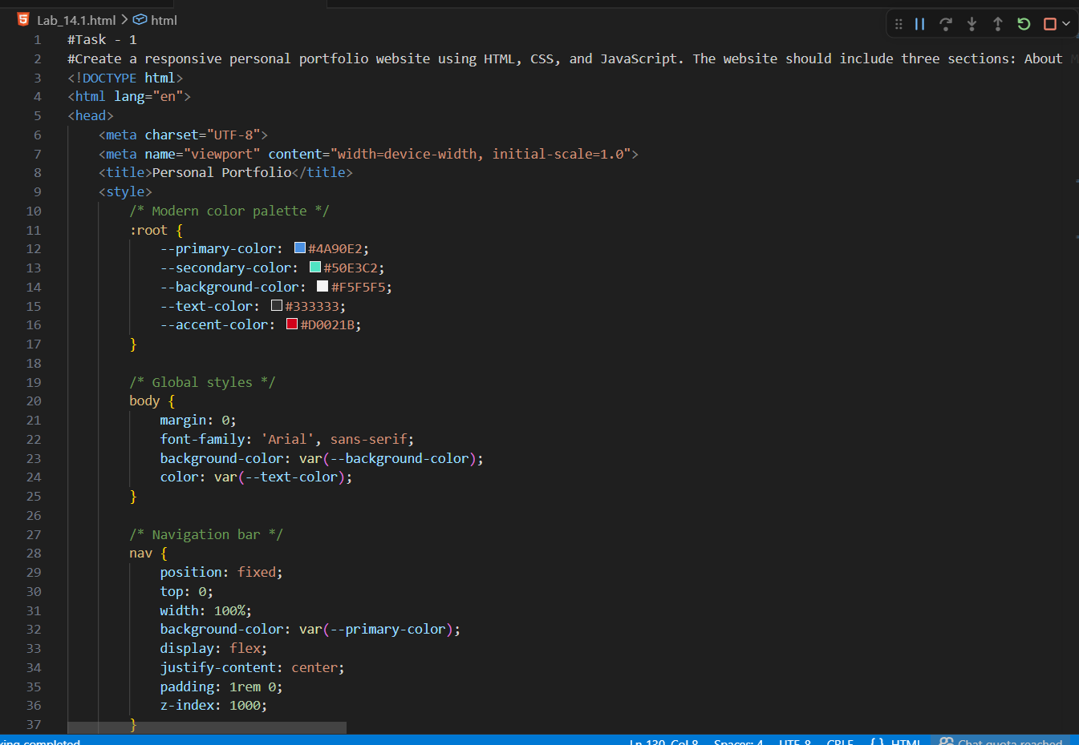
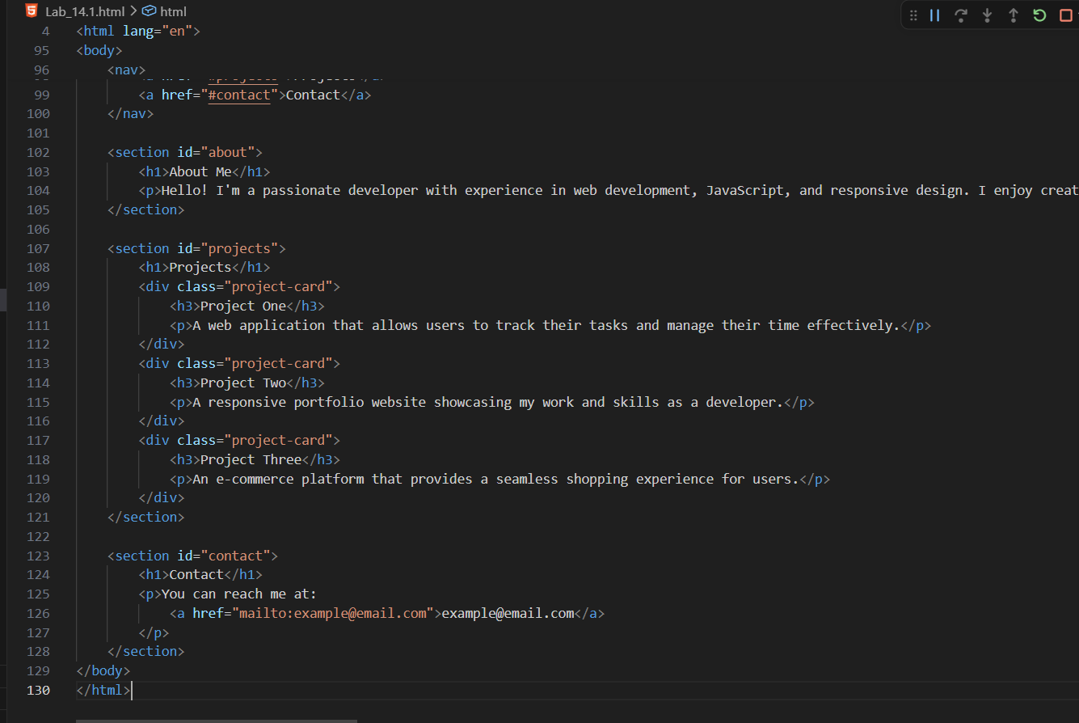
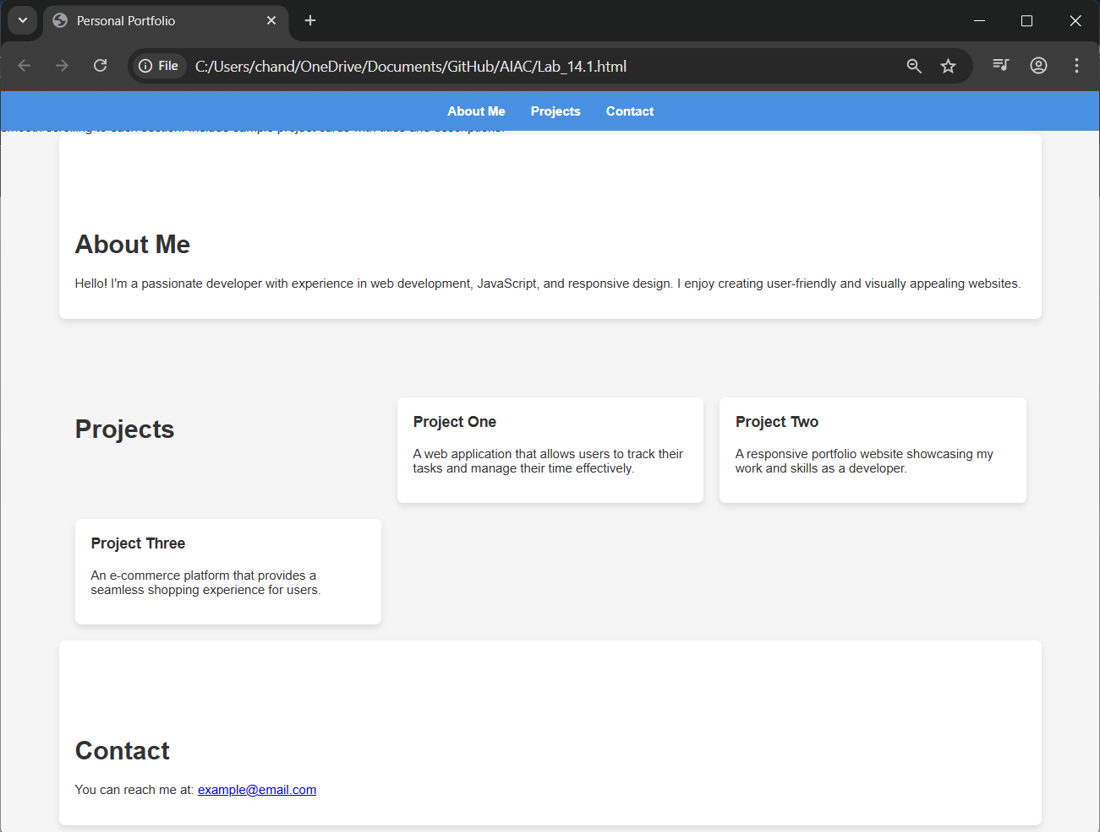
Task 2 – Online Store Product Page
Design a product display page for an online store.
Requirements:
• Display product image, title, price, and "Add to Cart" button.
• Use AI to:
o Style with BEM methodology.
o Make layout responsive.
o Add hover effects and "Add to Cart" alert.
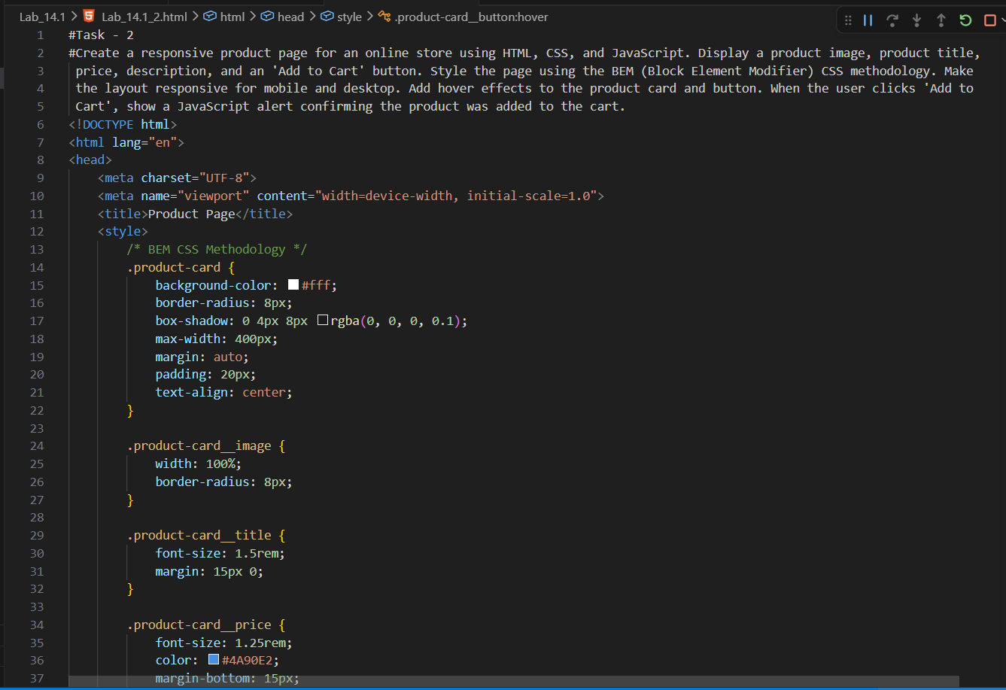
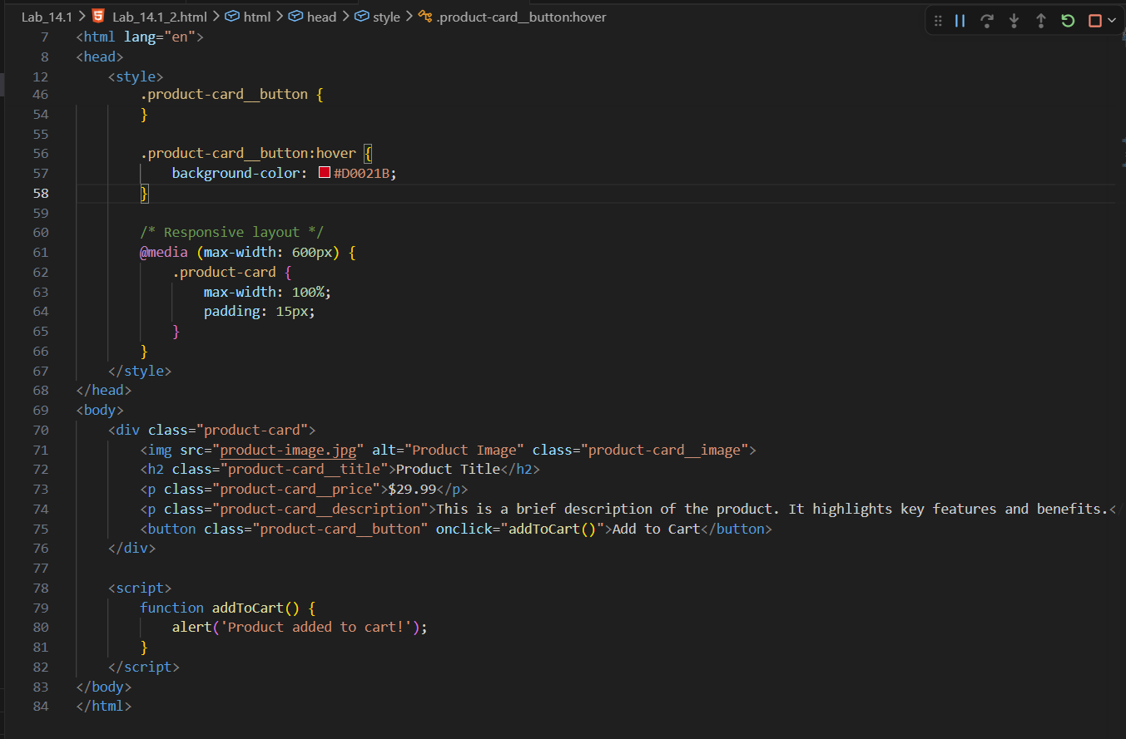
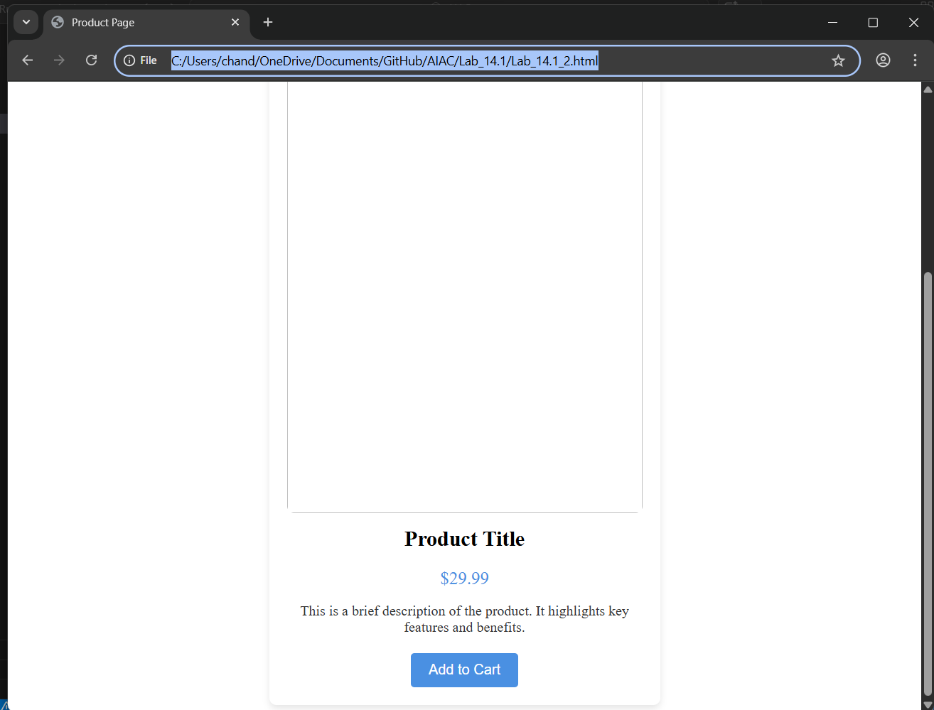
Task 3 – Event Registration Form
Build an event registration form for a conference.
Requirements:
• Collect name, email, phone number, and session selection.
• Use AI to:
o Add form validation with JavaScript.
o Make the form accessible with labels and ARIA.
o Style with a professional look.
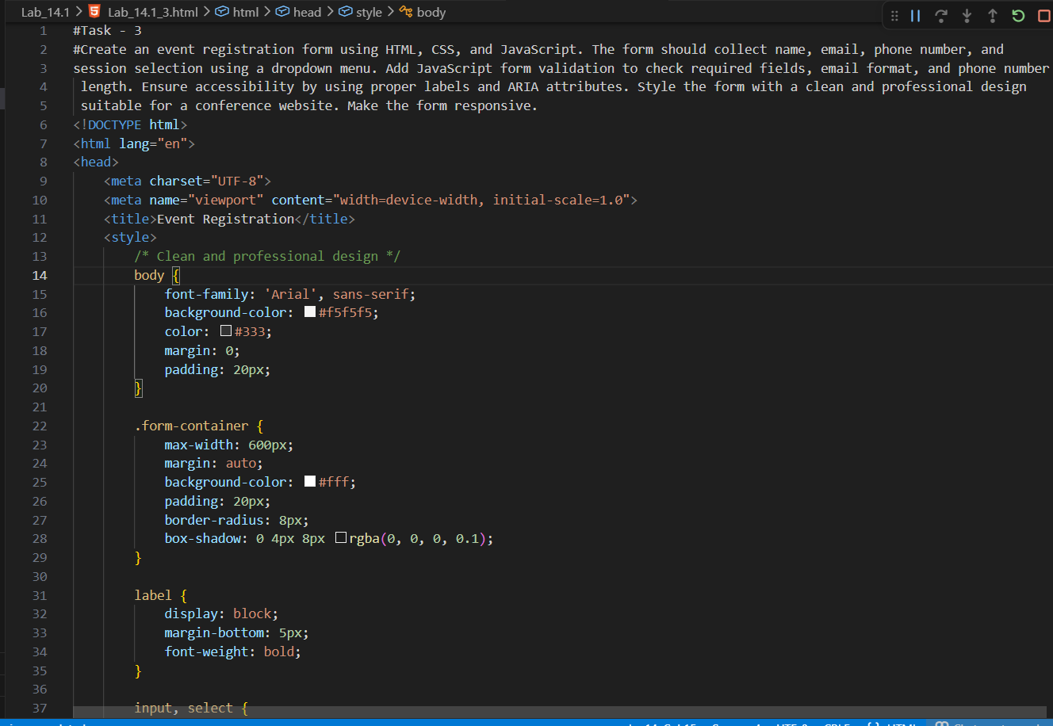
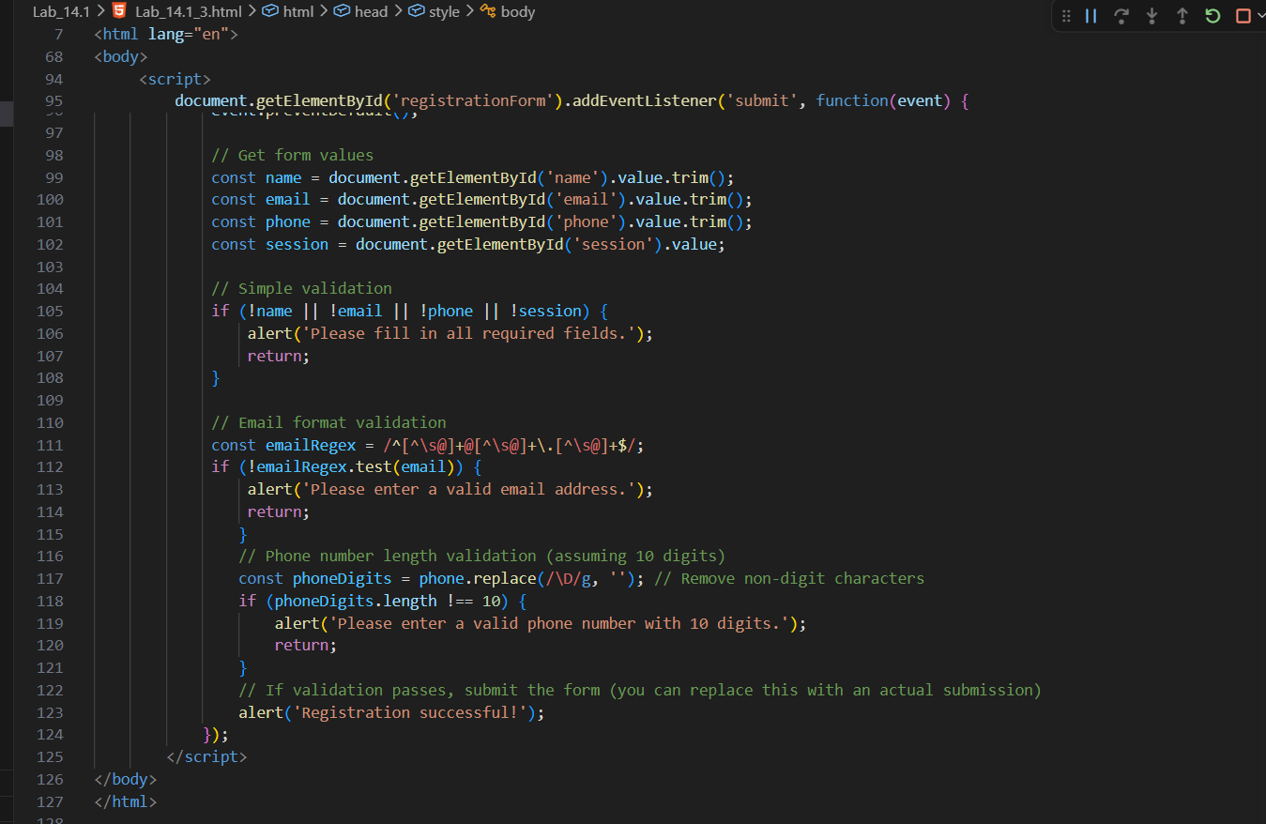
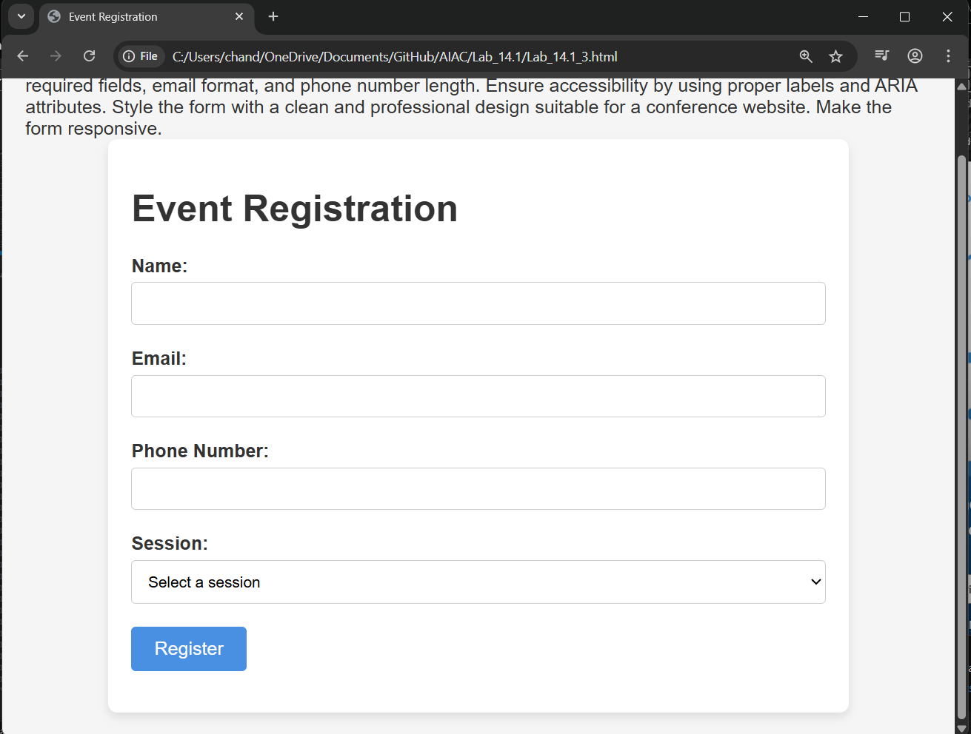
Task 4 – Resume Website
Build a one-page online resume.
Requirements:
• Sections: Profile Summary, Skills, Education, Experience.
• Use AI to:
o Propose professional typography styles.
o Align sections using CSS Grid.
o Add smooth scroll navigation between sections.
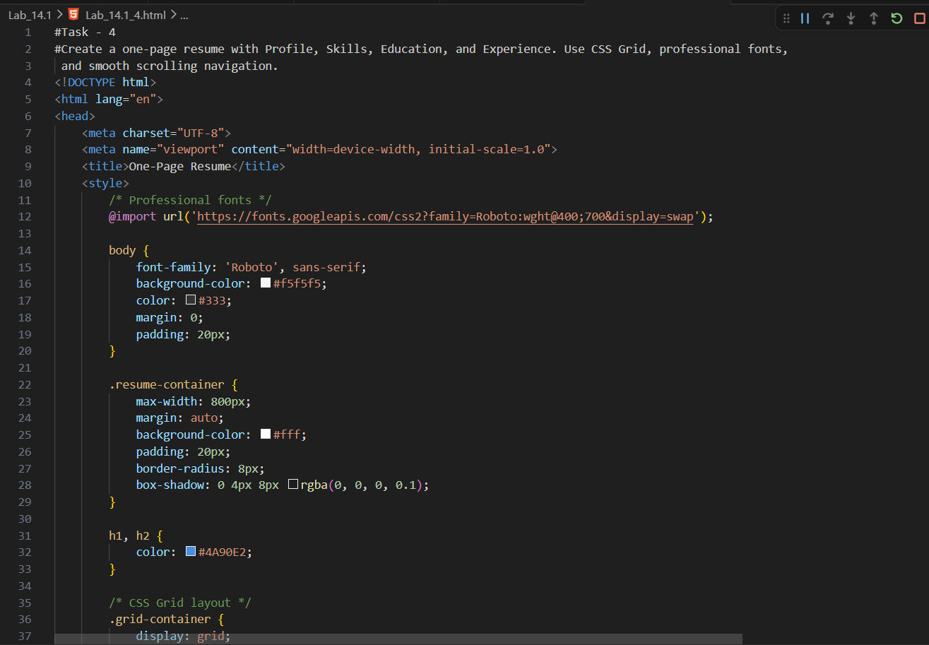
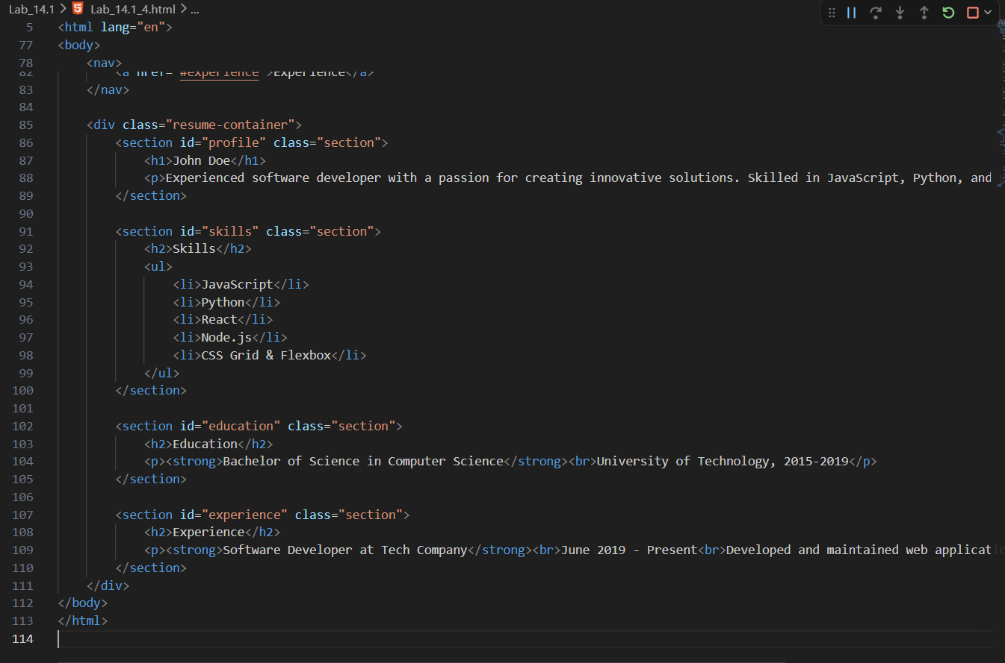
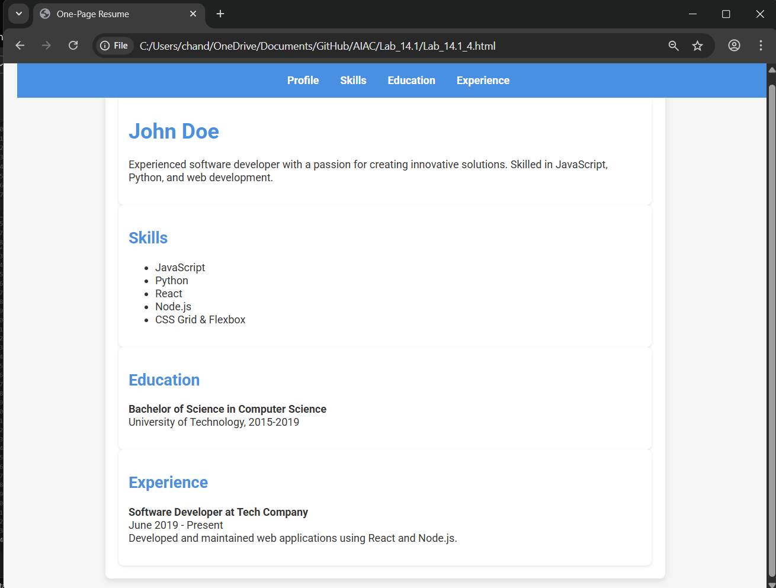
Task 5 – Restaurant Menu Page
Design a digital menu page for a restaurant.
Requirements:
• Display menu items with name, description, and price.
• Use AI to:
o Suggest a food-friendly color palette.
o Design a responsive card-based layout.
o Add hover effects on menu items.
