Assignment-1
NAME:B.Laxmi Spandana
ROLL NO: 2303A52094
COURSE: AI Assisted Coding

Question 1: Zero-Shot Prompting (Palindrome Number Program) Write a zero-shot prompt
(without providing any examples) to generate a Python function that checks whether a given
number is a palindrome.
Task:
• Record the AI-generated code.
• Test the code with multiple inputs.
• Identify any logical errors or missing edge-case handling.
PROMPT
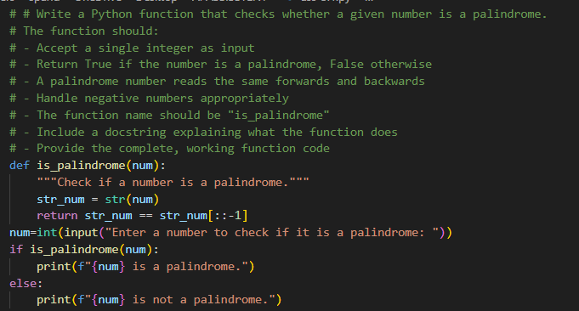
OUTPUT
ANALYSISI
- The zero-shot prompt gave a correct program for checking palindrome numbers.
- The program works well for normal positive numbers.
- It does not clearly handle negative numbers or wrong input types.
- This shows that the code works, but some special cases are missing.

Question 2: One-Shot Prompting (Factorial Calculation) Write a one-shot prompt by providing one input-output example and ask the AI to generate a Python function to compute the factorial of a given number.
Example:
Input: 5 → Output: 120
Task:
• Compare the generated code with a zero-shot solution.
• Examine improvements in clarity and correctness.
PROMPT
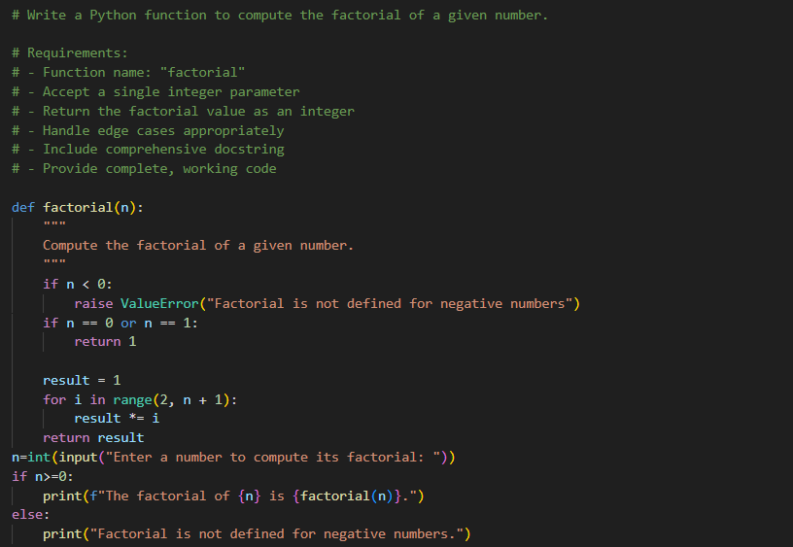
OUTPUT
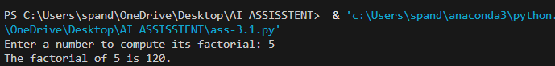
ANALYSIS
- One-shot prompting produces better and safer code than zero-shot prompting.
- The example helps the AI write clearer logic and handle edge cases correctly.

Question 3: Few-Shot Prompting (Armstrong Number Check) Write a few-shot prompt by providing multiple input-output examples to guide the AI in generating a Python function to check whether a given number is an Armstrong number.
Examples:
• Input: 153 → Output: Armstrong Number
• Input: 370 → Output: Armstrong Number
• Input: 123 → Output: Not an Armstrong Number
Task:
• Analyze how multiple examples influence code structure and
accuracy.
• Test the function with boundary values and invalid inputs.
PROMPT
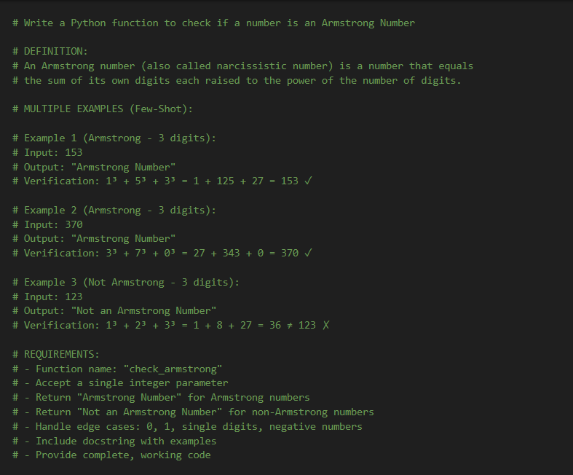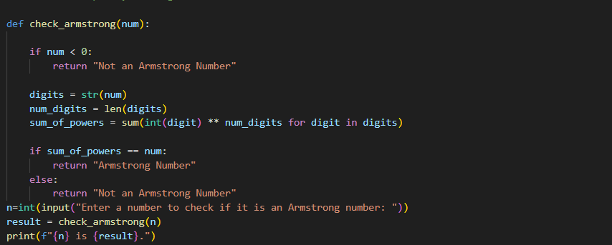
OUTPUT
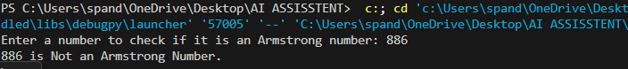
ANALYSIS
- The code structure is better and follows the examples.
- The code does not handle negative or invalid inputs properly.
- Accuracy is higher compared to zero-shot and one-shot prompting.

Question 4: Context-Managed Prompting (Optimized Number Classification) Design a context-managed prompt with clear instructions and constraints to generate an optimized Python program that classifies a number as prime, composite, or neither.
Task:
• Ensure proper input validation.
• Optimize the logic for efficiency.
• Compare the output with earlier prompting strategies.
PROMPT
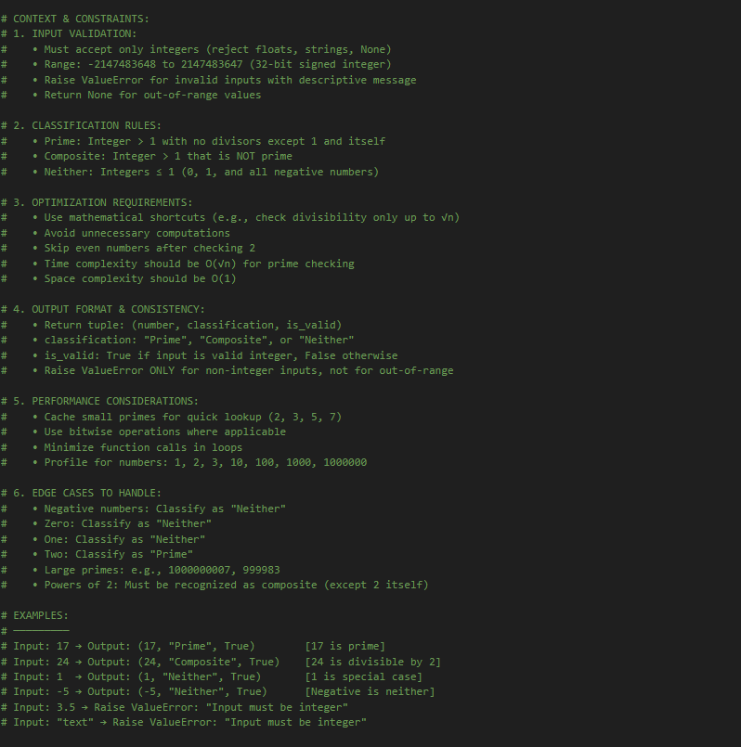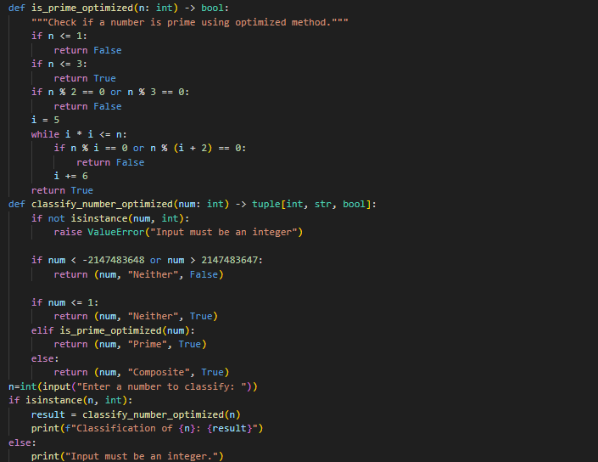
OUTPUT
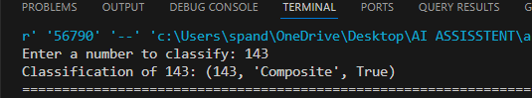
ANALYSIS
- Input validation is properly handled.
- Compared to earlier prompting methods, this gives the best accuracy and performance.
- Clear instructions helped the AI write correct and efficient code.

Question 5: Zero-Shot Prompting (Perfect Number Check) Write a zero-shot prompt (without providing any examples) to generate a Python function that checks whether a given number is a
perfect number.
Task:
• Record the AI-generated code.
• Test the program with multiple inputs.
• Identify any missing conditions or inefficiencies in the logic.
PROMPT
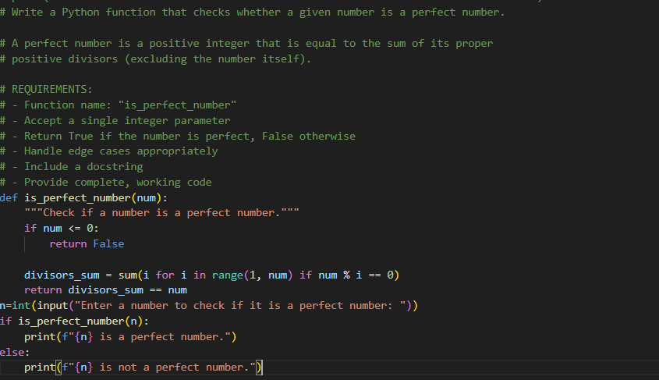
OUTPUT
ANALYSIS
The zero-shot prompt created a correct program for checking perfect numbers.
The program works well for normal positive numbers like 6 and 28.
It does not handle 0, negative numbers, or wrong inputs properly.

Question 6: Few-Shot Prompting (Even or Odd Classification with Validation) Write a few-shot prompt by providing multiple input-output examples to guide the AI in generating a Python program that determines whether a given number is even or odd, including proper input validation.
Examples:
• Input: 8 → Output: Even
• Input: 15 → Output: Odd
• Input: 0 → Output: Even
Task:
• Analyze how examples improve input handling and output
clarity.
• Test the program with negative numbers and non-integer inputs.
PROMPT
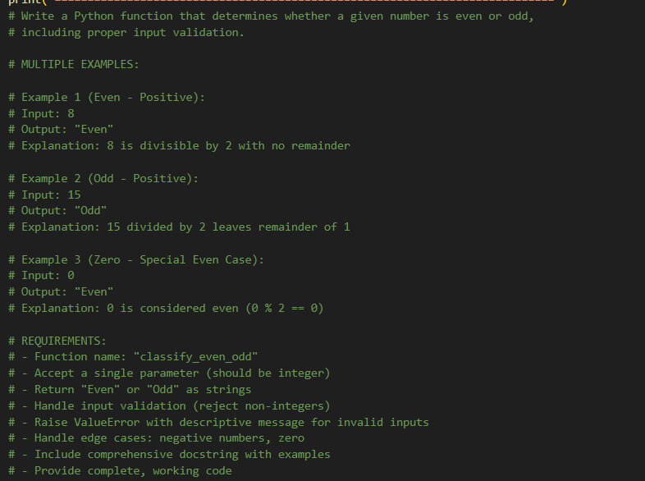
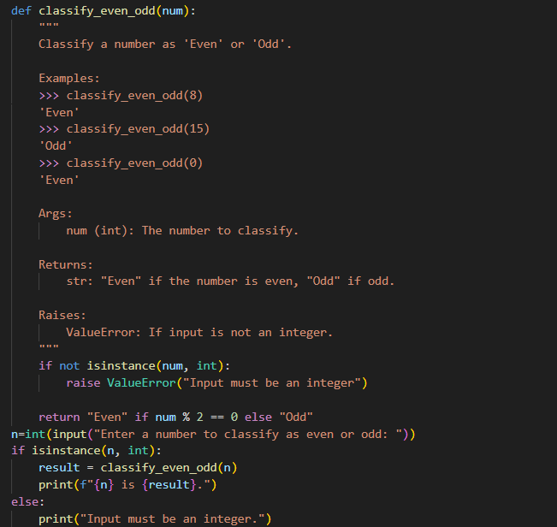
OUTPUT
ANALYSIS
The given examples helped the AI understand what even and odd mean.
The program gives clear output like “Even” or “Odd”.
It correctly works for negative numbers also.
It safely rejects non-integer inputs like decimals or strings.

