WEEK -1& 2
Build a responsive web application for College website with register, login and Achievement pages using CSS3 features, html and jsp
Make the above web application responsive web application using jsp
Main.html :
<!DOCTYPE html>
<html lang="en">
<head>
<meta charset="UTF-8">
<meta name="viewport" content="width=device-width, initial-scale=1.0">
<title>Bhoj reddy</title>
<link rel="stylesheet" href="style.css">
</head>
<body>
<div class="outbox">
<div id="in1">
<img src="brecwlogo.jfif" alt="" height="161px" width="170">
</div>
<div id="in2">
<h1 id="clgname">Bhoj Reddy Engineering College for Women </h1>
<h1 id="clgname 1">(Sponsored by Sangam Laxmibai Vidyapeet)</h1>
<h3 id="name1">Approved by AICTE to JNTU Hyderabad</h3>
<h3 id="name1">Accreditated by NAAC with 'A' Grade,Recognised by UGC under section 2(f) of the UGC Act,1956</h3>
</div>
<div id="in3">
<img src="Naaclogo.jpg" alt="" height="161px" width="100px" >
<img src="aictelogo.jpg" alt="" height="161px" width="100px">
</div>
</div>
<div id="navbox">
<ul>
<li><a href="achivements.html">ACHIVEMENTS</a></li>
<li><a href="aboutus.html">ABOUT US</a></li>
<li><a href=""> HOME</a></li>
<li><a href="sports.html">SPORTS</a></li>
<li><a href="faculty.html">FACULTY</a></li>
<li><a href="Login.html">LOGIN</a></li>
<li><a href="register.html">REGISTER</a></li>
<li><a href="timetable.html">TIMETABLE</a></li>
</ul>
<br>
</div>
<div class="outerbox">
<img src="collegepic.jfif" alt="" width="1263px" height="400px">
</div>
<!---------placements-------->
<section class="placements">
<h1> PLACEMENTS</h1>
<img src="placementlogo.jfif" alt="" width="1000" height="300">
<div class="row">
<div class="placements-col">
<h3> AMAZON</h3>
<h5> how to get placed in amazon?</h5>
<p>To get placed at Amazon off-campus, focus on building a strong resume, mastering technical skills (especially data structures and algorithms), and practicing coding problems on platforms like HackerRank and LeetCode. Also, network and utilize your contacts to find referrals and direct HR contacts.
</p>
</div>
<div class="placements-col">
<h3> INFOSYS</h3>
<h5> how to get placed in infosys?</h5>
<p> To get placed at Infosys off-campus, you can apply through their career portal, focusing on roles matching your skills and experience, and consider referral opportunities from Infosys employees. </p>
</div>
<div class="placements-col">
<h3> TCS</h3>
<h5> how to get placed in tcs?</h5>
<p>to get placed in TCS we have to qualify in code vita or TCS NQT test</p>
</div>
<div class="outerbox">
<img src="amazon.jfif" alt="" width="300" height="300">
<img src="infosys.jfif" alt="" width="300" height="300">
<img src="tcs.jfif" alt="" width="300" height="300">

</div>
</div>
</section>
</body>
</html>

Style.css:
*{
margin: 0px;
padding: 0px;
}
.outbox{
border: solid 1px;
height: 15%;
display: flex;
}
#in1,#in2,#in3{
border: solid 1px;
height: 15%;
}
#in1{
width: 170px;
}
#in2{
width: 1200px;
text-align: center;
background-color: blanchedalmond;
}
#in3{
width: 280px;
}
#clgname{
font-size: 43px;
color: rgb(255, 0, 0)}
#clgname1{
font-size: 22px;
color: rgb(0, 255, 42);
}
#name1{
font-size: 22px;
color: navy;
}
#navbox{
border: solid 1px;
height: 50px;
}
ul li{
height: 50px;
width: 150px;

float:inline-end;
text-align: center;
line-height: 50px;
justify-content: right;
}
ul{
list-style: none;
}
ul li a{
font-size: 22px;
color: black;
text-decoration: none;
}
ul li ul li{
display: none;
}
ul li:hover ul li{
display: block;
}
ul li:hover{
background-color: goldenrod;
}
/* --------placements------ */
.placements{
text-align: center;
padding: 40px 20px;
background-color: #f9f9f9;
}
h1{

font-size: 36px;
font-weight: 600;
}
p{
color: rgb(228, 216, 226);
font-weight: 300;
line : 22px;
padding:10px
}
.row{
display: flex;
justify-content: center;
flex-wrap: wrap;
gap: 20px;
margin-top: 20px;
}
.placements-col{
flex-basis: 31%;
max-width: 350px;
background-color: burlywood;
border-radius: 10px;
padding: 20px;
text-align: left;
box-shadow: 0px 4px 8px rgba(0, 0, 0, 0.2);
transition: transform 0.3s;
}
.row .outerbox{
gap:60px;
padding:20px;}

Output :

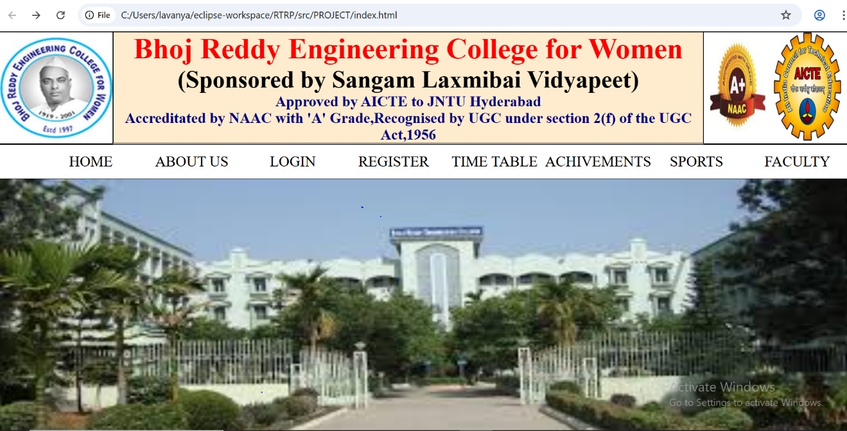

About.html :
<!DOCTYPE html>
<html lang="en">
<head>
<meta charset="UTF-8">
<meta name="viewport" content="width=device-width, initial-scale=1.0">
<title>About Us - Our College</title>
<link rel="stylesheet" href="about.css">
</head>
<body>
<h1>ABOUT-US</h1>
<section class="about-section">
<div class="container">
<h2>Welcome to Our College</h1>
<p>Our college is a center of academic excellence, fostering a vibrant and inclusive community for students. With a strong commitment to education, research, and innovation, we strive to create future leaders and changemakers.</p>
<h3>Our Mission</h3>
<p>To provide high-quality education, encourage critical thinking, and cultivate a culture of creativity and leadership among students.</p>
<h2>Why Choose Our College?</h2>
<ul>
<li>Experienced faculty dedicated to student success</li>
<li>State-of-the-art facilities and resources</li>
<li>Vibrant student life with clubs and organizations</li>
<li>Strong industry connections and career opportunities</li>
</ul>
<p>Join us and embark on a journey of knowledge, innovation, and personal growth!</p>
</div>
</section>
</body>
</html>

<style>
body {
font-family: Arial, sans-serif;
background-color: #f4f4f4;
margin: 0;
padding: 0;
}

.about-section {
display: flex;
justify-content: center;
align-items: center;
height: 100vh;
}

.container {
background: hsl(0, 10%, 94%);
padding: 30px;
width: 50%;
border-radius: 10px;
box-shadow: 0px 0px 10px rgba(0, 0, 0, 0.1);
text-align: center;
}
.ab{
color: black;

}

h1{
text-align: center;
}
h2 {
color: #d9534f;
}
h3 {
color: #5bc0de;
}
p, ul {
font-size: 18px;
color: #333;
}
ul {
text-align: left;
display: inline-block;
margin: auto;
}
</style>

Output :

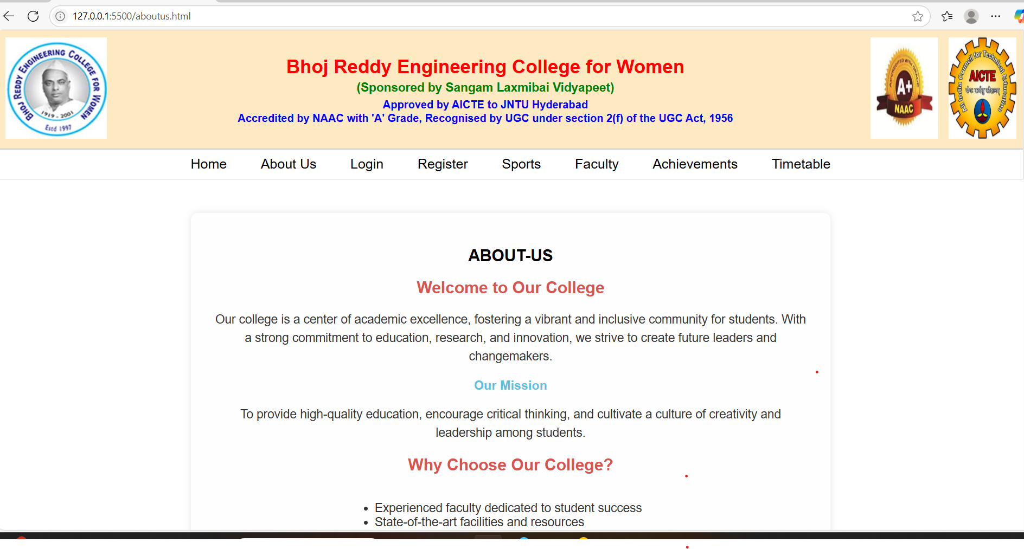

Register.html :

<!DOCTYPE html>
<html lang="en">
<head>
<meta charset="UTF-8">
<meta name="viewport" content="width=device-width, initial-scale=1.0">
<title>College- Register</title>
<link rel="stylesheet" href="register.css">
</head>
<body>
<div class="register-container">
<h2>college - Register</h2>
<form action="register.jsp" method="POST">
<input type="text" name="firstname" placeholder="firstname" required>
<input type="text" name="lastname" placeholder="lastname" required>
<input type="text" name="studentid" placeholder="studentid" required>
<input type="password" name="password" placeholder="password" required>
<button type="submit">register</button>
</form>
<p>Already have an account? <a href="Login.html">Login here</a></p>
</div>
</body>
</html>

Register.css :

body {
font-family: Arial, sans-serif;
background: #f4f4f4;

display: flex;
justify-content: center;
align-items: center;
height: 100vh;
}

.register-container {
background: #fff;
padding: 40px;
border-radius: 10px;
box-shadow: 0 0 10px rgba(0,0,0,0.1);
width: 100%;
max-width: 400px;
}

h2 {
text-align: center;
color: #333;
}
form {
display: flex;
flex-direction: column;
}
input {
padding: 12px;
margin: 10px 0;
border: 1px solid #ccc;
border-radius: 5px;
}
button {

padding: 12px;
background-color: #2e86de;
color: white;
border: none;
border-radius: 5px;
cursor: pointer;
font-weight: bold;
}
button:hover {
background-color: #1e6bb8;
}
p {
text-align: center;
margin-top: 15px;
}
a {
color: #2e86de;
text-decoration: none;
}
select {
padding: 12px;
margin: 10px 0;
border: 1px solid #ccc;
border-radius: 5px;
background-color: white;
font-size: 16px;
}

Register.jsp :
<%@ page import="java.sql.*" %>

<%
String firstname = request.getParameter("firstname");
String lastname = request.getParameter("lastname");
String department = request.getParameter("department");
String password = request.getParameter("password");

// JDBC connection variables
String url = "jdbc:mysql://localhost:3306/college"; // Replace with your DB name
String dbUsername = "root"; // Replace with your DB username
String dbPassword = "123456"; // Replace with your DB password

Connection conn = null;
PreparedStatement pstmt = null;

try {
Class.forName("com.mysql.cj.jdbc.Driver");
conn = DriverManager.getConnection(url, dbUsername, dbPassword);
String sql = "INSERT INTO register (firstname, lastname, studentid, password) VALUES (?, ?, ?, ?)";
pstmt = conn.prepareStatement(sql);
pstmt.setString(1, firstname);
pstmt.setString(2, lastname);
pstmt.setString(3, department);
pstmt.setString(4, password); // For better security, hash the password (see note below)
int rowsInserted = pstmt.executeUpdate();

if (rowsInserted > 0) {
out.println("<script>alert('Registration successful!'); window.location='Login.html';</script>");
} else {
out.println("<script>alert('Registration failed. Try again.'); history.back();</script>");
}
} catch (Exception e) {
out.println("<script>alert('Error: " + e.getMessage() + "'); history.back();</script>");
} finally {
try { if (pstmt != null) pstmt.close(); } catch (Exception e) {}
try { if (conn != null) conn.close(); } catch (Exception e) {}
}
%>

Output :

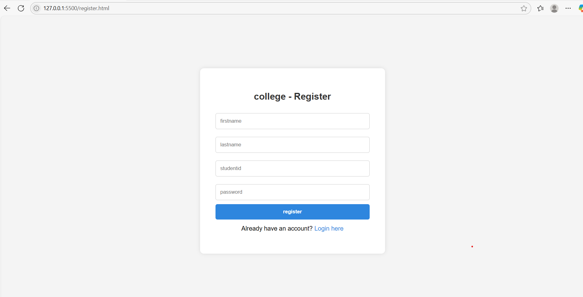

Login.html :

<!DOCTYPE html>
<html lang="en">
<head>
<meta charset="UTF-8">
<meta name="viewport" content="width=device-width, initial-scale=1.0">
<title>College- Login</title>
<link rel="stylesheet" href="Login.css">
<link href="https://fonts.googleapis.com/css2?family=Poppins:wght@400;600&display=swap" rel="stylesheet">
</head>
<body>
<div class="login-wrapper">
<div class="login-box">
<h2>college website</h2>
<p class="subtitle">login here!</p>
<form action="Login.jsp" method="POST">
<div class="input-group">
<label for="studentid">studentid</label>
<input type="text" id="studentid" name="studentid" placeholder="studentid" required>
<div class="input-group" >
<label for="password">Password</label>
<input type="password" id="password" name="password" placeholder="••••••••" required>
</div>

<div class="options">
<a href="#">Forgot password?</a>
</div>
</div>
<button type="submit" class="login-btn">Login</button>

<p class="signup-text">Don't have an account? <a href="register.html">Register here</a></p>
</form>
</div>
</div>
</body>
</html>

Login.css :
* Basic Reset */
* {
margin: 0;
padding: 0;
box-sizing: border-box;
}

body {
font-family: 'Poppins', sans-serif;
background: linear-gradient(135deg, #00b4d8, #0077b6);
height: 100vh;
display: flex;
align-items: center;
justify-content: center;
}

/* Wrapper for alignment */
.login-wrapper {
width: 100%;
max-width: 420px;
padding: 20px;
}

/* Login box */
.login-box {
background: hwb(0 96% 3%);
padding: 40px;
border-radius: 30px;
text-align: center;
animation: fadeIn 0.6s ease-in-out;
}

.login-box h2 {
color: #4b5609;
margin-bottom: 10px;
}

.subtitle {
font-size: 14px;
color: #da2727;
margin-bottom: 30px;
}

/* Input group */
.input-group {
margin-bottom: 20px;
text-align: left;
}

.input-group label {
font-weight: 500;
font-size: 14px;
margin-bottom: 6px;
display: block;
color: #333;
}
.input-group input {
width: 100%;
padding: 12px 14px;
border: 1px solid #ccc;
border-radius: 8px;
font-size: 15px;
transition: border-color 0.3s ease;
}
.input-group input:focus {
border-color: #0077b6;
outline: none;
}
/* Options row */
.options {
display: flex;
justify-content: space-between;
align-items: center;
font-size: 14px;
margin-bottom: 20px;
}
.options a {
color: #0077b6;
text-decoration: none;
}

.options input[type="checkbox"] {
margin-right: 5px;
}
/* Button */
.login-btn {
width: 100%;
padding: 12px;
background-color: #0077b6;
color: #fff;
border: none;
border-radius: 8px;
font-size: 16px;
font-weight: 600;
cursor: pointer;
transition: background-color 0.3s ease;
}
.login-btn:hover {
background-color: #ef650f;
}
/* Signup text */
.signup-text {
margin-top: 20px;
font-size: 14px;
}
.signup-text a {
color: #b60095;
font-weight: 500;
text-decoration: none;
}
/* Animation */

@keyframes fadeIn {
from {
opacity: 0;
transform: translateY(-15px);
}
to {
opacity: 1;
transform: translateY(0);
}
}
/* Mobile responsive */
@media (max-width: 480px) {
.login-box {
padding: 30px 20px;
}
}

Login.jsp :
<%@ page import="java.sql.*" %>
<%
// Set encoding to handle special characters
request.setCharacterEncoding("UTF-8");
response.setContentType("text/html;charset=UTF-8");

// Get form inputs
String firstname = request.getParameter("firstname");
String password = request.getParameter("password");

// Database credentials
String dbUrl = "jdbc:mysql://localhost:3306/college"; // replace with your DB
String dbUser = "root"; // your DB username
String dbPass = "123456"; // your DB password

Connection conn = null;
PreparedStatement stmt = null;
ResultSet rs = null;

try {
Class.forName("com.mysql.cj.jdbc.Driver");
conn = DriverManager.getConnection(dbUrl, dbUser, dbPass);

String sql = "SELECT * FROM register WHERE firstname = ? AND password = ?";
stmt = conn.prepareStatement(sql);
stmt.setString(1, firstname);
stmt.setString(2, password);

rs = stmt.executeQuery();

if (rs.next()) {
// Login success
response.sendRedirect("main.html");
return;
} else {
// Login failed
out.println("<script>alert('Invalid firstname or password'); history.back();</script>");
}
} catch (Exception e) {
out.println("<h3>Error: " + e.getMessage() + "</h3>");
} finally {
try { if (rs != null) rs.close(); } catch (Exception e) {}
try { if (stmt != null) stmt.close(); } catch (Exception e) {}

try { if (conn != null) conn.close(); } catch (Exception e) {}
}
%>
Output :

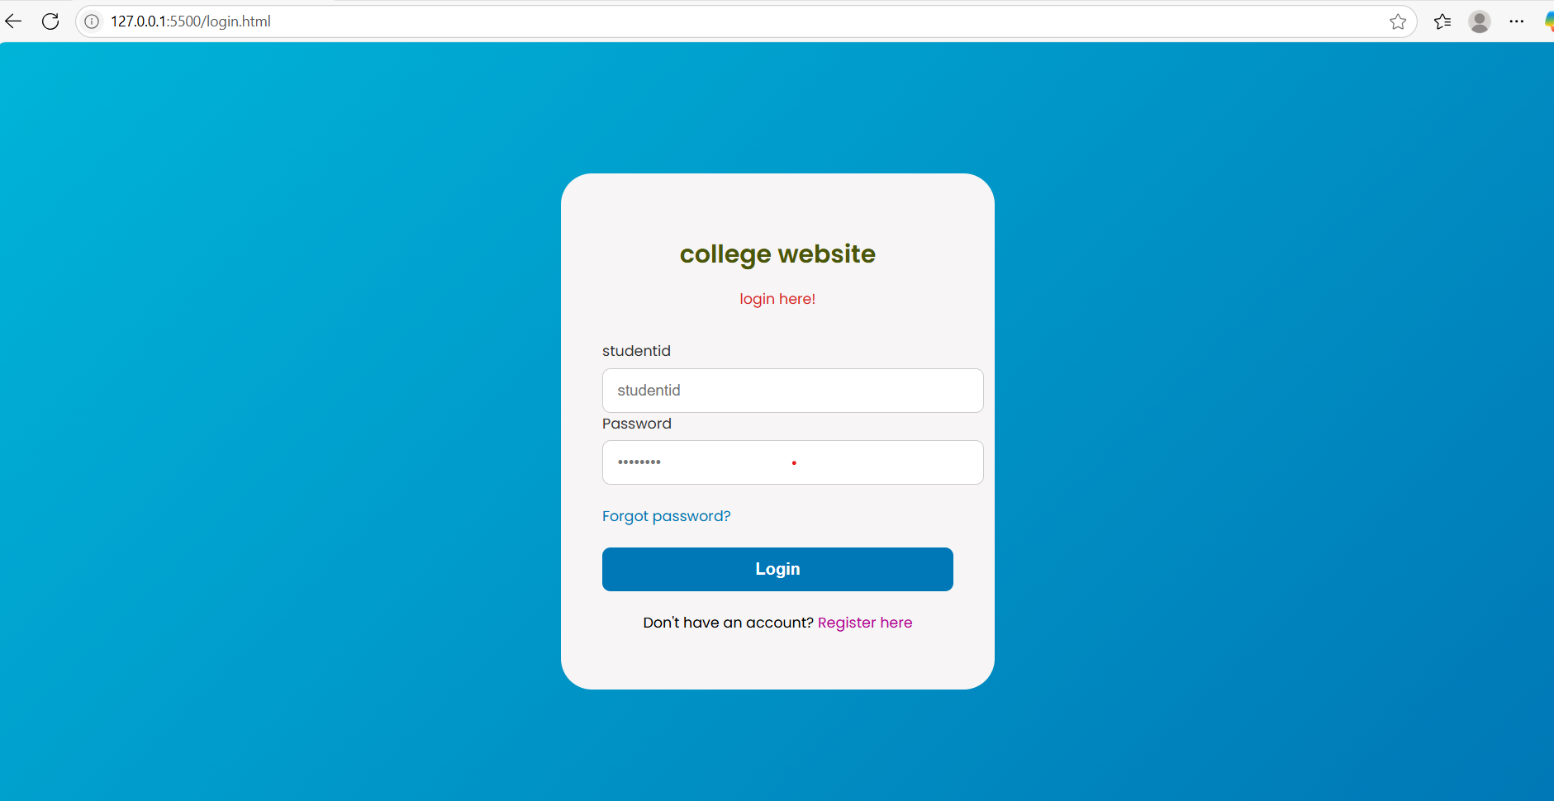

Sports.html :
<!DOCTYPE html>
<html lang="en">
<head>
<meta charset="UTF-8">
<meta name="viewport" content="width=device-width, initial-scale=1">
<title>College Sports</title>
<link rel="stylesheet" href="sports.css">
</head>
<body>
<header>
<h1>Bhoj Reddy Engineering College for Women - Sports Activities</h1>
<nav>
<a href="#">Home</a>
<a href="#">Events</a>
<a href="#">Teams</a>
<a href="#">Contact</a>
</nav>
</header>

<section class="intro">
<h2>Welcome to Our Sports Department</h2>
<p>We encourage all students to participate in sports to enhance their physical and mental well-being.<br>
The Outdoor games facilities include a 200 mts track with Basket Ball, Volley Ball, Throw Ball, Tenni Koit and Shuttle badminton courts. <br>The indoor games facilities include Table Tennis, Carroms and Chess.<br>

Inter Engineering Games Meets for Women students will be conducted every year.Many medals own by the students in JNTUH Inter Engineering Collegiate Tournment every year.

Many students represented the JNTUH in All India Inter University Championships held in various places in India.<br>

The Management of the College encouraging the students by giving cash awards for the University players as well as the winners in JNTUH Inter Engineering Collegiate Tournaments.<br>

National Cadet Corps (NCC) :<br>
The NCC Unit was established in the college in 2003. This college is attached to Unit2 (Andhra) Air Sqn(Technical) Cadre. Many students attended the selections and they completed the campus successfully and got 'B' & 'C' certificates.</p>
</section>

<section class="sports-list">
<h2>Sports We Offer</h2>
<ul>
<li>Cricket</li>
<li>Football</li>
<li>Basketball</li>
<li>Volleyball</li>
<li>Badminton</li>
<li>Table Tennis</li>
</ul>
</section>
<section class="events">
<h2>Gallery</h2>
<img src="https://encrypted-tbn0.gstatic.com/images?q=tbn:ANd9GcT4ZKVXU4aLpIZfkXdEQaHIlFp8-6srqE78uQ&s" alt="" width="300px" height="300px>
<img src="https://encrypted-tbn0.gstatic.com/images?q=tbn:ANd9GcS9F5mKjnAVvbenNZZt0GIms6aKRrJc9X7RnA&s" alt="" width="300px" height="300px">
<img src="https://slv-edu.in/WebImageGallery/6_6_Gallery_I12aA.D.e_2023_01_07_031218.jpg" alt="" width="300px" height="300px>
<img src="https://encrypted-tbn0.gstatic.com/images?q=tbn:ANd9GcQLhn0ax1Bm9c1vkftJLjKj38vHkvgsDaDDzg&s" width="300px" height="300px>

</section>
<section class="events">
<h2>Recent Events</h2>
<div class="event-card">
<h3>Annual Sports Day 2025</h3>
<p>Held on March 20th, featuring track and field, inter-department matches, and more.</p>
</div>
<div class="event-card">
<h3>Intercollege Football Tournament</h3>
<p>XYZ College won the runner-up trophy among 10 participating colleges.</p>
</div>
</section>

<footer>
<p>Contact: sports@brecwcollege.edu | Phone: 123-456-7890</p>
<p>&copy; 2025 BRECW</p>
</footer>
</body>
</html>
Sports.css :
body {
margin: 0;
font-family: Arial, sans-serif;
background: #f8f8f8;
color: #333;
}

header {
background-color: #004080;
color: white;
padding: 20px;
text-align: center;
}

nav a {
color: white;
margin: 0 15px;
text-decoration: none;
}

.intro, .sports-list, .events {
padding: 30px;
background: white;
margin: 20px auto;
width: 80%;
border-radius: 10px;
box-shadow: 0 0 10px rgba(0,0,0,0.1);
}

.sports-list ul {
list-style: square;
padding-left: 20px;
}

.event-card {
background: #e8f4ff;
padding: 15px;
margin: 10px 0;
border-left: 5px solid #004080;
}

footer {
text-align: center;
background: #004080;
color: white;
padding: 15px;
}
Output :

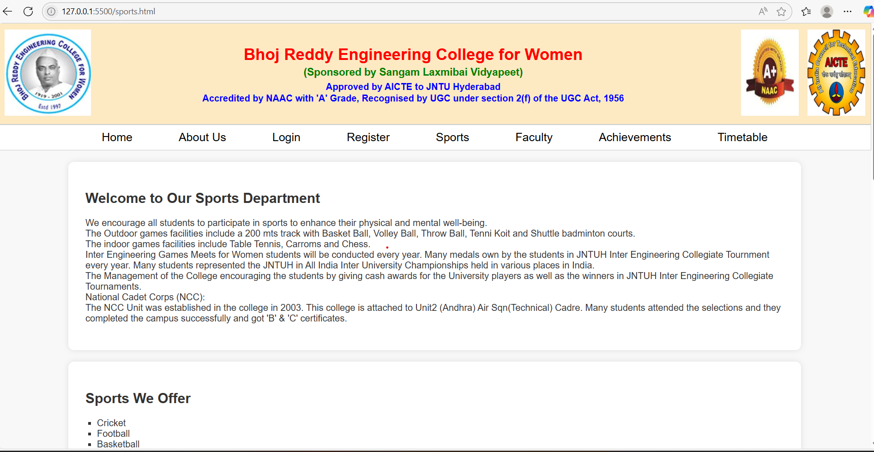

Faculty.html :
<!DOCTYPE html>
<html lang="en">
<head>
<meta charset="UTF-8">
<meta name="viewport" content="width=device-width, initial-scale=1">
<title>Faculty - Bhoj Reddy Engineering College for Women</title>
<link rel="stylesheet" href="faculty.css">
</head>
<body>
<header>
<h1>BRECW College - Faculty Members</h1>
<nav>
<p align="center">DEPARTMENT - IT</p>
</nav>
</header>

<section class="faculty-section">
<h2>HOD OF IT DEPARTMENT</h2>
<div class="faculty-container">
<div class="faculty-card">
<img src="https://via.placeholder.com/150" alt="Dr. A Kumar">
<h3>DR C MURUGAMANI</h3>
<p>Professor & HOD</p>
<p>Ph.D in IT</p>
</div>
</div>
<h2>FACULTY OF IT DEPARTMENT</h2>
<div class="faculty-container">
<div class="faculty-card">

<img src="https://via.placeholder.com/150" alt="Ms. B Sharma">
<h3>DR M SANDHYA RANI</h3>
<p>Associate Professor</p>
<p>PhD-CSE</p>
</div>
<div class="faculty-card">
<img src="https://via.placeholder.com/150" alt="Dr. C Patel">
<h3>Navaneetha D</h3>
<p>Associate Professor</p>
<p>M.Tech-CSE</p>
</div>
<div class="faculty-card">
<img src="https://via.placeholder.com/150" alt="Mr. D Singh">
<h3>Jyothi G</h3>
<p>Associate Professor</p>
<p>M.Tech-CSE</p>
</div>
<div class="faculty-card">
<img src="https://via.placeholder.com/150" alt="Mr. D Singh">
<h3>Tasneem Rahath</h3>
<p>Assistant Professor</p>
<p>M.Tech-CSE</p>
</div>
<div class="faculty-card">
<img src="https://via.placeholder.com/150" alt="Mr. D Singh">
<h3>Revathi Simhadri</h3>
<p>Assistant Professor</p>
<p>M.Tech-IT</p>
</div>
<div class="faculty-card">

<img src="https://via.placeholder.com/150" alt="Mr. D Singh">
<h3>Madhuravani</h3>
<p>Assistant Professor</p>
<p>M.Tech-CSE</p>
</div>
<div class="faculty-card">
<img src="https://via.placeholder.com/150" alt="Mr. D Singh">
<h3>Minhaj Begum</h3>
<p>Assistant Professor</p>
<p>M.Tech-SE</p>
</div>
</div>
</section>
<footer>
<p>Contact: faculty@brecwcollege.edu | Phone: 123-456-7890</p>
<p>&copy; 2025 BRECW College</p>
</footer>
</body>
</html>
Faculty.css :
body {
margin: 0;
font-family: 'Segoe UI', sans-serif;
background-color: #f4f4f4;
color: #333;
}
header {
background-color: #003366;
color: white;
padding: 20px;

text-align: center;
}
nav a {
color: white;
margin: 0 10px;
text-decoration: none;
}
.faculty-section {
padding: 40px 20px;
text-align: center;
}
.faculty-container {
display: flex;
flex-wrap: wrap;
justify-content: center;
gap: 30px;
margin-top: 20px;
}
.faculty-card {
background: white;
border-radius: 10px;
padding: 20px;
width: 200px;
box-shadow: 0 0 10px rgba(0,0,0,0.1);
transition: transform 0.3s ease;

}
.faculty-card:hover {
transform: translateY(-5px);
}

.faculty-card img {
width: 100%;
border-radius: 50%;
}
footer {
text-align: center;
background-color: #003366;
color: white;
padding: 15px;
}
Output :

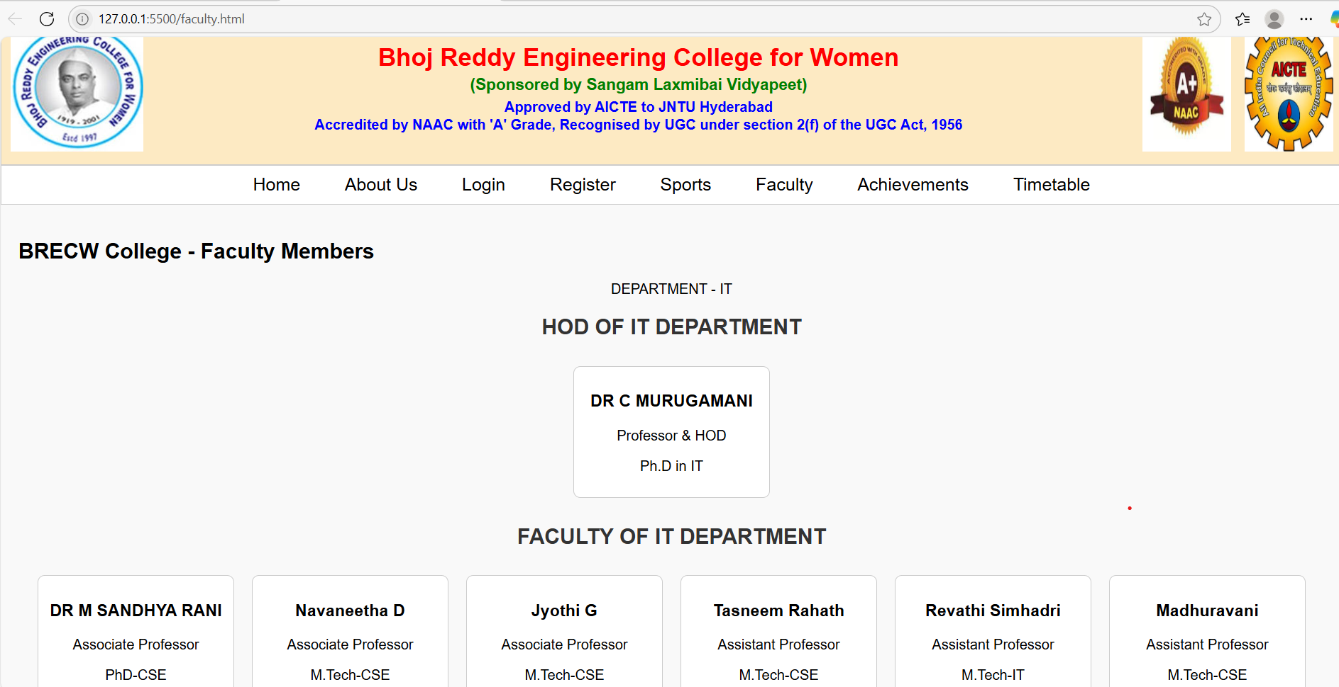

Timetable.html:

<!DOCTYPE html>
<html lang="en">
<head>
<meta charset="UTF-8">
<meta name="viewport" content="width=device-width, initial-scale=1.0">
<title>IT Department Timetable</title>
<link rel="stylesheet" href="timetable.css">
</head>
<body>
<div class="container">
<header>
<h1>IT Department Timetable</h1>
</header>

<!-- First Year Timetable -->
<section class="year-timetable">
<h2>First Year</h2>
<table class="timetable">
<thead>
<tr>
<th>Time</th>
<th>Monday</th>
<th>Tuesday</th>
<th>Wednesday</th>
<th>Thursday</th>
<th>Friday</th>
</tr>
</thead>
<tbody>
<tr>
<td>8:00 - 9:00</td>
<td>Maths</td>
<td>Physics</td>
<td>Computer Science</td>
<td>English</td>
<td>Introduction to IT</td>
</tr>
<tr>
<td>9:00 - 10:00</td>
<td>Data Structures</td>
<td>Maths</td>
<td>Chemistry</td>
<td>Communication Skills</td>
<td>Computer Programming</td>
</tr>
<tr>
<td>10:00 - 11:00</td>
<td>Break</td>
<td>Break</td>
<td>Break</td>
<td>Break</td>
<td>Break</td>
</tr>
<tr>
<td>11:00 - 12:00</td>
<td>Computer Networks</td>
<td>Electrical Engineering</td>
<td>Software Engineering</td>
<td>Operating Systems</td>
<td>Maths</td>
</tr>
<tr>
<td>12:00 - 1:00</td>
<td>Computer Programming</td>
<td>Chemistry</td>
<td>English</td>
<td>Data Structures</td>
<td>Physics</td>
</tr>
</tbody>
</table>
</section>

<!-- Second Year Timetable -->
<section class="year-timetable">
<h2>Second Year</h2>
<table class="timetable">
<thead>
<tr>
<th>Time</th>
<th>Monday</th>
<th>Tuesday</th>
<th>Wednesday</th>
<th>Thursday</th>
<th>Friday</th>
</tr>
</thead>
<tbody>
<tr>
<td>8:00 - 9:00</td>
<td>Operating Systems</td>
<td>Data Structures</td>
<td>Database Systems</td>
<td>Maths</td>
<td>Communication Skills</td>
</tr>
<tr>
<td>9:00 - 10:00</td>
<td>Data Communication</td>
<td>Software Engineering</td>
<td>Mathematics</td>
<td>Algorithms</td>
<td>Programming</td>
</tr>
<tr>
<td>10:00 - 11:00</td>
<td>Break</td>
<td>Break</td>
<td>Break</td>
<td>Break</td>
<td>Break</td>
</tr>
<tr>
<td>11:00 - 12:00</td>
<td>Database Systems</td>
<td>Operating Systems</td>
<td>Computer Networks</td>
<td>Software Design</td>
<td>Data Structures</td>
</tr>
<tr>
<td>12:00 - 1:00</td>
<td>Java Programming</td>
<td>Networking</td>
<td>Communication Skills</td>
<td>Data Communication</td>
<td>Maths</td>
</tr>
</tbody>
</table>
</section>

<!-- Third Year Timetable -->
<section class="year-timetable">
<h2>Third Year</h2>
<table class="timetable">
<thead>
<tr>
<th>Time</th>
<th>Monday</th>
<th>Tuesday</th>
<th>Wednesday</th>
<th>Thursday</th>
<th>Friday</th>
</tr>
</thead>
<tbody>
<tr>
<td>8:00 - 9:00</td>
<td>Machine Learning</td>
<td>Cloud Computing</td>
<td>Advanced Algorithms</td>
<td>Database Management</td>
<td>Computer Vision</td>
</tr>
<tr>
<td>9:00 - 10:00</td>
<td>Data Mining</td>
<td>Operating Systems</td>
<td>Software Engineering</td>
<td>Computer Networks</td>
<td>Machine Learning</td>
</tr>
<tr>
<td>10:00 - 11:00</td>
<td>Break</td>
<td>Break</td>
<td>Break</td>
<td>Break</td>
<td>Break</td>
</tr>
<tr>
<td>11:00 - 12:00</td>
<td>Data Science</td>
<td>Java Programming</td>
<td>AI</td>
<td>Web Development</td>
<td>Cloud Computing</td>
</tr>
<tr>
<td>12:00 - 1:00</td>
<td>Advanced Networking</td>
<td>Database Systems</td>
<td>Data Structures</td>
<td>Digital Electronics</td>
<td>Cyber Security</td>
</tr>
</tbody>
</table>
</section>

<!-- Final Year Timetable -->
<section class="year-timetable">
<h2>Final Year</h2>
<table class="timetable">
<thead>
<tr>
<th>Time</th>
<th>Monday</th>
<th>Tuesday</th>
<th>Wednesday</th>
<th>Thursday</th>
<th>Friday</th>
</tr>
</thead>
<tbody>
<tr>
<td>8:00 - 9:00</td>
<td>Project Work</td>
<td>Cloud Computing</td>
<td>Data Science</td>
<td>Artificial Intelligence</td>
<td>Project Work</td>
</tr>
<tr>
<td>9:00 - 10:00</td>
<td>Machine Learning</td>
<td>Data Analytics</td>
<td>Web Technologies</td>
<td>Database Management</td>
<td>Cyber Security</td>
</tr>
<tr>
<td>10:00 - 11:00</td>
<td>Break</td>
<td>Break</td>
<td>Break</td>
<td>Break</td>
<td>Break</td>
</tr>
<tr>
<td>11:00 - 12:00</td>
<td>Project Work</td>
<td>Digital Marketing</td>
<td>AI</td>
<td>Project Work</td>
<td>Data Mining</td>
</tr>
<tr>
<td>12:00 - 1:00</td>
<td>Cloud Computing</td>
<td>Ethical Hacking</td>
<td>Software Testing</td>
<td>Networking</td>
<td>Project Work</td>
</tr>
</tbody>
</table>
</section>
</div>
</body>
</html>

Timetable.css :
/* Reset default margin and padding */
* {
margin: 0;
padding: 0;
box-sizing: border-box;
}

/* Global Styles */
body {
font-family: 'Arial', sans-serif;
background-color: #f4f4f4;
color: #333;
line-height: 1.6;
padding: 20px;
}

.container {
width: 90%;
margin: 0 auto;
max-width: 1200px;
}

header {
text-align: center;
margin-bottom: 40px;
}

h1 {
font-size: 3em;
color: #003366;
font-weight: bold;
text-transform: uppercase;
}

/* Section for each year */
.year-timetable {
margin-bottom: 40px;
border: 2px solid #ddd;
border-radius: 10px;
background-color: #ffffff;
padding: 20px;
}

.year-timetable h2 {
text-align: center;
color: #005e92;
font-size: 2em;
margin-bottom: 20px;
}

/* Table Styles */
table {
width: 100%;
border-collapse: collapse;
margin-top: 20px;
}

th, td {
padding: 15px;
text-align: center;
border: 1px solid #ddd;
font-size: 1.1em;
}

th {
background-color: #005e92;
color: #fff;
font-size: 1.2em;
}

td {
background-color: #f9f9f9;
}

td:nth-child(odd) {
background-color: #e9f1fa;
}

tr:nth-child(even) td {
background-color: #fafafa;
}

/* Hover effects */
table tbody tr:hover {
background-color: #d3e4f7;
cursor: pointer;
}

/* Mobile Responsive */
@media (max-width: 768px) {
table th, table td {
font-size: 0.9em;
padding: 10px;
}

h1 {
font-size: 2em;
}

.year-timetable h2 {
font-size: 1.5em;
}
.container {
width: 100%;
}
}
Output:
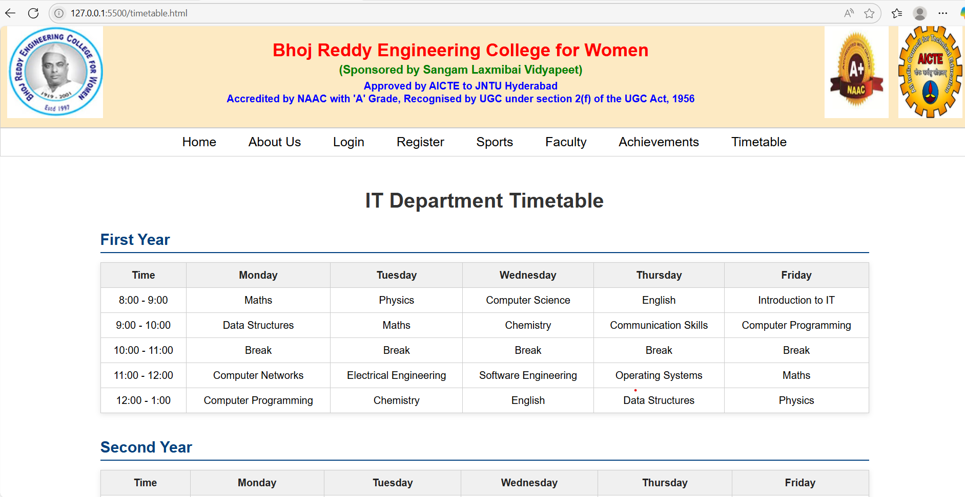

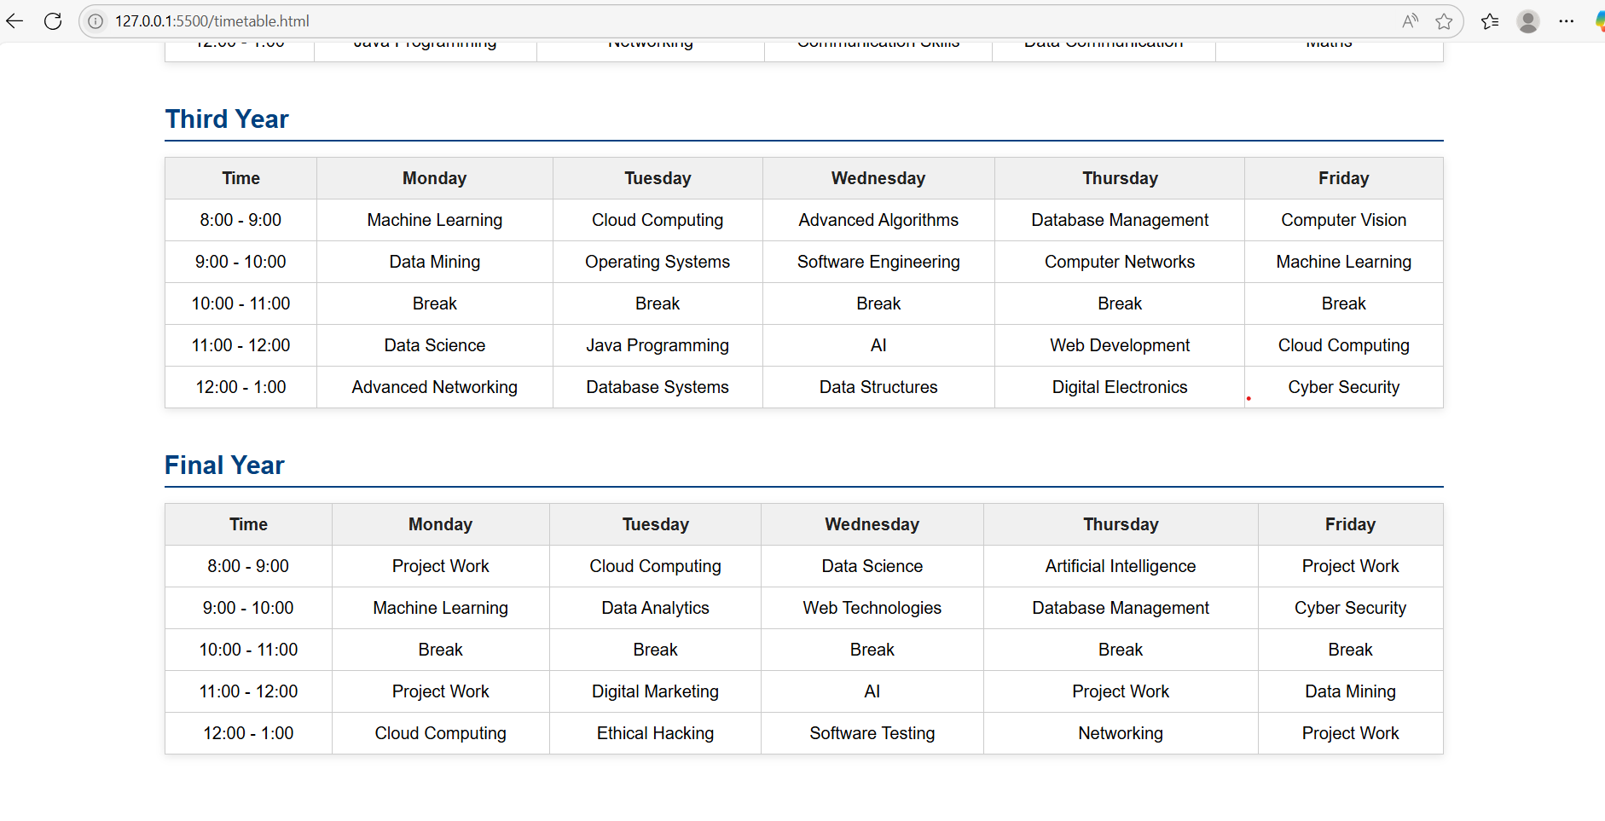

Achievements.html:
<!DOCTYPE html>
<html lang="en">
<head>
<meta charset="UTF-8" />
<meta name="viewport" content="width=device-width, initial-scale=1.0" />
<title>BRECW Achievements</title>
<link rel="stylesheet" href="achivements.css" />
</head>
<body>
<header>
<h1>Achievements of Bhoj Reddy Engineering College for Women</h1>
</header>

<section>
<h2>Academic Excellence</h2>
<img src="images/academic.jpg" alt="Academic Excellence" class="achievement-img" />
<ul>
<li>Consistent pass percentage: 85% - 90%.</li>
<li>Notable alumni: K. Himaja (EIE), AVSLG Swetha (IT), K. Hima Bindu (CHE).</li>
</ul>
</section>

<section>
<h2>Placement Achievements</h2>
<img src="images/placement.jpg" alt="Placement Achievements" class="achievement-img" />
<ul>
<li>2023 placement: 85%, 2022: 80%, 2021: 78%.</li>
<li>Highest package: ₹46 LPA; average: ₹4–6 LPA.</li>
<li>Top recruiters: Microsoft, Amazon, Infosys, Wipro, TCS, Accenture, IBM, Tech Mahindra.</li>
</ul>
</section>

<section>
<h2>Research & Innovation</h2>
<img src="images/research.jpg" alt="Research and Innovation" class="achievement-img" />
<ul>
<li>Focus areas: Computer Science and AI, Embedded Systems, Structural Engineering, Renewable Energy.</li>
<li>Students encouraged to publish research and present at conferences.</li>
</ul>
</section>

<section>
<h2>Technical & Cultural Events</h2>
<img src="images/events.jpg" alt="Tech and Cultural Events" class="achievement-img" />
<ul>
<li>JIGNASA Tech Fest: 630+ participants nationwide.</li>
<li>JIJNASA-2024: 1,100+ registrations, ₹1 lakh cash prizes.</li>
</ul>
</section>

<section>
<h2>Sports & Extracurricular Activities</h2>
<img src="images/sports.jpg" alt="Sports and Extracurricular Activities" class="achievement-img" />
<ul>
<li>Medals in JNTUH Inter Engineering Collegiate Tournaments.</li>
<li>Participation in All India Inter-University Championships.</li>
</ul>
</section>

<section>
<h2>Campus Innovations</h2>
<img src="images/radio.jpg" alt="Younify Campus Radio" class="achievement-img" />
<ul>
<li>Launched Younify Campus Radio in June 2025.</li>
</ul>
</section>

<section>
<h2>Scholarships & Financial Aid</h2>
<img src="images/scholarships.jpg" alt="Scholarships and Financial Aid" class="achievement-img" />
<ul>
<li>Scholarships: Swami Vivekananda Merit Cum Means, Post-Matric for SC, OBC, students with disabilities.</li>
<li>1,039 students benefited in 2022–23.</li>
</ul>
</section>

<section>
<h2>Infrastructure & Facilities</h2>
<img src="images/infrastructure.jpg" alt="Infrastructure and Facilities" class="achievement-img" />
<ul>
<li>6.5-acre campus with smart classrooms, labs, library, sports, cafeteria.</li>
<li>Health center, gym, and hostel accommodations.</li>
</ul>
</section>
</body>
</html>

Achievement.css:

/* Basic styles for the Achievements page with images */

body {
font-family: Arial, sans-serif;
margin: 0;
padding: 0;
background: #f4f4f4;
color: #333;
}

header {
background: #003366;
color: #fff;
padding: 20px;
text-align: center;
}

header h1 {
margin: 0;
}

section {
background: #fff;
margin: 20px;
padding: 20px;
border-radius: 8px;
box-shadow: 0 2px 5px rgba(0,0,0,0.1);
}

section h2 {
color: #003366;
margin-top: 0;
}

ul {
list-style: square;
margin: 10px 0;
padding-left: 20px;
}

.achievement-img {
width: 100%;
max-width: 600px;
border-radius: 8px;
margin: 15px 0;
}

footer {
text-align: center;
padding: 15px;
background: #003366;
color: #fff;
}

footer a {
color: #ffcc00;
text-decoration: none;
}

footer a:hover {
text-decoration: underline;
}

Output:

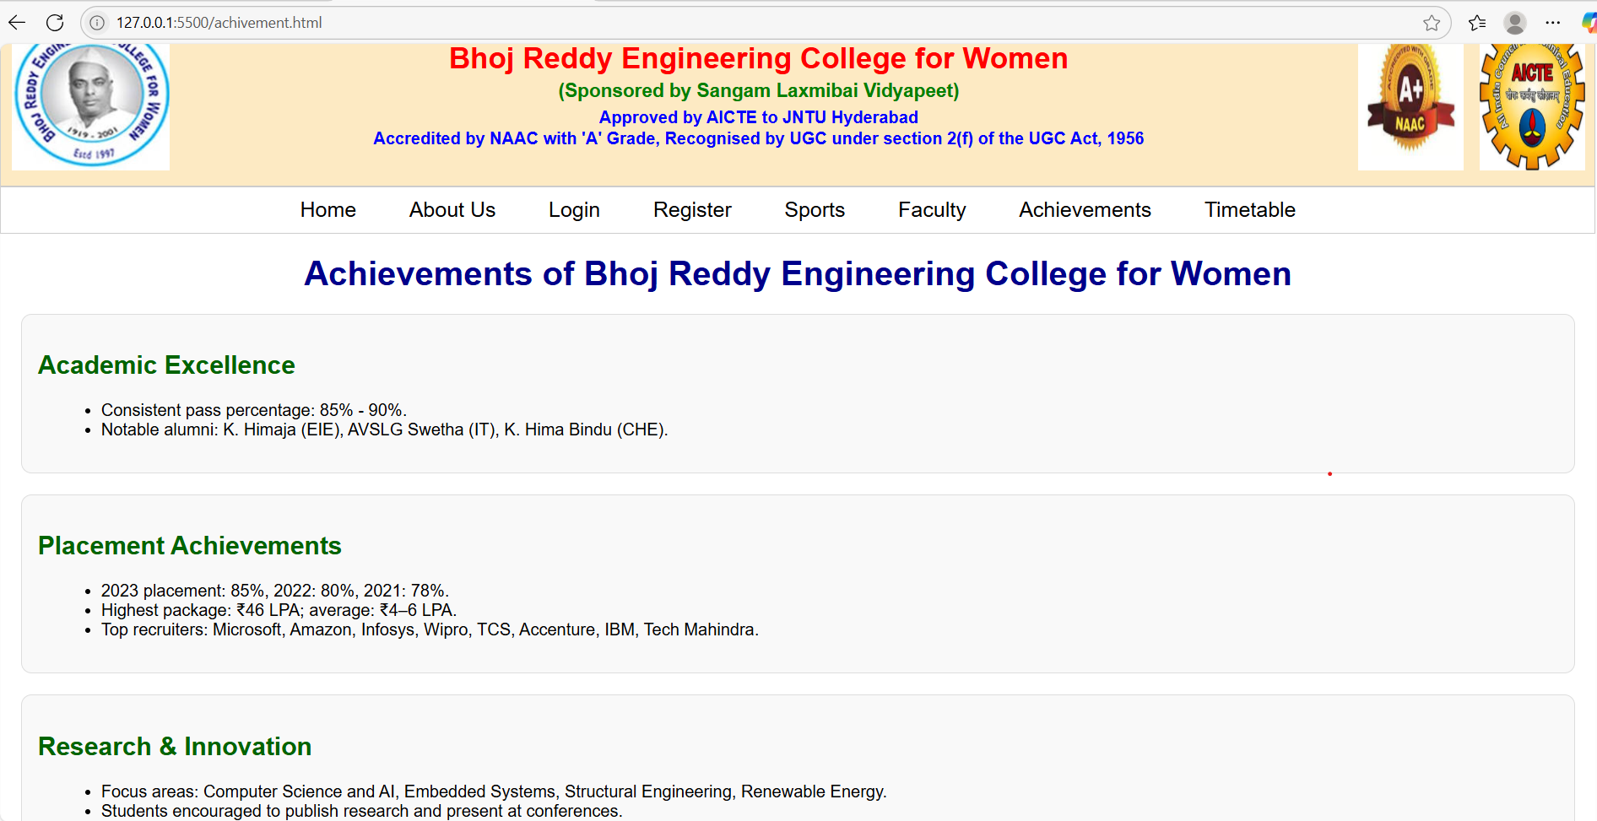

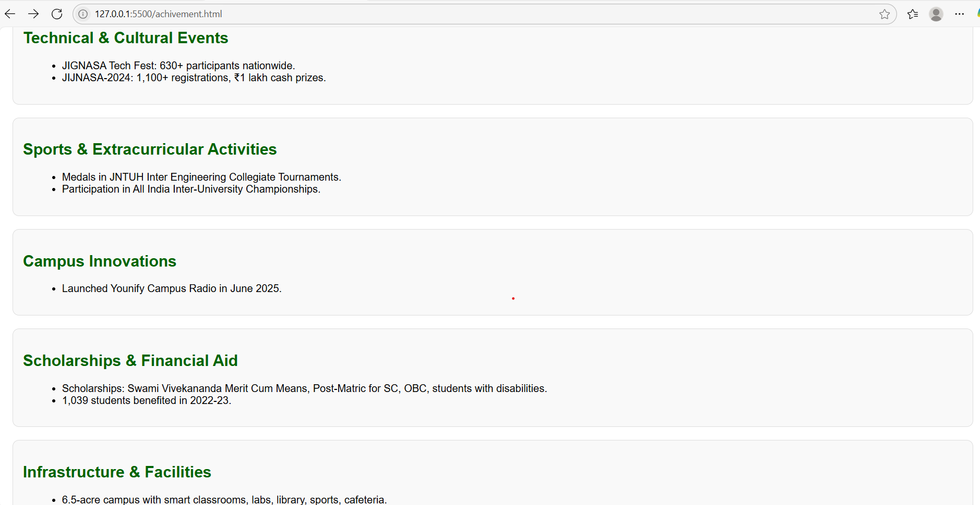

Login Table:
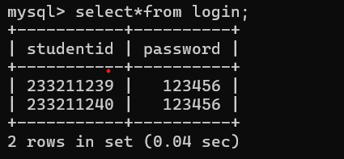
Register Table:
