Industrial Training Report
on
EMOTION-AWARE MULTIMODAL SENTIMENT ANALYSIS USING PROTOTYPE MEMORY
Submitted to
GLA University
In Partial Fulfilment of the Requirement For the Degree of
Bachelor of Technology (Hons) in Computer Science and Engineering
Submitted by
Laxmi (2415800050)

Department of Computer Science and Engineering
GLA University, Mathura
2026-27

ABSTRACT
This report presents the work undertaken on Emotion-Aware Multimodal Sentiment Analysis Using Prototype Memory, a project that combines textual, acoustic, and visual information to classify human sentiment more effectively than any single modality alone. Pretrained models are used to extract features from each modality, which are then processed through a multimodal framework that ranks modalities by importance and progressively combines them using cross-attention-based fusion.
To further improve the fused representation, an Emotion Prototype Memory (EPM) module is introduced. The EPM module learns representative patterns for different sentiment classes and uses them to refine the fused multimodal features before final classification. The proposed approach is evaluated on the MELD dataset for three sentiment classes: positive, negative, and neutral.
Experimental results show that the addition of EPM improves test accuracy from 55.25% to 60.92% and weighted F1-score from 55.64% to 61.02%, demonstrating the usefulness of prototype-based refinement for sentiment prediction. This report documents the motivation, related work, proposed methodology, experimental setup, results, challenges faced, and learnings gained while carrying out this project.

1. Introduction
Sentiment analysis is an important area of Natural Language Processing (NLP) that focuses on identifying opinions and sentiments expressed by people. Traditional sentiment analysis methods mainly use textual information to classify sentiment as positive, negative, or neutral. However, human sentiment is not expressed only through words — voice tone, speaking style, and visual expressions also carry useful information about a person's sentiment. Using multiple modalities can therefore provide a better understanding of human sentiment.
Multimodal sentiment analysis combines information from text, audio, and video. One of the main challenges in this area is that all modalities do not contribute equally to every input sample — in some cases textual information provides stronger sentiment cues, while in others audio or visual information is more useful. Another challenge is effectively combining information across modalities, since simple concatenation fails to capture the relationships between them.
This project addresses both challenges. Modality features are ranked according to their estimated importance and progressively combined using a cross-attention-based fusion process. An Emotion Prototype Memory (EPM) module is then introduced to further refine the fused representation by comparing it against learned, class-representative prototype patterns before final classification.
The proposed framework is evaluated using the MELD dataset, which contains textual, acoustic, and visual information from multi-party conversations. Text features are extracted using BERT, audio features using HuBERT, and visual features using CLIP with a ViT-B/32 visual encoder. This report consolidates the motivation, background, methodology, implementation, and results of the project into a single, structured account of the work carried out.
2. Background and Related Work
Earlier sentiment analysis approaches relied mainly on traditional machine learning methods such as Naive Bayes, Support Vector Machines, and Logistic Regression. With the growth of deep learning, transformer-based contextual language models such as BERT improved text representation by capturing word meaning based on context.
Multimodal sentiment analysis extends this by combining text with audio and visual cues. The MELD dataset is a widely used benchmark for this purpose, offering synchronized textual, acoustic, and visual information from conversations. Pretrained models such as BERT, HuBERT, and CLIP have been widely adopted to obtain meaningful single-modality representations without training separate feature extractors from scratch.
Attention mechanisms, introduced through the Transformer architecture, allow a model to capture relationships between elements of a sequence. In multimodal learning, cross-modal attention extends this idea so that one modality can attend to informative features of another, producing richer joint representations than simple concatenation.
Since different modalities are not equally informative for every sample, dynamically estimating modality importance before fusion can help a model focus on the most useful signal for each input. Separately, prototype-based learning represents each class using learned representative patterns, allowing a model to compare an input representation against these prototypes to obtain additional class-related information. This project builds on both ideas by introducing a Dynamic Modality Importance module before fusion and an Emotion Prototype Memory module after fusion.
3. Project Overview and Objectives
The overall goal of the project is to develop a multimodal sentiment classification framework that:
1. Extracts complementary features from text, audio, and video using pretrained encoders
2. Reduces feature dimensionality while preserving the most informative characteristics of each modality
3. Estimates the relative importance of each modality for a given input sample
4. Fuses modality representations progressively using cascaded cross-attention
5. Refines the fused representation using a learnable Emotion Prototype Memory module
6. Classifies the refined representation into positive, neutral, or negative sentiment
The work directly supports research on more accurate and interpretable multimodal sentiment classification, with the Emotion Prototype Memory module forming the central contribution of the project.
4. Technical Work Done

The proposed framework consists of six major stages: multimodal feature extraction, feature dimensionality reduction, modality projection and context encoding, dynamic modality importance estimation, cascaded cross-attention fusion, and sentiment classification with Emotion Prototype Memory.
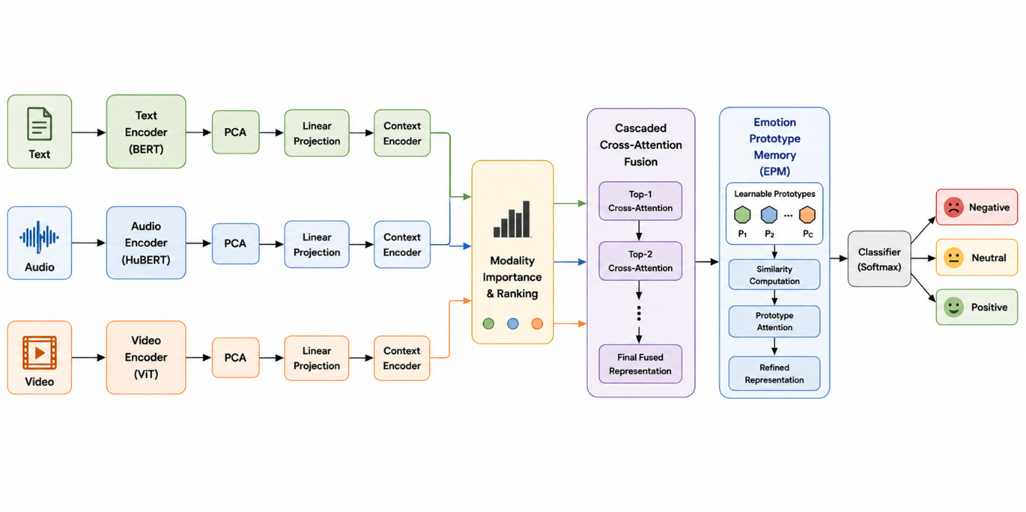

Fig. 1: Overall six-stage architecture of the proposed framework
4.1 Multimodal Feature Extraction
Each modality is processed independently using a pretrained model:
- Text: BERT generates a 768-dimensional contextual embedding using the [CLS] token as the sentence-level representation.
- Audio: HuBERT, a self-supervised speech representation model, produces a 768-dimensional acoustic feature vector.
- Video: CLIP ViT-B/32 extracts a 512-dimensional visual embedding from a representative frame of each utterance.
4.2 Feature Dimensionality Reduction (PCA)
Since the extracted vectors have different dimensions and may contain redundant information, Principal Component Analysis (PCA) is applied to each modality to obtain compact representations while preserving the most informative characteristics.
Modality | Original Dimension | Reduced Dimension
Text (BERT) | 768 | 256
Audio (HuBERT) | 768 | 128
Video (CLIP ViT-B/32) | 512 | 16

4.3 Modality Projection and Context Encoding
The reduced features are projected into a shared embedding space using independent linear projection layers, and then passed through a Transformer-based context encoder that captures contextual dependencies within each modality before fusion.
4.4 Dynamic Modality Importance (DMI)
The context-enhanced representations are passed through independent scoring layers to compute an importance score for each modality. These scores are normalized using Softmax to produce importance weights αt, αa, and αv that sum to 1. A higher weight indicates that the corresponding modality carries more useful sentiment information for the current sample. The weighted representations are then ranked before fusion.
4.5 Cascaded Cross-Attention Fusion
The ranked modality representations are combined progressively rather than concatenated. The highest-ranked modality first attends to the second-ranked modality to produce an intermediate fused representation, which is then combined with the remaining modality through a second cross-attention operation, producing the final fused multimodal representation F.
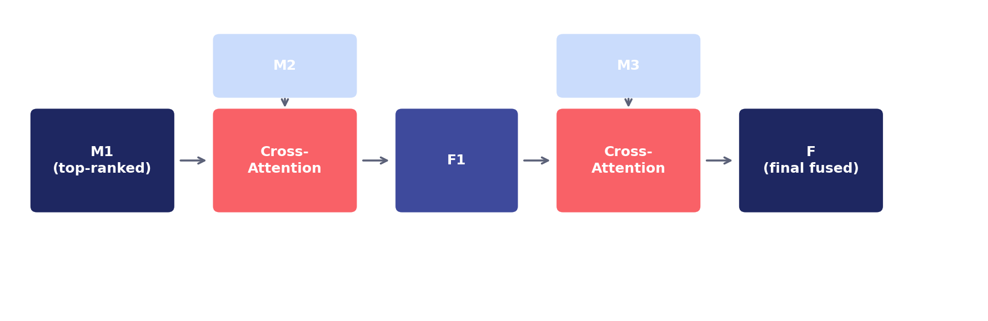
Fig. 2: Cascaded cross-attention fusion of the three modalities
4.6 Emotion Prototype Memory (EPM)
The EPM module is the central contribution of this project. It maintains a set of learnable prototype vectors representing characteristic patterns of each sentiment class. The workflow is as follows:
1. Compute cosine similarity between the fused representation F and each prototype Pi
2. Normalize similarity scores with Softmax to obtain attention weights βi
3. Retrieve a prototype representation R as the weighted combination of all prototypes
4. Refine the fused representation as F′ = F + R
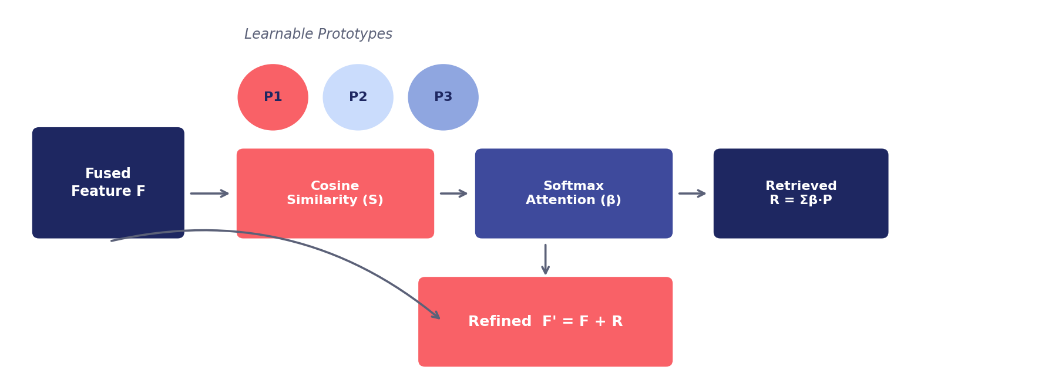
Fig. 3: Emotion Prototype Memory (EPM) module workflow
Since the prototype vectors are learnable parameters, they are updated automatically during training through backpropagation, gradually learning representative characteristics of each sentiment pattern.
4.7 Sentiment Classification
The refined feature vector F′ is passed through a fully connected layer followed by Softmax to produce class probabilities for positive, neutral, and negative sentiment. The model is trained end-to-end using the cross-entropy loss function, with all components — projection layers, context encoder, DMI, cross-attention fusion, EPM, and the classifier — optimized jointly through backpropagation.
5. Experimental Setup
The proposed framework was evaluated using the Multimodal EmotionLines Dataset (MELD), a widely used benchmark for multimodal sentiment and emotion analysis. The dataset is collected from the television series Friends and contains multi-party conversations with synchronized textual, acoustic, and visual information.
- Only sentiment labels were used: positive, neutral, or negative.
- The official train, validation, and test splits provided with the dataset were used to ensure fair evaluation.
- The framework was implemented in Python using PyTorch.
- Pretrained BERT, HuBERT, and CLIP models were used for feature extraction, with PCA for dimensionality reduction.
- The model was trained using the Adam optimizer with cross-entropy loss.
6. Results and Key Outcomes
The proposed framework was compared against a baseline multimodal model using the same feature extraction, preprocessing, and training settings, with the only difference being the inclusion of the Emotion Prototype Memory module.
Model | Test Accuracy | Weighted F1-Score
Baseline Multimodal Model | 55.25% | 55.64%
Proposed Model with EPM | 60.92% | 61.02%

The proposed framework achieved a test accuracy of 60.92%, compared to 55.25% for the baseline model — an absolute improvement of 5.67 percentage points. The weighted F1-score similarly increased from 55.64% to 61.02%. Key outcomes of the project include:
1. A working multimodal sentiment classification pipeline covering feature extraction, fusion, and classification
2. A Dynamic Modality Importance module that adaptively weights text, audio, and video per sample
3. A cascaded cross-attention fusion mechanism that outperforms simple feature concatenation
4. A novel Emotion Prototype Memory module that measurably improves classification performance
5. Consistent, reproducible evaluation on the official MELD train/validation/test splits
7. Challenges and Learnings
7.1 Technical Challenges
- Selecting appropriate PCA target dimensions for each modality without losing informative content, especially for the highly redundant 512-dimensional CLIP embeddings.
- Designing the Dynamic Modality Importance scoring function so that weights reflect genuine sample-level informativeness rather than dataset-level bias.
- Tuning the number and dimensionality of prototypes in the Emotion Prototype Memory module for stable training.
- Balancing the cascaded cross-attention fusion order so that no single modality dominates the final representation.
- Handling class imbalance in the MELD sentiment labels during training.
7.2 Key Learnings
- Practical experience extracting and combining features from pretrained BERT, HuBERT, and CLIP models.
- Deeper understanding of attention-based and cross-modal fusion techniques.
- Hands-on experience designing and training a prototype-based memory module in PyTorch.
- Understanding of dimensionality reduction trade-offs across modalities with very different feature statistics.
- Experience with structuring, training, and evaluating an end-to-end deep learning pipeline on a real conversational dataset.
8. Conclusion
This project presented a multimodal sentiment analysis framework that combines textual, acoustic, and visual information for sentiment classification. Text, audio, and video features were extracted using pretrained BERT, HuBERT, and CLIP models respectively, reduced using PCA, and projected into a shared embedding space refined by a Transformer-based context encoder.
The Dynamic Modality Importance module adaptively estimated the contribution of each modality, while cascaded cross-attention fusion effectively combined the multimodal representations. To further improve sentiment classification, an Emotion Prototype Memory module was introduced after the fusion stage, learning representative prototype patterns and refining the fused multimodal representation before final classification.
Experimental evaluation on the MELD dataset demonstrated that the proposed framework improves sentiment classification performance, with test accuracy increasing from 55.25% to 60.92% and weighted F1-score from 55.64% to 61.02%. These results confirm that prototype-based refinement provides a meaningful improvement to attention-based multimodal fusion pipelines.
In future work, the framework can be extended to support additional modalities, multilingual sentiment analysis, and missing-modality scenarios, along with more advanced prototype learning strategies and lightweight architectures for real-time applications. Overall, this project strengthened practical skills in multimodal deep learning, attention mechanisms, and end-to-end model design and evaluation.

