HW 10: Cryptography

HOME PAGE

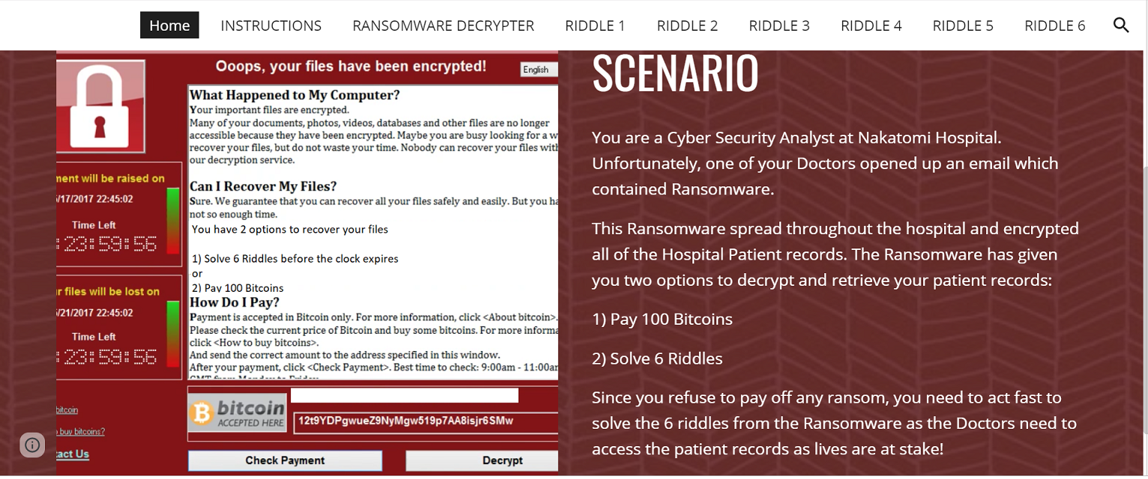

Instructions:

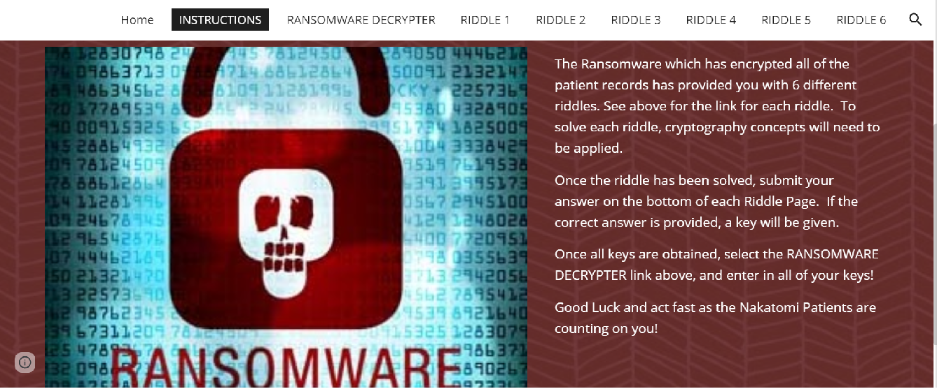

RIDDLE 1:

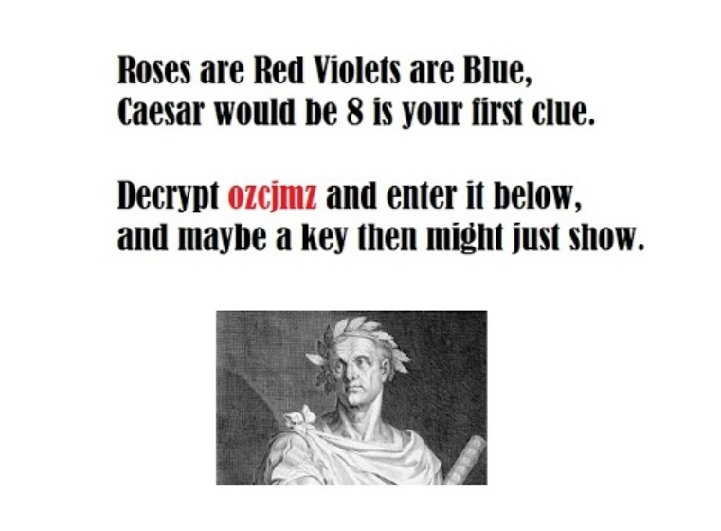

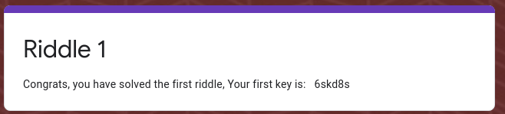

RIDDLE 2:



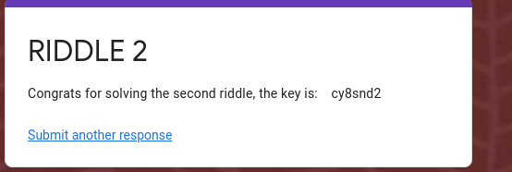

RIDDLE 3:

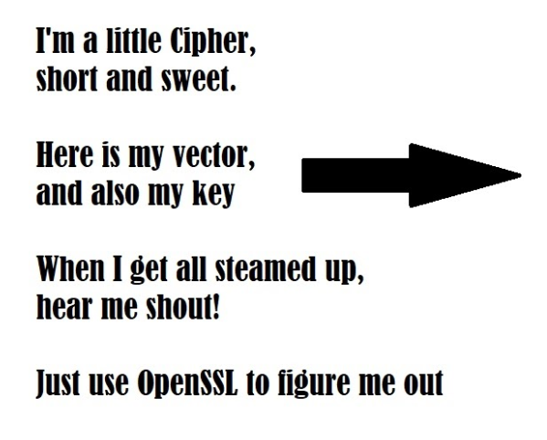

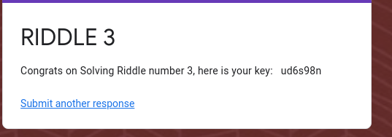
Cipher Text:
4qMOIvwEGXzvkMvRE2bNbg
Key:
5284A3B154D99487D9D8D8508461A478C7BEB67081A64AD9A15147906E8E8564
IV (Initialization Vector):
1907C5E255F7FC9A6B47B0E789847AED
OpenSSL Options:
- -pbkdf2
- -nosalt
- -aes-256-cbc
- base64

RIDDLE 4:
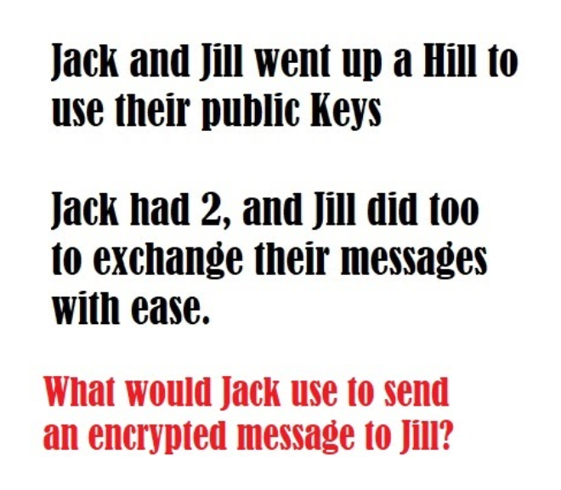

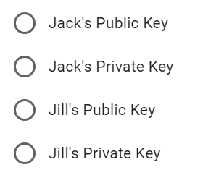

ans:Jills public key

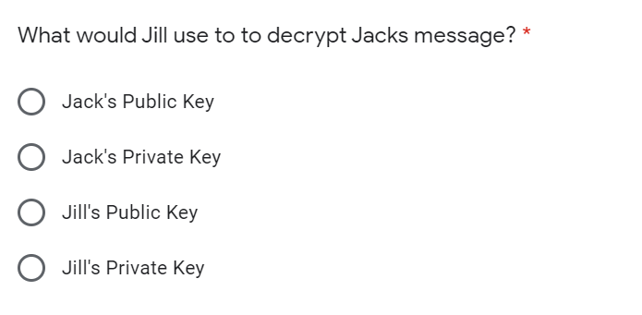

Ans: Jills private key

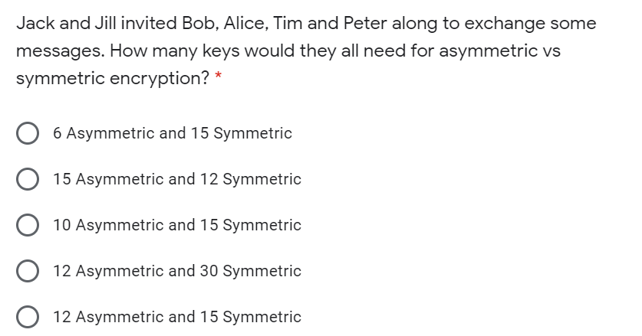

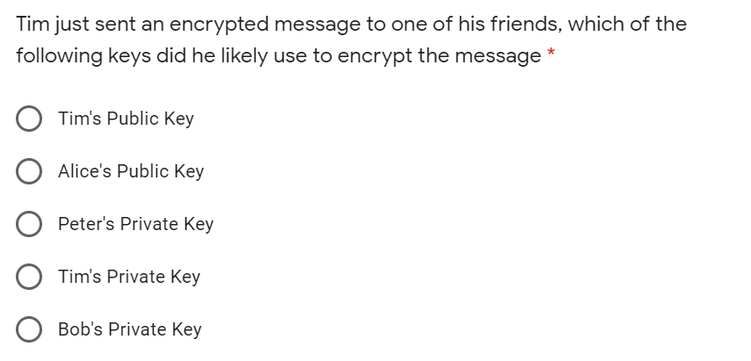

ans:12 asymmetric 15 symmetric

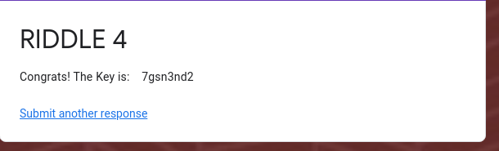

RIDDLE 5:

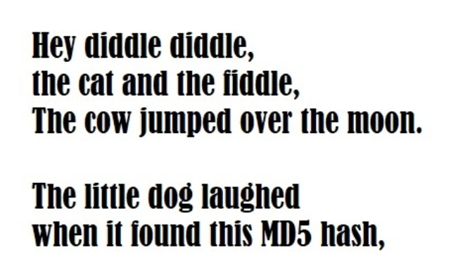

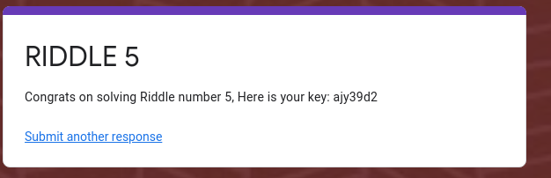

Hash:
3b75cdd826a16f5bba0076690f644dc7

RIDDLE 6:
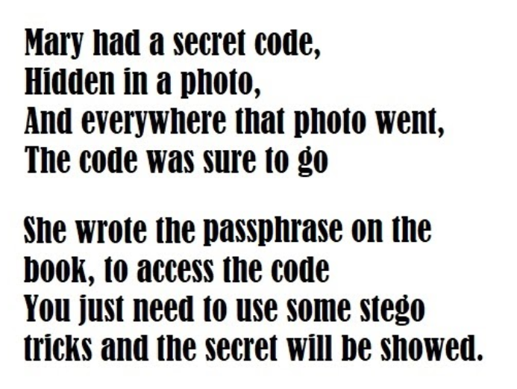

Image Link: https://drive.google.com/file/d/1m9ykscnTGzgkkVet9wmiBCYsbhzbrKR9/view



