

Module Title

Internet Technologies (IT)

Individual Coursework

Year-2024

Name: Laxmi MAhji

UWE ID:22085626

L3 Section-B

**Introduction**

Using HTML and CSS, I created a portfolio website as the final project for the "Internet Technologies" module. I started with preliminary prototypes. The five connected pages that make up the portfolio are skills.html, gallery.html, contact.html, index.html, and about.html. Anchor tags are used to connect each page, making navigation simple. This arrangement successfully highlights various facets of my work and abilities.

**Github Link :**

**Mockup Link:** https://app.moqups.com/1GtYxQ1udSeIziB2GUyt8EFF6HSvM1LU/view/page/ad64222d5

**Code**

**Index.html**

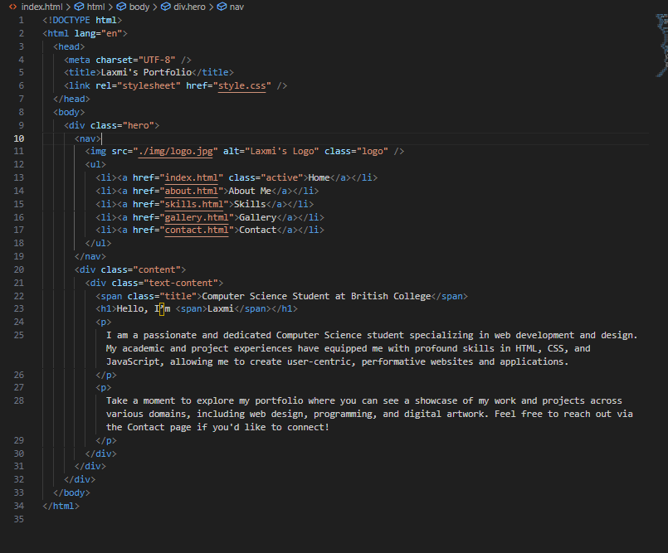

**About.html**

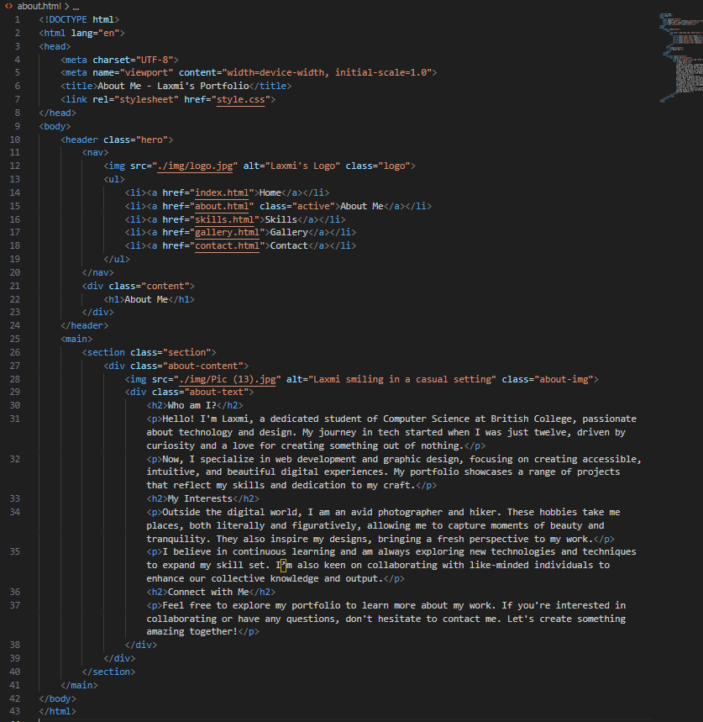

**Skills.html**

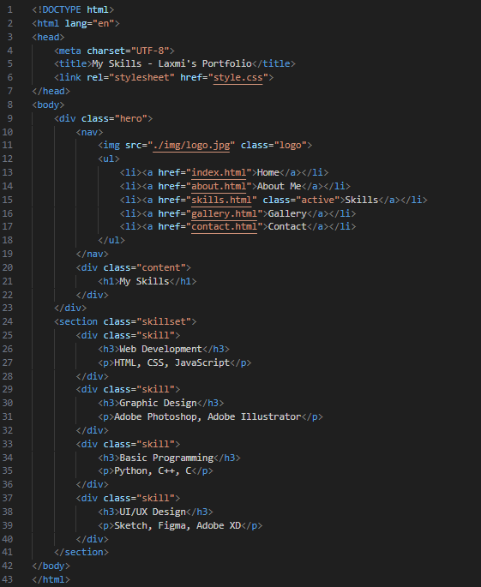

**Gallery.html**

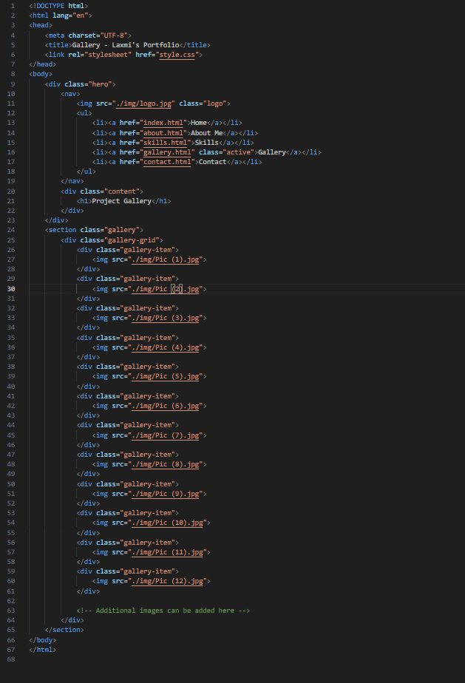

**Contact.html**

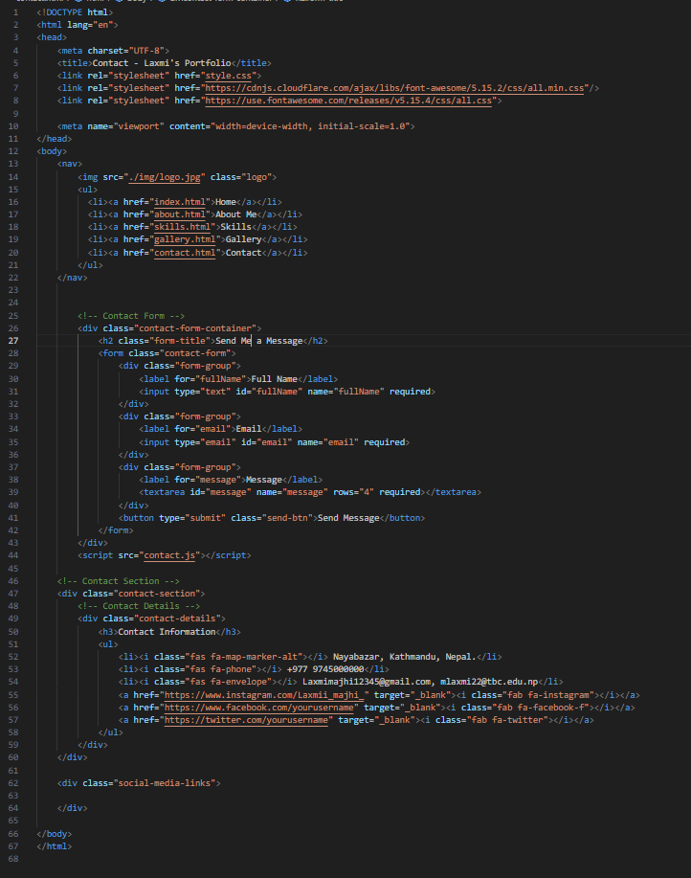

**Contact.js**

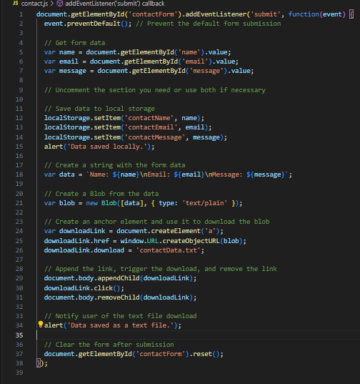

**Style.css**

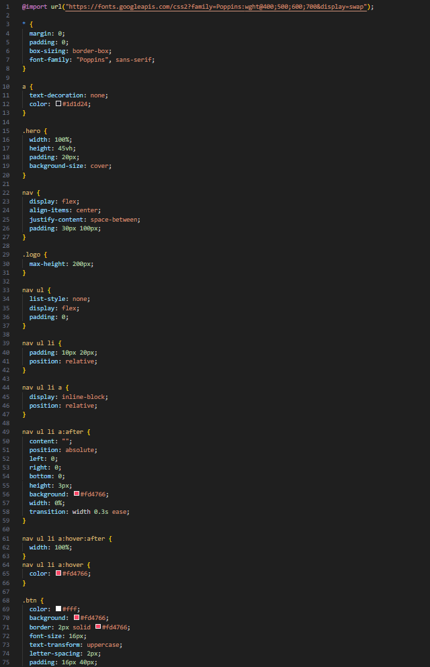

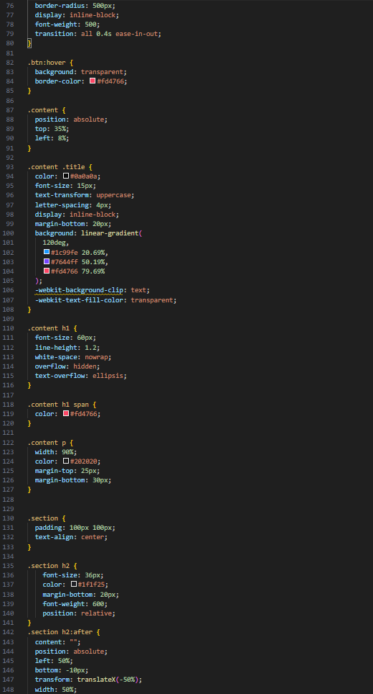

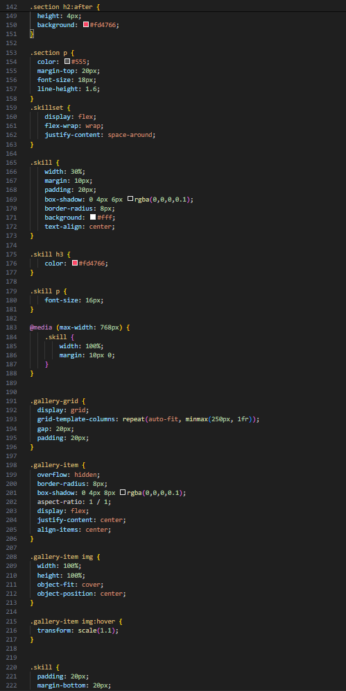

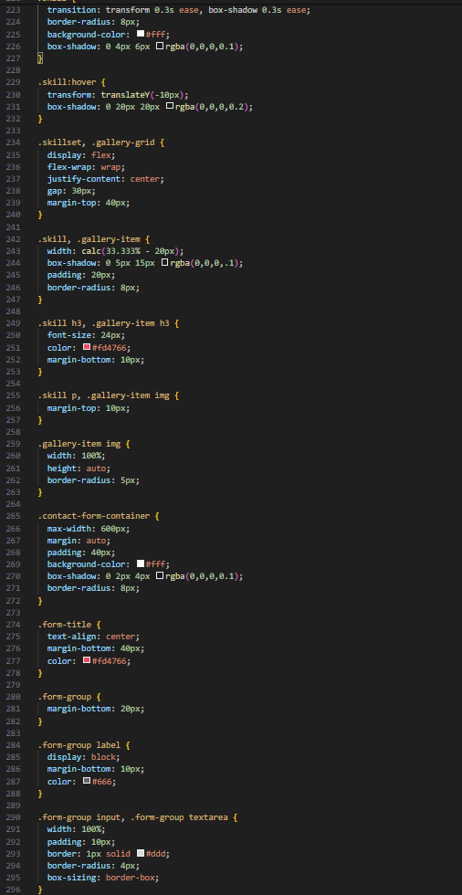

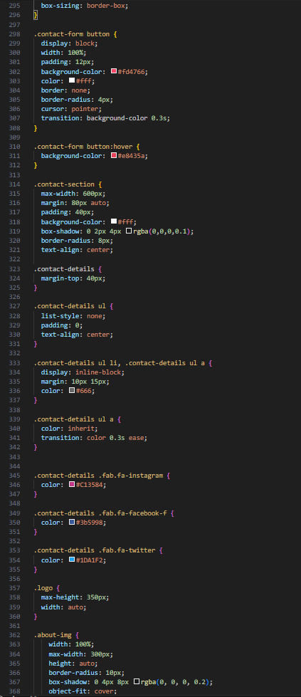

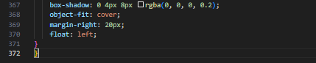

**Final Result of my Website**

**Home Page:**

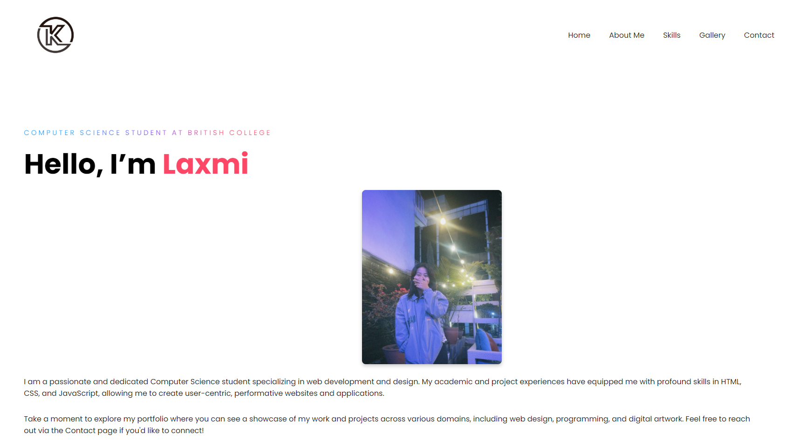

**About Me:**

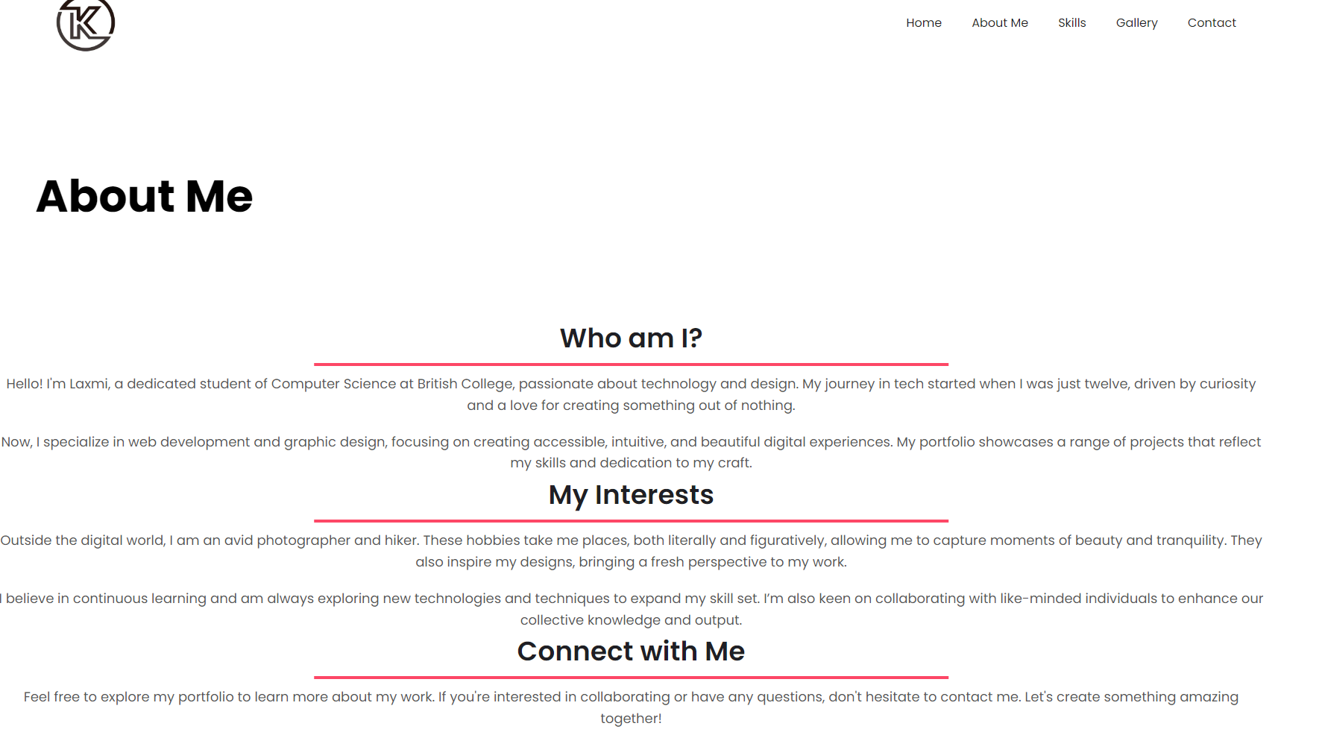

**Skills:**

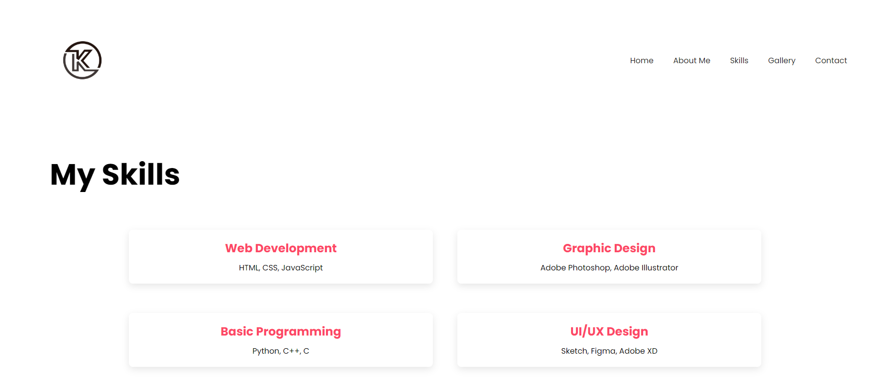

**Gallery:**

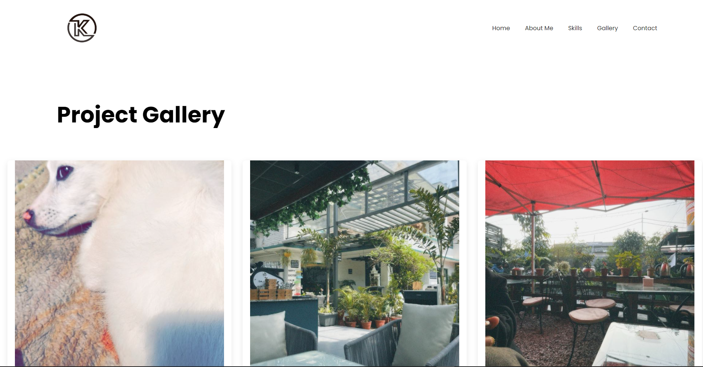

**Contact:**

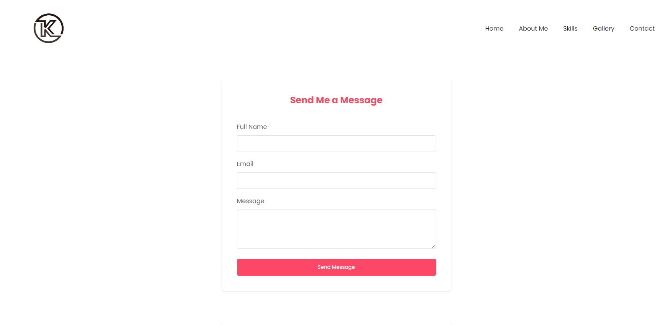

**Code Description:**

The purpose of Laxmi's portfolio webpage is to highlight my abilities as a computer science student with a focus on web design and development. The website is divided into five primary pages, each with a different function:

Home (index.html): This is the main page where guests are welcomed with a synopsis of Laxmi's background in web development, as well as an opportunity to peruse her portfolio. The page has a navigation bar, a welcoming message-filled hero section, and an eye-catching picture of Laxmi.

About Me (about.html): Laxmi provides more thorough details about her upbringing, schooling, and career path on this page. Visitors can learn more about her interests and career path on this website.

Skills (skills.html): Laxmi's software expertise and technical prowess are described on this website. It is intended to provide information about the particular technology she is proficient in to prospective employers or partners.

Gallery (gallery.html): A visual display of projects and artworks created by Laxmi. This page is visually oriented and showcases her work through images and descriptions, highlighting her capabilities in web design and programming.

Contact (contact.html): Offers a form for users to get in touch with Laxmi. It makes it simple for admirers, collaborators, or possible employers to get in touch by having areas for names, emails, and messages.

The site is simple to navigate because each page is connected to the next by a unified navigation bar at the top. The website makes use of contemporary HTML and CSS techniques, such as CSS transitions for subdued animations and flexbox for layout configurations. With an eye-catching color scheme and legible font, the entire design is polished and uncluttered.

**Git Commit Log:**

**GitHub Repository Link:**