Method 1: Define plane by three points
Cube bounds: X=[2500.00, 3250.00], Y=[250.00, 1000.00], Z=[-1000.00, -0.00]

Enter three points (x, y, z coordinates):
Point 1 (x, y, z): 2500,250,-1000
Point 2 (x, y, z): 3000,700,-700
Point 3 (x, y, z): 3200,800,-0
✅ Cross-section obtained: 18683 points

Interpolating data onto cross-section...
Temperature range: [-1.8338, 1.9328]
Salinity range: [0.0000, 34.3875]
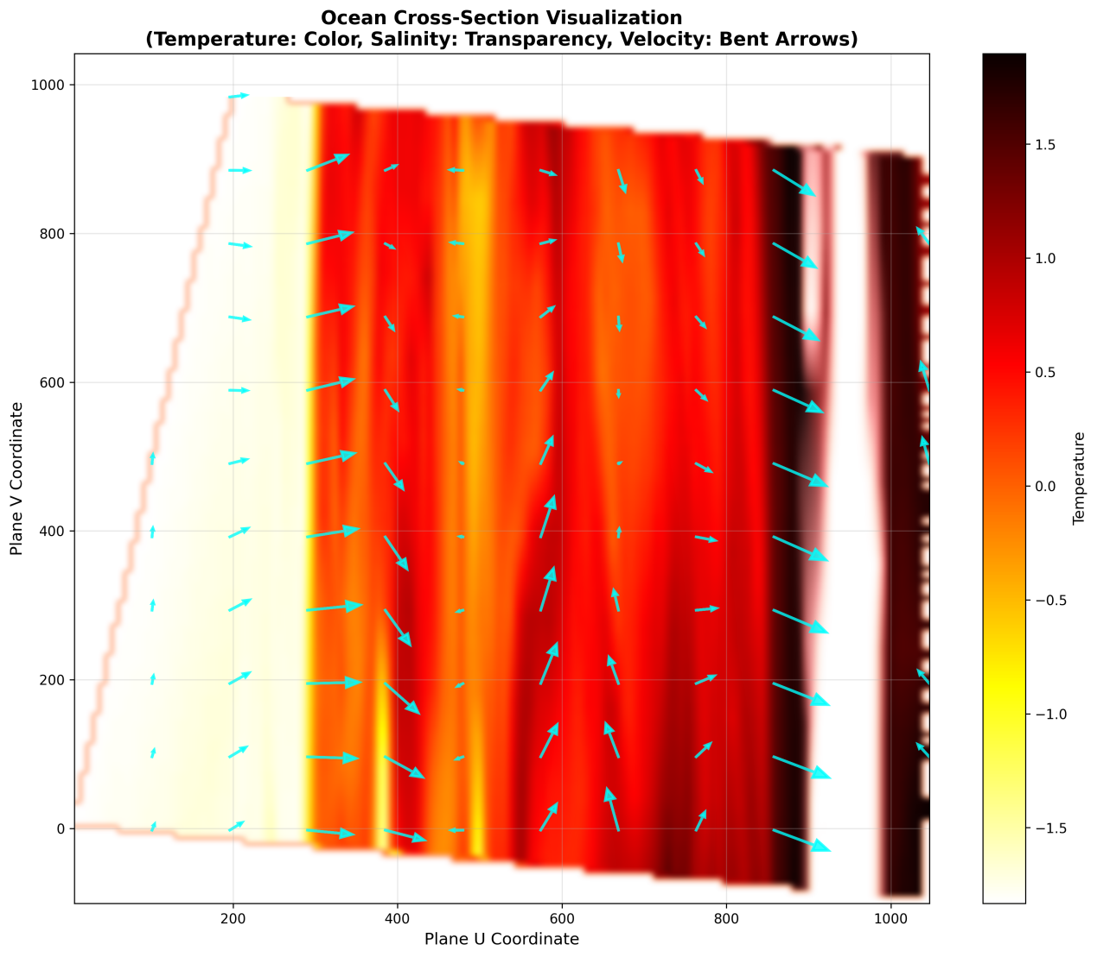

Method 2: Define plane perpendicular to view line
Cube center: (2875.00, 625.00, -500.00)

Enter view direction vector (x, y, z):
View direction (x, y, z): 333,333,-200
Depth offset from center (positive=forward, negative=backward, default 0):
✅ Cross-section obtained: 12490 points

Interpolating data onto cross-section...
Temperature range: [-1.8118, 3.7835]
Salinity range: [0.0000, 34.6792]
