IMPORT DATA USING TRANSFORM MAPS (SPREADSHEET)
TABLE OF CONTENTS
1. INTRODUCTION
1.1 Project Overview
1.2 Purpose
2. IDEATION PHASE
2.1 Problem Statement
2.2 Empathy Map Canvas
2.3 Brainstorming
3. REQUIREMENT ANALYSIS
3.1 Customer Journey Map
3.2 Solution & Functional Requirement
3.3 Data Flow
3.4 Technology Stack
4. PROJECT DESIGN
4.1 Problem Solution Fit
4.2 Proposed Solution
4.3 Solution Architecture
5. PROJECT PLANNING & SCHEDULING
5.1 Project Planning
6. FUNCTIONAL AND PERFORMANCE TESTING
6.1 Performance Testing
7. RESULTS
7.1 Output Screenshots
8. ADVANTAGES & DISADVANTAGES
9. CONCLUSION
10. FUTURE SCOPE
11. APPENDIX

1. INTRODUCTION

1.1 Project Overview
This micro project demonstrates the process of importing structured employee information from an external spreadsheet into ServiceNow. The project uses a staging-oriented import workflow in which source data is loaded and then transformed into a target employee table. The final records are validated and presented through ServiceNow reports and a dashboard.

1.2 Purpose
The purpose is to provide practical beginner-level understanding of spreadsheet-based data migration in ServiceNow. It covers preparation of source data, creation of a target table, Import Set processing, Transform Map configuration, duplicate-control using coalesce, transformation execution, validation, and reporting.

1.3 Project Objectives
- Prepare structured employee information in spreadsheet form.
- Create and use an Employee Test target table.
- Load source information through an Import Set process.
- Configure a Transform Map for source-to-target mapping.
- Use coalesce-related matching to help avoid duplicate records.
- Transform and validate imported records.
- Create reports and an Employee Analytics Dashboard.

1.4 Project Scope
The project is focused on employee-data migration and visualization inside ServiceNow. It does not attempt to implement a complete HR system. The supplied evidence concentrates on import processing, transformation, employee records, report creation, and dashboard presentation.

2. IDEATION PHASE

2.1 Problem Statement
Employee data is commonly received in structured spreadsheet files. Entering every record manually into ServiceNow is inefficient for bulk data and makes validation harder. A repeatable import workflow is therefore required to move spreadsheet records into a ServiceNow target table while preserving field relationships and reducing duplicate creation.
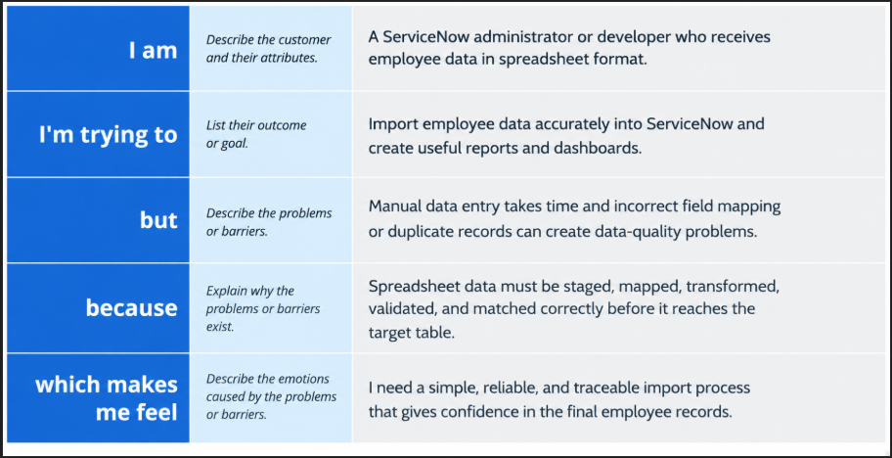

2.2 Empathy Map Canvas
For this technical project, the user can be viewed as a ServiceNow administrator/developer who works with external employee data.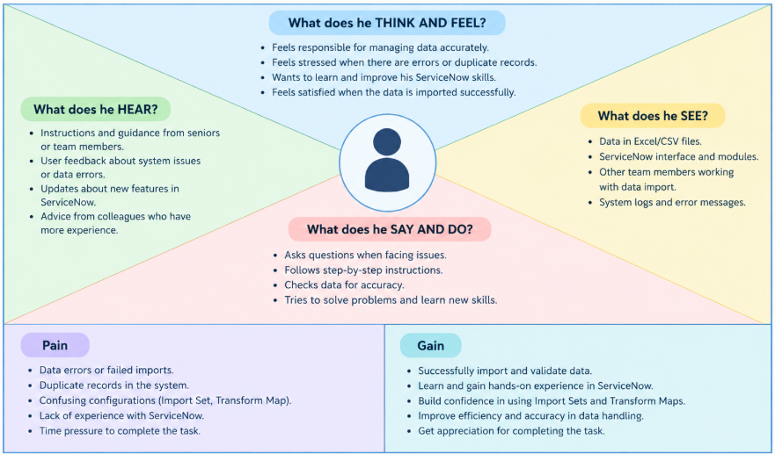
2.4 Brainstorming
The project workflow was organized into four milestones: source and target preparation; Import Set and Transform Map configuration; transformation, validation and duplicate control; and reporting/dashboard creation. This sequence keeps data preparation, migration, verification, and visualization logically separated.
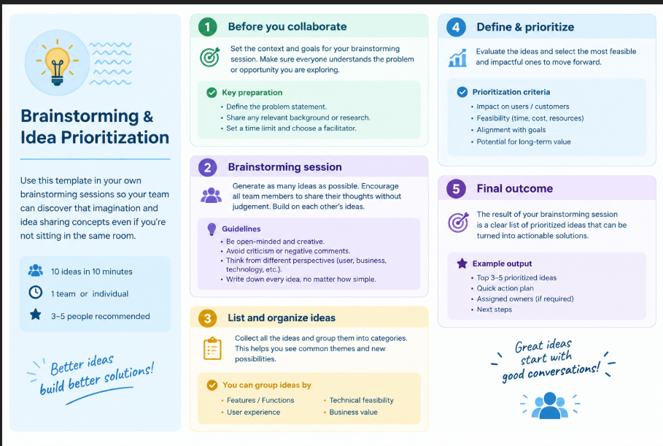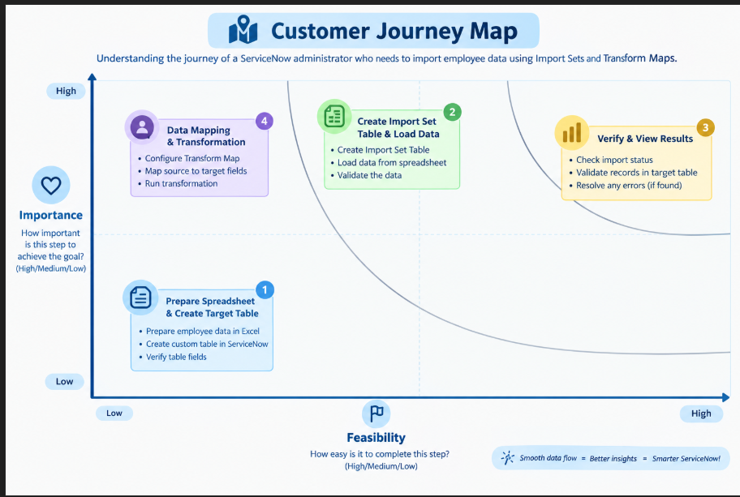

3. REQUIREMENT ANALYSIS

3.1 Customer Journey Map
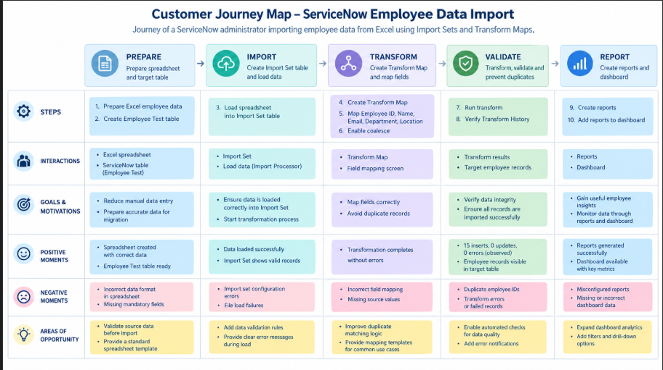

3.2 Solution Requirement
The solution requires a spreadsheet dataset, ServiceNow instance access, an Employee Test target table, an Import Set table/process, a Transform Map, matching/coalesce configuration, and the ServiceNow reporting/dashboard facilities.
Functional Requirements
Following are the functional requirements of the proposed solution.
FR No. | Functional Requirement (Epic) | Sub Requirement (Story / Sub-Task)
FR-1 | Spreadsheet Data Preparation | Create employee data in Excel/Spreadsheet format
 |  | Maintain required fields such as Employee ID, Employee Name, Email, Department and Location
 |  | Validate the spreadsheet data before importing
FR-2 | Import Set Table Creation | Create an Import Set table to receive the spreadsheet data
 |  | Upload/load the employee spreadsheet into ServiceNow
 |  | Verify that the imported source records are available in the staging table
FR-3 | Transform Map Configuration | Create a Transform Map for the employee data
 |  | Map source fields to the corresponding target Employee Test table fields
 |  | Configure the required transformation settings
FR-4 | Data Transformation and Validation | Execute the transformation from the Import Set to the target table
 |  | Validate that employee records are inserted correctly
 |  | Enable Coalesce to identify matching records and help avoid duplicate records
 |  | Insert new employee data and verify the transformation results
FR-5 | Import Result Verification | Check Transform History after transformation
 |  | Verify the number of inserted, updated and failed records
FR-6 | Reports and Dashboard | Create reports based on imported employee data
 |  | Create reports such as Employees by Department and Employees by Location
 |  | Add the reports to the Employee Analytics Dashboard

Non-Functional Requirements
Following are the non-functional requirements of the proposed solution.
NFR No. | Non-Functional Requirement | Description
NFR-1 | Usability | The import process should be simple and easy for ServiceNow administrators or beginners to understand and execute.
NFR-2 | Security | Only authorized ServiceNow users should be allowed to import, transform, modify and view employee data.
NFR-3 | Reliability | The system should consistently transform valid spreadsheet data into the target table without unexpected data loss or incorrect field mapping.
NFR-4 | Performance | The system should process spreadsheet records efficiently and complete the import and transformation within a reasonable time for the given dataset.
NFR-5 | Availability | The import, transformation, reports and dashboard features should be available whenever the ServiceNow instance is accessible and the user has the required.
NFR-6 | Scalability | The solution should be capable of handling larger employee datasets as the number of records increases, with appropriate configuration and performance testing.

3.4 Data Flow
Spreadsheet / Excel → Import Set / staging area → Transform Map → field mapping and coalesce matching → Employee Test table → validation → reports → Employee Analytics Dashboard.
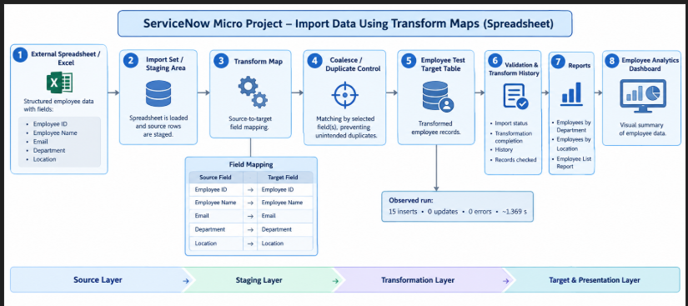

3.5 Technology Stack
Component | Purpose
ServiceNow | Platform used for data import, transformation and reporting
Spreadsheet / Excel | External source format
Import Set | Staging mechanism for incoming source data
Transform Map | Controls source-to-target transformation
Coalesce | Matching mechanism used to help prevent duplicate records
Reports | Structured views of imported data
Dashboard | Visual presentation of multiple report outputs

4. PROJECT DESIGN

4.1 Problem Solution Fit
The proposed design directly addresses the problem by introducing a controlled path between an external spreadsheet and the final ServiceNow table. The staging and transformation steps make the data flow easier to inspect and validate than direct manual record entry.
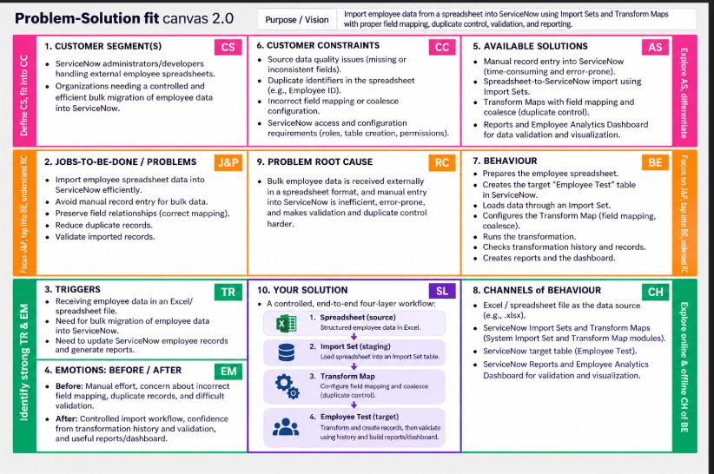

4.2 Proposed Solution
S.No. | Parameter | Content
1 | Problem Statement | Manual entry of bulk employee spreadsheet data into ServiceNow is time-consuming and may cause mapping errors, duplicates, and validation difficulties.
2 | Idea / Solution Description | Use Import Sets and Transform Maps to import spreadsheet data, map fields, control duplicates using coalesce, validate records, and generate reports/dashboard.
3 | Novelty / Uniqueness | Combines staging, field mapping, duplicate control, transformation history, validation, and visualization into one controlled workflow.
4 | Social Impact / Customer Satisfaction | Reduces repetitive manual work, improves data accuracy and validation, and provides useful employee-data reports and dashboards.
5 | Business Model | No direct revenue model is defined; business value comes from reducing manual effort and improving the efficiency and reliability of employee-data migration.
6 | Scalability | Can be extended with scheduled imports, automated error notifications, standardized templates, stronger validation, additional matching rules, and expanded reports/dashboard features.

4.3 Solution Architecture
The architecture can be represented as four layers: Source Layer (spreadsheet), Staging Layer (Import Set), Transformation Layer (Transform Map + mapping + coalesce), and Presentation Layer (target records + reports + dashboard).

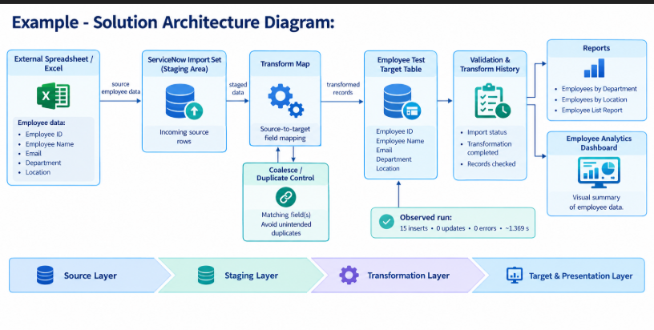

5. PROJECT PLANNING & SCHEDULING

5.1 Project Planning
Sprint | Functional Requirement (Epic) | User Story Number | User Story / Task | Story Points | Priority | Team Members
Sprint-1 | Spreadsheet Preparation | USN-1 | As a ServiceNow developer, I can prepare structured employee data in an Excel/spreadsheet format so that it can be imported into ServiceNow. | 2 | High | —
Sprint-1 | Target Table | USN-2 | As a ServiceNow developer, I can create the Employee Test target table with fields such as Employee ID, Employee Name, Email, Department, and Location. | 2 | High | —
Sprint-1 | Data Validation | USN-3 | As a ServiceNow developer, I can check the spreadsheet data for missing, inconsistent, or duplicate information before importing it. | 2 | Medium | —
Sprint-2 | Import Set | USN-4 | As a ServiceNow developer, I can load the spreadsheet data into an Import Set staging area so that the source records are available for transformation. | 3 | High | —
Sprint-2 | Transform Map | USN-5 | As a ServiceNow developer, I can create a Transform Map to map source spreadsheet fields to the corresponding Employee Test target fields. | 3 | High | —
Sprint-2 | Field Mapping | USN-6 | As a ServiceNow developer, I can configure source-to-target field mappings for Employee ID, Employee Name, Email, Department, and Location. | 2 | High | —
Sprint-3 | Duplicate Control | USN-7 | As a ServiceNow developer, I can configure coalesce matching so that existing employee records can be identified and unintended duplicates can be reduced. | 3 | High | —
Sprint-3 | Transformation & Validation | USN-8 | As a ServiceNow developer, I can execute the transformation and verify the transformation status, history, and imported employee records. | 3 | High | —
Sprint-3 | Record Verification | USN-9 | As a ServiceNow developer, I can verify that the transformed records are correctly available in the Employee Test target table. | 2 | Medium | —
Sprint-4 | Reports | USN-10 | As a ServiceNow developer, I can create reports such as Employees by Department, Employees by Location, and Employee List Report. | 3 | Medium | —
Sprint-4 | Dashboard | USN-11 | As a ServiceNow developer, I can create an Employee Analytics Dashboard to visualize the imported employee data. | 3 | High | —
Sprint-4 | Final Testing | USN-12 | As a ServiceNow developer, I can verify the complete import workflow, reports, and dashboard to ensure the project output is correct. | 2 | High | —

6. FUNCTIONAL AND PERFORMANCE TESTING

6.1 Performance testing
1. Project Overview
Parameter | Details
Project Name | Import Data Using Transform Maps (Spreadsheet)
Project Description | Import employee data from an Excel spreadsheet into ServiceNow using Import Sets and Transform Maps.
Project Version | Version 1.0
Testing Type | Functional Testing / UAT

2. Test Case Analysis
Test Case ID | Test Scenario | Expected Result | Actual Result | Status
TC-001 | Import spreadsheet data | Employee data should be loaded successfully. | Data imported successfully. | Pass
TC-002 | Verify Transform Map | Source fields should map to target fields correctly. | Field mapping verified. | Pass
TC-003 | Verify transformation | Records should be transformed without errors. | Transformation completed successfully. | Pass
TC-004 | Verify reports and dashboard | Reports and dashboard should display employee data. | Reports and dashboard verified. | Pass

3. Defect / Bug Tracking
Bug ID | Bug Description | Severity | Status | Additional Feedback
BG-001 | No import error observed during testing. | Low | Closed | Import completed successfully.
BG-002 | No transformation error observed. | Low | Closed | Transformation completed successfully.
4. Final Test Summary
Section | Total Cases | Not Tested | Fail | Pass
Spreadsheet Import | 1 | 0 | 0 | 1
Transform Map | 1 | 0 | 0 | 1
Transformation | 1 | 0 | 0 | 1
Reports & Dashboard | 1 | 0 | 0 | 1
Total | 4 | 0 | 0 | 4
Final Result: PASS – Ready for UAT.

7. RESULTS

7.1 Output Screenshots
The output evidence is arranged in the same sequence as the four milestones requested for the project. Each figure is accompanied by a description of what is visible in the supplied screenshot.

MILESTONE 1 : CREATION OF SPREADSHEET AND TABLE
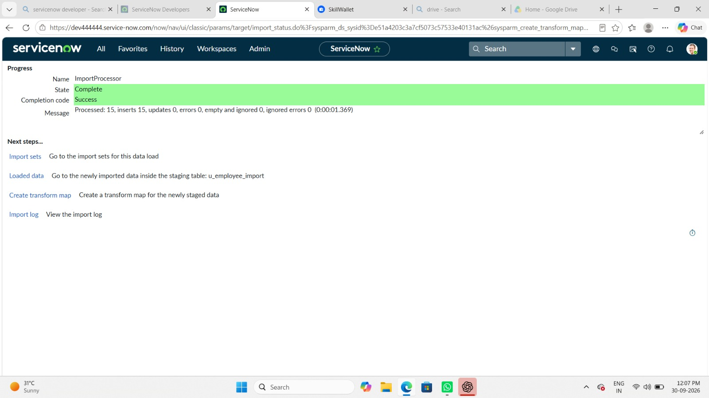
Figure 1. Spreadsheet / Import Processor Result. The import processor result shows the spreadsheet data was processed successfully, with 15 inserts, 0 updates, and 0 errors.
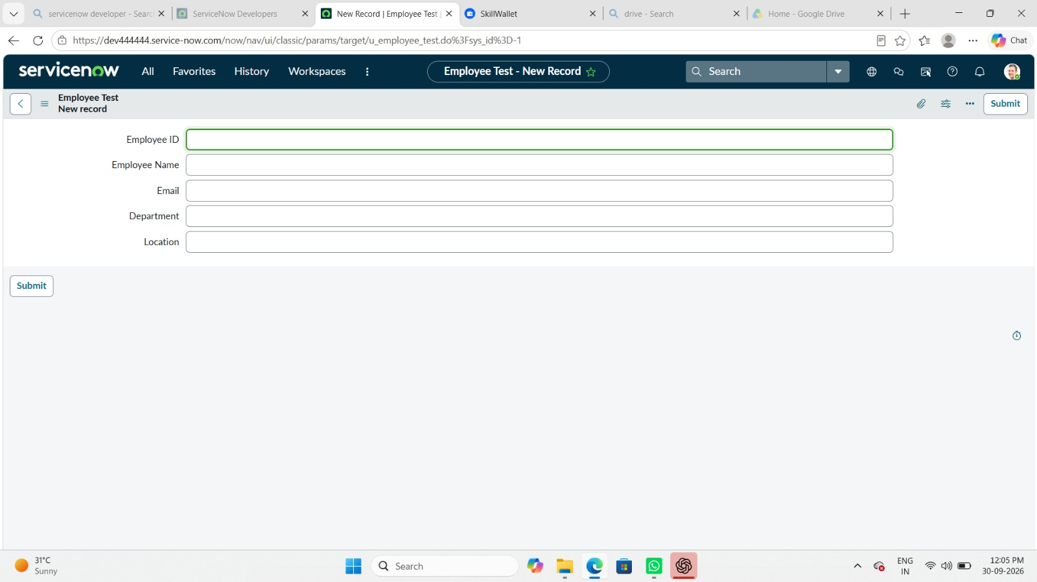
Figure 2. Employee Test Target Table. The target Employee Test table contains fields such as Employee ID, Employee Name, Email, Department, and Location.
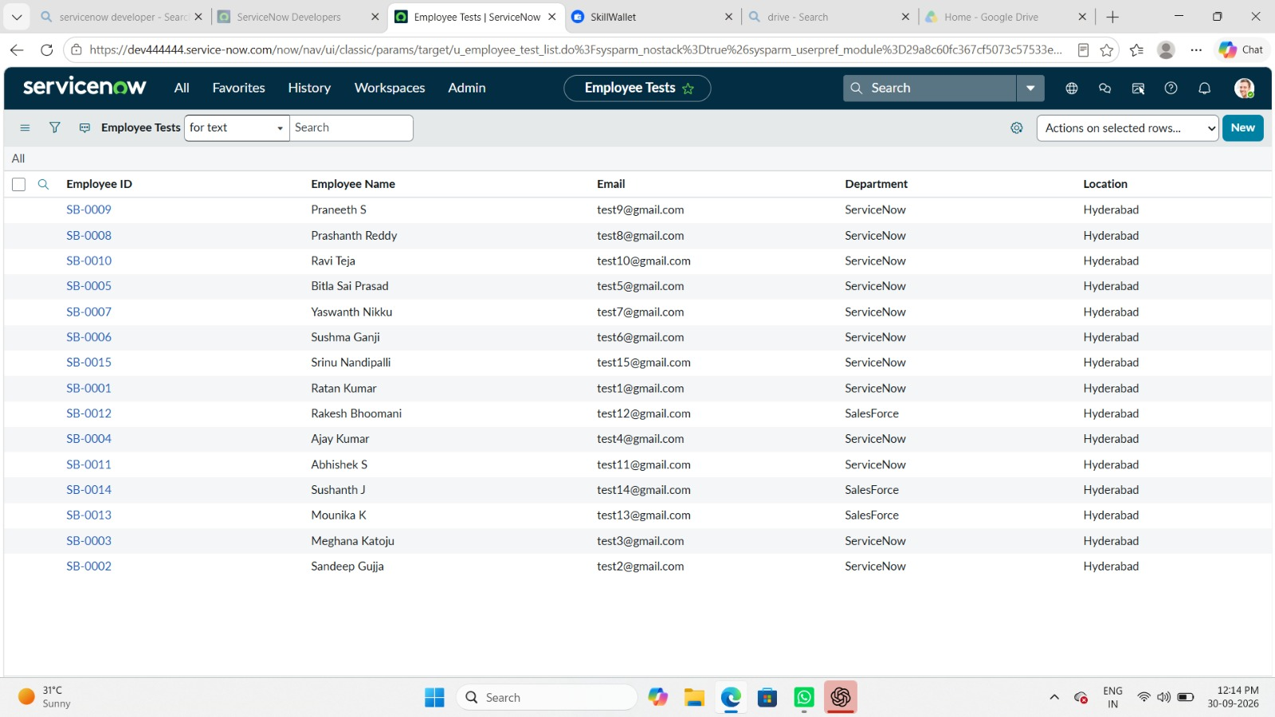
Figure 3. Employee Test Table Records. The target table is populated with employee records after the data-loading and transformation workflow.

MILESTONE 2 : CREATION OF IMPORT SET TABLE AND TRANSFORM MAP
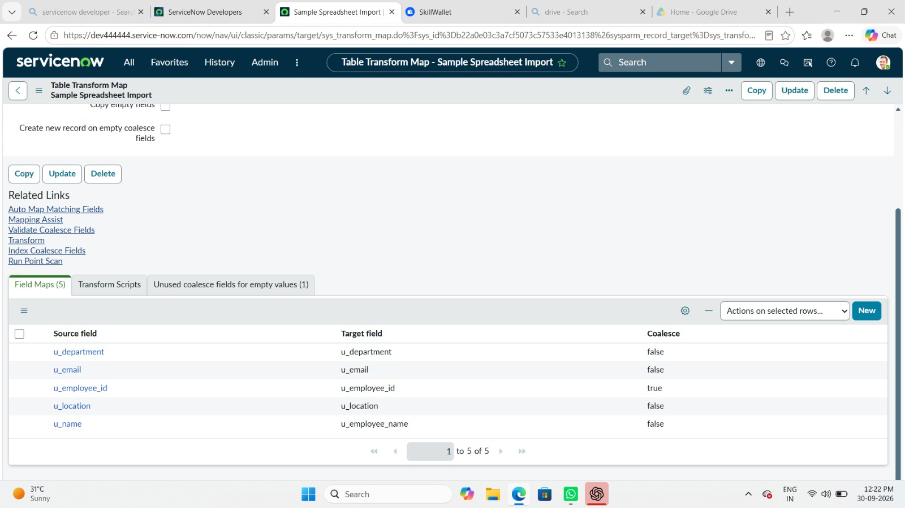
Figure 4. Transform Map Configuration. The Transform Map configuration defines how imported spreadsheet fields are handled and mapped into the target table.
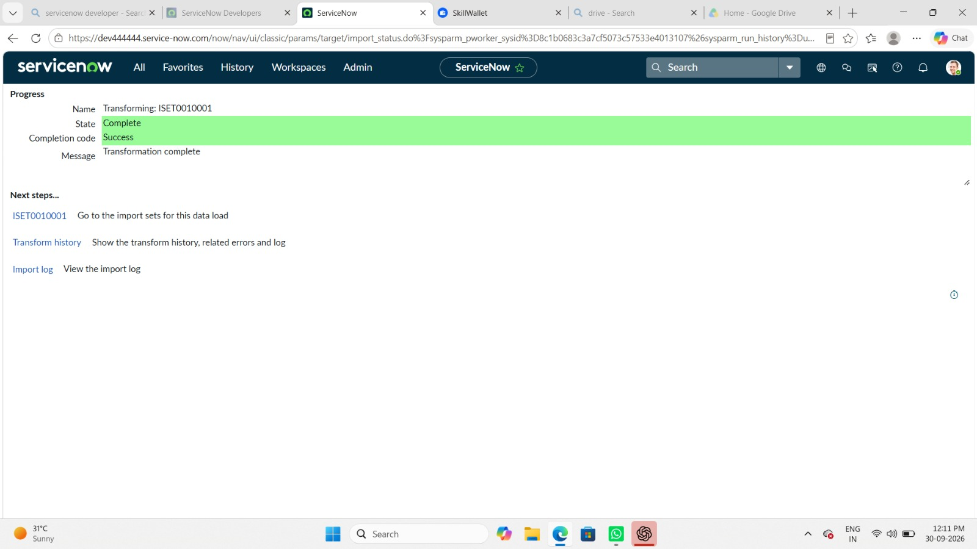
Figure 5. Transform Execution Result. The transformation is shown as completed successfully.

MILESTONE 3 : TRANSFORM DATA & VALIDATE / COALESCE / NEW DATA
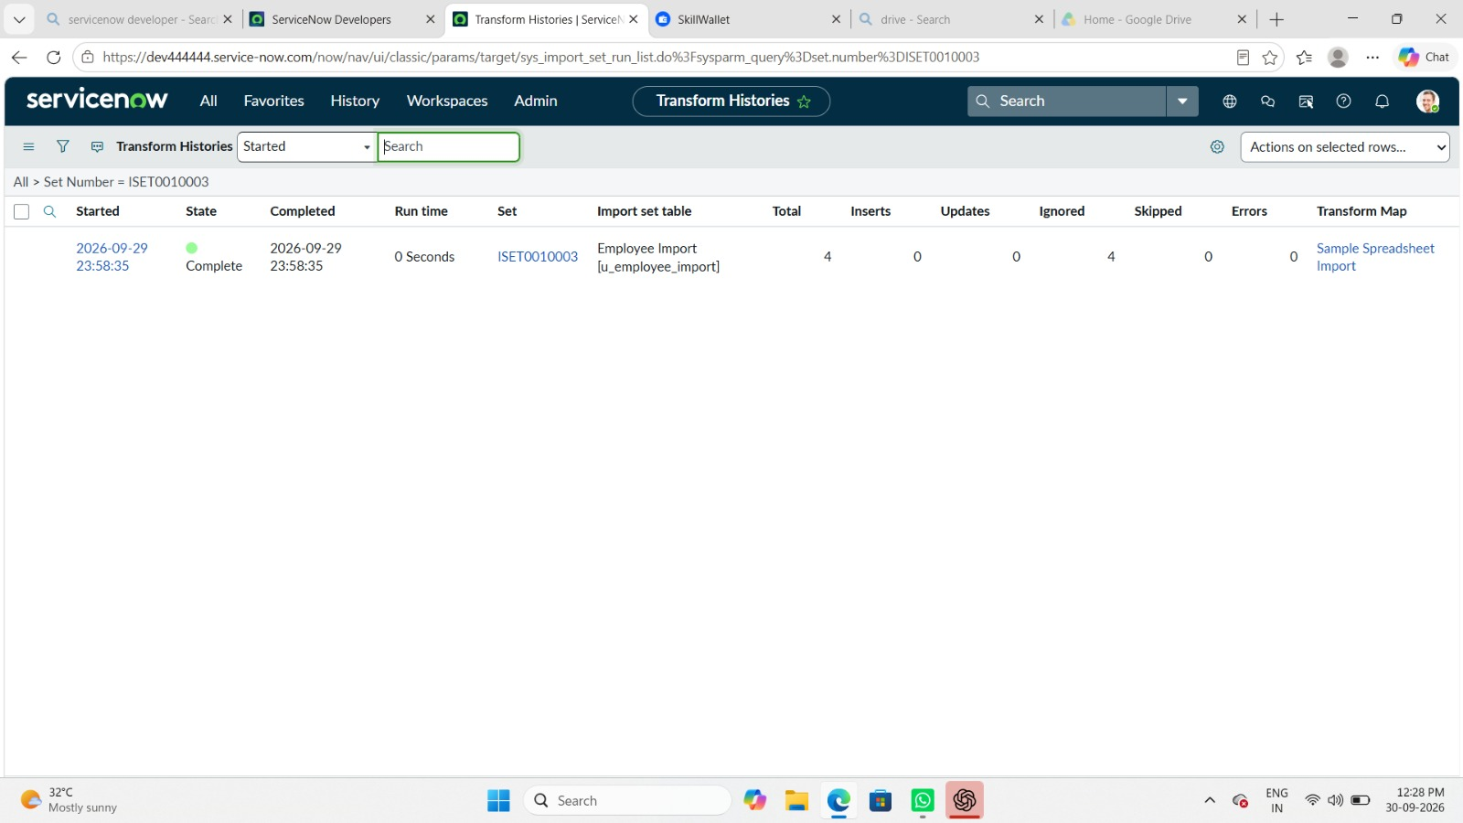
Figure 6. Transform History. Transform History provides a record of the completed import/transformation run.
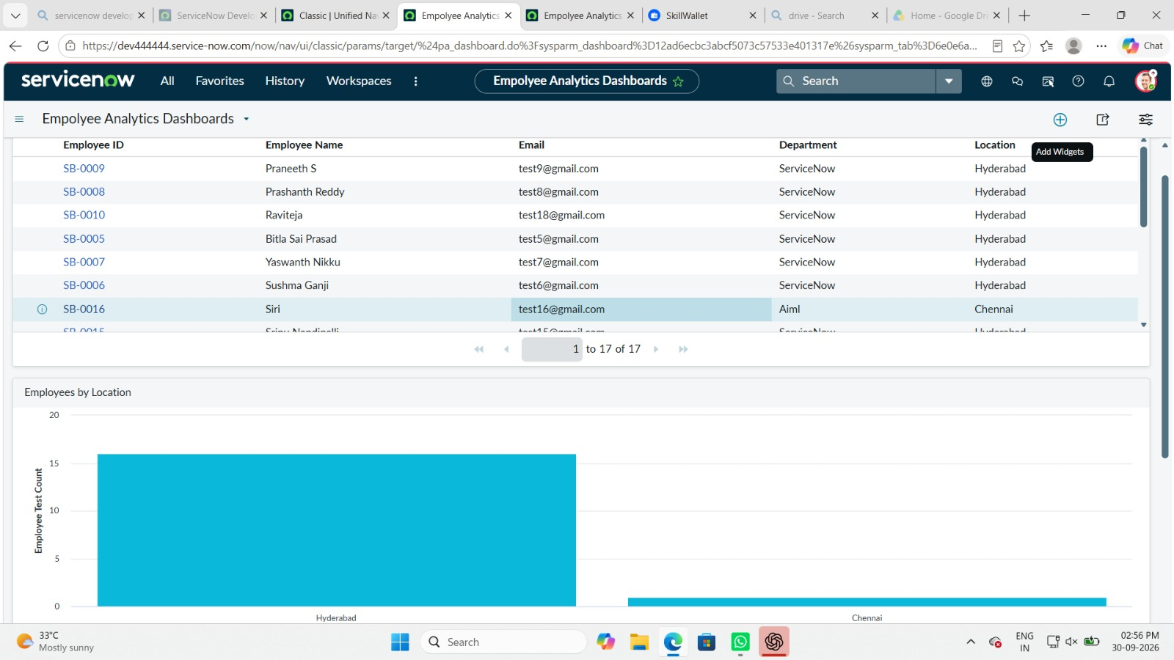
Figure 7. Employee Data After Import. The dashboard/data view shows employee records after the import process, with 17 employee records visible.

MILESTONE 4 : CREATION OF REPORTS & DASHBOARDS
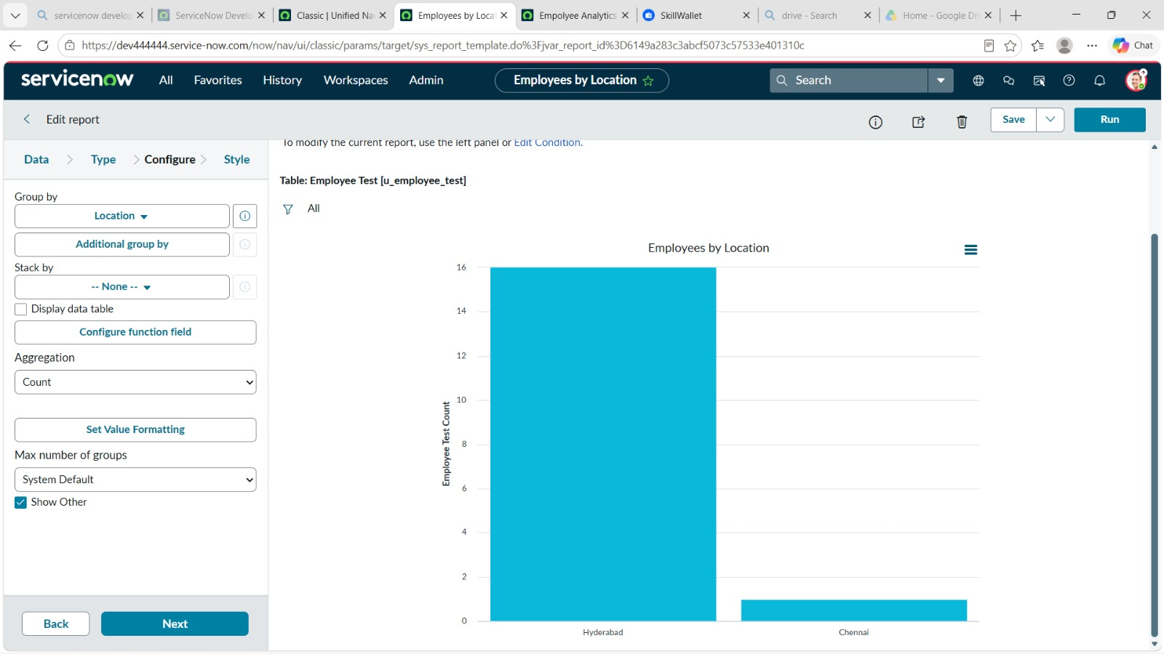
Figure 8. Employees by Department Report. Report configuration for analyzing employee records by Department.
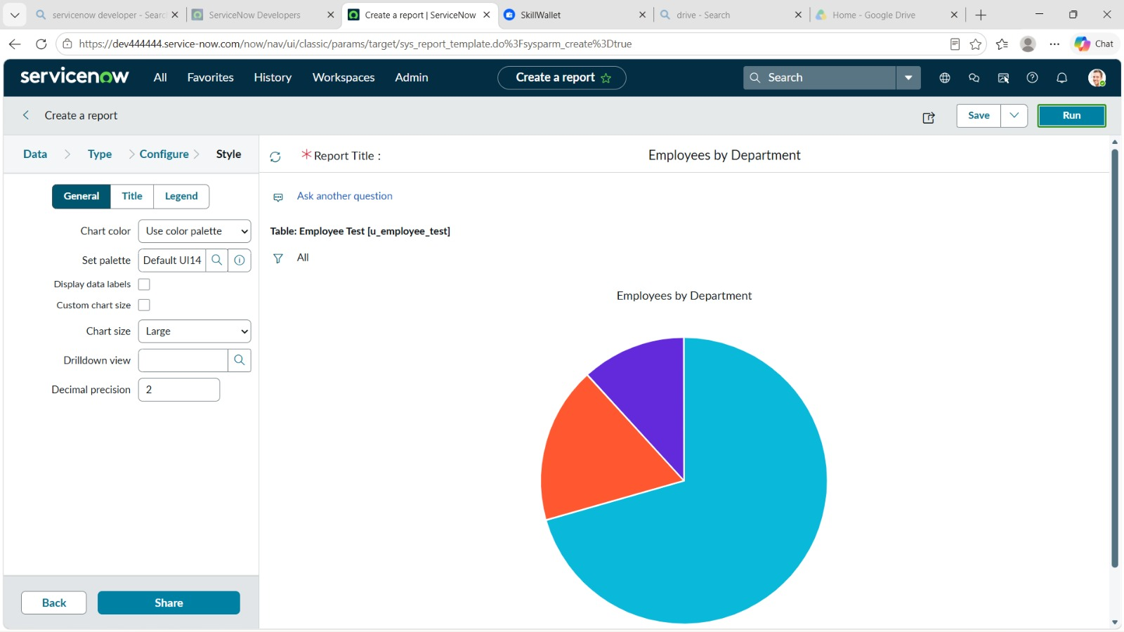
Figure 9. Employees by Department Chart. Chart configuration/preview for the Employees by Department report.
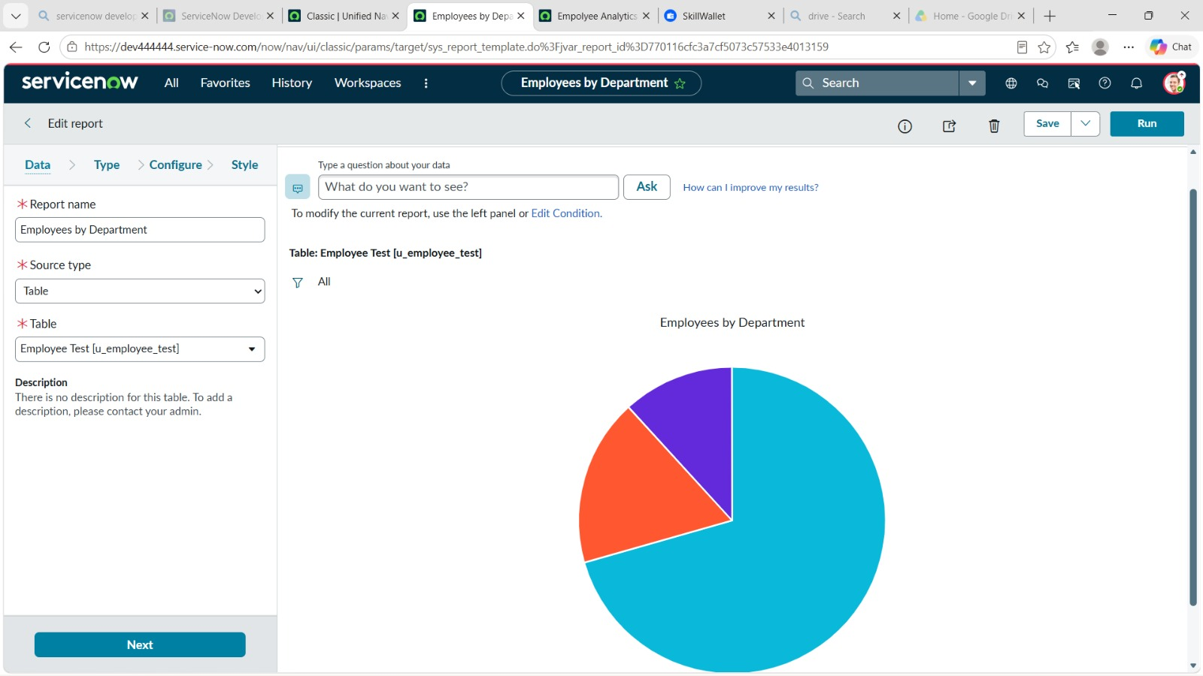
Figure 10. Employees by Location Report. Report configuration for grouping employee records by Location using a count aggregation.
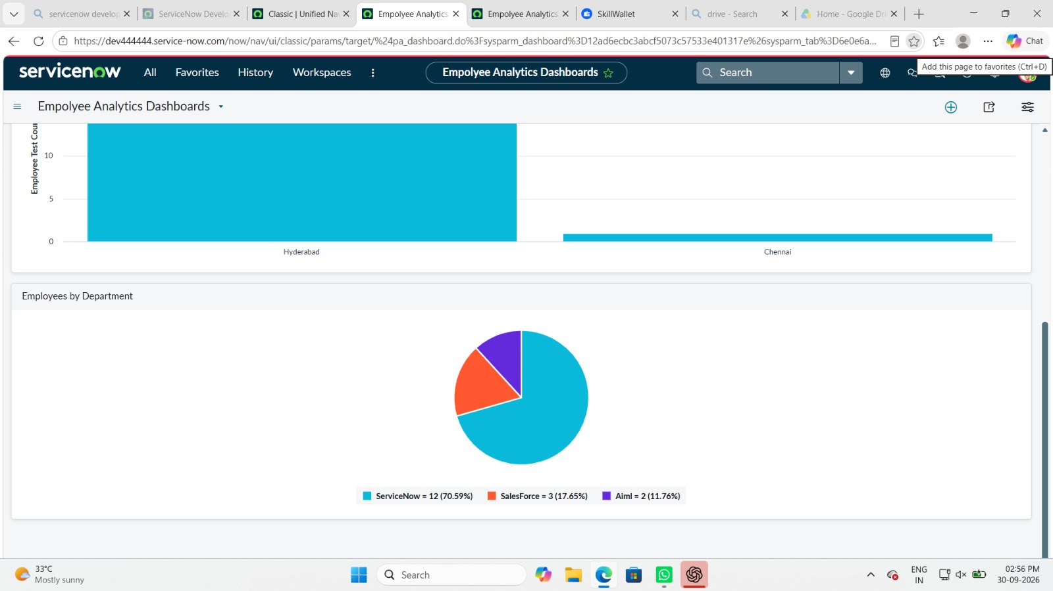
Figure 11. Employee Analytics Dashboard. The Employee Analytics Dashboard combines the project reports into a visual summary.
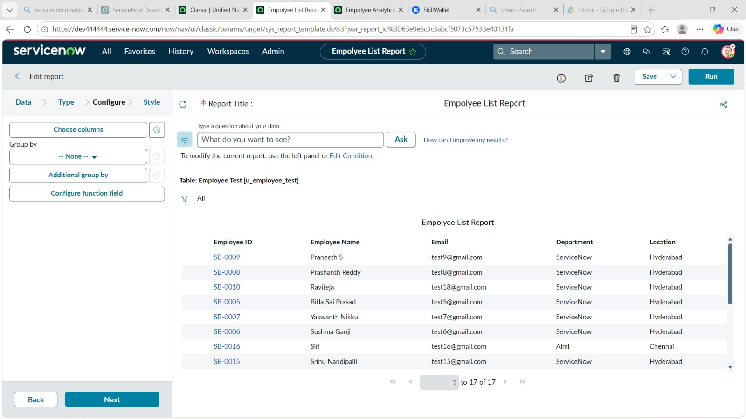
Figure 12. Employee List Report Verification. Employee List Report configuration/preview used to verify the report output.

8. ADVANTAGES & DISADVANTAGES

8.1 Advantages
- Supports bulk data loading rather than manual record-by-record entry.
- Provides a staging step before data reaches the target table.
- Makes source-to-target field mapping explicit.
- Supports duplicate-control through coalesce configuration.
- Provides transformation history and import results for verification.
- Allows imported data to be converted into useful reports and dashboards.
- The milestone-based workflow is easy for beginners to follow and test.

8.2 Disadvantages
- Incorrect source data can still produce incorrect target records.
- Field mapping requires careful configuration.
- Incorrect coalesce matching can affect whether a record is treated as existing or new.
- Large imports may require additional performance and error-handling considerations.
- Reports are only useful when the underlying imported data is accurate and complete.

9. CONCLUSION

9.1 Summary
This project successfully demonstrates a structured ServiceNow data-import workflow using spreadsheet data, Import Sets, Transform Maps, coalesce-related duplicate control, validation, reports, and a dashboard. The supplied screenshots provide evidence of the main process stages and their outputs.

9.2 Learning Outcomes
- Understanding the purpose of an Import Set as a staging mechanism.
- Understanding how a Transform Map controls source-to-target transformation.
- Understanding the role of field mapping in migration.
- Understanding how coalesce can be used for record matching and duplicate control.
- Learning how to verify transformation results through history and target records.
- Learning how to create reports and combine them into a dashboard.
Overall, the micro project connects data preparation, migration, validation, and visualization into one practical ServiceNow workflow.

10. FUTURE SCOPE

10.1 Enhancements
- Add stronger validation rules for mandatory employee fields.
- Add handling for invalid email formats and incomplete records.
- Extend duplicate matching to multiple business identifiers where appropriate.
- Add filters for department, location, or other employee categories.
- Add more report types for deeper analysis.
- Introduce controlled error logging for failed transformations.

10.2 Automation Opportunities
- Schedule recurring imports when employee spreadsheets are received regularly.
- Automate notifications when an import contains errors.
- Create dashboard indicators for import success, failure, and record counts.
- Use standardized spreadsheet templates to reduce source-data variation.
- Introduce a controlled data-validation step before transformation.
These future enhancements can turn the micro project into a more reusable employee-data integration workflow.

11. APPENDIX
Dataset Link
GitHub & Project Demo Link

