PROJECT REPORT
Import Data using Transform Maps (Spreadsheet)
Bulk employee data migration into ServiceNow using Import Sets, Transform Maps and Coalesce, with Reports and a Dashboard
Project Name | Import Data using Transform Maps (Spreadsheet)
Platform | ServiceNow (Global application scope)
Team ID | SWTID-2026-4970
Team Members | Layavarshini S(Team Leader),Nishanthini A, Suganthara K, Jumana Hasin N, Devika N.
Project Duration | 19 January 2026 to 31 January 2026 (2 sprints of 6 days)
Report Date | 30 September 2026
Version | 1.0

TABLE OF CONTENTS
1. INTRODUCTION
1.1 Project Overview
1.2 Purpose
2. IDEATION PHASE
2.1 Problem Statement
2.2 Empathy Map Canvas
2.3 Brainstorming
3. REQUIREMENT ANALYSIS
3.1 Customer Journey Map
3.2 Solution Requirement
3.3 Data Flow Diagram
3.4 Technology Stack
4. PROJECT DESIGN
4.1 Problem Solution Fit
4.2 Proposed Solution
4.3 Solution Architecture
5. PROJECT PLANNING & SCHEDULING
5.1 Project Planning
6. FUNCTIONAL AND PERFORMANCE TESTING
6.1 Performance Testing
7. RESULTS
7.1 Output Screenshots
8. ADVANTAGES & DISADVANTAGES
9. CONCLUSION
10. FUTURE SCOPE
11. APPENDIX
Dataset
Configuration Summary
Source Code
GitHub & Project Demo Link
References

1. INTRODUCTION

1.1 Project Overview
Organisations regularly receive bulk employee data as Excel or Google Sheets files from HR teams and external systems. Typing these records into ServiceNow one by one is slow and error-prone, and importing the same or an updated file a second time can create duplicate records. This project solves that problem with ServiceNow’s built-in data import framework.
The spreadsheet data (Employee ID, Name, Email, Department and Location) is first loaded into an Import Set table that acts as a staging area. A Transform Map then maps the staged source fields to the fields of a custom target table, Employee Test (u_employee_test). Coalesce is enabled on Employee ID so that a repeated import updates matching records, inserts only new employees and ignores unchanged rows. The result of every load is verified in Transform History, and the final data is presented through three reports combined on the Employee Analytics Dashboard.
The project simulates a real-world onboarding and update scenario and helps beginners understand the end-to-end import process: data loading, field mapping, transformation execution, duplicate prevention and result verification.
Item | Detail
Source data | Sample Spreadsheet.xlsx (Google Sheets export), 15 employee rows, 5 columns
Staging (Import Set) table | Employee Import (u_employee_import)
Target table | Employee Test (u_employee_test) with 5 String fields
Transform Map | Sample Spreadsheet Import (Employee Import to Employee Test)
Duplicate control | Coalesce = true on Employee ID
Reports | Employees by Department (Pie), Employees by Location (Bar), Employee List Report (List)
Dashboard | Employee Analytics Dashboard
Table 1: Project at a glance

1.2 Purpose
The purpose of the project is to provide a reliable, repeatable and duplicate-safe way of moving spreadsheet data into ServiceNow, and to give HR and administrators a clear view of the imported data. The specific objectives are to:
- Load structured employee data from an Excel spreadsheet into a ServiceNow staging table using Load Data.
- Create a custom target table (Employee Test) and map source fields to it with a Transform Map.
- Prevent duplicate records by enabling Coalesce on the Employee ID field, so repeated imports update rather than duplicate.
- Validate every import using the Progress page, Transform History and the Employee Test list.
- Build reports (pie, bar, list) and combine them on a dashboard that can be shared with users, groups and roles.

2. IDEATION PHASE

2.1 Problem Statement
A customer problem statement helps the team view the problem from the user’s point of view. The statement below was written for the main user, the ServiceNow administrator.
I am | A ServiceNow administrator who receives bulk employee data (Employee ID, Name, Email, Department, Location) in an Excel spreadsheet.
I’m trying to | Import that data into the ServiceNow platform quickly and accurately, and keep it up to date when new spreadsheets arrive.
But | Typing records one by one is slow, and importing the same or an updated file again creates duplicate or incorrect records.
Because | There is no staging area, field mapping or unique-key check (Coalesce) to validate data before it reaches the target table.
Which makes me feel | Frustrated, stressed about data accuracy, and unsure whether the records in ServiceNow can be trusted.
Table 2: Customer problem statement (PS-1)
PS | I am | I’m trying to | But | Because | Which makes me feel
PS-1 | ServiceNow Administrator | Import bulk employee data from an Excel spreadsheet accurately | Manual entry is slow and re-importing creates duplicates | No staging, field mapping or Coalesce check | Frustrated, worried about data accuracy
PS-2 | HR Manager / Reporting Analyst | See employee counts by department and location | Data is scattered across spreadsheets with no reliable view | Records are not centralised with reports or a dashboard | Uninformed, unable to decide with confidence
Table 3: Problem statements

2.2 Empathy Map Canvas
The empathy map captures what the administrator thinks, hears, sees, says and does, together with the pains and gains that shape the solution.
User / Persona: ServiceNow Administrator (HR data admin) who receives bulk employee data in Excel for onboarding and updates and must load it accurately without duplicates.
Think & Feel  • “Will this data land correctly the first time?”  • Worried about duplicate or wrong employee records  • Under pressure to onboard new joiners on time  • Wants a repeatable process that is not error-prone | Hear  • Manager: “New joiners’ records are needed by Monday.”  • HR: “The spreadsheet is updated again, please refresh ServiceNow.”  • Colleagues: “Manual entry always leads to typos.”  • Community: “Use Import Sets and Transform Maps for bulk loads.”
See  • Excel sheets with dozens or hundreds of employee rows  • The same Employee ID in different files with changed names or emails  • Records typed one by one into ServiceNow forms  • Import logs showing inserts, updates and errors | Say & Do  • Says: “Can we automate this instead of typing each record?”  • Cross-checks rows against Excel  • Re-uploads corrected files and checks Transform History  • Builds reports to show HR the final numbers
Pain  • Slow, repetitive manual data entry  • Duplicate records when the same file is imported twice  • Typos and inconsistent names, emails and departments  • Hard to prove what was inserted and what was updated  • No quick view of employees by department or location | Gain  • Whole spreadsheet loaded in one go through an Import Set  • Field mapping done once in a reusable Transform Map  • Coalesce on Employee ID updates instead of duplicating  • Transform History confirms inserts, updates and ignored rows  • Dashboard gives HR live visibility of employee data
Table 4: Empathy map
Key insight: the administrator needs a repeatable, duplicate-safe way to bring spreadsheet data into ServiceNow and to see the results clearly. This leads to the solution: Import Set (staging) + Transform Map (field mapping) + Coalesce on Employee ID + Reports and a Dashboard.

2.3 Brainstorming
The team gathered to discuss how bulk employee data received as an Excel spreadsheet can be moved into ServiceNow quickly and accurately. Ground rules were: volume over value, no idea is a bad idea, build on each other’s ideas, and stay focused on problem statement PS-1. Twelve ideas were listed and grouped into four themes: Data Loading, Mapping & Transformation, Data Integrity and Reporting.
Each idea was scored on Importance (value to the project goal) and Feasibility (how easily it can be built in ServiceNow) on a 1 to 5 scale. Ideas in the high-importance, high-feasibility area were selected.
# | Idea | Group | Imp. | Feas. | Decision
1 | Load Excel data into an Import Set using Load Data | A: Data Loading | 5 | 5 | Selected
2 | Accept CSV / TSV files | A: Data Loading | 3 | 5 | Future scope
3 | Scheduled imports from an external Data Source | A: Data Loading | 4 | 2 | Future scope
4 | Custom target table (u_employee_test) | B: Mapping | 5 | 4 | Selected
5 | Transform Map with Auto Map Matching Fields | B: Mapping | 4 | 5 | Selected
6 | Transform scripts to clean data | B: Mapping | 3 | 4 | Future scope
7 | Coalesce on Employee ID (no duplicates) | C: Integrity | 5 | 4 | Selected
8 | Verify loads with Transform History & Import Log | C: Integrity | 4 | 4 | Selected
9 | Mandatory-field validation rules | C: Integrity | 3 | 2 | Future scope
10 | Reports: by Department, by Location, Employee List | D: Reporting | 4 | 4 | Selected
11 | Employee Analytics Dashboard | D: Reporting | 4 | 3 | Selected
12 | Scheduled / shared reports | D: Reporting | 2 | 3 | Future scope
Table 5: Idea scoring and decision
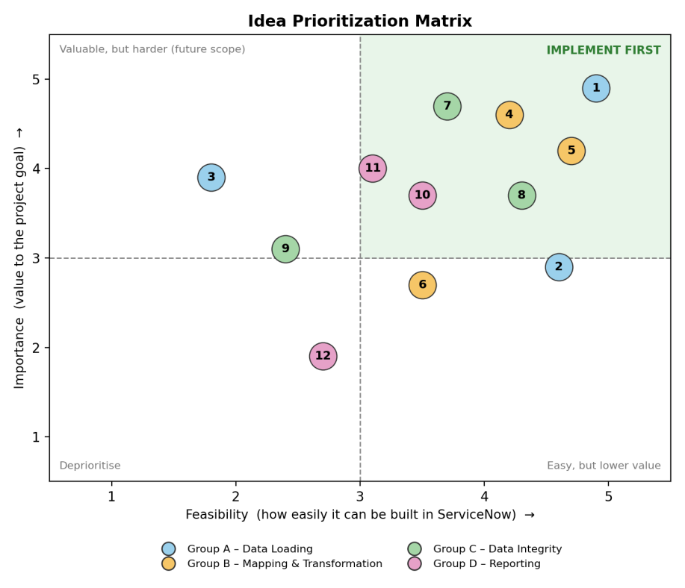
Figure 1: Importance versus feasibility matrix of the 12 ideas
Outcome: ideas 1, 4, 5, 7, 8, 10 and 11 form the final solution. The remaining ideas are recorded as future enhancements (Section 10).

3. REQUIREMENT ANALYSIS

3.1 Customer Journey Map
The journey map follows the administrator from receiving the spreadsheet to presenting the results to HR, and shows where the solution improves the experience.
Stage | User activity | Touchpoint | Experience / pain point | Opportunity addressed
1. Receive data | Receives the employee list as an Excel or Google Sheet | Email, Google Sheets | Worried about volume and deadline | Prepare the sheet once and export as .xlsx
2. Prepare target | Creates the Employee Test table and its five String fields | Tables, Form Layout | Unsure how to structure the data | Simple custom table with matching fields
3. Load data | Uploads the file with Load Data into the staging table | System Import Sets, Load Data | Fear of changing live data directly | Staging table keeps raw data separate
4. Map and transform | Creates the Transform Map, auto-maps fields and runs Transform | Transform Map, Mapping Assist | Manual entry is slow and typo-prone | Bulk transform in about a second
5. Validate and de-duplicate | Enables Coalesce, re-imports changed data, reviews Transform History | Transform History, Import Log | Duplicates and unclear results | Coalesce updates or ignores; counts prove it
6. Report | Builds three reports and a dashboard, shares with HR | Reports, Dashboards, Share | Needs a quick view of headcount | One shared dashboard with live charts
Table 6: Customer journey map

3.2 Solution Requirement
Functional requirements
FR No. | Requirement (Epic) | Sub requirements
FR-1 | Data Preparation | Prepare employee data in a spreadsheet and download it as .xlsx  Create the custom table Employee Test (u_employee_test)  Create Employee ID, Employee Name, Email, Department, Location
FR-2 | Data Import (Import Set) | Upload the spreadsheet through System Import Sets > Load Data  Create the staging table Employee Import (u_employee_import)  Load later files into the existing Import Set table
FR-3 | Field Mapping & Transformation | Create the Transform Map “Sample Spreadsheet Import”  Map fields using Auto Map Matching Fields / Mapping Assist  Run the Transform and confirm State Complete and Success
FR-4 | Duplicate Prevention (Coalesce) | Enable Coalesce on the Employee ID field map  Update existing records when the Employee ID matches  Insert only new IDs and ignore unchanged records
FR-5 | Validation & Verification | View imported records in the Employee Tests list  Review Transform History (total, inserts, updates, ignored, skipped, errors)  Check the Import Log for errors
FR-6 | Reports | Employees by Department (Pie, Count)  Employees by Location (Bar, Count)  Employee List Report (List, 5 columns)
FR-7 | Dashboard & Sharing | Create the Employee Analytics Dashboard  Add the three reports  Share with users, groups and roles
Table 7: Functional requirements
Non-functional requirements
NFR No. | Requirement | Description
NFR-1 | Usability | Guided, menu-based screens (Load Data, Transform Map, Mapping Assist) with no coding. The target table has five simple String fields and list columns can be personalised.
NFR-2 | Security | Access is controlled by roles and ACLs. Administrator access is needed for tables, Transform Maps and the dashboard form (pa_dashboards create ACL with Admin overrides). The dashboard can be restricted to selected users, groups and roles.
NFR-3 | Reliability | Raw data stays in a separate staging table, every load reports a State and Completion code, and Coalesce keeps the employee table consistent across repeated imports.
NFR-4 | Performance | Bulk processing: 15 rows in about 1.4 seconds and a 4-row update file in about 0.04 seconds.
NFR-5 | Availability | Runs on the cloud-hosted ServiceNow instance through a web browser, so no local installation is needed.
NFR-6 | Scalability | Import Sets and Transform Maps are built for bulk loads. The same map can be reused for new spreadsheets and extra fields, tables or reports can be added.
Table 8: Non-functional requirements

3.3 Data Flow Diagram
The data flow diagram shows how data enters the system, what transforms it and where it is stored.
Ref. | Name | Description
1.0 | Load Data (Import Set) | The Excel file is uploaded through System Import Sets > Load Data and its rows are stored in the staging table.
2.0 | Transform Map (field mapping) | The Transform Map maps source fields to target fields using Auto Map Matching Fields / Mapping Assist.
3.0 | Coalesce Check (Employee ID) | Each incoming ID is compared with existing records: a new ID is inserted, a matching ID is updated and an unchanged record is ignored.
4.0 | Verify Results | Transform History and the Import Log show total, inserts, updates, ignored, skipped and error counts for every load.
5.0 | Reports & Dashboard | Pie, bar and list reports are built on the target table and combined on the Employee Analytics Dashboard.
D1 | Employee Import (u_employee_import) | Staging table holding raw spreadsheet rows before transformation.
D2 | Employee Test (u_employee_test) | Target table holding final employee records.
Table 9: Processes and data stores
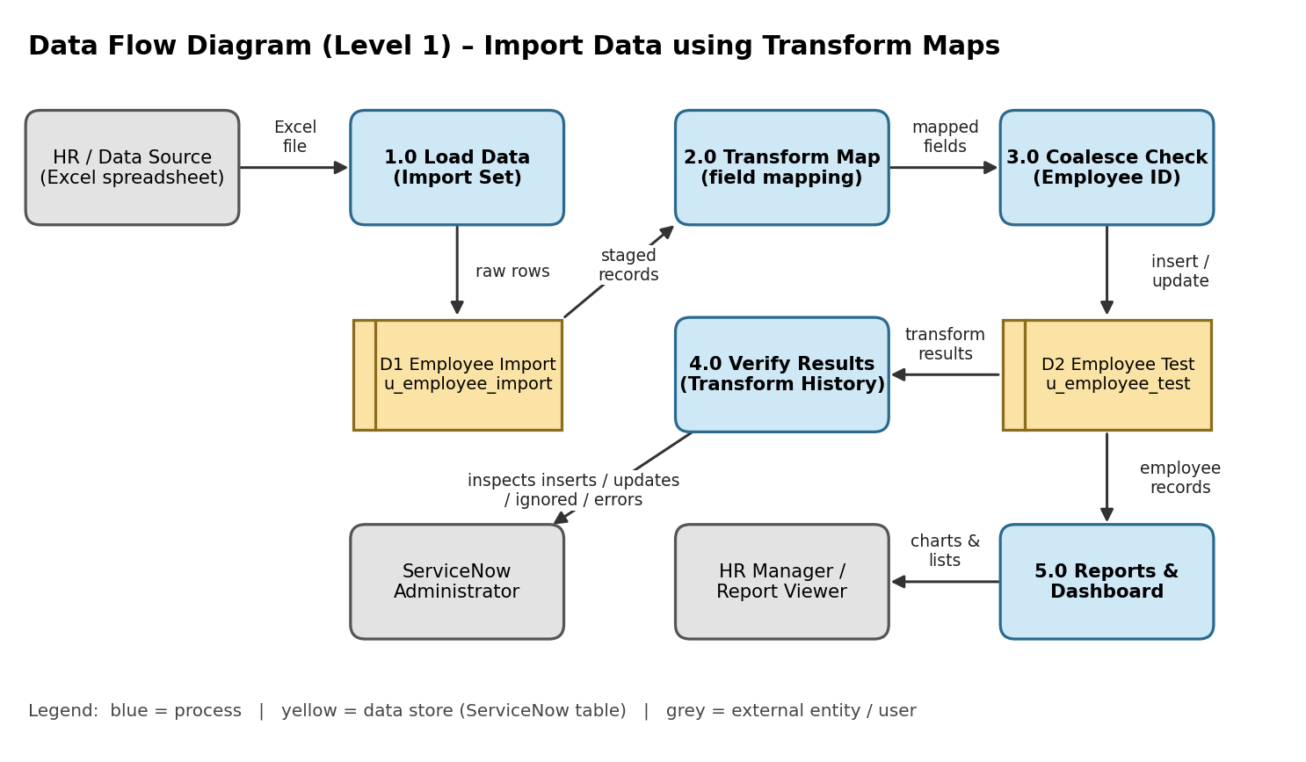
Figure 2: Data flow diagram (Level 1)
User stories
User type | Story | User story / task | Priority | Release
Administrator | USN-1 | Create custom table Employee Test with the five fields | High | Sprint-1
Administrator | USN-2 | Upload Sample Spreadsheet.xlsx using Load Data into Employee Import | High | Sprint-1
Administrator | USN-3 | Create a Transform Map and auto-map the matching fields | High | Sprint-1
Administrator | USN-4 | Run the Transform so staged records are created in the target table | High | Sprint-1
Administrator | USN-5 | Enable Coalesce on Employee ID so repeat imports update instead of duplicating | High | Sprint-2
Administrator | USN-6 | Open Transform History to see total, inserts, updates, ignored, skipped and errors | Medium | Sprint-2
HR Manager | USN-7 | View a pie chart of employees by department | Medium | Sprint-2
HR Manager | USN-8 | View a bar chart of employees by location | Medium | Sprint-2
HR Manager | USN-9 | View a list report of all employees with five columns | Medium | Sprint-2
HR Manager | USN-10 | See all three reports together on the Employee Analytics Dashboard | High | Sprint-2
Administrator | USN-11 | Share the dashboard with selected users, groups and roles | Low | Sprint-2
Table 10: User stories

3.4 Technology Stack
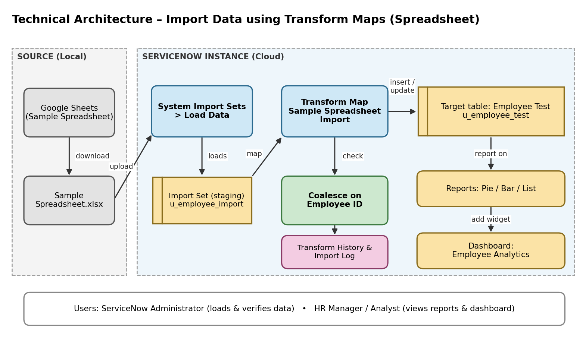
Figure 3: Technical architecture of the project
S.No | Component | Description | Technology
1 | User Interface | ServiceNow web UI (navigator, forms, lists, Reports, Dashboards) and Google Sheets for source data | ServiceNow UI, Google Sheets
2 | Application Logic-1 (Import) | Loads spreadsheet rows into a staging table before any real data changes | Load Data, table u_employee_import
3 | Application Logic-2 (Transform) | Maps source fields to target fields and creates records | Transform Map “Sample Spreadsheet Import”
4 | Application Logic-3 (Duplicate check) | Updates a record when the Employee ID already exists | Coalesce on Employee ID
5 | Database | Custom target table with five String fields | ServiceNow table u_employee_test
6 | Cloud Database / Infrastructure | All tables hosted by the ServiceNow cloud instance, used from any browser | ServiceNow cloud instance
7 | File Storage | Spreadsheet used as the data source, uploaded once per load | Sample Spreadsheet.xlsx
8 | External API / ML model | Not used: data is brought in by file upload | Not applicable
Table 11: Components and technologies
S.No | Characteristic | Description | Technology
1 | Open-source frameworks | None needed; uses built-in low-code modules | Import Sets, Transform Maps, Reports, Dashboards
2 | Security | Role-based access, ACLs and dashboard sharing restricted to users, groups and roles | Roles, ACLs, Share settings
3 | Scalable architecture | Staging table, Transform Map and target table are separate layers, so the map can be reused for larger files | 3-tier ServiceNow architecture
4 | Availability | Cloud hosted and browser accessed | ServiceNow cloud
5 | Performance | Batch transform instead of manual entry: 15 rows in about 1.4 s and 4 rows in about 0.04 s | Import Set batch transform
Table 12: Application characteristics

4. PROJECT DESIGN

4.1 Problem Solution Fit
Problem-solution fit confirms that the problem found with the customer is actually solved by the solution. Here, the administrator’s problems (slow manual entry, duplicate records after re-imports, and no clear view of employee data) are matched by a staged import, a reusable Transform Map, Coalesce on Employee ID and a reporting dashboard. The completed canvas is shown below.
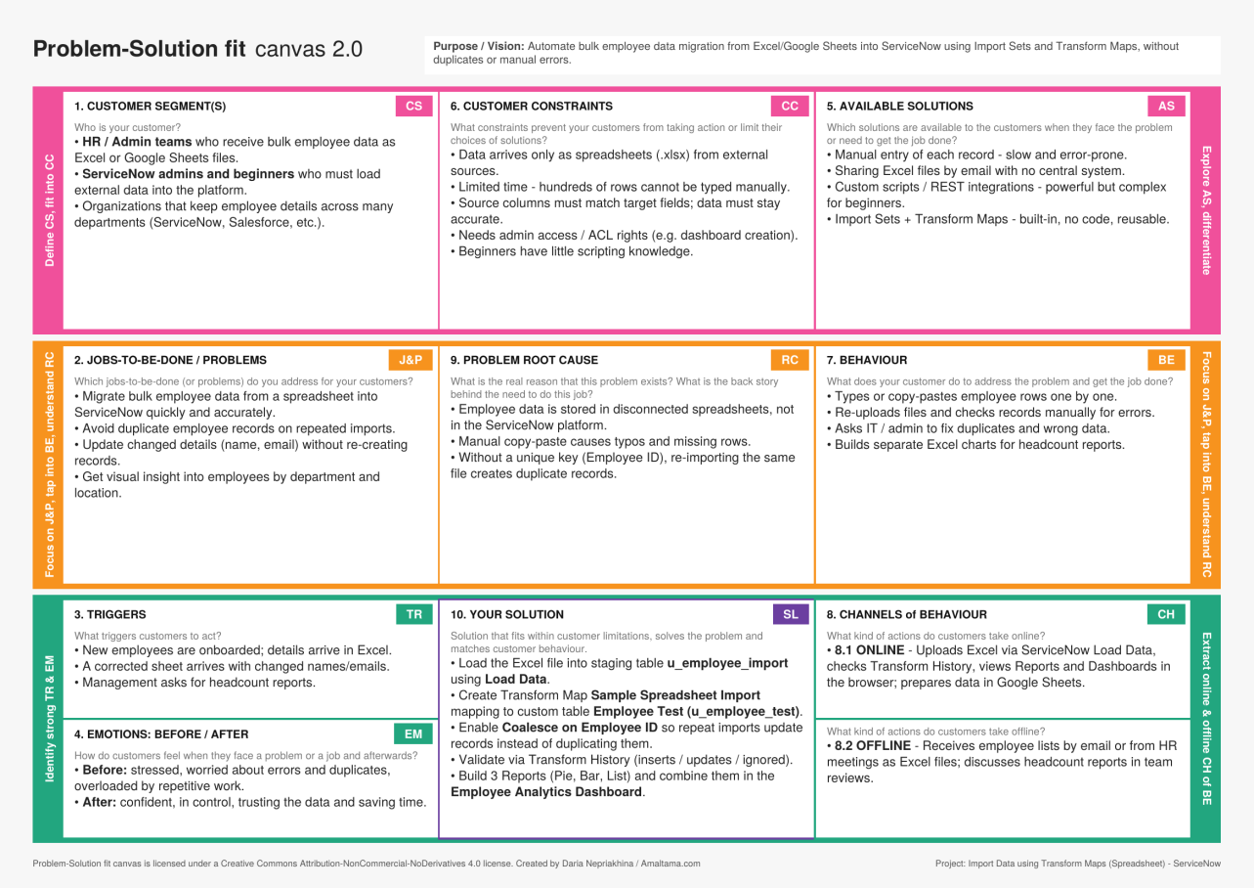
Figure 4: Completed problem-solution fit canvas

4.2 Proposed Solution
S.No | Parameter | Description
1 | Problem statement | Bulk employee data arrives as Excel or Google Sheets files. Manual entry into ServiceNow is slow and error-prone, and importing the same file more than once creates duplicate records. There is no simple, reliable way for beginners and admins to migrate, update and monitor this data.
2 | Idea / solution description | Use Import Sets and Transform Maps to load the spreadsheet into a staging table (u_employee_import) and map it to the custom table Employee Test (u_employee_test). Enable Coalesce on Employee ID so repeated imports update existing records and insert only new ones. Validate in Transform History, then build three reports and combine them in the Employee Analytics Dashboard.
3 | Novelty / uniqueness | A completely no-code, end-to-end flow covering loading, mapping, transforming, de-duplicating, validating and reporting with built-in ServiceNow features only. The same Transform Map can be re-run with new files, and the project demonstrates insert, update and ignore behaviour on real sample data.
4 | Social impact / customer satisfaction | Saves HR and admin teams hours of repetitive data entry, reduces human error and gives leadership trusted, up-to-date employee data. Beginners also gain a practical learning path for ServiceNow data import.
5 | Business model (revenue model) | A reusable implementation accelerator: one-time setup fee, optional support and maintenance subscription, training workshops, and a packaged template (table, map, reports, dashboard) for other clients.
6 | Scalability of the solution | Import Sets handle large row counts and any number of files. New fields, departments or target tables can be added by extending the Transform Map, and the approach extends to users, assets, locations or incidents. Scheduled imports and data sources (JDBC, REST, LDAP) can be added as volumes grow.
Table 13: Proposed solution

4.3 Solution Architecture
The architecture bridges the business problem and the technology solution. Data flows through five stages:
- Source data: employee records are prepared in Google Sheets and downloaded as Sample Spreadsheet.xlsx.
- Load Data: the file is uploaded through System Import Sets > Load Data (Sheet 1, Header row 1) into the staging table u_employee_import.
- Transform Map: Sample Spreadsheet Import maps the five source fields to the target table Employee Test; Coalesce is enabled on Employee ID.
- Transform and validate: running Transform inserts new records, updates matching ones and ignores unchanged rows; results are checked in Transform History.
- Reports and dashboard: three reports (Pie, Bar, List) are added to the Employee Analytics Dashboard, which can be shared with users, groups and roles.
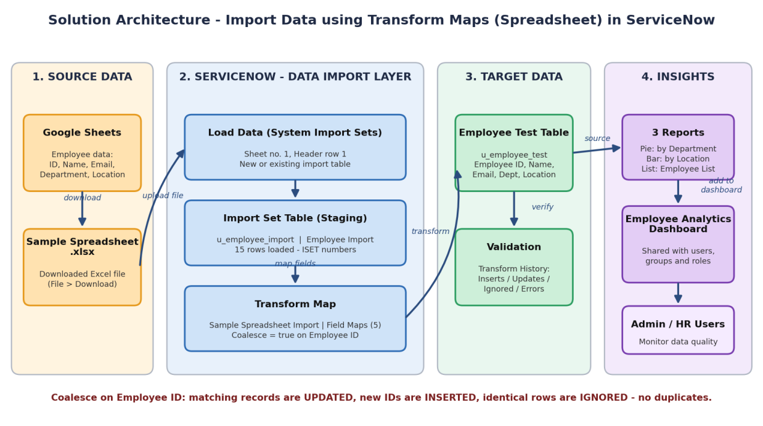
Figure 5: Architecture and data flow of the project

5. PROJECT PLANNING & SCHEDULING

5.1 Project Planning
The work was planned in two Scrum sprints of six days each. An Epic is a large body of work, a Story is a small task within an epic, and a Story Point measures effort on a 1, 2, 3, 5 scale (1 = very easy, 2 = normal, 3 = moderate, 5 = difficult).
Product backlog and sprint plan
Sprint | Epic | Story | User story / task | Pts | Priority
Sprint-1 | Data Preparation | USN-1 | Create a Google Spreadsheet with sample employee data | 1 | High
Sprint-1 |  | USN-2 | Download the spreadsheet as Sample Spreadsheet.xlsx | 1 | High
Sprint-1 | Custom Table | USN-3 | Create the custom table Employee Test (u_employee_test) | 2 | High
Sprint-1 |  | USN-4 | Add the five String fields using Form Layout | 2 | High
Sprint-1 | Import Set | USN-5 | Load the Excel file into u_employee_import using Load Data | 2 | High
Sprint-1 | Transform Map | USN-6 | Create the Transform Map and map fields with Auto Map / Mapping Assist | 3 | High
Sprint-1 |  | USN-7 | Run the Transform and validate that 15 records are created | 3 | High
Sprint-2 | Coalesce | USN-8 | Enable Coalesce on Employee ID | 2 | High
Sprint-2 |  | USN-9 | Import updated data and verify 2 inserts and 2 updates | 3 | High
Sprint-2 |  | USN-10 | Re-import the same file and verify 4 rows are ignored | 1 | Medium
Sprint-2 | Reports | USN-11 | Report: Employees by Department (Pie, Count) | 2 | Medium
Sprint-2 |  | USN-12 | Report: Employees by Location (Bar, Count) | 2 | Medium
Sprint-2 |  | USN-13 | Report: Employee List (List, 5 columns) | 2 | Medium
Sprint-2 | Dashboard | USN-14 | Set Admin overrides on pa_dashboards ACL and create the dashboard | 3 | Medium
Sprint-2 |  | USN-15 | Add the three reports to the dashboard and share it | 3 | Medium
Table 14: Product backlog and sprint plan (total 32 story points)
Sprint schedule and velocity
Sprint | Story points | Duration | Start date | Planned end | Points completed | Release date
Sprint-1 | 14 | 6 days | 19 Jan 2026 | 24 Jan 2026 | 14 | 24 Jan 2026
Sprint-2 | 18 | 6 days | 26 Jan 2026 | 31 Jan 2026 | 18 | 31 Jan 2026
Table 15: Sprint schedule
Velocity: total story points completed = 14 + 18 = 32 across 2 sprints, so the team velocity is 32 / 2 = 16 story points per sprint. With a six-day sprint, the average velocity is 16 / 6 ≈ 2.67 story points per day.
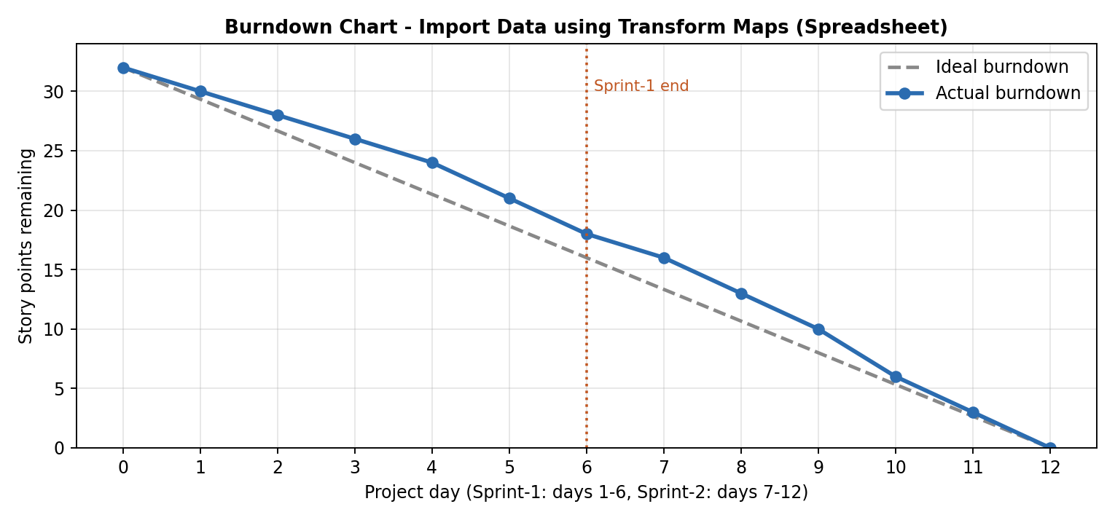
Figure 6: Burndown chart: ideal versus actual
The chart shows 32 story points remaining at the start, 18 at the end of Sprint-1 and 0 at the end of Sprint-2, closely following the ideal line.

6. FUNCTIONAL AND PERFORMANCE TESTING

6.1 Performance Testing
Functional tests (FT), performance tests (PT) and user acceptance tests (UAT) were run between 19 and 31 January 2026 on the ServiceNow instance, covering user stories USN-1 to USN-15. All results below were observed during the project run.
Functional and performance test results
ID | Scenario | Expected result | Actual result | Result
FT-01 | Data load (Load Data) | Table u_employee_import created, 15 rows loaded | State Complete, Success; Processed 15, inserts 15, errors 0 | Pass
FT-02 | Field mapping | All 5 source fields mapped | 5 field maps created (u_name to u_employee_name, ID, department, location, email) | Pass
FT-03 | Transform execution | Records created in Employee Test | Transformation complete, Success; 15 of 15 records visible | Pass
FT-04 | Coalesce: update existing | Existing records updated, no duplicates | 2 updates: SB-0004 name = Ajay; SB-0010 email = test18@gmail.com | Pass
FT-05 | Coalesce: insert new | New IDs inserted | 2 inserts: SB-0016 and SB-0017 (17 records) | Pass
FT-06 | Duplicate prevention | No inserts or updates on re-import | Total 4, Inserts 0, Updates 0, Ignored 4, Errors 0 | Pass
FT-07 | Report output | Charts and list match table data | Pie: ServiceNow 11 / Salesforce 4 / AIML 2; Bar: Hyderabad 16 / Chennai 1; List: 17 rows | Pass
FT-08 | Dashboard | All 3 reports display | List, Bar and Pie widgets shown; share options available | Pass
PT-01 | Import response time | Small file loads in under 3 s | 15 rows in about 1.4 s; 4 rows in 0.04 s | Pass
PT-02 | Transform speed | Finishes within a few seconds | Run time 1 s for 4 rows; 0 s for the re-run | Pass
PT-03 | Repeated import stability | No errors across repeated loads | 3 imports (15, 4, 4 rows) completed with 0 errors | Pass
Table 16: Functional and performance test results
Import accuracy
Import | Rows | Inserts | Updates | Ignored | Errors
Import 1: initial file | 15 | 15 | 0 | 0 | 0
Import 2: changed + new rows | 4 | 2 | 2 | 0 | 0
Import 3: same 4 rows again | 4 | 0 | 0 | 4 | 0
Total | 23 | 17 | 2 | 4 | 0
Table 17: Import accuracy across three imports (100%, 0 errors)
User acceptance testing
Section | Total cases | Not tested | Fail | Pass
Data Preparation | 1 | 0 | 0 | 1
Custom Table | 2 | 0 | 0 | 2
Import Set (Load Data) | 1 | 0 | 0 | 1
Transform Map | 2 | 0 | 0 | 2
Coalesce (insert / update / ignore) | 3 | 0 | 0 | 3
Reports | 3 | 0 | 0 | 3
Dashboard | 2 | 0 | 0 | 2
Total | 14 | 0 | 0 | 14
Table 18: UAT test case analysis
Defects
Bug ID | Description | Severity | Status | Resolution / feedback
BG-001 | Department typed as “Servicenow” (lower-case n) in updated rows SB-0004 and SB-0010, so it differs from “ServiceNow” | Low | Open | Correct the casing in the source sheet and re-import; Coalesce will update the records.
BG-002 | Create Dashboard form not opening through PA_DASHBOARDS.FORM | Medium | Closed | Fixed by setting Admin overrides = true on the pa_dashboards create ACL.
Table 19: Bug tracking

7. RESULTS

7.1 Output Screenshots
The screenshots below show the main outputs of the project in the order the work was carried out.
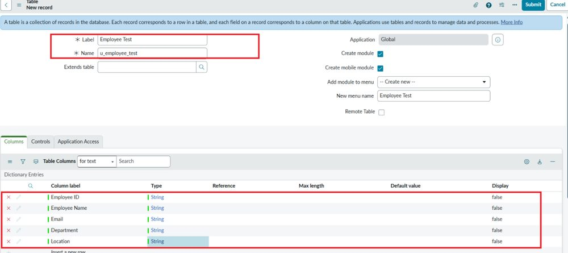
Figure 7: Custom table Employee Test (u_employee_test) with its five String columns
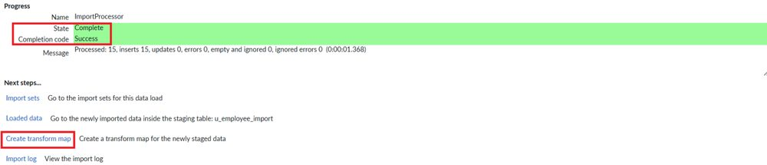
Figure 8: Load Data result: State Complete, Success; 15 processed, 15 inserts, 0 errors
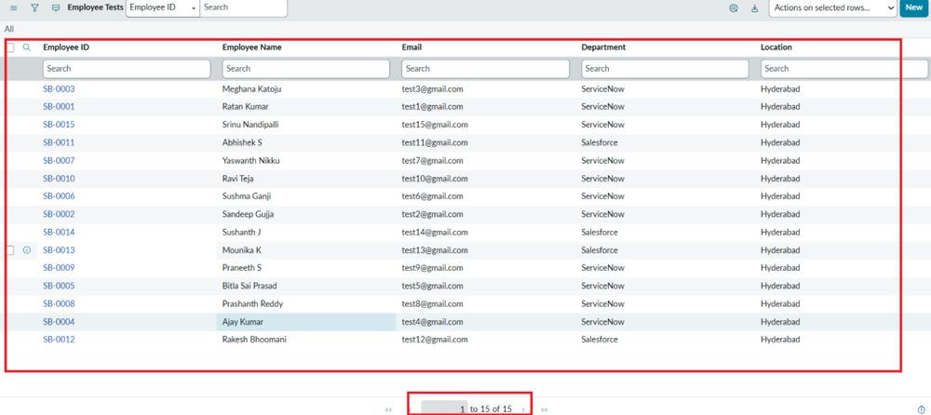
Figure 9: Employee Tests list showing all 15 imported records
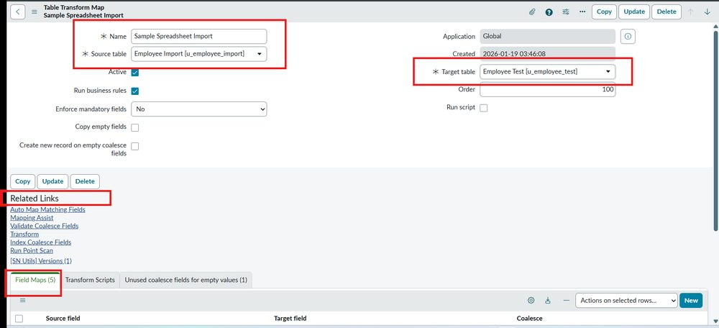
Figure 10: Transform Map “Sample Spreadsheet Import” from Employee Import to Employee Test
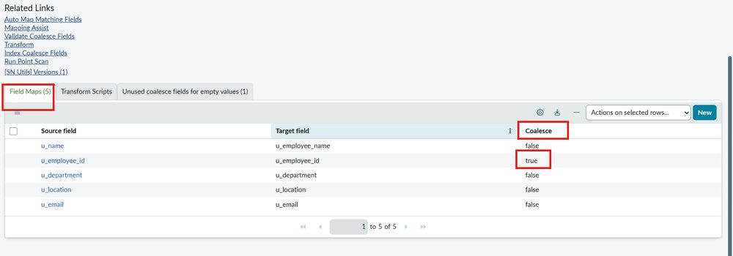
Figure 11: Field maps with Coalesce set to true on Employee ID
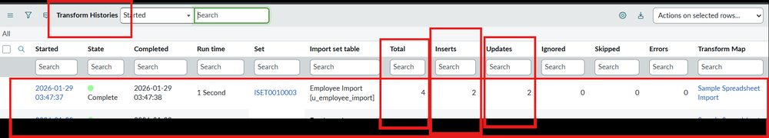
Figure 12: Transform History for the updated file: Total 4, Inserts 2, Updates 2
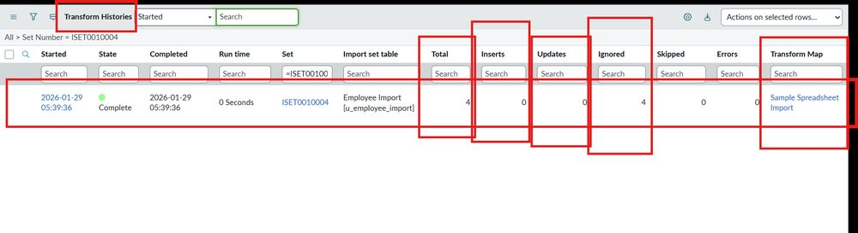
Figure 13: Transform History for the same file re-imported: Inserts 0, Updates 0, Ignored 4
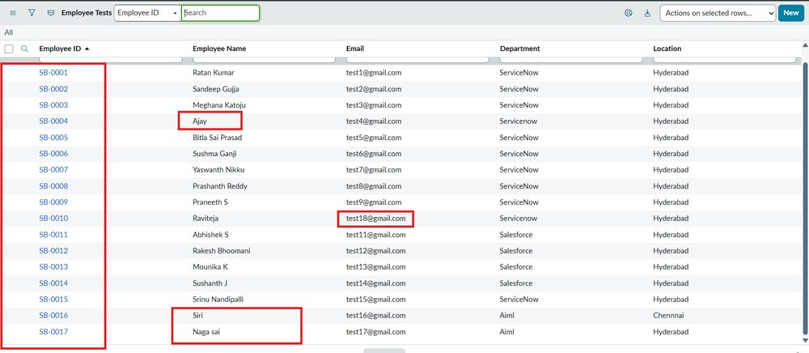
Figure 14: Employee Tests list with 17 records after the update and new inserts (SB-0004, SB-0010, SB-0016, SB-0017)
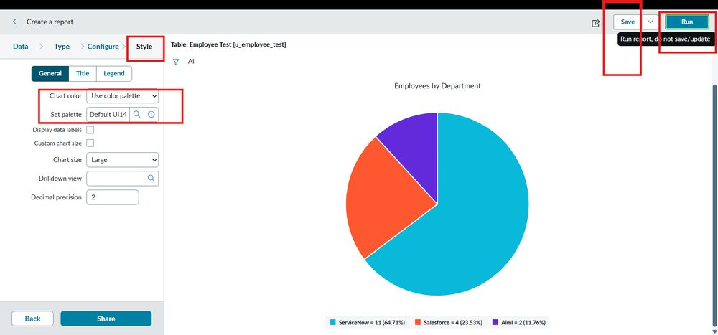
Figure 15: Report 1: Employees by Department (Pie): ServiceNow 11, Salesforce 4, AIML 2
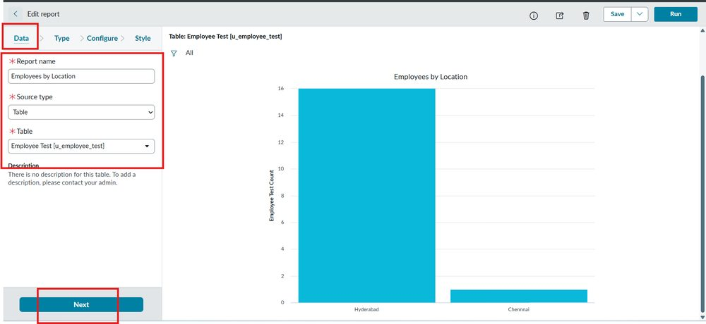
Figure 16: Report 2: Employees by Location (Bar): Hyderabad 16, Chennai 1
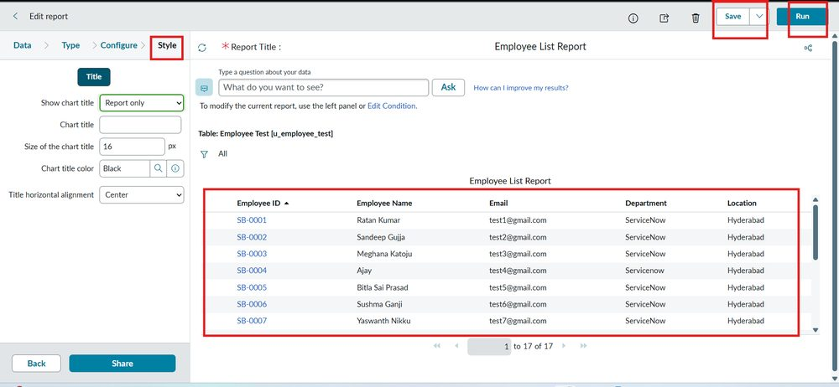
Figure 17: Report 3: Employee List Report (List with five columns, 17 rows)
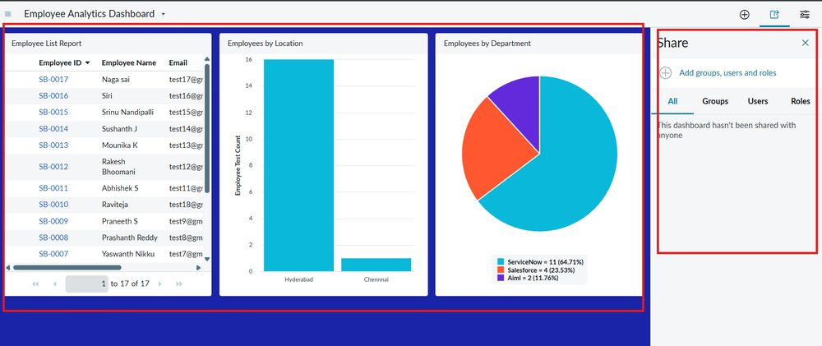
Figure 18: Employee Analytics Dashboard with all three reports and the Share panel

8. ADVANTAGES & DISADVANTAGES

Advantages
- Saves time: a whole spreadsheet is loaded and transformed in about a second instead of typing records one by one.
- No duplicates: Coalesce on Employee ID updates existing employees and inserts only new ones; re-importing the same file changed nothing.
- Safe staging: raw data is held in an Import Set table, so live data is touched only after mapping.
- Reusable: the same Transform Map can be run again for every new spreadsheet.
- Traceable: Transform History and the Import Log show inserts, updates, ignored rows and errors for every load.
- Visible results: reports and a shareable dashboard give HR a clear view by department and location.
- No code and no extra cost: everything uses built-in ServiceNow features and a browser.

Disadvantages
- Manual trigger: each file must be uploaded and transformed by an administrator; imports are not yet scheduled.
- Data quality depends on the source: typing differences such as “Servicenow” versus “ServiceNow” (BG-001) are imported as they are.
- Single match key: only Employee ID is used for Coalesce, so a wrongly typed ID would create a new record.
- Small sample: the project was tested with 15 to 17 rows, so very large volumes were not measured.
- Admin access needed: creating tables, Transform Maps and the dashboard form requires administrator rights and an ACL change.
- Basic validation: mandatory-field rules and data-cleaning scripts were not implemented.

9. CONCLUSION
This project successfully implemented an automated employee data management solution using ServiceNow Import Sets and Transform Maps, ensuring accuracy, efficiency and data integrity throughout the employee onboarding and update process. Fifteen employee records were loaded and transformed into the custom Employee Test table without errors, and later imports added two new employees and updated two existing ones.
A key enhancement was the use of Coalesce on the Employee ID field. It lets the system identify existing employee records on every import, which prevents duplicates and makes repeated imports update existing data instead of inserting redundant entries. Re-importing the same file produced 0 inserts, 0 updates and 4 ignored rows, which confirmed that the employee table stays clean, reliable and consistent.
The project was extended with three reports (Employees by Department, Employees by Location and Employee List) and the Employee Analytics Dashboard, giving administrators and HR teams a single view of employee data and its distribution. All 14 user acceptance test cases and all functional and performance tests passed, and the two sprints delivered 32 story points at a velocity of 16 points per sprint. Only one low-severity data-casing observation (BG-001) remains open. Together, these results show that the approach is practical, repeatable and suitable for real enterprise data migration.

10. FUTURE SCOPE
Several ideas from the brainstorming session were kept outside the current scope and can be added in the future:
- More file formats: accept CSV and TSV files in addition to .xlsx.
- Scheduled imports: connect an external Data Source (JDBC, REST or LDAP) and run the import automatically on a schedule.
- Data cleaning: add transform scripts to trim spaces, fix letter case (for example “Servicenow”) and standardise names before records are inserted.
- Validation rules: enforce mandatory fields and value checks before insertion.
- Import reporting: add reports for import success and error counts, newly added employees and updated employees.
- Scheduled and shared reports: email reports to HR and managers automatically.
- Wider use: reuse the same pattern to import users, assets, locations or incidents.
- Notifications: alert administrators when an import finishes with errors.

11. APPENDIX

Dataset
The dataset is a Google Sheet exported as Sample Spreadsheet.xlsx (Sheet 1, Header row 1) with five columns. The initial file contains 15 employees.
Employee ID | Name | Email | Department | Location
SB-0001 | Ratan Kumar | test1@gmail.com | ServiceNow | Hyderabad
SB-0002 | Sandeep Gujja | test2@gmail.com | ServiceNow | Hyderabad
SB-0003 | Meghana Katoju | test3@gmail.com | ServiceNow | Hyderabad
SB-0004 | Ajay Kumar | test4@gmail.com | ServiceNow | Hyderabad
SB-0005 | Bitla Sai Prasad | test5@gmail.com | ServiceNow | Hyderabad
SB-0006 | Sushma Ganji | test6@gmail.com | ServiceNow | Hyderabad
SB-0007 | Yaswanth Nikku | test7@gmail.com | ServiceNow | Hyderabad
SB-0008 | Prashanth Reddy | test8@gmail.com | ServiceNow | Hyderabad
SB-0009 | Praneeth S | test9@gmail.com | ServiceNow | Hyderabad
SB-0010 | Ravi Teja | test10@gmail.com | ServiceNow | Hyderabad
SB-0011 | Abhishek S | test11@gmail.com | Salesforce | Hyderabad
SB-0012 | Rakesh Bhoomani | test12@gmail.com | Salesforce | Hyderabad
SB-0013 | Mounika K | test13@gmail.com | Salesforce | Hyderabad
SB-0014 | Sushanth J | test14@gmail.com | Salesforce | Hyderabad
SB-0015 | Srinu Nandipalli | test15@gmail.com | ServiceNow | Hyderabad
Table 20: Initial dataset (Import 1, 15 rows)
Employee ID | Name | Email | Department | Location | Effect
SB-0004 | Ajay | test4@gmail.com | Servicenow | Hyderabad | Update (name changed from Ajay Kumar)
SB-0010 | Raviteja | test18@gmail.com | Servicenow | Hyderabad | Update (email changed from test10@gmail.com)
SB-0016 | Siri | test16@gmail.com | AIML | Chennai | Insert (new employee)
SB-0017 | Naga sai | test17@gmail.com | AIML | Hyderabad | Insert (new employee)
Table 21: Updated dataset (Import 2, 4 rows; re-imported unchanged as Import 3)

Configuration Summary
Object | Configuration
Target table | Label: Employee Test; Name: u_employee_test; fields (String): Employee ID, Employee Name, Email, Department, Location
Import Set table | Label: Employee Import; Name: u_employee_import (auto-populated); created through Load Data
Transform Map | Name: Sample Spreadsheet Import; Source: Employee Import; Target: Employee Test; Order 100; Run business rules: true; Enforce mandatory fields: No
Field maps (5) | u_name to u_employee_name; u_employee_id to u_employee_id (Coalesce = true); u_department to u_department; u_location to u_location; u_email to u_email
ACL | pa_dashboards, operation create: Admin overrides = true (needed to open PA_DASHBOARDS.FORM)
Reports | Employees by Department (Pie, Group by Department, Count); Employees by Location (Bar, Group by Location, Count); Employee List Report (List, 5 columns)
Dashboard | Employee Analytics Dashboard with the three reports; sharing by users, groups and roles
Table 22: Configuration summary

Source Code
No custom source code was written. The solution is configured entirely with ServiceNow out-of-the-box features (Tables, Import Sets, Transform Maps, Reports, Dashboards and ACLs).

GitHub & Project Demo Link
GitHub repository | [Enter GitHub link, if any]
Project demo video | [Enter demo video link]
ServiceNow instance | https://dev444444.service-now.com/login.do?user_name=admin&sys_action=sysverb_login&user_password=kgV6HQ9Lv!e-

References
- ServiceNow Product Documentation: Import sets, Transform maps and Coalesce (docs.servicenow.com)
- ServiceNow Product Documentation: Performance Analytics dashboards and Reports
- Atlassian Agile Coach: Scrum sprints, story points and burndown charts (atlassian.com/agile)
- Miro / Mural templates: Customer problem statement, empathy map, brainstorming and idea prioritisation

