Operating Systems

Deadlock Detection Simulator Using Graph Reduction

Project Overview & Objective
In this phase, we developed an automated simulator in Python to detect Resource Deadlocks in operating systems using the Graph Reduction Algorithm. The program analyzes system states by examining resource allocation matrices to determine whether all processes can successfully complete execution or if the system faces a deadlocked state.
- Methodology & Features
- Graph Reduction Logic:
The simulator evaluates the system by iteratively searching for unblocked processes( $Request_{i}≤ Available$ ),simulating their completion, and releasing their allocated resources back to the available pool.

- Interactive Cloud File Upload:
To provide a seamless and professional User Experience (UX) and avoid hardcoded file paths, the program integrates Python's native google.colab.files library. Upon execution, it prompts an interactive upload widget allowing the user to visually select and upload test case files (e.g., input1.txt or input2.txt) directly into the cloud environment.

- Simulation Results & Test Cases

- Test Case 1: No Deadlock (input1.txt)
- Description: Testing a system state where all processes can be fully reduced and completed without getting blocked.
- Output Screenshot:
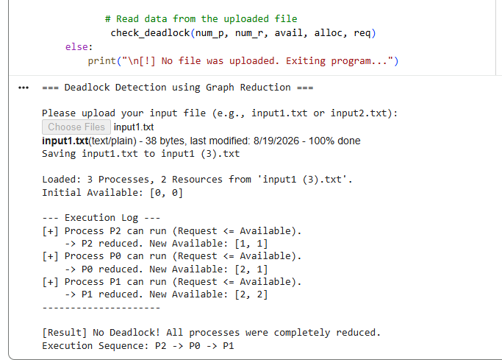
- Test Case 2: Deadlock Present (input2.txt)
- Description: Testing a system state where concurrent resource requests lead to process blocking and an unresolved deadlock.
- Output Screenshot:
