Part1: intro to crud

Api doc

https://www.postman.com/dark-firefly-81784/node10/request/dduxd9e/get-users

Part2: init project

Bootstrap , axios , react router dom , react-hook-form

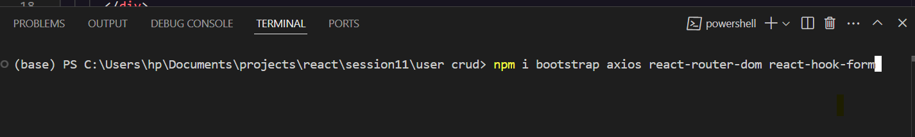

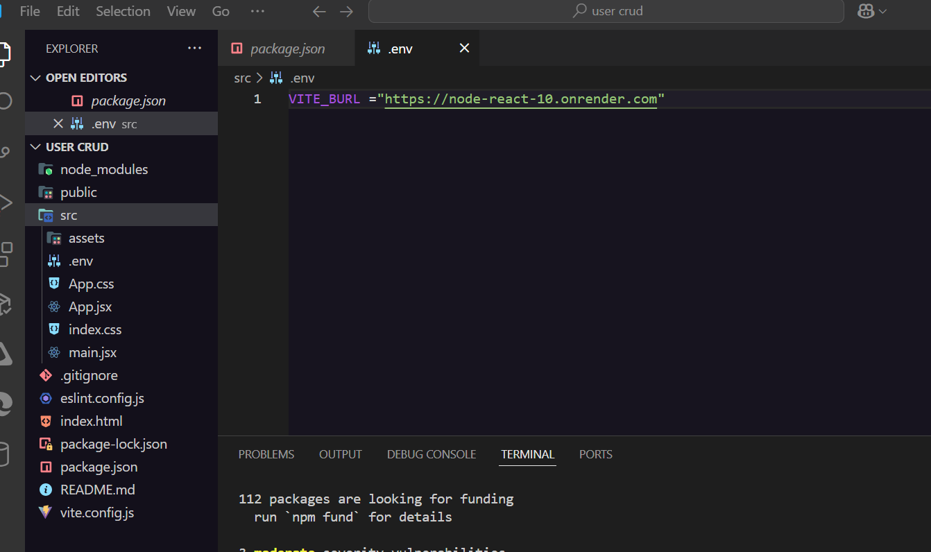

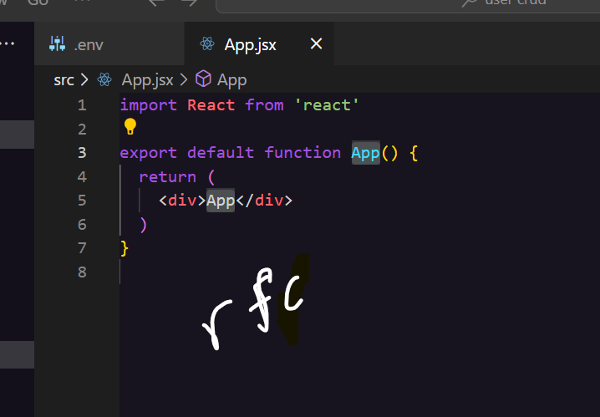

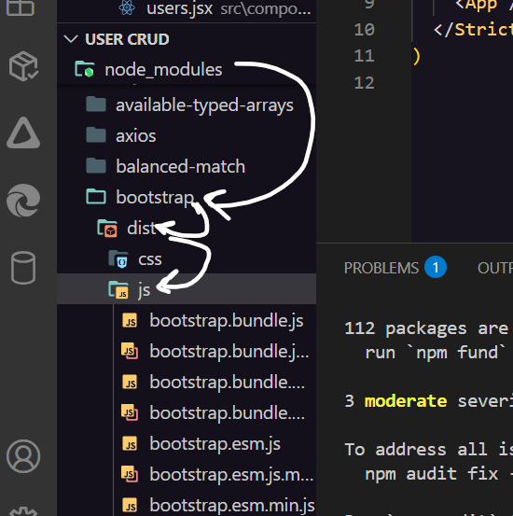

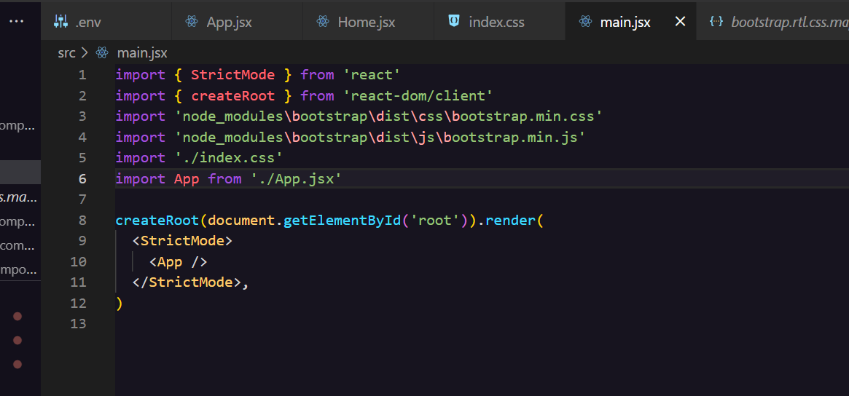

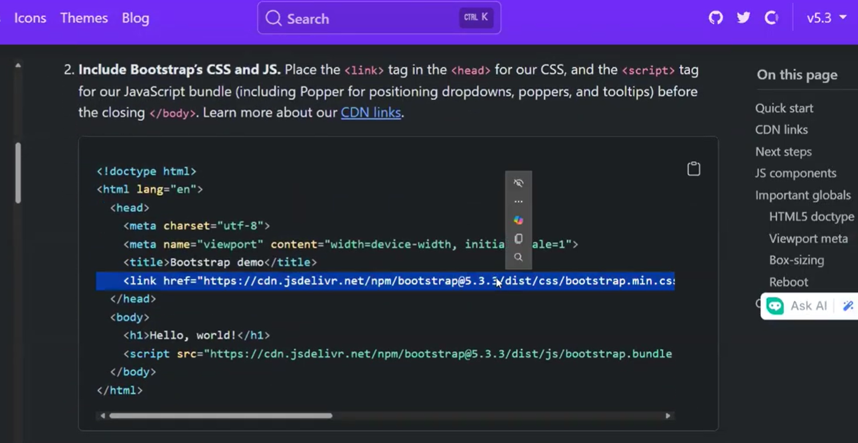<link href="https://cdn.jsdelivr.net/npm/bootstrap@5.3.3/dist/css/bootstrap.min.css" rel="stylesheet" integrity="sha384-QWTKZyjpPEjISv5WaRU9OFeRpok6YctnYmDr5pNlyT2bRjXh0JMhjY6hW+ALEwIH" crossorigin="anonymous">

[Get started with Bootstrap · Bootstrap v5.3](https://getbootstrap.com/docs/5.3/getting-started/introduction/)

BUT IT IN INDEX.HTML

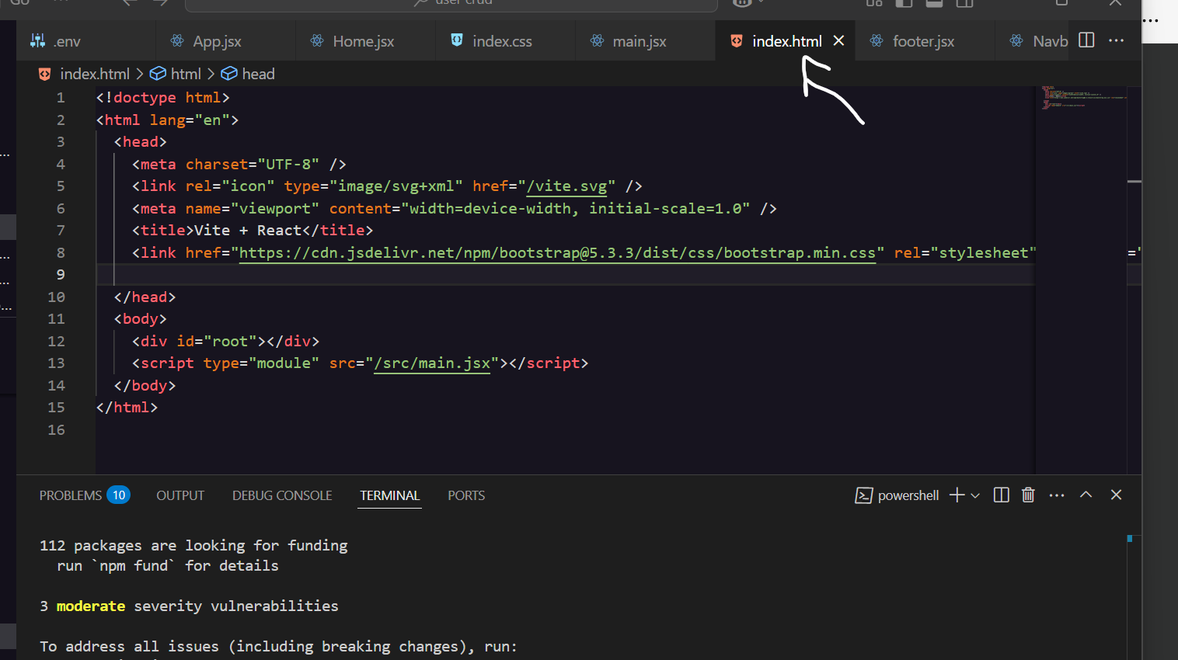

Part3: get users

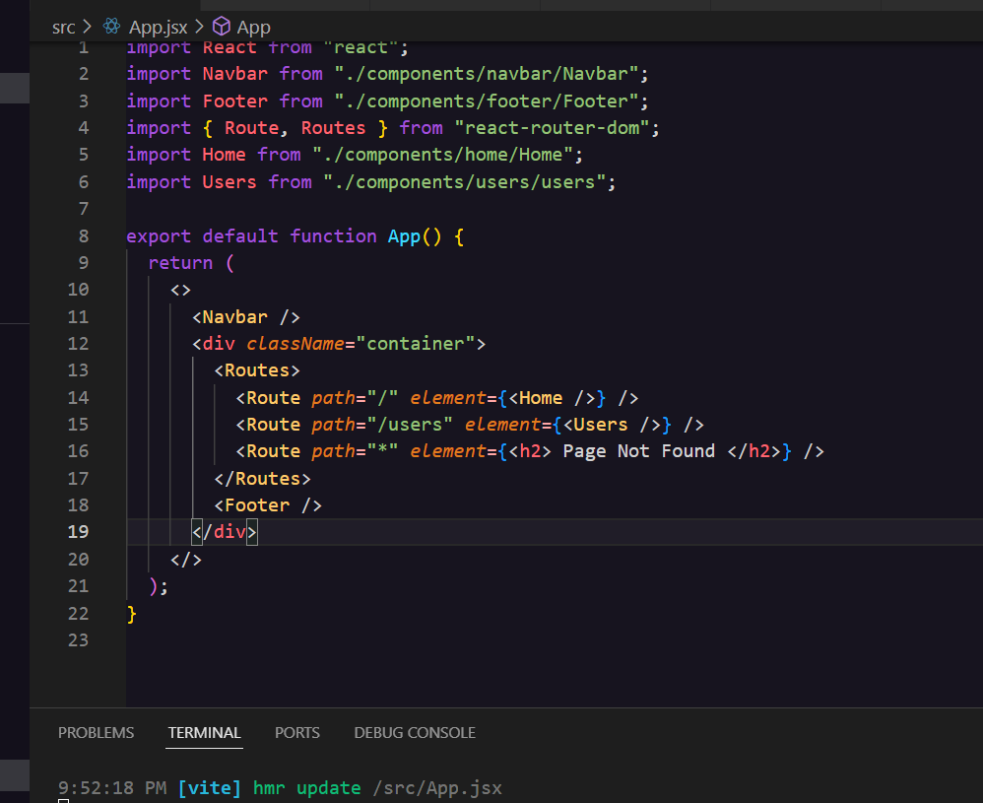

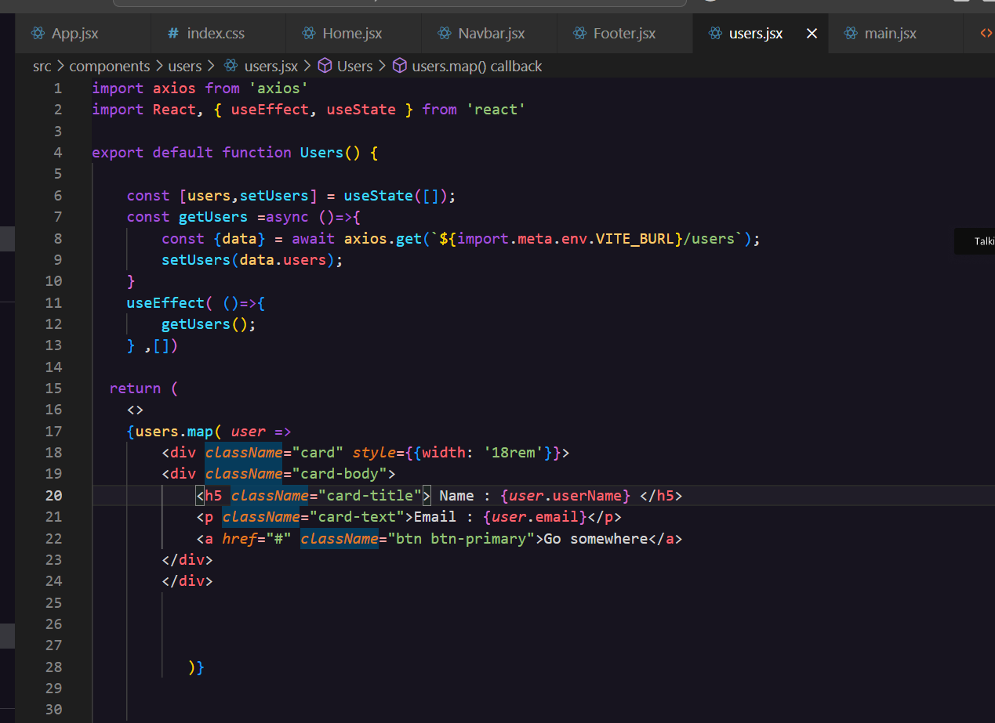

Part4 : create user

