### leyan MALHIS

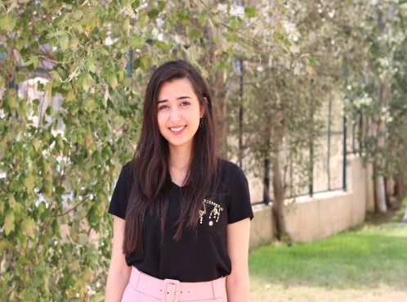

Palestine- Nablus   
cell: +970597135678  
Telephone: +97092342035  
email: layan2malhees@gmail.com

## EDUCATION:

- (2016-now) a 4th year computer Engineering student at AN-Najah National university (GPA IS 3.87: classified as good),

- (2016) Finished high school with an excellent mark (96.1) .

- (2013-2015) completed a scholarship at Amideast English center.

## About:

I'm an undergraduate computer engineering student in my fourth year at collage with a background of 2+ years of web development and networking experience, an active student in both tech communities( Academic) and non-academic activities , seeking to enhance my tech- background and management skills and have the chance to train at your company.

## Programming Languages:

* C++ (very good)
* Java (good)
* Python(good)
* PHP (good)
* HTML (very good)
* CSS (very good)

## Extra Programming Courses:

* Full HTML,CSS,PHP courses
* Data analysis course
* Full research and critical thinking course
* beginner course at Android
* Beginner AI course

## Skills:

* Excellent research skills
* Excellent English Language
* Effective communication
* Critical thinking
* Adaptability
* willingness to learn
* Teamwork
* Creativity

## Work Experience:

Freelancing experience:

* Currently working on Full website front and back end with (html,css ,php , python) to connect startups with investors to find funding for their ideas.

Non-academic experience:

* An organizer at AN-Najah debating Community.

## Achievements and Participations:

* Amid east scholarship for English learning (2013-2015).
* Women in engineering conference (WIE ,IEEE AN NAJAH branch) –certificate for participation (2019)
* IEEE Tech Camp for data Analysis and mobile development-Certificate for participation(2019)
* GDG DevFest –voluntary work and participant(2018)
* Participation at women’s history month in La Verne University California –participant Certificate (February -2019)
* Finalist in Palestine’s English Debate Competition-Finalist Certificate (February -2020)
* Best speaker at Palestine’s English debate at AN-NAJAH university (February -2020)
* Participation at Al-Quds Bard debate tournament - certificate of participation (February -2019)

## Extra-curricular Activities and positions:

* Organizer of An-Najah National university debate team(2019 - now)
* Voluntary work at GDG najah student branch
* Voluntary work at IEEE najah student branch

## References:

* Dr. Aladdin Masri  
  Email : masri@najah.edu
* Alia Gilbrechte

Email: alia.gilbrecht@gmail.com