

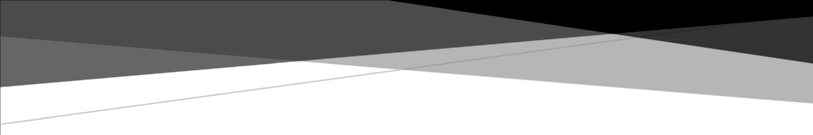

**WIREME**

**UNREGISTERED DEVICE ATTEMPT LOGGING AND VIEWING**

**Functional Specification Document**

**(FSD)**

Stakeholders: Development Team, QA Team, Business Team, BOC Team

Document Version V1.0.0

11.06.2025

# COPYRIGHTS

Ceylon Business Appliances (Pvt) Ltd PROPRIETARY INFORMATION. This software is supplied under the terms of a license agreement or nondisclosure agreement with Ceylon Business Appliances (Pvt) Ltd and may not be copied or disclosed except in accordance with the terms of that agreement.

# AUTHORS

|  |  |  |
| --- | --- | --- |
| **Name** | **Role** | **Department** |
| Chanuka Gunathilaka | Senior Tech Lead | IT |
| Layantha Lakranda | Senior Software Engineer | IT |

# DOCUMENT HISTORY

|  |  |  |  |
| --- | --- | --- | --- |
| **Version** | **Date** | **Document revision Description** | **Author** |
| V1.0.0 | 11.06.2025 | Initial Draft | Layantha Lakranda |
|  |  |  |  |

# APPROVALS

|  |  |  |  |
| --- | --- | --- | --- |
| **Version** | **Approval Date** | **Approver Role** | **Approver** |
| V1.0.0 | 11.06.2025 | Senior Tech Lead | Chanuka Gunathilaka |
|  |  |  |  |

# Table of Contents

COPYRIGHTS 1

AUTHORS 2

DOCUMENT HISTORY 2

APPROVALS 2

Table of Contents 3

1. Introduction 5

1.1 Purpose 5

1.2 Scope 5

1.3 Definitions, Acronyms, and Abbreviations 5

1.4 Document Overview 6

2. Overall Description 6

2.1 Product Perspective 6

2.2 Product Functions 6

2.3 User Characteristics 7

2.4 Operation Environment 7

2.5 Design and Implementation Constraints 7

3. Specific Requirements 8

3.1 Functional Requirements 8

FR1: Rejected Attempt Logging 8

FR2: Data Storage for Rejected Attempts 8

FR3: User Interface for Viewing Rejected Attempts 8

FR4: Resolution of Rejected Attempts 9

FR5: Manual Dismissal of Rejected Attempts 9

3.2 Interface Requirements 10

GUI Requirements 10

API Requirements 10

3.3 Database Requirements 10

3.4 Performance Requirements 11

3.5 Security Requirements 11

4. Specific Requirements 11

4.1 UC-RDA-001: System Logs a Rejected Device Attempt 11

4.2 UC-RDA-002: Authorized User Views Active Rejected Device Attempts 12

4.3 UC-RDA-003: Authorized User Views Details of a Specific Rejected Attempt 12

4.4 UC-RDA-004: Authorized User Manually Dismisses a Rejected Device Attempt 13

4.5 UC-RDA-005: System Automatically Resolves a Rejected Device Attempt 13

4.6 UC-RDA-006: Authorized User Views Historical (Resolved/Dismissed) Rejected Attempts 14

5. Other Non-Functional Requirements 14

5.1 Usability 14

5.2 Reliability 14

5.3 Maintainability 15

6. Future Development / Enhancements 15

6.1 Sample UI Screens 15

FD1: Daily Unregistered Device Attempt Report 15

FD2: Real-time Highlighting in Terminal Management System (TMS) 15

7. Appendices 16

7.1 Sample UI Screens 16

7.1.1 Main View: Rejected Device Attempts 16

7.1.2 Detail View Modal: Rejected Attempt Details 16

7.1.3 Confirmation Modal: Dismiss Confirmation 18

Figure 1 15

Figure 2 16

Figure 3 16

Figure 4 17

# Introduction

## Purpose

This Functional Specification Document (FSD) describes the functionality of a new feature within the Wireme application: "Unregistered Device Attempt Logging and Viewing." This feature aims to improve the diagnosis and resolution of issues arising from Point of Sale (POS) devices attempting to communicate with the Wireme backend using unregistered or mismatched identification details.

## Scope

The scope of this document covers:

* Logging of communication attempts (Transaction Sync, Settlement Sync, Echo Test) from devices with invalid Serial Number (S/N), Merchant ID (MID), or Terminal ID (TID) combinations.
* Store these logged attempts in a database table.
* A user interface for authorized personnel to view, filter, and manage these logged attempts.
* Automated marking of logged attempts as "resolved" when corresponding device/merchant/terminal configurations are corrected in the system.
* Manual "dismissal" of logged attempts by authorized users.

This document does not cover the underlying device communication protocols or the core transaction processing logic of Wireme, except where they directly interact with this new logging feature.

## Definitions, Acronyms, and Abbreviations

|  |  |
| --- | --- |
| **Term** | **Definition** |
| FSD | Functional Specification Document |
| POS | Point of Sale |
| S/N | Serial Number (of a POS device) |
| MID | Merchant ID |
| TID | Terminal ID |
| UI | User Interface |
| GUI | Graphical User Interface |
| API | Application Programming Interface |
| UTC | Coordinated Universal Time |
| RDA | Rejected Device Attempt |

## Document Overview

This document is organized into five main sections:

* **Section 1 (Introduction):** Provides the purpose, scope, definitions, and overview of this FSD.
* **Section 2 (Overall Description):** Describes the product perspective, key functions, user characteristics, and constraints.
* **Section 3 (Specific Requirements):** Details the functional, interface, database, performance, and security requirements.
* **Section 4 (Use Cases):** Outlines specific scenarios of user and system interaction with the feature.
* **Section 5 (Other Non-Functional Requirements):** Briefly covers usability, reliability, and maintainability.

# Overall Description

## Product Perspective

This feature is an enhancement to the existing Wireme application. It provides a diagnostic and administrative layer to manage issues related to device identification and registration, thereby improving operational efficiency and reducing troubleshooting time for support staff and bank personnel. It directly supports the system's security by providing visibility into rejected attempts.

## Product Functions

The "Unregistered Device Attempt Logging and Viewing" feature will provide the following core functions:

1. **Automated Logging:** Capture and store details of communication attempts from devices with unrecognized or mismatched S/N, MID, or TID.
2. **Attempt Management:** Update existing log entries for subsequent attempts from the same device combination, rather than creating duplicates.
3. **Visibility & Monitoring:** Provide a UI for authorized users to view a list of active rejected attempts, with sorting and filtering capabilities.
4. **Detailed Diagnostics:** Allow users to view detailed information for each logged attempt, including the specific reason for rejection.
5. **Automated Resolution:** Automatically transition the status of a logged attempt to "Resolved" when a corresponding device/merchant/terminal setup is corrected in Wireme.
6. **Manual Lifecycle Management:** Allow users to manually "Dismiss" logged attempts that are deemed irrelevant or handled through other means.

## User Characteristics

The primary users of this feature are:

* **Bank Administrators/Personnel:** Responsible for overseeing merchant and terminal setups and troubleshooting device connectivity issues.
* **CBA Support Staff:** Responsible for diagnosing and resolving technical issues within the Wireme system, including device communication problems.

These users are expected to have a good understanding of the Wireme system, merchant/terminal onboarding processes, and basic data interpretation skills.

**\*\*\*\*\*\*\*\* CBA support staff cannot directly access Wireme from the public internet. Therefore, if access is required, support from the bank will be necessary.**

## Operation Environment

This feature will operate within the existing Wireme application infrastructure. It will interact with the application's backend services responsible for device communication and the main application database.

## Design and Implementation Constraints

* **Database Growth:** The **rejected_device_attempts** table may grow significantly. A data retention or archival strategy must be considered.
* **Performance:** The logging mechanism and automated resolution checks must be designed to minimize performance impact on critical transaction processing and entity (device/merchant/terminal) management operations. Asynchronous processing should be considered.
* **Security:** Access to the rejected attempts view and dismissal functionality must be strictly controlled through existing authentication and authorization mechanisms.
* **Existing System Integration:** The feature must integrate smoothly with existing device validation logic and entity management (create/update) workflows.

# Specific Requirements

## Functional Requirements

### FR1: Rejected Attempt Logging

|  |  |
| --- | --- |
| **FR1.1** | The system should log any incoming Transaction Sync, Settlement Sync, or Echo Test request if the combination of S/N, MID, and TID provided by the device does not match a valid or registered one in Wireme. |
| **FR1.2** | The log entry should include the received S/N, MID, TID, the timestamp of the attempt, and the type of operation attempted. |
| **FR1.3** | The log entry should record the specific reason for rejection (e.g., "S/N_NOT_FOUND", "MID_MISMATCH", "TID_MISMATCH", "UNREGISTERED_DEVICE"). |
| **FR1.4** | If an active log entry already exists for the exact same S/N, MID, and TID combination, the system SHALL update the last_attempt_timestamp, operation_type, mismatch_reason (if changed), and increment an attempt_count on the existing record, instead of creating a new one. |
| **FR1.5** | If a rejected attempt matches a previously 'RESOLVED' or 'DISMISSED' entry (S/N, MID, TID combination), a new 'ACTIVE' record SHALL be created. |

### FR2: Data Storage for Rejected Attempts

|  |  |
| --- | --- |
| **FR2.1** | A database table, **rejected_device_attempts**, should be used to store the logged attempts. |
| **FR2.2** | The table should include, at a minimum, the fields specified in Section 3.3 (Database Requirements). |
| **FR2.3** | Each new log entry should default to a status of 'ACTIVE'. |

### FR3: User Interface for Viewing Rejected Attempts

|  |  |
| --- | --- |
| **FR3.1** | An accessible UI view should be provided for authorized users to list rejected device attempts. |
| **FR3.2** | By default, the view should display records with a status of 'ACTIVE'. |
| **FR3.3** | The view should display key information for each attempt, including S/N, MID, TID, last attempt timestamp, operation type, mismatch reason, first attempt timestamp, and attempt count. |
| **FR3.4** | Users should be able to sort the list by any displayed column, with a default sort by last_attempt_timestamp (descending). |
| **FR3.5** | Users should be able to filter the list by S/N, MID, TID, date range (for last_attempt_timestamp), operation type, mismatch reason, and status ('ACTIVE', 'RESOLVED', 'DISMISSED', 'ALL'). |
| **FR3.6** | Users should be able to click on a record to view full details, including all stored fields and a clear, user-friendly explanation of the mismatch. |

### FR4: Resolution of Rejected Attempts

|  |  |
| --- | --- |
| **FR4.1** | After a successful device creation, merchant create/update, or terminal creation/update operation, the system should check for 'ACTIVE' records in rejected_device_attempts that are resolved by this change. |
| **FR4.2** | An 'ACTIVE' record is considered resolved if the S/N, MID, and TID from the log entry now correspond to a valid, registered configuration due to the recent system change. |
| **FR4.3** | If an 'ACTIVE' record is resolved, its status should be updated to 'RESOLVED', the resolved_at timestamp SHALL be set to the current time, and a resolution_event_id (linking to the resolving operation) MAY be stored. |
| **FR4.4** | Records with status 'RESOLVED' should be hidden from the default 'ACTIVE' view. |

### FR5: Manual Dismissal of Rejected Attempts

|  |  |
| --- | --- |
| **FR51** | Authorized users should be able to manually dismiss an 'ACTIVE' rejected device attempt record via the UI. |
| **FR5.2** | Upon dismissal, the record's status should be updated to 'DISMISSED'. |
| **FR5.3** | The dismissed_at timestamp should be set to the current time. |
| **FR5.4** | The identifier of the user performing the dismissal (e.g., layantha) should be stored in dismissed_by. |
| **FR5.5** | Records with status 'DISMISSED' should be hidden from the default 'ACTIVE' view. |
| **FR5.6** | The system should prompt the user for confirmation before dismissing a record. |

## Interface Requirements

### GUI Requirements

* The UI for viewing and managing rejected device attempts should be consistent with the overall look and feel of the Wireme application.
* Controls for sorting, filtering, and dismissal should be intuitive and clearly labelled.
* The detail view SHALL present information in a clear, readable format, explicitly highlighting the cause of the rejection.
* Error messages and confirmations should be user-friendly.

### API Requirements

* API endpoints should be developed to support the GUI.
* These endpoints should provide functionality for:

Retrieving lists of rejected attempts with support for pagination, sorting, and filtering (including by status).

* Retrieving full details for a single rejected attempt.
* Updating the status of a rejected attempt (for dismissal).

## Database Requirements

The **rejected_device_attempts** table SHALL include the following columns:

|  |  |  |  |
| --- | --- | --- | --- |
| **Column Name** | **Data Type** | **Constraints** | **Description** |
| id | INT / BIGINT | PRIMARY KEY, AUTO_INCREMENT | Unique identifier for the log entry. |
| device_serial_number | VARCHAR(255) | NOT NULL | The Serial Number (S/N) received from the device. |
| merchant_id | VARCHAR(255) | NOT NULL | The Merchant ID (MID) is received from the device. |
| terminal_id | VARCHAR(255) | NOT NULL | The Terminal ID (TID) is received from the device. |
| last_attempt_timestamp | TIMESTAMP | NOT NULL | Timestamp of the most recent communication attempt. |
| operation_type | VARCHAR(50) | NOT NULL | Type of operation (e.g., "TRANSACTION", "SETTLEMENT", "ECHO_TEST"). |
| mismatch_reason | VARCHAR(255) | NULLABLE | Code/description of rejection reason. |
| first_attempt_timestamp | TIMESTAMP | NOT NULL, DEFAULT CURRENT_TIMESTAMP | Timestamp of the first communication attempt. |
| attempt_count | INT | NOT NULL, DEFAULT 1 | Number of attempts by this S/N, MID, TID combination. |
| status | VARCHAR(20) | NOT NULL, DEFAULT 'ACTIVE' | Status ('ACTIVE', 'RESOLVED', 'DISMISSED'). |
| resolved_at | TIMESTAMP | NULLABLE | Timestamp of automatic resolution. |
| resolution_event_id | VARCHAR(255) | NULLABLE | Identifier of the resolving system event. |
| dismissed_at | TIMESTAMP | NULLABLE | Timestamp of manual dismissal. |
| dismissed_by | VARCHAR(255) | NULLABLE | Login/ID of the user who dismissed the entry. |

## Performance Requirements

* **PR1:** The logging of a rejected attempt SHOULD NOT add more than a negligible latency (e.g., < 50ms) to the device communication processing time. Asynchronous logging is preferred.
* **PR2:** The automated resolution check after entity (device/merchant/terminal) creation/update SHOULD be efficient and not significantly delay the completion of these operations. Asynchronous processing is preferred.
* **PR3:** The UI for viewing rejected attempts SHOULD load within an acceptable timeframe (e.g., < 3 seconds for a typical number of active records) with default filters.

## Security Requirements

* **SR1:** Access to the "Rejected Device Attempts" view and its functionalities (details, dismissal) SHALL be restricted to authorized users based on their roles and permissions within Wireme.

# Specific Requirements

## UC-RDA-001: System Logs a Rejected Device Attempt

|  |  |
| --- | --- |
| Use Case Id | UC-RDA-001 |
| Use Case Name | System Logs a Rejected Device Attempt |
| Purpose | Maintain the attempts received from the unregistered / replaced devices |
| Actor(s) | **Primary:** WireMe Backend  **Secondary:** POS Device |
| Trigger | A POS device sends a request (Transaction, Settlement, or Echo Test) with an S/N, MID, TID combination that is not recognized or is mismatched. |
| Pre-Conditions | The device's S/N, MID, TID combination is not validly registered and active in Wireme. |
| Basic Flow | 1. Wireme backend receives the request. 2. Validation logic determines that the S/N, MID, TID combination is invalid. 3. System checks if an 'ACTIVE' log entry already exists for this S/N, MID, TID. 4. If an 'ACTIVE' entry exists (as per FR1.4): a. System updates last_attempt_timestamp, operation_type, mismatch_reason (if changed), and increments attempt_count of the existing record. 5. If no 'ACTIVE' entry exists (or matches a 'RESOLVED'/'DISMISSED' one as per FR1.5): a. System creates a new record in the rejected_device_attempts table with status 'ACTIVE', populating all relevant fields (S/N, MID, TID, timestamps, operation type, mismatch reason, attempt count = 1). |
| Post Condition | * The rejected attempt is logged or updated in the rejected_device_attempts table. * The original device request is rejected by Wireme. |

## UC-RDA-002: Authorized User Views Active Rejected Device Attempts

|  |  |
| --- | --- |
| Use Case Id | UC-RDA-002 |
| Use Case Name | Authorized User Views Active Rejected Device Attempts |
| Purpose | View the reject attempts |
| Actor(s) | **Primary:** Authorized User (Bank Administrator, Support Staff)  **Secondary:** WireMe Backend |
| Trigger | The user navigates to the "Rejected Device Attempts" view. |
| Pre-Conditions | User is authenticated and has the necessary permissions. |
| Basic Flow | 1. User accesses the "Rejected Device Attempts" UI. 2. System displays a list of records from rejected_device_attempts where status is 'ACTIVE'. 3. The list is sorted by last_attempt_timestamp (descending) by default. 4. The user can apply filters (S/N, MID, TID, date range, etc.) to refine the list. 5. The user can change the sorting order. |
| Post Condition | * The user can view a list of active rejected device attempts based on applied filters and sorting. |

## UC-RDA-003: Authorized User Views Details of a Specific Rejected Attempt

|  |  |
| --- | --- |
| Use Case Id | UC-RDA-003 |
| Use Case Name | Authorized User Views Details of a Specific Rejected Attempt |
| Purpose | View the details of a selected rejected attempt. |
| Actor(s) | **Primary:** Authorized User (Bank Administrator, Support Staff)  **Secondary:** WireMe Backend |
| Trigger | User clicks on a specific record in the "Rejected Device Attempts" list. |
| Pre-Conditions | The user is viewing the list of rejected attempts (UC-RDA-002). |
| Basic Flow | 1. The user selects a record. 2. System displays a detailed view/modal for the selected record. 3. The detail view shows all stored information for that attempt, including a clear explanation of the mismatch reason. |
| Post Condition | * The user has viewed the comprehensive details of the selected rejected attempt. |

## UC-RDA-004: Authorized User Manually Dismisses a Rejected Device Attempt

|  |  |
| --- | --- |
| Use Case Id | UC-RDA-004 |
| Use Case Name | Authorized User Manually Dismisses a Rejected Device Attempt |
| Purpose | Dismiss the unnecessary attempts, like testing. |
| Actor(s) | **Primary:** Authorized User (Bank Administrator, Support Staff)  **Secondary:** WireMe Backend |
| Trigger | The user decides that an active rejected attempt is irrelevant or handled externally. |
| Pre-Conditions | * User is viewing the list of active rejected attempts (UC-RDA-002) or the detail view of an active attempt (UC-RDA-003). * The selected record has status = 'ACTIVE'. |
| Basic Flow | 1. User clicks the "Dismiss" button for an active record. 2. System prompts for confirmation. User confirms. 3. System updates the record's status to 'DISMISSED'. 4. System sets dismissed_at to the current timestamp. 5. System sets dismissed_by to the current user's identifier. 6. The record is removed from the default 'ACTIVE' view. |
| Post Condition | * The selected rejected attempt is marked as 'DISMISSED' and hidden from the default active list. |

## UC-RDA-005: System Automatically Resolves a Rejected Device Attempt

|  |  |
| --- | --- |
| Use Case Id | UC-RDA-005 |
| Use Case Name | System Automatically Resolves a Rejected Device Attempt |
| Purpose | Resolve the unregistered attempts automatically after completing the device, merchant, or terminal registration. |
| Actor(s) | **Primary:** Authorized User (Bank Administrator, Support Staff)  **Secondary:** WireMe Backend |
| Trigger | A device, merchant, or terminal is created or updated successfully in Wireme. |
| Pre-Conditions | An 'ACTIVE' record exists in rejected_device_attempts with S/N, MID, TID that now matches the new/updated valid configuration. |
| Basic Flow | 1. A relevant entity (device, merchant, terminal) is successfully created/updated. 2. The system performs a check against 'ACTIVE' records in rejected_device_attempts. 3. The System identifies one or more 'ACTIVE' records whose S/N, MID, TID combination is now valid due to the change. 4. For each such record:  * System updates its status to 'RESOLVED'. * System sets resolved_at to the current timestamp. * System MAY set resolution_event_id with an identifier from the creation/update event.  1. The resolved record(s) are removed from the default 'ACTIVE' view. |
| Post Condition | * The relevant rejected attempt(s) are marked as 'RESOLVED' and hidden from the default active list. |

## UC-RDA-006: Authorized User Views Historical (Resolved/Dismissed) Rejected Attempts

|  |  |
| --- | --- |
| Use Case Id | UC-RDA-006 |
| Use Case Name | Authorized User Views Historical (Resolved/Dismissed) Rejected Attempts |
| Purpose | View the RESOLVED/DISMISSED issues for audit purposes. |
| Actor(s) | **Primary:** Authorized User (Bank Administrator, Support Staff)  **Secondary:** WireMe Backend |
| Trigger | User wants to see records that are not 'ACTIVE'. |
| Pre-Conditions | User is viewing the "Rejected Device Attempts" UI (UC-RDA-002). |
| Basic Flow | 1. The user uses the status filter. 2. User selects 'RESOLVED', 'DISMISSED', or 'ALL' from the status filter options. 3. System displays records matching the selected status(es), along with any other applied filters. |
| Post Condition | * The user can view historical rejected attempts that have been resolved or dismissed. |

# Other Non-Functional Requirements

## Usability

* The interface for viewing and managing rejected attempts should be intuitive and require minimal training for authorized users.
* Error messages and system feedback should be clear and informative.

## Reliability

* The logging mechanism should be robust and capture all relevant rejected attempts accurately.
* The automated resolution process should reliably identify and update resolved attempts.

## Maintainability

* The code for this feature should be well-structured, commented, and easily maintainable.

# Future Development / Enhancements

## Sample UI Screens

### FD1: Daily Unregistered Device Attempt Report

**Description:** Implement a scheduled task to generate and distribute a daily summary report of new and ongoing unregistered device attempts.

**Proposed Functionality:**

* The report should be generated automatically every day at a configurable time (e.g., 06:00 AM system time).
* The report SHALL summarize new 'ACTIVE' rejected attempts logged in the past 24 hours (configurable like the unsettled report).
* The report may include a count of ongoing 'ACTIVE' attempts older than a certain threshold (e.g., > 48 hours).
* The report should be delivered via email to a configurable list of recipients (e.g., administrators, support teams).
* The format of the report could be a PDF attachment in the email.

**User Value:** Proactive notification for support and administrative staff, reducing the need to manually check the UI daily for new issues.

### FD2: Real-time Highlighting in Terminal Management System (TMS)

**Description:** Integrate data from the rejected_device_attempts table directly into the existing Terminal Management Dashboard to provide immediate visual cues about problematic terminals or configurations.

**Proposed Functionality:** Display the rejected summary in a highlight. When the user clicks a tile then provide a quick summary or a direct link to the corresponding entry in the "Rejected Device Attempts" view.

This could involve real-time data lookups or a slightly delayed synchronization mechanism to update TMS views.

**User Value:** Provides immediate context to administrators working within the TMS, helping them identify and address registration issues more efficiently without needing to cross-reference with a separate screen.

# Appendices

This appendix provides references to visual mockups for the "Rejected Device Attempts" feature. These mockups are intended to illustrate the layout, key elements, and overall user experience, consistent with the Wireme application's existing design language.

## Sample UI Screens

### Main View: Rejected Device Attempts

**Description:** This screen serves as the primary interface for viewing and managing rejected device attempts. It includes a comprehensive filter section and a results table displaying the logged attempts.

**Key Elements:**

* **Filter Panel:** Allows users to search by Device S/N, MID, TID, Last Attempt Date Range, Operation Type, Mismatch Reason, and Status.
* **Results Table:** Displays columns such as Device S/N, MID, TID, Last Attempt Timestamp, Operation Type, Mismatch Reason, Attempts, Status, and action buttons.
* **Action Buttons:** "Details" to open a modal with more information, and "Dismiss" for 'ACTIVE' records.
* **Pagination and Record Count:** Standard controls for navigating through multiple pages of results.

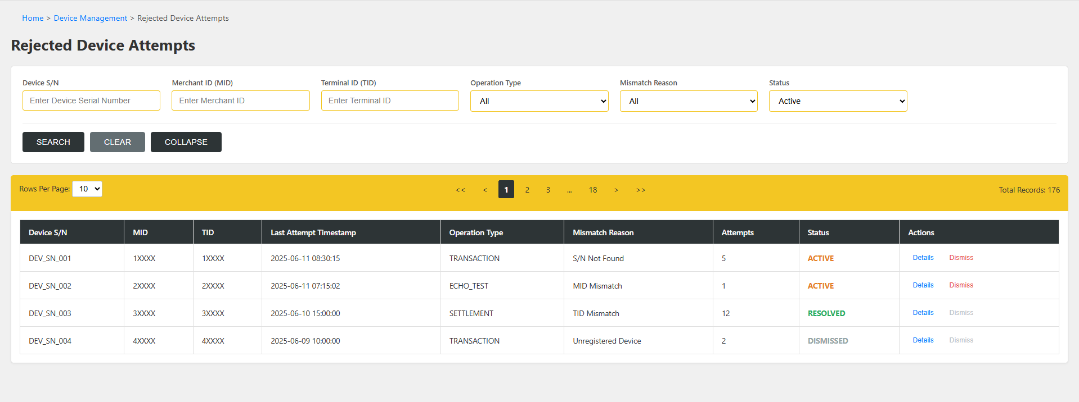

Figure 1

### Detail View Modal: Rejected Attempt Details

**Description:** A modal window that appears when a user requests more details about a specific rejected attempt. It provides a comprehensive overview of all stored information for that attempt.

**Key Elements:**

* Device Identification (S/N, MID, TID).
* Attempt Information (Status, Mismatch Reason, Timestamps, Count, Operation Type).
* Conditional sections for Resolution Details (if status is 'RESOLVED').
* Conditional sections for Dismissal Details (if status is 'DISMISSED', showing Dismissed At: 2025-06-11 08:54:13 UTC and Dismissed By: layantha).
* Action buttons: "Close" and "Dismiss Attempt" (if the record is 'ACTIVE').

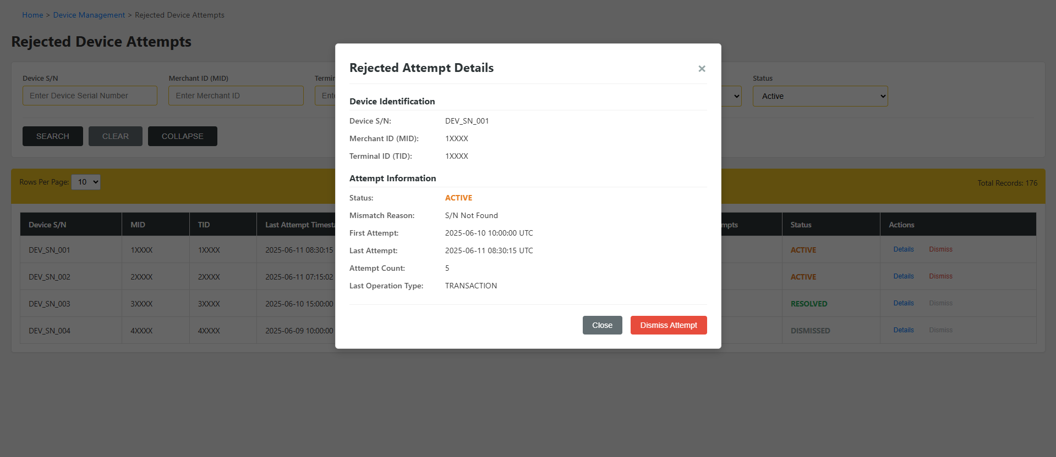

Figure 2

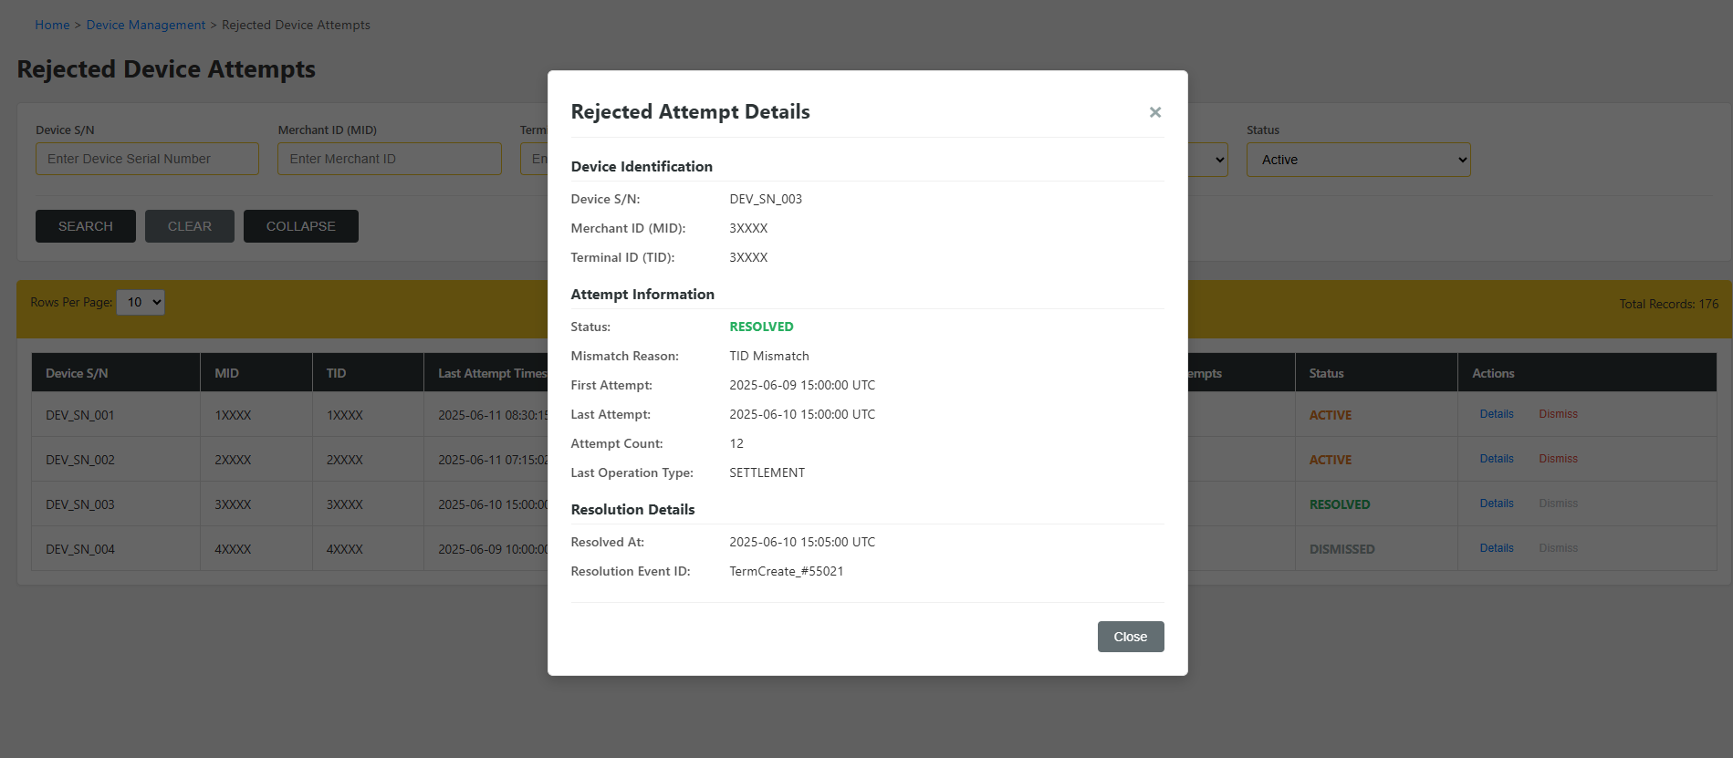

Figure 3

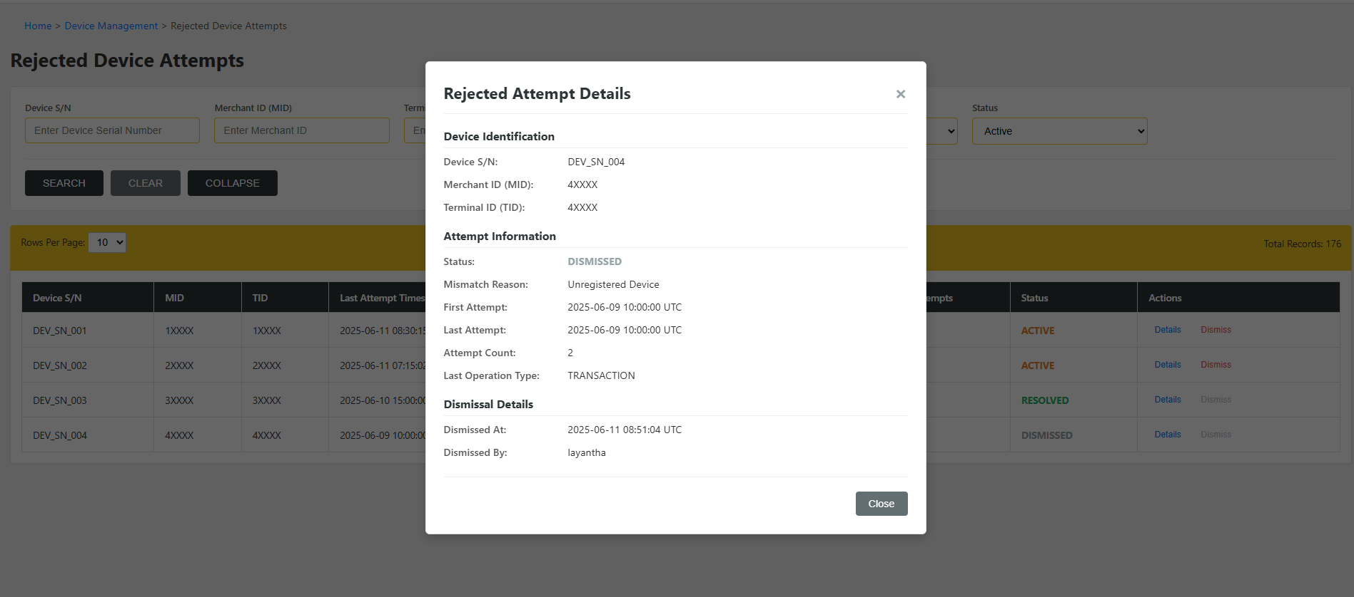

Figure 4

### Confirmation Modal: Dismiss Confirmation

**Description:** A small modal window to confirm the user's intention before dismissing a rejected device attempt.

**Key Elements:**

* Warning message and icon.
* Summary of the attempt being dismissed (S/N, MID, TID).
* Contextual information: User: **layantha**, Time: **2025-06-11 08:54:13**.
* Action buttons: "Cancel" and "Confirm Dismiss."
* Reference: This modal can be conceptually designed based on standard confirmation dialogs.