Ml defnition
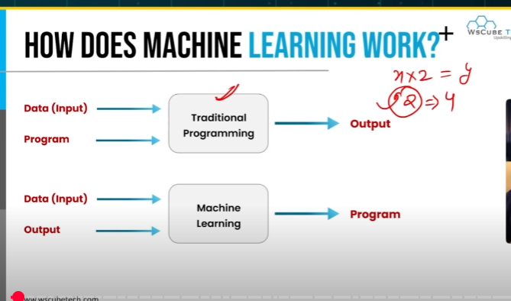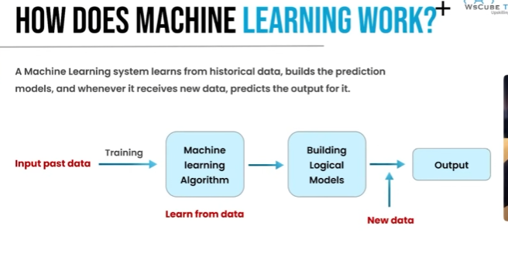

Types of variable
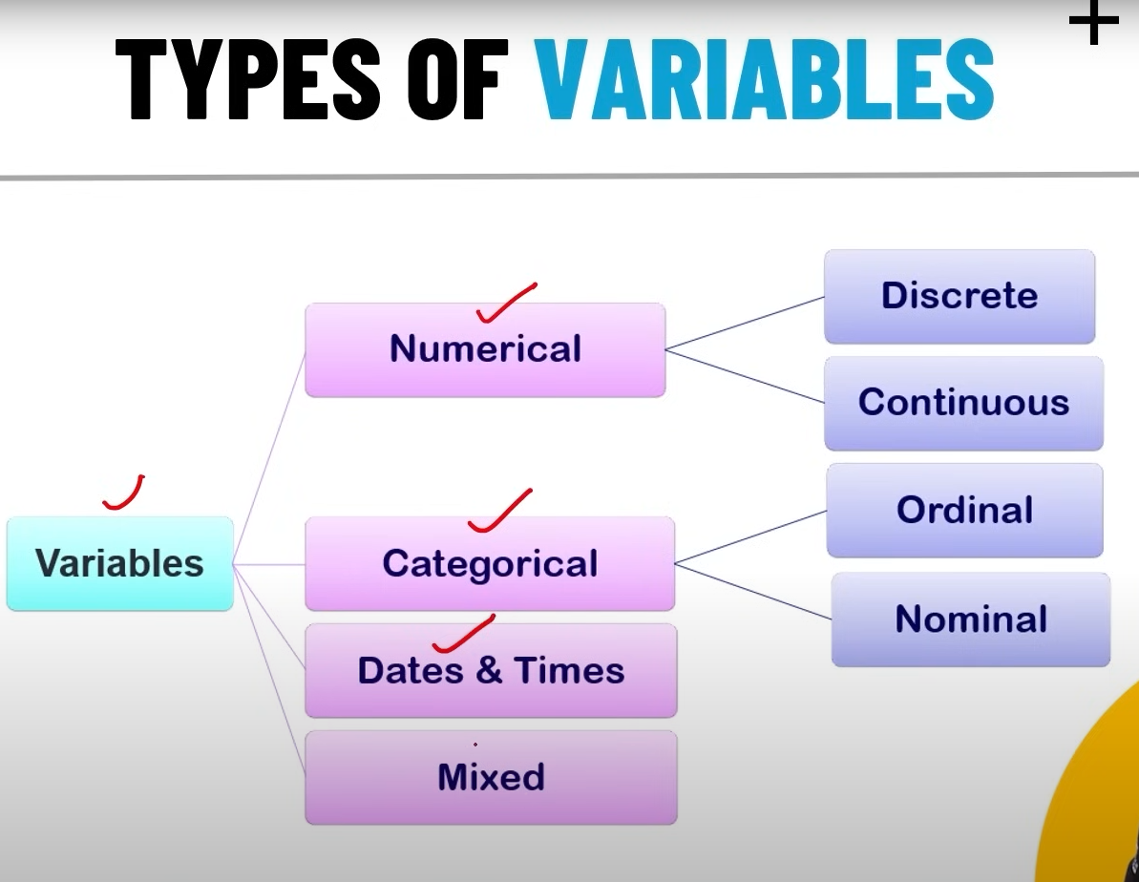

🔹 Main Types of Variables
Numerical Variables
Variables that represent numbers/quantities.
Can be used for mathematical operations (addition, average, etc.).
Subtypes:
Discrete → Whole number counts.
👉 Example: Number of students in a class (1, 2, 3 …).
Continuous → Can take any value within a range (decimals possible).
👉 Example: Height = 172.4 cm, Temperature = 36.5°C.
Categorical Variables
Variables that represent categories or labels instead of numbers.
Cannot be used in direct math operations.
Subtypes:
Ordinal → Categories with a natural order/rank.
👉 Example: Education Level (Primary < Secondary < Graduate < Postgraduate).
Nominal → Categories with no order, just labels.
👉 Example: Colors (Red, Blue, Green), Gender (Male, Female)
Dates & Times Variables
Variables that represent temporal data (time-based).
Can be split into features like day, month, year, hour, weekday, etc.
👉 Example: "2025-09-07 10:15 AM".
Mixed Variables
Variables that contain both numbers and categories
They may need preprocessing before use.
👉 Example: Postal codes (e.g., "560001") → look like numbers but are actually categories.

Data cleaning
