STATISTICS

📌 Complete Statistics Topics List

1️⃣ Basics & Foundations
What is statistics?
Branches of statistics
Descriptive statistics
Inferential statistics
Data & variables
Qualitative vs Quantitative
Discrete vs Continuous
Scales of measurement
Nominal
Ordinal
Interval
Ratio

2️⃣ Population, Sampling & Data Collection
Population vs Sample
Sampling frame
Sampling error & bias
Sampling techniques
Random sampling
Stratified sampling
Cluster sampling
Systematic sampling
Convenience sampling
Central Limit Theorem

3️⃣ Descriptive Statistics
Measures of Central Tendency
Mean
Median
Mode
Measures of Dispersion
Range
Variance
Standard Deviation
Mean Absolute Deviation
Shape of Distribution
Skewness
Kurtosis
Percentiles & Quartiles
IQR (Interquartile Range)

4️⃣ Data Visualization & EDA
Frequency tables
Histograms
Boxplots
Scatterplots
Bar charts
Heatmap
Pair plots
Outlier detection concepts

5️⃣ Probability Theory
Sample space & events
Mutually exclusive events
Independent & dependent events
Complement rule
Addition rule

Multiplication rule
Conditional probability
Law of Total Probability
Bayes’ Theorem

6️⃣ Random Variables & Distributions
Random variables
Discrete
Continuous
Probability Mass Function (PMF)
Probability Density Function (PDF)
Cumulative Distribution Function (CDF)

Discrete Distributions
Bernoulli
Binomial
Geometric
Poisson

Continuous Distributions
Uniform
Normal
Standard Normal (Z-Score)
Log-Normal
Exponential
Gamma

Important Concepts
Empirical Rule (68–95–99.7)
z-score & standardization
Normalization

7️⃣ Correlation & Relationships
Covariance
Pearson correlation
Spearman correlation
Correlation vs causation

8️⃣ Inferental Statistics
Estimation
Point estimation
Interval estimation
Confidence intervals
Z-distribution
T-distribution
Standard Error
Margin of Error

9️⃣ Hypothesis Testing
Null hypothesis (H₀)
Alternate hypothesis (H₁)
Level of significance (α)
P-value interpretation
Test statistics
One-tailed vs Two-tailed tests
Type I & Type II errors
Statistical power
Effect size

Hypothesis Tests (Parametric)
Z-test
t-test
One sample t-test
Two sample t-test
Paired t-test
ANOVA
One-way ANOVA
Two-way ANOVA

Hypothesis Tests (Non-Parametric)
Mann-Whitney U test
Wilcoxon test
Kruskal-Wallis test

Categorical Tests
Chi-Square Test
Goodness of Fi
Independence Test

🔟 Regression & Modeling Basics
Correlation vs Regression
Simple Linear Regression
Multiple Linear Regression
Residual analysis
Multicollinearity
Heteroscedasticity
R² & Adjusted R²

1️⃣1️⃣ Time Series (Basic)
Trend
Seasonality
Stationarity
Moving averages

1️⃣2️⃣ A/B Testing & Practical Analytics
Experimental design
Control vs Treatment
Randomization
Sample size & power
Practical significance vs statistical significance

📌 Inferential Statistics – Complete Topic List

1️⃣ Population & Sample
Population
Sample
Census vs Sampling
Sampling Error
Parameter vs Statistic

2️⃣ Sampling Techniques
Probability Sampling
Simple Random Sampling
Stratified Sampling
Systematic Sampling
Cluster Sampling
Non-Probability Sampling
Convenience Sampling
Judgment Sampling
Quota Sampling
Snowball Sampling

3️⃣ Probability Concepts (Foundation)
Random Variables
Discrete Random Variables
Continuous Random Variables
Probability Distribution
Probability Density Function (PDF)
Cumulative Distribution Function (CDF)

4️⃣ Probability Distributions (Very Important)
Discrete Distributions
Bernoulli Distribution
Binomial Distribution

Poisson Distribution
Continuous Distributions
Normal Distribution
Standard Normal Distribution (Z-distribution)
Uniform Distribution
Exponential Distribution
t-Distribution
Chi-Square Distribution
F-Distribution

5️⃣ Estimation Theory
Point Estimation
Interval Estimation
Confidence Interval (CI)
Confidence Level
Margin of Error
Confidence Intervals for
Mean (σ known)
Mean (σ unknown)
Proportion
Difference between means

6️⃣ Hypothesis Testing (Core of Inferential Statistics)
Statistical Hypothesis
Null Hypothesis (H₀)
Alternative Hypothesis (H₁)
One-tailed Test
Two-tailed Test
Level of Significance (α)
Test Statistic
Critical Value
Rejection Region

7️⃣ Errors in Hypothesis Testing
Type I Error (α-error)
Type II Error (β-error)
Power of a Test

8️⃣ Parametric Tests
(Used when data follows normal distribution)
Z-test
One sample Z-test
Two sample Z-test
t-test
One sample t-test
Independent (Two sample) t-test
Paired t-test
ANOVA (Analysis of Variance)
One-way ANOVA
Two-way ANOVA

9️⃣ Non-Parametric Tests
(Used when data does NOT follow normal distribution)
Chi-Square Test
Test of Independence
Test of Goodness of Fit
Mann-Whitney U Test
Wilcoxon Signed-Rank Test
Kruskal-Wallis Test
Friedman Test

🔟 Correlation & Association
Pearson Correlation Coefficient
Spearman Rank Correlation
Kendall’s Tau
Interpretation of Correlation
Hypothesis Testing for Correlation

1️⃣1️⃣ Regression Analysis (Inferential Aspect)
Simple Linear Regression
Multiple Linear Regression
Regression Coefficients
Hypothesis Testing of Regression Coefficients
R² (Coefficient of Determination)
Adjusted R²

1️⃣2️⃣ Goodness of Fit & Model Testing
Chi-Square Goodness of Fit
Residual Analysis
Model Assumptions Testing

1️⃣3️⃣ Bayesian Inference (Advanced)
Prior Probability
Posterior Probability
Likelihood
Bayes’ Theorem
Bayesian Estimation

1️⃣4️⃣ Resampling Techniques
Bootstrapping
Permutation Tests

1️⃣5️⃣ Decision Theory (Related Area)
Statistical Decision Making
Loss Function
Risk Function

Statistics DEFNITION
Statistics is the branch of mathematics that deals with the collection, organization, analysis, interpretation, and presentation of data to support decision-making.
In simple words:
👉 Statistics helps us convert raw data into meaningful information and insights.

📌 Types of Statistics
Statistics is broadly divided into two main types:
1️⃣ Descriptive Statistics

1️⃣ Descriptive Statistics — Definition
Descriptive Statistics refers to the methods used to summarize, organize, and present data using tables, graphs, and numerical measures.
It helps to describe the main features of a dataset.
👉 It answers:
✔ What does the data look like?
2️⃣ Inferential Statistics

2️⃣ Inferential Statistics — Definition
Inferential Statistics refers to the methods used to draw conclusions or make predictions about a population based on data collected from a sample.
It helps to infer (generalize) results from sample → population

Types of data
Data
├── Qualitative (Categorical)
└── Quantitative (Numerical)

Qualitative Data (Categorical Data)

🔹 Definition
Qualitative data represents categories or labels and cannot be measured numerically.
Types of qualitative data

2.1 Nominal Data

✔ Definition
Data with names or labels and no natural order.

✔ Examples
Gender: Male / Female
Country: India, USA
Product Type: Coffee, Tea
Ordinal data

✔ Definition
Categorical data with a meaningful order, but no fixed difference between values.

✔ Examples
Customer ratings: Poor < Average < Good < Excellent
Education level: School < UG < PG < PhD

3️⃣ Quantitative Data (Numerical Data)

🔹 Definition
Data that represents numbers and can be measured mathematically.
📌 Used for calculations, trends, forecasting
Types of quantitative data

3.1 Discrete Data

✔ Definition
Numerical data that can take only whole numbers (countable).

✔ Examples
Number of customers
Number of defects
Employees in a departmen
3.2 Continuous Data

✔ Definition
Numerical data that can take any value within a range, including decimals.

✔ Examples
Height (165.5 cm)
Salary
Time taken

4.1 Interval Data

✔ Definition
Numerical data with equal intervals, but no true zero.

✔ Examples
Temperature (°C, °F)
Calendar years

4.2 Ratio Data

✔ Definition
Numerical data with equal intervals and a true zero.

✔ Examples
Height
Weight
Sales revenue

Measure of central tendency
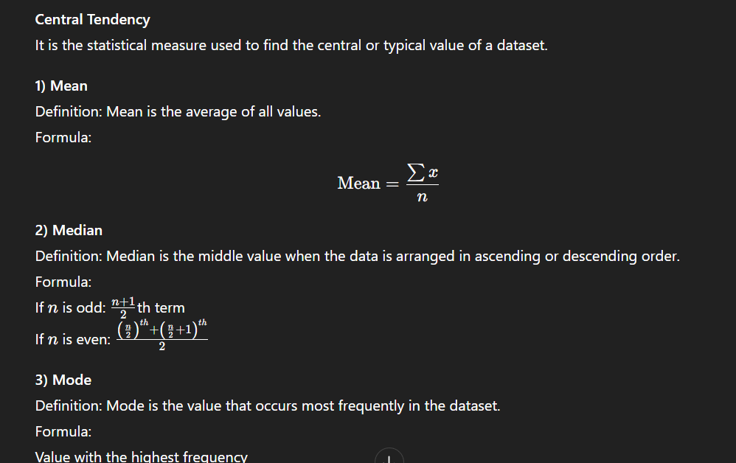
Measures of Dispersion

1) Range
Definition: Difference between the maximum and minimum values.
Formula:

Python Code:
data = [10, 20, 30, 40, 50]
range_val = max(data) - min(data)
print(range_val)

2) Variance
Definition: Average of the squared differences from the mean.
Formula:

Python Code:
import numpy as np
data = [10, 20, 30, 40, 50]
variance = np.var(data)
print(variance)

3) Standard Deviation
Definition: Square root of variance, showing how far values spread from the mean.
Formula:

Python Code:
import numpy as np
data = [10, 20, 30, 40, 50]
std_dev = np.std(data)
print(std_dev)

Interquartile Range (IQR)
Definition: IQR measures the spread of the middle 50% of the data.
Formula:
IQR= Q3 - Q1
where (Q1) = first quartile, (Q3) = third quartile
Python Code:
import numpy as np

data = [10, 20, 30, 40, 50, 60, 70]

Q1 = np.percentile(data, 25)
Q3 = np.percentile(data, 75)

iqr = Q3 - Q1
print(iqr)

Measures of Position

1) Percentile
Definition: Divides data into 100 equal parts to show relative position.
Python Code:
import numpy as np
data = [10, 20, 30, 40, 50, 60]
p90 = np.percentile(data, 90)
print(p90)

2) Quartile
Definition: Divides data into four equal parts.
Python Code:
import numpy as np
data = [10, 20, 30, 40, 50, 60]
Q1 = np.percentile(data, 25)
Q2 = np.percentile(data, 50)
Q3 = np.percentile(data, 75)
print(Q1, Q2, Q3)

Data Distribution

Definition
Data distribution describes how data values are spread or arranged across different values or ranges.

📌 Types of Data Distribution

1️⃣ Symmetric Distribution
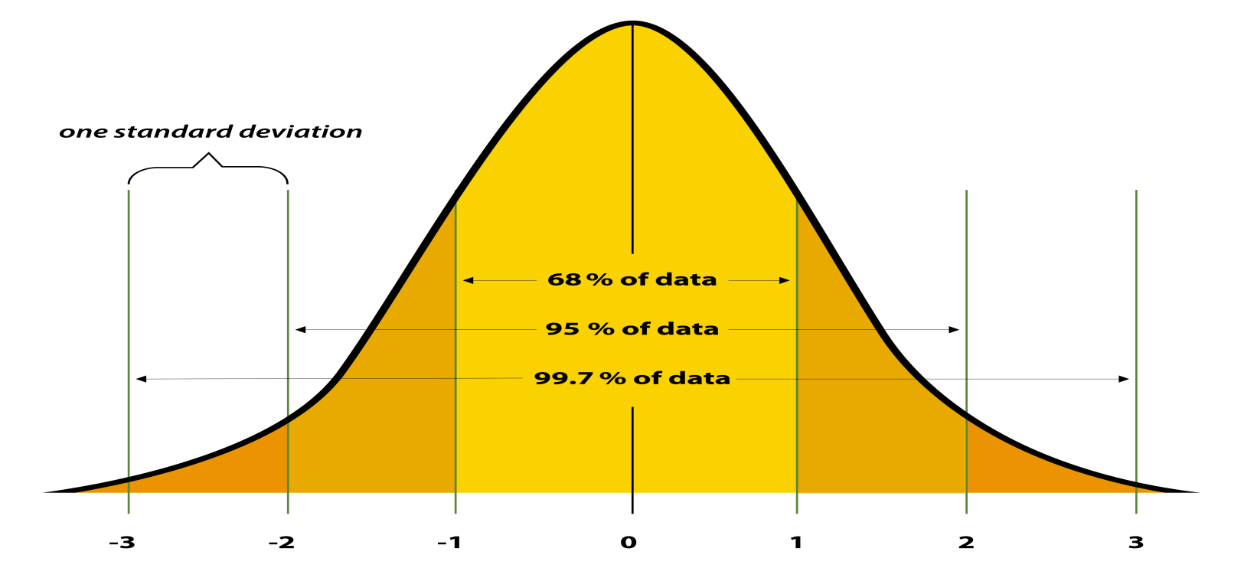

Definition
A distribution where left and right sides are mirror images.

Property
Mean = Median = Mode
Example:
Heights of students in a class
Graph shape: Bell-shaped

2️⃣ Positively Skewed (Right Skewed)
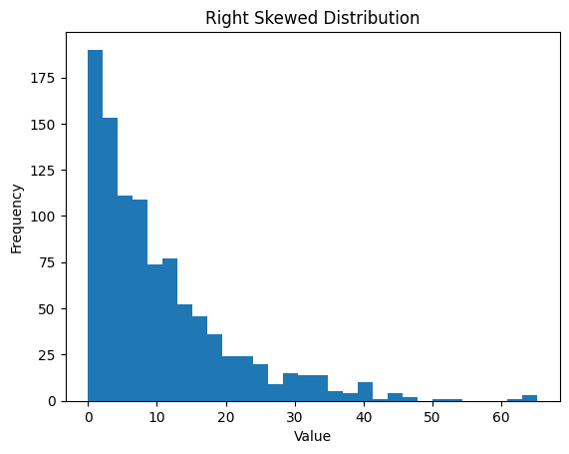

Definition
A distribution where the tail is longer on the right side.

Property
Mean > Median > Mode
Example:
Income of people
(many low incomes, few very high incomes)
Graph: Tail stretches to the right

3️⃣ Negatively Skewed (Left Skewed)
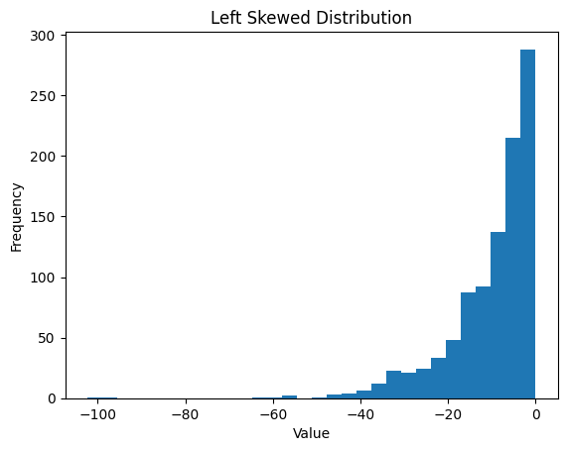

Definition
A distribution where the tail is longer on the left side.

Property
Mean < Median < Mode
Example:
Marks in an easy exam
(many high scores, few low scores)
Graph: Tail stretches to the left

4️⃣ Uniform Distribution
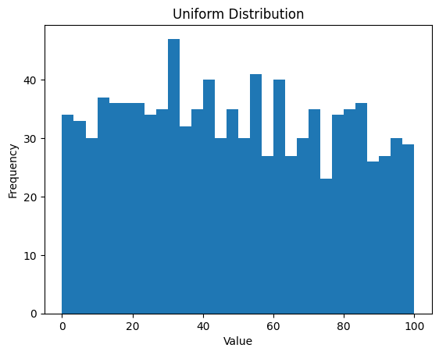

Definition
All values occur with equal frequency.
Example:
Rolling a fair die
Every number has equal chance
Graph: Flat shape

📌 Normal Distribution (Very Important)
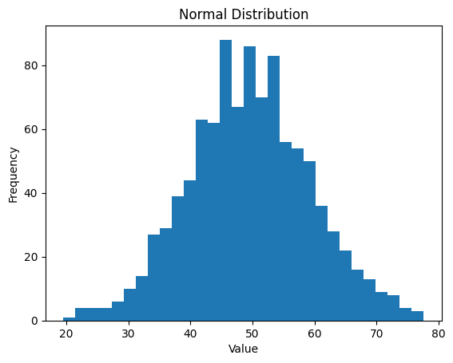

Definition
A bell-shaped symmetric distribution where most values lie near the mean.
Properties:
Mean = Median = Mode
Symmetric
Follows Empirical Rule
Empirical Rule:
68% data within 1σ
95% data within 2σ
99.7% data within 3

Kurtosis
Kurtosis measures how peaked or flat a data distribution is compared to a normal distribution (i.e., how heavy the tails are).
High kurtosis → sharp peak + more extreme values (outliers)
Low kurtosis → flatter distribution + fewer extreme values
Mathematically (population form):

Population and sample
A population is the entire group of individuals, items, or observations that you want to study or draw conclusions about.
It includes every member that fits a defined set of characteristics.
Examples:
All people living in India

Sample (in statistics)
A sample is a small part or subset of the population that is selected for study or analysis.
Sampling techniques
Sure — here is a clear, exam-oriented explanation of the Types of Sampling (with definitions, examples, and when to use each).
Sampling methods are mainly divided into two major categories:

✅ 1.1 Simple Random Sampling
Every member of the population has an equal and independent chance of selection.
Methods:
lottery method
random number generator
Example
Select 100 students randomly from 1,000 students.
👉 Best when population is small & homogeneous.

✅ 1.2 Systematic Sampling
Select every kth element from a list.
Example
If population = 1,000 and sample = 100
Sampling interval (k) = 1000 / 100 = 10
Select every 10th person.
👉 Simple and easy but may cause bias if data has patterns.

✅ 1.3 Stratified Sampling
Population is divided into homogeneous groups called strata, then samples are taken from each stratum.
Examples of strata
gender
age group
income level
education level
departments
Example
Population = All college students
Strata = 1st year, 2nd year, 3rd year
Take sample from each year.
👉 Best when groups are different from each other.

✅ 1.4 Cluster Sampling
Population is divided into clusters (natural groups) and entire clusters are selected randomly.
Example
Schools in a city = clusters
Randomly select 5 schools
Survey all students in those schools.
👉 Used when population is large & spread geographically.

Statistical data analysis complete steps
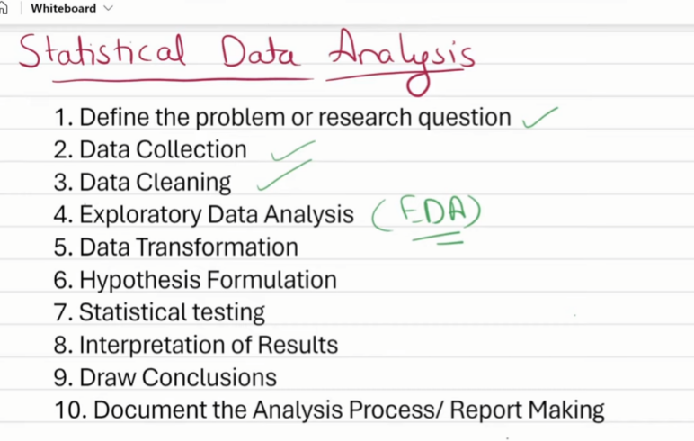
1️⃣ Define the problem / research question — Clearly identify what issue or question the analysis is meant to solve or answer.
2️⃣ Data Collection — Gather relevant data from appropriate sources for analysis.
3️⃣ Data Cleaning — Detect and correct errors, missing values, and inconsistencies in the dataset.
4️⃣ Exploratory Data Analysis (EDA) — Explore and summarize data to understand patterns, trends, and anomalies.
5️⃣ Data Transformation — Modify or convert data into a suitable format for analysis or modeling.
6️⃣ Hypothesis Formulation — Develop testable statements or assumptions about relationships in the data.
7️⃣ Statistical Testing — Apply statistical tests to evaluate the hypothesis using sample data.
8️⃣ Interpretation of Results — Explain what the statistical findings mean in practical or real-world terms.
9️⃣ Draw Conclusions — Summarize insights and determine answers to the original research question.
🔟 Document the Analysis Process / Report Making — Record methods, results, and conclusions in a structured report.

Measures of central tendency(part of desriptive analysis)

✅ Measure of Central Tendency — Definition
Measures of central tendency are statistical values that represent the center, midpoint, or typical value of a dataset.

🧠 The three main measures are
1️⃣ Mean — average of all values
2️⃣ Median — middle value when data is arranged
3️⃣ Mode — most frequently occurring value

Frequwncy

✅ Meaning / Definition of Frequency
Frequency is the number of times a value, observation, or event occurs in a dataset.
Example:
If the number 5 appears 7 times in a dataset,
then frequency of 5 = 7.

🟡 Types of Frequency (Statistics)

1️⃣ Absolute Frequency
The actual count of how many times a value occurs.
Value | Count
2 | 3 times
4 | 6 times
Here,
Frequency of 2 = 3
Frequency of 4 = 6

2️⃣ Relative Frequency
Shows proportion or percentage of occurrence.
Relative Frequency = Frequency of a valuet/Total Observations
Example:
If a value appears 5 times out of 20,
5/20=0.25 = 25%
So relative frequency = 25%

3️⃣ Cumulative Frequency
The running total of frequencies.
Class | Frequency | Cumulative Frequency
0–10 | 4 | 4
10–20 | 6 | 10
20–30 | 5 | 15
Cumulative frequency keeps adding previous values.
Used in:
Ogive curves
Median calculation

Outliers

🧾 Outliers — Short Notes

✅ What are Outliers?
Outliers are data points that are much higher or lower than the rest of the values in a dataset.
They do not follow the general pattern of the data.
Examples: extremely high salary, abnormally high transaction, wrong recorded value.

🎯 How to Find Outliers
We will use only:
Box Plot
Histogram (histplot)
IQR Method

📌 1) Using Box Plot
Box plot shows:
Q1 (25th percentile)
Median (50th percentile)
Q3 (75th percentile)
Points outside whiskers are outliers.
Outliers appear as small dots outside the box.

📌 2) Using Histogram (histplot)
Most data forms a cluster.
Outliers appear as:
bars far away from main bars
values at the extreme tail
They indicate rare / extreme values.

📌 3) Using IQR Method (Statistical Method)
Steps:
Steps:
1️⃣ Find Q1 and Q3
2️⃣ Compute
IQR=Q3−Q1
3️⃣ Calculate limits
Lower=Q1−1.5×IQR
Upper=Q3+1.5×IQR
Values:
less than Lower bound
greater than Upper bound
👉 are considered outliers
This is the same rule used in box plots.

🛠️ How to Remove Outliers (Using IQR Method)
Keep only values inside limits:
values < lower limit → remove
values > upper limit → remove
So final data contains only:
Q1−1.5×IQR≤x≤Q3+1.5×IQR

🟢 Summary (Very Short)
Outliers = values far from majority of data
Box plot → dots outside whiskers
Histplot → bars far from main cluster
IQR detects outliers statistically
Remove values outside IQR limits
Coveriance and corelation

1️⃣ Covariance — Definition
Covariance measures how two variables vary together.
If both increase together → covariance is positive
If one increases while the other decreases → covariance is negative
If they do not move together → covariance is close to zero
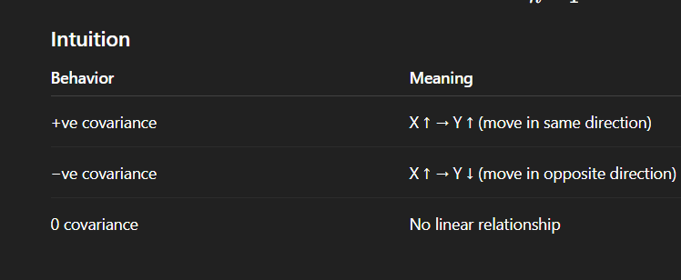

Formula
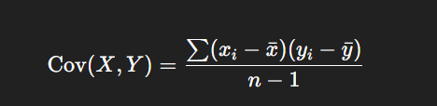

2️⃣ Correlation — Definition
Correlation measures:
How strongly two variables are related (strength + direction)
It is a scaled version of covariance.
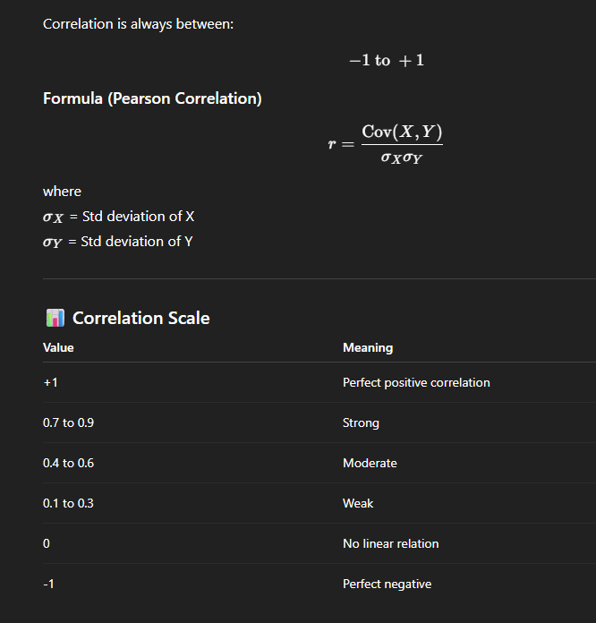

Probablity

🎯 What is Probability? (Simple Definition)
Probability measures:
It is a measure of likelihood of a particular event accuring
How likely an event is to happen.
It is written as a value between 0 and 1.
Probability value | Meaning
0 | Impossible event
1 | Guaranteed event
Between 0 & 1 | Event may or may not occur

Formula

🧠 Example
A coin is tossed.
Sample space = {Head, Tail}
Probability of Head:
[

🧩 Core Probability Terms (Explained Simply)

1️⃣ Experiment
An action that produces an outcome.
Examples:
Tossing a coin
Rolling a dice
Drawing a card

2️⃣ Outcome
Result of an experiment.
Examples:
Coin toss → Head
Dice roll → 4
Card drawn → King

3️⃣ Sample Space (S)
Set of all possible outcomes.
Examples:
Coin toss
[
S={H,T}
]
Rolling a dice
[
S={1,2,3,4,5,6}
]

4️⃣ Event (E)
A subset of the sample space — outcomes we are interested in.
Example: Dice roll → Event “Even Number”
Sure — here is a clear and focused explanation of only the requested event types:

Joint vs Disjoint Events

Dependent vs Independent Events

Explained in a simple and exam-oriented way 👇

Types of joints

✅ 1️⃣ Disjoint Events (Mutually Exclusive Events)
Events are disjoint when they cannot happen at the same time.
Meaning
No common outcome
Probability of occurring together = 0

✅ 2️⃣ Joint Events
Events are joint when they can occur together
(They have at least one common outcome)

✔ Example — Playing Cards
A = card is Red
B = card is King
A card can be Red King
So A and B are joint events
They can happen simultaneously

✅ 3️⃣ Independent Events
Two events are independent when:
The outcome of one event does not affect the other
Rule:

✅ 4️⃣ Dependent Events
Events are dependent when:
The outcome of one event affects the probability of the other
Conditional probablity

Bayes throrem
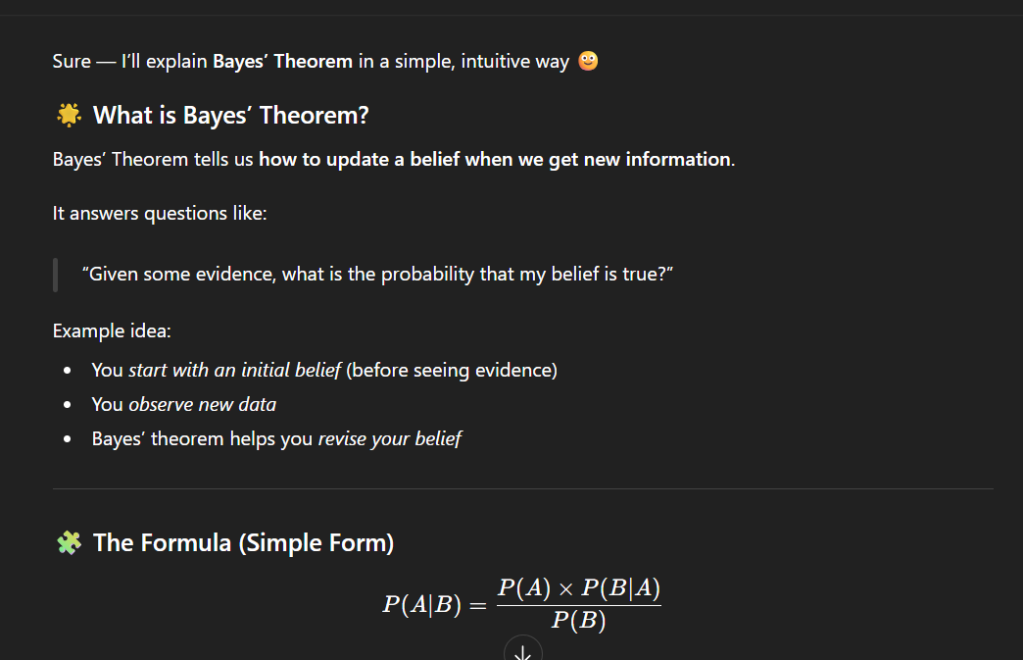
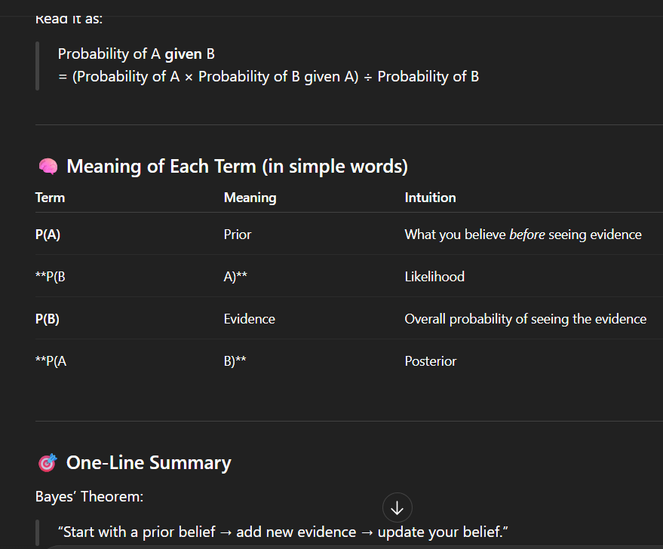
Bernoulli Distribution
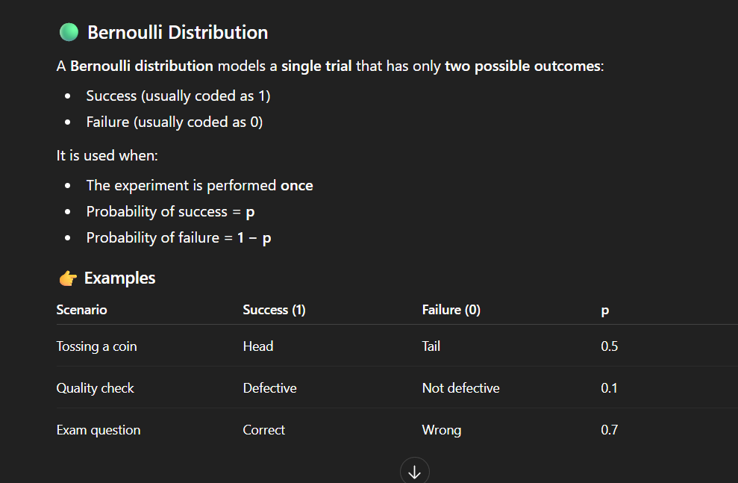
Binomial Distribution

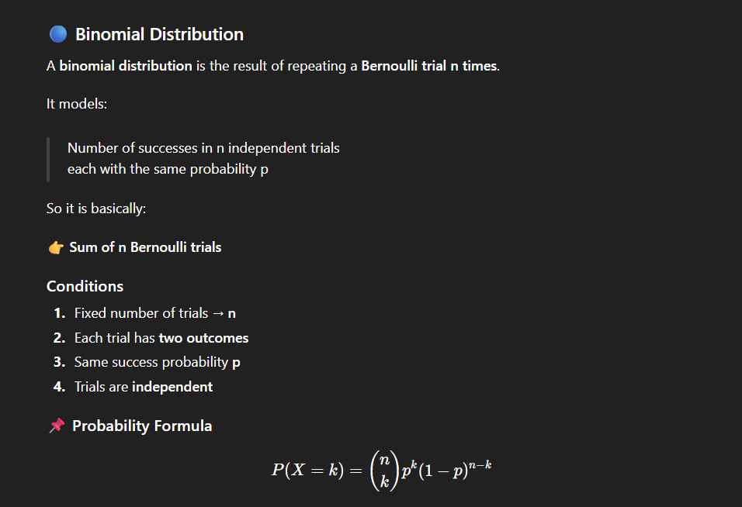
Uniform distribution
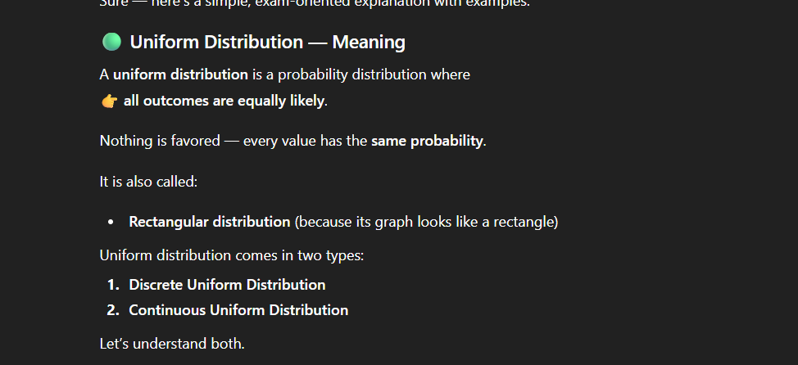
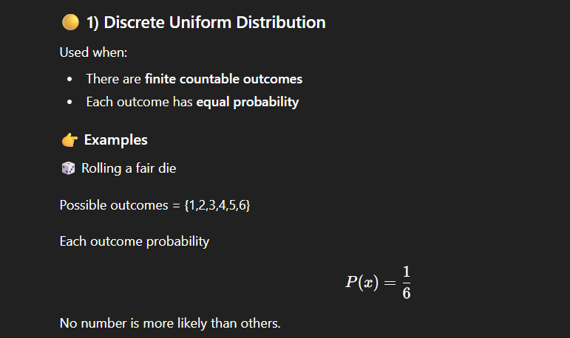
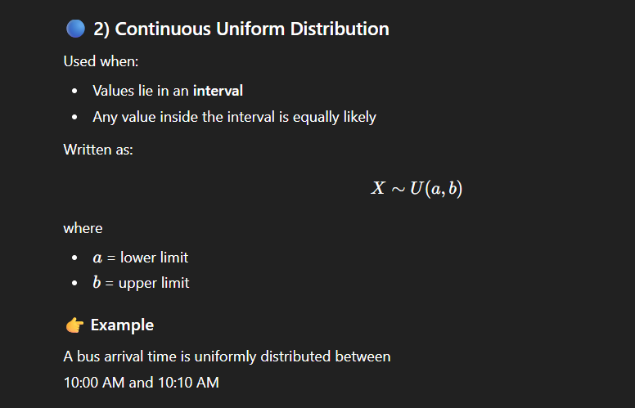

Nornal distribuion
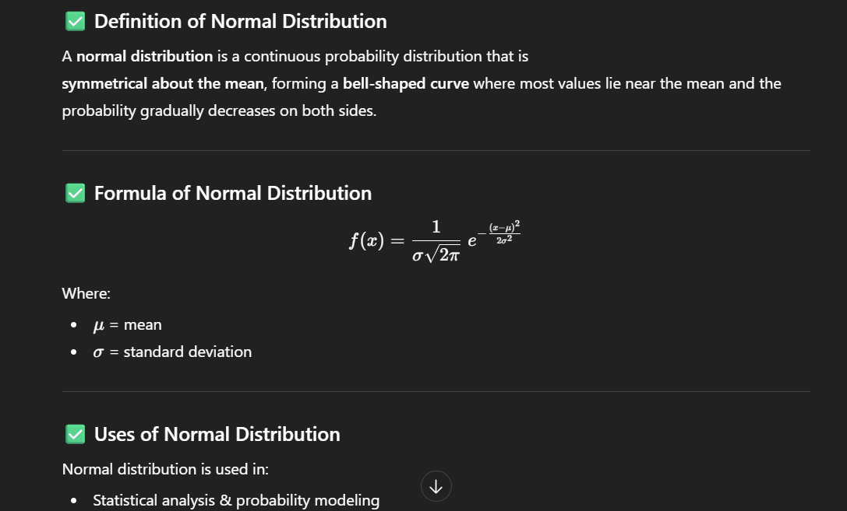

Standardization and Normalization.

🟡 Standardization

✅ Definition
Standardization is a data transformation technique that converts data into a form where:
Mean = 0
Standard deviation = 1
It transforms data to follow the Standard Normal Distribution (N(0,1)).
This is also called:
Z-score normalization
Standard score scaling

🧮 Formula (Standardization / Z-score)

(x) = original value
(\mu) = mean of the data
(\sigma) = standard deviation

🟢 Normalization (Min–Max Scaling)

✅ Definition
Normalization is a scaling technique that transforms data into a fixed range, usually 0 to 1, without changing the distribution shape.
It is also called:
Min–Max scaling
` Feature scaling

🧮 Formula (Normalization)
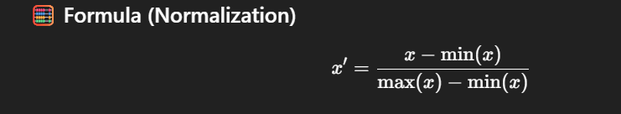
(x) = original value
(\min(x)) = minimum value in feature
(\max(x)) = maximum value in feature
(x') = normalized value (scaled between 0 and 1)

✅ Empirical Rule (68-95-99.7 Rule)
The Empirical Rule is a statistical rule that applies to normally distributed data (bell-shaped distribution) and tells us how much data lies within certain standard deviations from the mean.
Sure — here it is in compact form as you asked:

📌 Empirical Rule (68–95–99.7 Rule
68% of data lies within ±1σ of the mean
95% of data lies within ±2σ of the mean
99.7% of data lies within ±3σ of the mean
(μ = mean, σ = standard deviation)

✏️ Example — Student Heights
Mean height (μ) = 160 cm
Standard deviation (σ) = 10 cm
Within 1σ:
` 160 ± 10 → 150 to 170 cm → ~68% students
Within 2σ:
160 ± 20 → 140 to 180 cm → ~95% students
Within 3σ:
160 ± 30 → 130 to 190 cm → ~99.7% students

— Introduction to Inferential Statistics

**Inferential statistics** deals with drawing conclusions about a **population** using data from a **sample**.

Since studying the whole population is difficult, we:

* collect a sample
* analyze it
* make predictions or estimates about the population

👉 It helps in generalizing results beyond the observed data.

Examples:

* Predicting election results using opinion polls

✔ Inferential statistics mainly includes:

* Estimation
* Hypothesis testing

---
What is Estimation?**

**Estimation** is the process of using **sample data** to estimate an **unknown population parameter**.

Population parameters (unknown):

* μ → population mean
* σ → population standard deviation
* p → population proportion

Sample statistics (known from sample):

* x̄ → sample mean
* s → sample standard deviation
* p̂ → sample proportion

👉 Estimation connects **sample statistics → population parameters**

---

Point Estimation**

A **point estimate** gives a **single best numerical value** to estimate a population parameter.

Examples:

| Population Parameter | Sample Point Estimate |
| ------------------------- | ---------------------- |
| μ (population mean) | x̄ (sample mean) |
| p (population proportion) | p̂ (sample proportion) |
| σ² (population variance) | s² (sample variance) |

Example:

Average height of students in college is unknown.

Take a sample:

* sample mean height = **160 cm**

So **x̄ = 160 cm** is the **point estimate of μ**

------
Drawback of Point Estimate**

Point estimates give **only one value** — but do NOT show:

* uncertainty
* confidence level
* sampling error

---

Interval Estimation

An **interval estimate** gives a **range of values** instead of a single value.

It provides:

* estimate range
* confidence level
* uncertainty representation

Example:

Instead of:

> Mean height = 160 cm (point estimate)

Interval estimate:

> Mean height lies between **155 and 165 cm**
> with **95% confidence**

This is called a **Confidence Interval (CI)**
Interval estimation
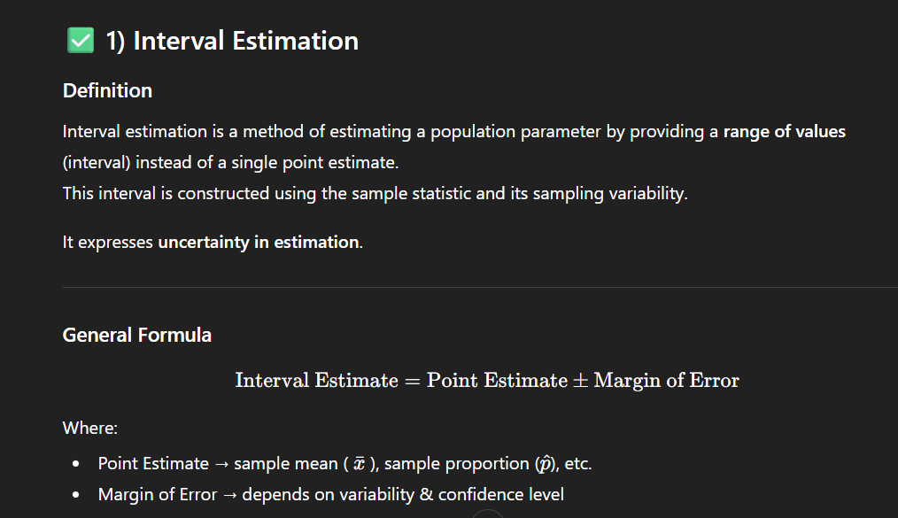

Confidence interval
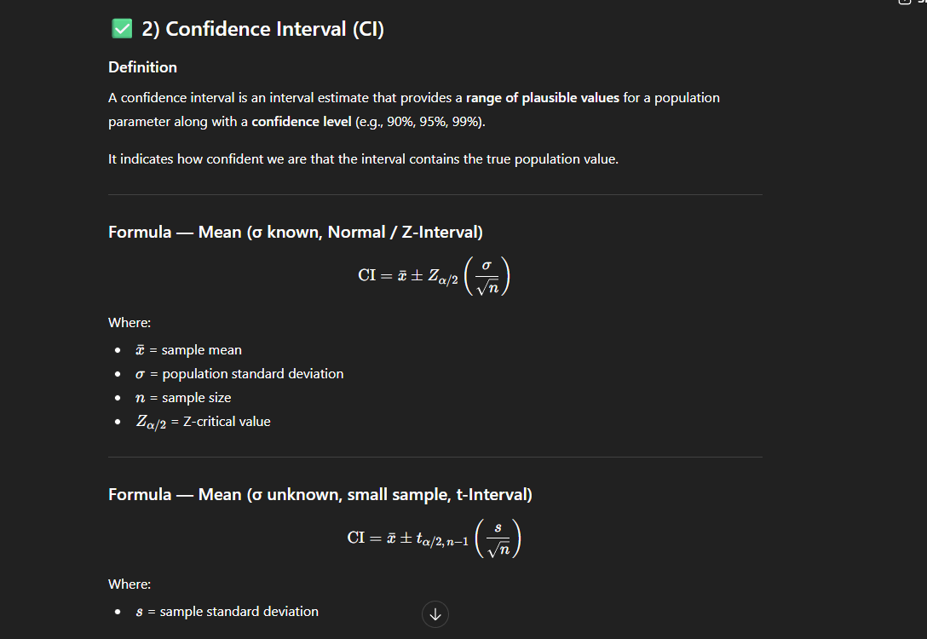

Margin of error
