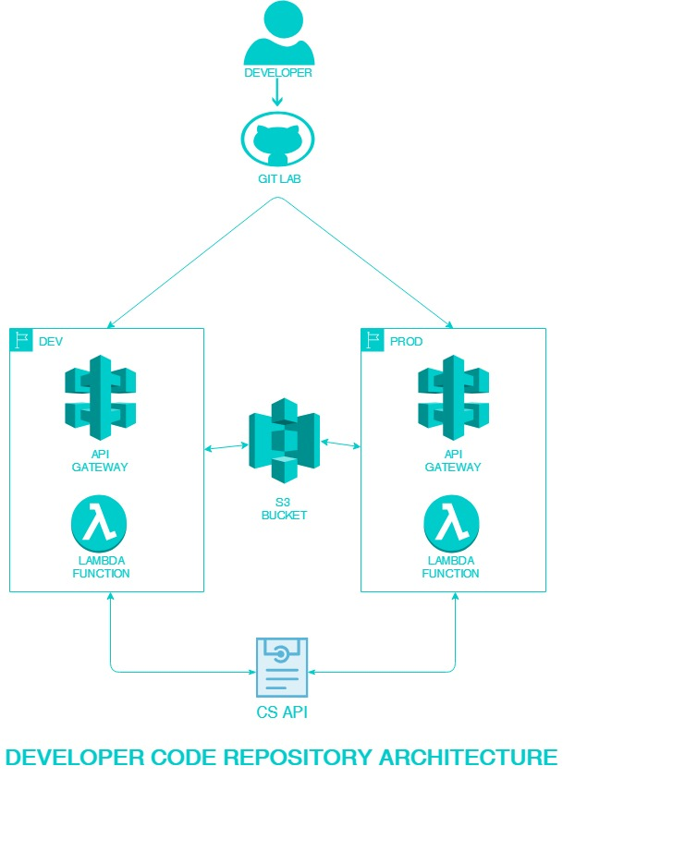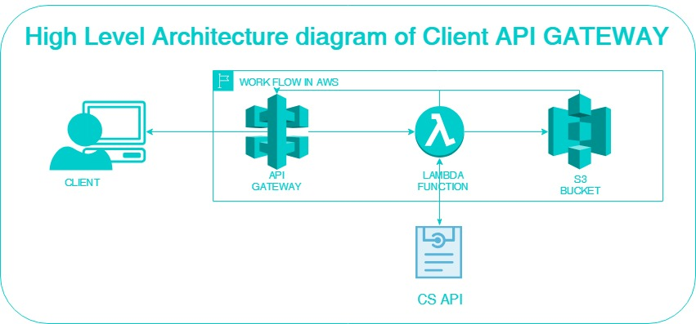

**APiGateway**

Amazon Api Gateway enables you to create API to use in your applications or you can make it available to third-party app developer.

**Lambda function**

With Lambda, you can run code for virtually any type of application or backend service - all with zero administration. Just upload your code and Lambda takes care of everything required to run and scale your code with high availability

**S3**

Amazon Simple Storage Service (Amazon S3) is an object storage service that offers industry-leading scalability, data availability, security, and performance

1. User installs the SDK in his system.
2. Depending upon the request, Specific API of ApiGateway is fired.
3. Api Gateway internally triggers the Lambda function.
4. Lambda function handles the token management and serves the request.
5. Desired data is fetched from CreditSight server and processed in the Lambda function.
6. If applicable it is stored in S3 and the data is returned to the User.

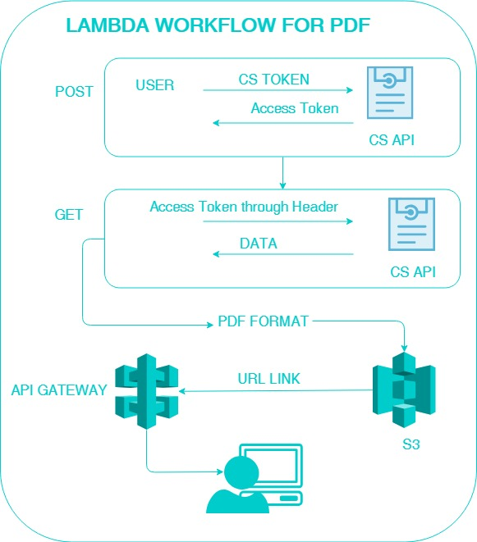

* User will install the SDK in the system
* User requests for the pdf
* Request goes to API gateway
* Api gateway triggers the lambda
  + POST request (CSToken in the body) get the Access token
  + GET request (Access Token in the header) request for the pdf
  + Data received from server is stored in the pdf file and uploaded to the S3
  + URL of the pdf is sent back to the user

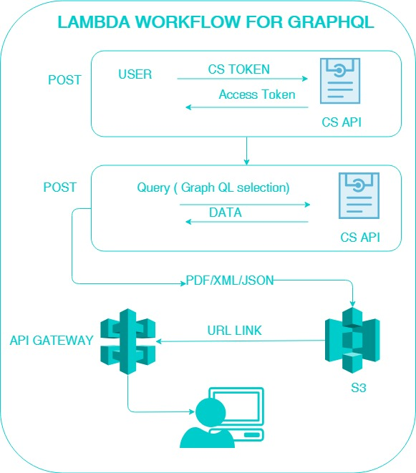

* User will install the sdk in the system
* User requests for the specific json data
* Request goes to API gateway
* Api gateway triggers the lambda
  + POST request (CsToken in the body) get the Access token
  + POST request (Access Token in the header & graphQL query in the body) request for the specific data
  + Data received from server is sent back to the user