Downloaded From : ExamCompetition.com

- The basic function that a computer can performs are

a) Data processing and storage b) Data movement and control

C) both a & b d) none

- the following diagram depicts a _________

a) storage b) mobile

c) memory d) register

3. ______ is the extension of the 8086 enabled addressing a 16-MByte memory instead of just 1MByte

a) 80286 b) 80386

b) Pentium d) core

4. MBR stand for ?

- Memory buffer reader

- Memory buffer register

- Magnetic buffer reader

- Magnetic buffer register

- The collection of paths connecting the various modules is called

a) Bus

b) communication line c) path

d) interconnection structure

- ________ determines the maximum possible memory capacity of the system.

a) data lines b) control lines

c) address lines d) control signals

7. The unit of data transfer between CPU and cache is known as

Max marks 50.

Time 45 min

a) Word transfer b) Byte transfer

c) block transfer d) data transfer

8. To achieve greater performance and higher availability, servers and larger systems use

_____ disk technology.
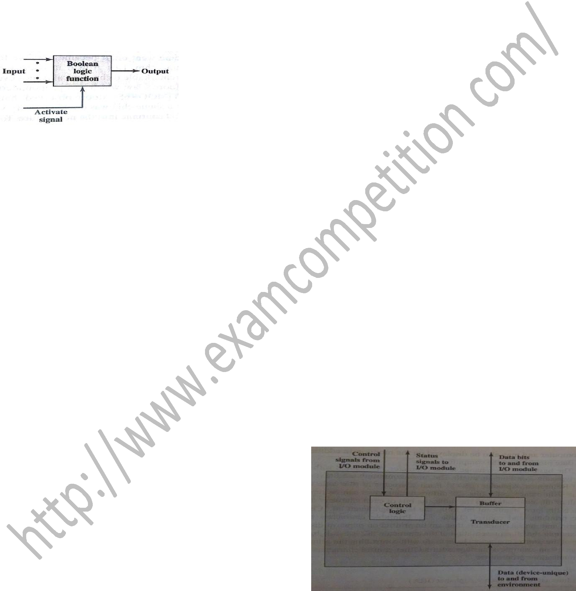
a) RAID b) Register

c) Faster CPU d) Bus

9. which of the following is/are external I/O interfaces ?

a) Fire Wire b) InfiniBand

c) both a & b d) None

10. _______, in which I/O occurs under the direct and continuous control of the program requesting the I/O operation.

a) interrupt-driven I/O b) Programmed I/O

c) DMA d) All of the above

11. Peripherals cannot be directly connected to system bus because of

- different peripheral have different method of operation.

- data transfer rate are different.

- peripheral use different data formats.

- All of the above

12.The following block diagram depicts

a) I/O module b) internal devices

c) External devices d) Register

13. which I/O technique use the interrupt and processor for communication

a) Programmed I/O b) DMA

c) interrupt-driven I/O d) None
Downloaded From : ExamCompetition.com

14. 111001 this number is represent in 2’s complement form the decimal equivalent to

the given number is
a) 57 | b) -57
c) -6 | d) -7

15. the range for n bit 2’s complement

number is
a) 0 to 2^{n}-1 | b) 0 to 2^{n-1}-1
c) -2^{n-1}-1 to 2^{n-1}-1 | d) - 2^{n-1} to 2^{n-1}-1

16. ______ addressing mode is used for array

indexing

a) Immediate b) direct

c) Displacement d) register indirect

17.The addressing mode, where you directly specify the operand value is _______ .

a) Immediate b) Direct

c) Register d) Stack

18. User visible mode can be characterized in which of following categories

a) General Purpose b) Data and address

c) condition code d) All of the above

19. The decoded instruction is stored in ____.

a) IR b) PC

c) MBR d) MAR

21.Which of the register/s of the processor is/are connected to Memory Bus ?

a) PC b) MAR

c) IR d) Both a and b

22.Which representation is most efficient to perform arithmetic operations on the

numbers ?

a) Sign-magnitude b) 1′s compliment

c) 2′S compliment d) None of the above

23. Which method/s of representation of numbers occupies large amount of memory than others ?
a) Sign-magnitude b) 1′s compliment

c) 2′s compliment d) Both a and b

- The time delay between two successive initiation of memory operation _______ . a) Memory access time

b) Memory search time c) Memory cycle time d) Instruction delay

- MIMD stands for _____.

a). Multiple instruction multiple data

b). Multiple instruction memory data c). Memory instruction multiple data d). Multiple information memory data

26. Which of the following is TRUE?

- Every relation in 2NF is also in BCNF

- A relation R is in 3NF if every non-prime attribute of R is fully functionally dependent on every key of R
- Every relation in BCNF is also in 3NF
d) No relation can be in both BCNF and 3NF

27. A table has fields F1, F2, F3, F4, and F5, with the following functional dependencies: F1->F3, F2->F4, (F1,F2)->F5 in terms of normalization, this table is in

a) 1NF b) 2NF

c) 3NF d) None

- Which one of the following statements about normal forms is FALSE?

a) BCNF is stricter than 3NF

b) Lossless, dependency-preserving decomposition into 3NF is always possible c) Lossless, dependency-preserving decomposition into BCNF is always possible d) Any relation with two attributes is in BCNF

- Which one of the following statements if

FALSE?

a) Any relation with two attributes is in BCNF

- A relation in which every key has only one attribute is in 2NF

- A prime attribute can be transitively dependent on a key in a 3 NF relation.

- A prime attribute can be transitively dependent on a key in a BCNF relation.

Downloaded From : ExamCompetition.com

30. Which normal form is considered adequate for normal relational database design?

a) 2NF b) 5NF

c) 4NF d) 3NF

31. Which can a derived attribute for an entity?

a) Age b) Name

c) Father Name d) address

32. The clause in the SQL that specifies that the query result should be sorted in ascending or descending order based on the one or

more columns is

a) View b) Order by

c) Group by d) having

33. According to the level of abstraction the schema at the intermediate level is called as

a) conceptual Schema b) Physical Schema

c) Subschema d) Super Schema

34. DROP is a _________ statement in SQL

a) Query b) Embedded SQL

c) DDL d) DCL

35. In 2NF

- No functional dependency (FD) exist.

- No multivalued dependency (MVD) exist.

- No partial FD exist.

- No partial MVD exist.

36. the keyword used to eliminate duplicate rows from the Query result in SQL is

a) DISTINCT b) NO DUPLICATE
c) UNIQUE d) None

37. Which of the following aggregate function does not ignore the NULL in its result?

a) COUNT b) COUNT(*)

c) MAX d) MIN

38. Which of the following statement on the view concept in SQL is invalid

- All views are not updatable.

- The views may be referenced in an SQL statement whenever tables are referenced.

- The views are instantiated at the time they

are referenced and not when they are defined. 

d) The definition of View should not have a Group By clause in it.

39. In SQL testing whether a sub query is

empty is done using

a) DISTINCT b) UNIQUE

c) NULL d) EXISTS

- The clause ALTER TABLE in SQL can be used to

a) add an attribute b) delete an attribute

c) alter the default value of an attribute d) All of the above

- A table can have only one

a) secondary key b) primary key

c) candidate key d) super key

42. ________ operator is used to compare a value to a list of literals values that have been

specified

a) LIKE b) COMPARE

c) BETWEEN d) IN

43.An _____ is a person,place,thing or event for which data is collected and maintained.

a) entity b) attribute

c) domain d) relation

44. the FD A →B, DB → C implies
a) DA → C b) A →C
c) B →A d) DB →A

45. the functional dependency of the form X
→Y is trivial if
a) X subset of Y b) Y subset of X

c) both a and b d) none


- Select name, course_id from instructor, teaches

where instructor_ID= teaches_ID;

This Query can be replaced by which one of the following ?

a) Select name,course_id from teaches,instructor where instructor_id=course_id;

b) Select name, course_id from instructor natural join teaches;

c) Select name ,course_id from instructor; d) Select course_id from instructor join teaches;

- Select * from employee where salary>10000 and dept_id=101;

Which of the following fields are displayed as

output?

- Salary, dept_id

- Employee

- Salary

- All the field of employee relation

48.How to select all data from studentinfo table starting the name from letter 'r'?

- SELECT * FROM studentinfo WHERE sname LIKE 'r%';

- SELECT * FROM studentinfo WHERE sname LIKE '%r%';

- SELECT * FROM studentinfo WHERE sname LIKE '%r';

- SELECT * FROM studentinfo WHERE sname LIKE '_r%';

49. The result of a SQL SELECT statement is

a(n) ________ .

a) report b) form

c) file d) table

50. NOT IN connective in SQL is identical to

a) <ALL b) <> ALL

c) =SOME d) <>SOME

Downloaded From : ExamCompetition.com Visit this website for More notes Mock test papers Sample papers guess papers previous year papers of various exams.

If you don’t find any paper do comment us contact us. We will try our best to provide you the latest information, exam papers.

