ExamCompetition.com ARRAY

1. Which of the following correctly declares an

array?

A. int anarray[10]; B. int anarray;

C. anarray{10}; D. array anarray[10];

2. What is the index number of the last element of an array with 29 elements? A. 29 B. 28 C.Programmer-defined D. 0 ExamCompetition.com

3. What is a array?

- An array is a series of elements of the same type in contiguous memory locations

- An array is a series of element

- An array is a series of elements of the same type placed in non-contiguous memory locations

- None of the mentioned

4. Which of the following accesses the seventh element stored in array?

A. array[6]; B. array[7];

C. array(7); D. array;

Linked list

1. In a circular linked list

- Components are all linked together in some sequential manner.

- There is no beginning and no end.

- Components are arranged hierarchically.

- Forward and backward traversal within the list is permitted.

2. A linear collection of data elements where the linear node is given by means of pointer is called?

a) Linked list b) Node list

c) Primitive list d) None

- Which of the following operations is performed more efficiently by doubly linked list than by singly linked list?

a) Deleting a node whose location in given b) Searching of an unsorted list for a given item

c) Inverting a node after the node with given location

d) Traversing a list to process each node

- In linked list each node contain minimum of two fields. One field is data field to store the data second field is?

a) Pointer to character b) Pointer to integer

c) Pointer to node d) Node

5. What would be the asymptotic time complexity to add a node at the end of singly linked list, if the pointer is initially pointing to

the head of the list?

a) O(1) b) O(n)

c) θ (n) d) θ (1)

6. What would be the asymptotic time complexity to find an element in the linked

list?

a) O(1) b) O(n)
c) O(n²) d) None

ExamCompetition.com

7. What would be the asymptotic time complexity to insert an element at the 5th position in the linked list?

a) O(1) b) O(n)

c) O(n²) d) None

8. A variant of linked list in which last node of the list points to the first node of the list is?

a) Singly linked list b) Doubly linked list

c) Circular linked list d) Multiply linked list

- In doubly linked lists, traversal can be performed?

a) Only in forward direction b) Only in reverse direction c) In both directions

d) None ExamCompetition.com

- A variation of linked list is circular linked list, in which the last node in the list points to first node of the list. One problem with this type of list is?

a) It waste memory space since the pointer head already points to the first node and thus the list node does not need to point to the first node.

b) It is not possible to add a node at the end of the list.

c) It is difficult to traverse the list as the pointer of the last node is now not NULL d) All of above

- Which of the following statements about linked list data structure is/are TRUE?

a) Addition and deletion of an item to/ from the linked list require modification of the existing pointers

b) The linked list pointers do not provide an efficient way to search an item in the linked list

c) Linked list pointers always maintain the list in ascending order

d) The linked list data structure provides an efficient way to find k^{th} element in the list ExamCompetition.com

- Linked lists are best suited
- for relatively permanent collections of data

- for the size of the structure and the data in the structure are constantly changing

- for both of above situation

- for none of above situation
Stack

- The postfix form of the expression (A+ B)*(C*D- E)*F / G is?

a) AB+ CD*E - FG /** b) AB + CD* E - F **G / c) AB + CD* E - *F *G / d) AB + CDE * - * F *G /

- The data structure required to check whether an expression contains balanced parenthesis is?

a) Stack b) Queue

c) Array d) Tree

3. What data structure would you mostly likely see in a non recursive implementation of a recursive algorithm?

a) Link List b) Stack

c) Queue d) Tree

4. Which data structure is needed to convert infix notation to postfix notation?

a) Branch b) Tree

c) Queue d) Stack

ExamCompetition.com

5. What is the result of the following

operation

Top (Push (S, X))

a) X b) Null

c) S d) None

6. The result of evaluating the postfix expression 5, 4, 6, +, *, 4, 9, 3, /, +, * is?

a) 600 | b) 350
c) 650 | d) 588

7. Which of the following statement(s) about stack data structure is/are NOT correct?

- Stack data structure can be implemented using linked list

- New node can only be added at the top of the stack

- Stack is the FIFO data structure

- The last node at the bottom of the stack has a NULL link

8. Consider the following operation performed on a stack of size 5. Push(1);Pop();Push(2);Push(3);Pop();Push(4);P op();Pop();Push(5);

After the completion of all operation, the no of element present on stack are

a) 1 | b) 2
c) 3 | d) 4
ExamCompetition.com
- Which of the following is not an inherent application of stack?

a) Reversing a string

b) Evaluation of postfix expression c) Implementation of recursion d) Job scheduling

- The type of expression in which operator

succeeds its operands is?

a) Infix Expression b) pre fix Expression

c) postfix Expression d) None

11.Which of the following application generally use a stack?

- Parenthesis balancing program

- Syntax analyzer in compiler

- Keeping track of local variables at run time

- All of the above

ExamCompetition.com Queue

1. Which data structure allows deleting data elements from front and inserting at rear?

a. Stacks b. Queues

c. Deques d. Binary search tree

2. Identify the data structure which allows deletions at both ends of the list but insertion at only one end.

- Input-restricted deque

- Output-restricted deque

- Priority queues

- None of above

3. A linear list of elements in which deletion can be done from one end (front) and insertion can take place only at the other end

(rear) is known as a ?

a) Queue b) Stack

c) Tree d) Linked list

4. The data structure required for Breadth First Traversal on a graph is?

a) Stack b) Array

c) Queue d) Tree

5. If the elements “A”, “B”, “C” and “D” are placed in a queue and are deleted one at a time, in what order will they be removed?

a) ABCD b) DCBA

c) DCAB d) ABCD

- In linked list implementation of a queue, where does a new element be inserted? a) At the head of link list

b) At the tail of the link list

c) At the centre position in the link list d) None

ExamCompetition.com

- A circular queue is implemented using an array of size 10. The array index starts with 0, front is 6, and rear is 9. The insertion of next element takes place at the array index.

a) 0 | b) 7
c) 9 | d) 10

Tree

1. A binary tree T has n leaf nodes. The number of nodes of degree 2 in T is
a) log₂n b) n-1

c) n d) 2n

2. In a full binary tree, every internal node has exactly two children. A full binary tree with

2n+1 nodes contains

a) n leaf node b) n internal nodes

c) n-1 leaf nodes d) n-1 internal nodes

b) 2^{h -1} + 1 d) 2^{h} +1
3. In a full binary tree, every internal node has exactly two children. A full binary tree with 2n+1 nodes contains

a) n leaf node b) n internal nodes

c) n-1 leaf nodes d) n-1 internal nodes

4. Suppose a complete binary tree has height h>0. The minimum no of leaf nodes possible

in term of h is? a) 2^{h -1}
c) 2^{h} -1

- Suppose we have numbers between 1 and 1000 in a binary search tree and want to search for the number 363. Which of the following sequence could not be the sequence of the node examined?

a) 2, 252, 401, 398, 330, 344, 397, 363 b) 924, 220, 911, 244, 898, 258, 362, 363 c) 925, 202, 911, 240, 912, 245, 258, 363

d) 2, 399, 387, 219, 266, 382, 381, 278, 363

- Which of the following statement about binary tree is CORRECT?

a) Every binary tree is either complete or full b) Every complete binary tree is also a full binary tree

c) Every full binary tree is also a complete binary tree

d) A binary tree cannot be both complete and full

ExamCompetition.com

- A binary tree whose every node has either zero or two children is called

a. Complete binary tree b. Binary search tree

c. Extended binary tree d. None of above

- The depth of a complete binary tree is given

by
a. Dn = n log₂n b. Dn = n log₂n+1
c. Dn = log₂n d. Dn = log₂n+1
ExamCompetition.com Searching and Sorting

1. Complexity of linear search algorithm is

.........

A. O(n) B. O(logn)
C. O(n²) D. O(n logn)

- The worst case occur in linear search algorithm when .......

A. Item is somewhere in the middle of the array

B. Item is not in the array at all

C. Item is the last element in the array

D. Item is the last element in the array or item is not there at all

- The complexity of merge sort algorithm is

......

A. O(n) B. O(logn)

C. O(n²) D. O(n logn)

4. .......... is putting an element in the appropriate place in a sorted list yields a

larger sorted order list.

A. Insertion B. Extraction

C. Selection D. Distribution

5. ............ is the method used by card sorter.

A. Radix sort B. Insertion

C. Heap D. Quick

ExamCompetition.com

6. Which of the following sorting algorithm is of divide and conquer type?

A. Bubble sort B. Insertion sort

C. Merge sort D. Selection sort

7. Partition and exchange sort is ........

A. quick sort B. tree sort

C. heap sort D. bubble sort

8. Finding the location of a given item in a

collection of items is called ......

A. Discovering B. Finding

C. Searching D. Mining
9. Which of the following is an external

sorting?

A. Insertion Sort B. Bubble Sort

C. Merge Sort D. Tree Sort

10. Selection sort first finds the ..........

element in the list and put it in the first

position.

A. Middle element B. Largest element

C. Last element D. Smallest element

- Quick sort is also known as ........

A. merge sort B. tree sort C. shell sort

D. partition and exchange sort

ExamCompetition.com

- Two main measures for the efficiency of an algorithm are

A. Processor and memory B. Complexity and capacity

C. Time and space

D. Data and space

- The complexity of Binary search algorithm

is

A. O(n) B. O(logn )

C. O(n2) D. O(n log n)

14. Which of the following data structure is not linear data structure?

A. Arrays B. Linked lists

C. Both of above D. None of above

15. Arrays are best data structures

- for relatively permanent collections of data

- for the size of the structure and the data in the structure are constantly changing

- for both of above situation

- for none of above situation
16. Which of the following is not a stable

sorting algorithm?

A. Insertion sort B. Selection sort

C. Bubble sort D. Merge sort

ExamCompetition.com KVS 2013

1. An array is

- Probably the most widely used data structure.

- A homogeneous structure.

- A random access structure.

- All of these.
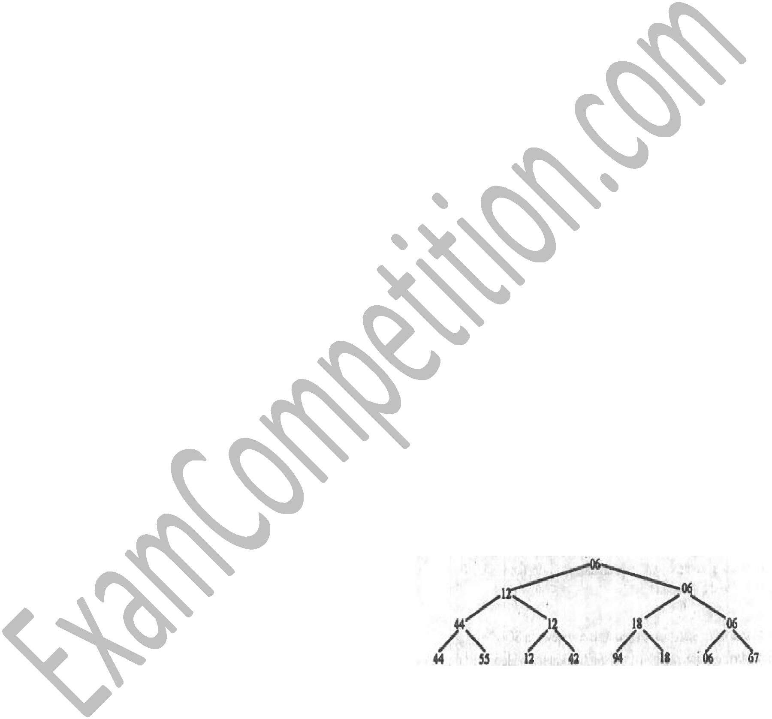

2. _____ are used to access data on secondary, sequential-access store, such as

disks and tapes.

A. Sequences. B. Arrays.

C. Records. D. Registers.

3. Sorting is

- a process of re-arranging a given set of objects in a specific order.

- to facilitate the later search for members of the sorted set.

- is a relevant and essential activity, particularly in data processing

- All of these

4. The figure below represents a ______ sort.

A. Bubble B. Shake.

C. Tree. D. Insertion

5. The figure below represents a
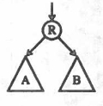

A. Binary tree B. Recursive tree

C. Insert sort D Unitary tree

