Question Paper of Digital Electronics and

Downloaded From : ExamCompetition.com

1. Keyboard and traditional monitors are

examples of

a) Simplex devices b) Duplex devices

c) Half Duplex devices d) Full Duplex devices
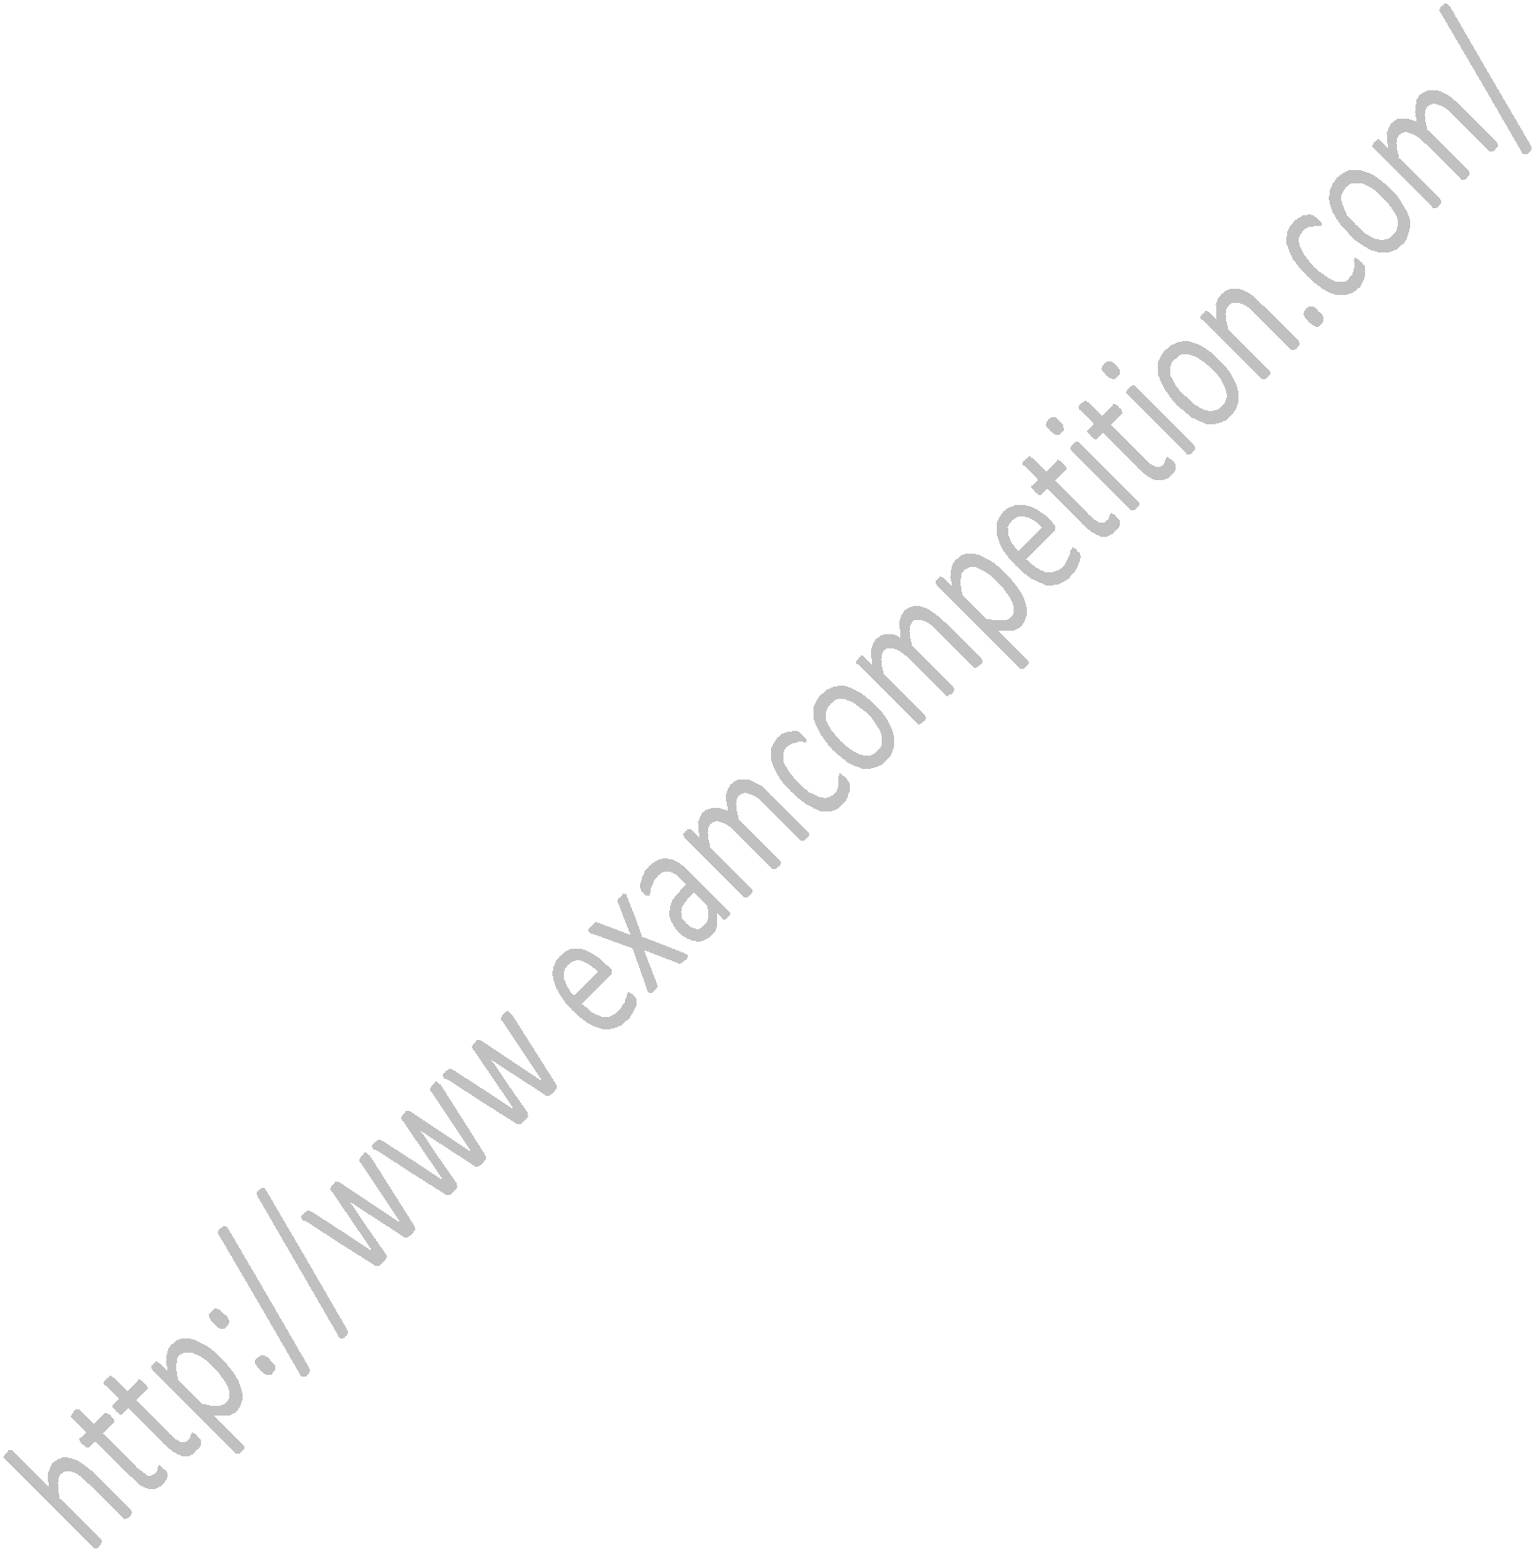

- The black and white TV is an example of a) non periodic composite signal

b) periodic composite signal c) signal

d) periodic signal

- A sine wave is defined by

a) amplitude b) frequency

c) Phase d) All of the above

4. If a noiseless channel with a bandwidth of

3000 Hz transmitting a signal with two signal levels the maximum Bit rate would be

a) 12000 bps b) 6000 bps

c) 1800bps d) zero

5. The change or lack of change in the level of the voltage determines the value of the bit is

called

a) NRZ b) NRZ-L

c) NRZ-I d) RZ

ExamCompetition.com

6. Transmission media are directly controlled by the

a) physical layer b) data link layer

c) network layer d) session layer

7. The most common unshielded twisted pair

connector is

a) RG-45 b) RG-59

c) RG-58 d) RG-ll
DBMS

Max marks 50.

Time 45 min

8. In this topology there is a central controller

or hub

a) Star b) Mesh

c) Ring d) Bus

9. Expand WAN

- World area network

- Wide area network

- Web area network

- None of the mentioned

10. In File Transfer Protocol (FTP), while the control connection is open, the data

connection can be

opened and closed

a) One time b) Several Times

c) Multiple Times d) None of the given

- Which one of the following protocol is used to receive mail messages?

a) SMTP

b) post office protocol

c) internet message access protocol d) all of the mentioned

- The Hypertext Transfer Protocol (HTTP), uses the services of TCP on

a) well-known port 80 b) well-known port 81 c) well-known port 82 d) well-known port 83

- If an Address Resolution Protocol (ARP) request is broadcast, an Address Resolution Protocol (ARP) reply is

a) Universal b) Unicast

c) Multicast d) Data link
14. The 14.23.120.8 address lies in which class

b)repeater
d)none of the above

a) class A b) class B

c) class D d) class E

15. The 127.255.255.255 address belongs to

a) loop back b) class B

c) broadcast d) limited broadcast

15. Datagram switching is done at the
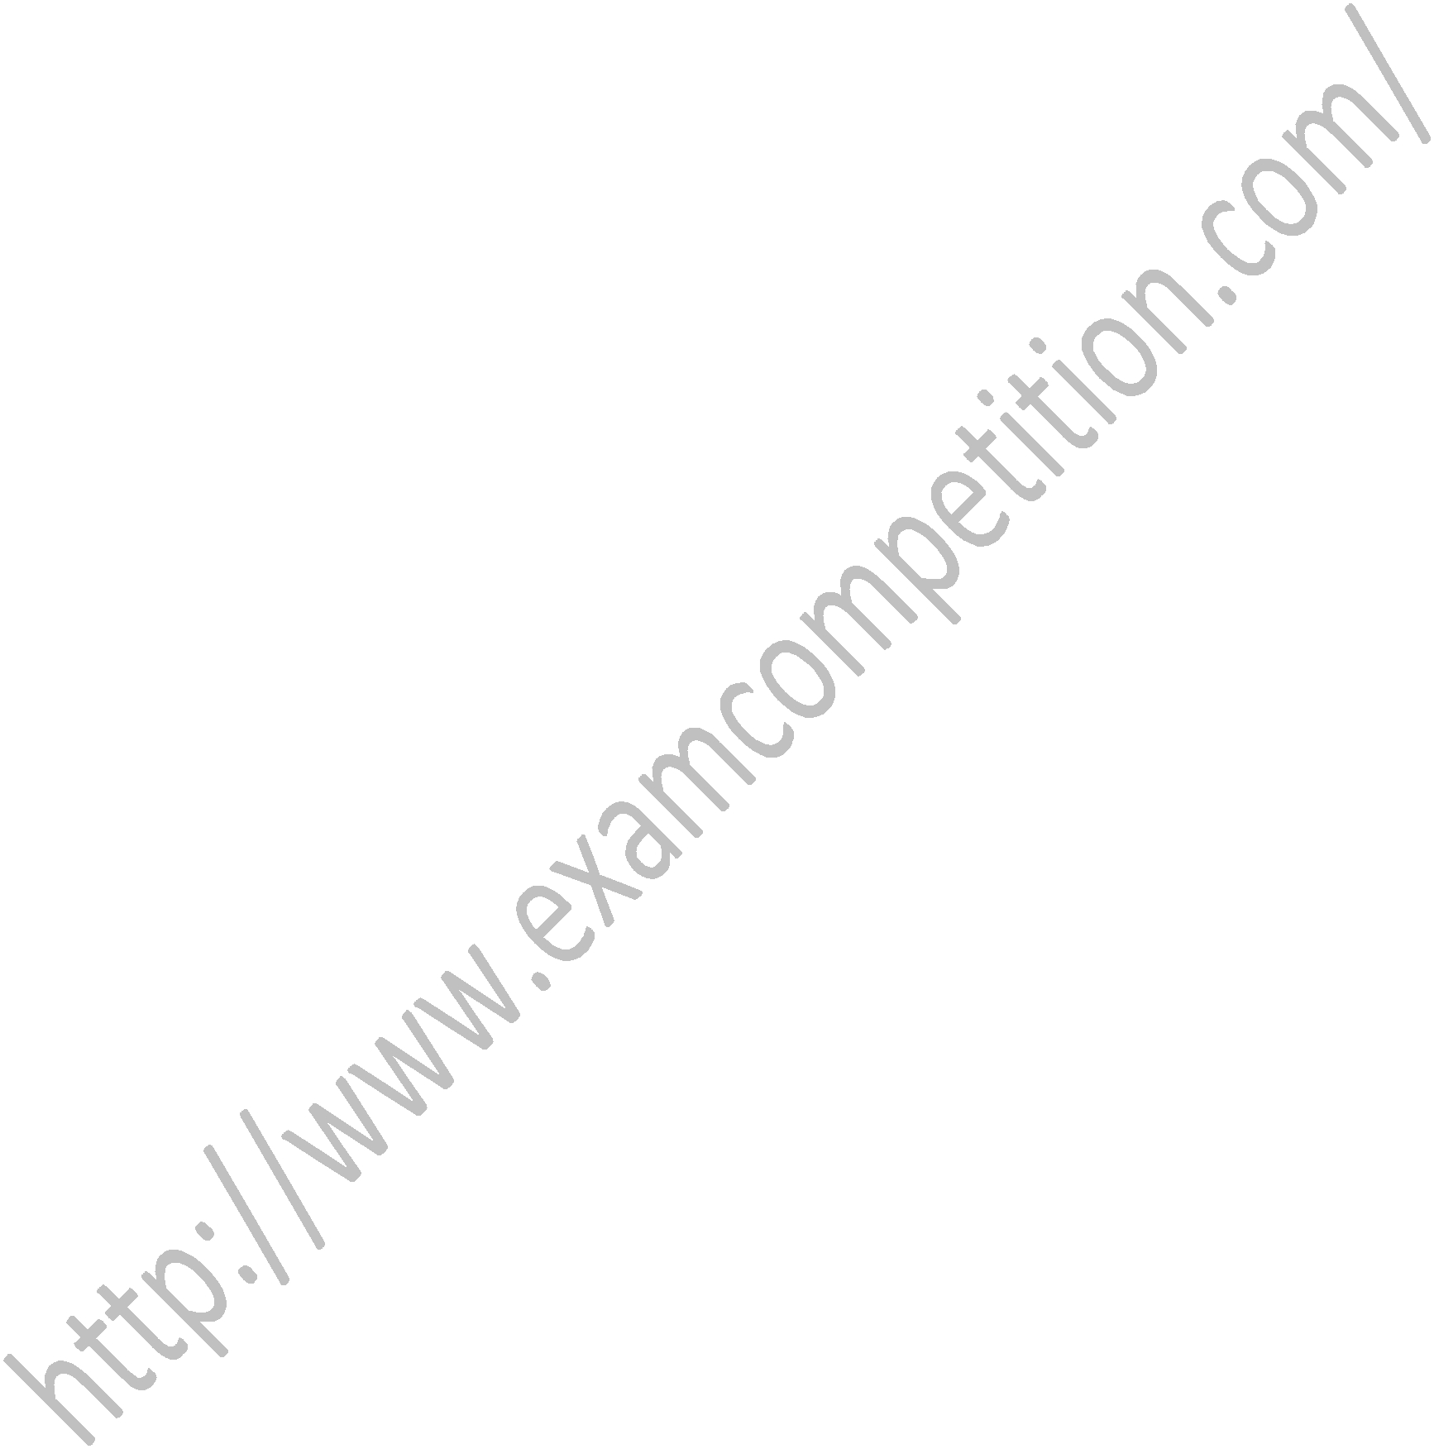
a) network layer b) physical layer

c) session layer d) data link layer

- The Asynchronous Transfer Mode (ATM) network is an example of

a) Packet switching network b) Datagram Networks

c) Virtual circuit network

d) message switched network

- A packet filter firewall filters at the

- application or transport

- data link layer

- physical

- network or transport layer

18. A subnet mask in class A has 14 1s. How many subnet does it define ?

a) 16 | b) 32
c) 64 | d) 128

ExamCompetition.com

19. What is the maximum number of IP addresses that can be assigned to hosts on a local subnet that uses the 255.255.255.224

subnet mask?
a) 14 | b) | 15
c) 16 | d) | 30

20. Small files that are deposited on a user’s hard drive when they visit a Web site are best

described as

a) cookies b) codes

c) profiles d) trackers

21. People who gain unauthorized access to computers for the fun of it, but do not intentionally do damage, are __________.

a) employees b) hackers

c) crackers d) members of

organized crime

22. A _______ regenerates a signal, connects segments of a LAN, and has no filtering

capability.

a) repeater b) bridge

c) router d) none of the above

23. A ______ has a table used in filtering

decisions.

a)passive hub c)bridge

24. A three-layer switch is a kind of ________.

a)repeater b)bridge

c)router d)none of the above

ExamCompetition.com

25. A ________ is normally a computer that operates in all five layers of the Internet model or seven layers of OSI model.

a) repeater b) bridge

c) router d) gateway

26. Which of the following is minimum error

code?

[A] Octal code [B] Grey code

[C] Binary code [D] Excess 3 code

27. Radix of binary number system is _____?

[A] 0 | [B] 1
[C] 2 | [D] A & B

28. The output of an OR gate is LOW when

________.

- all inputs are LOW

- any input is LOW

- any input is HIGH

- all inputs are HIGH

29. How many data select lines are required for selecting eight inputs?

A. 1 | B. 2
C. 3 | D. 4

30. How is a J-K flip-flop made to toggle?

A. J = 0, K = 0 B. J = 1, K = 0

C. J = 0, K = 1 D. J = 1, K = 1
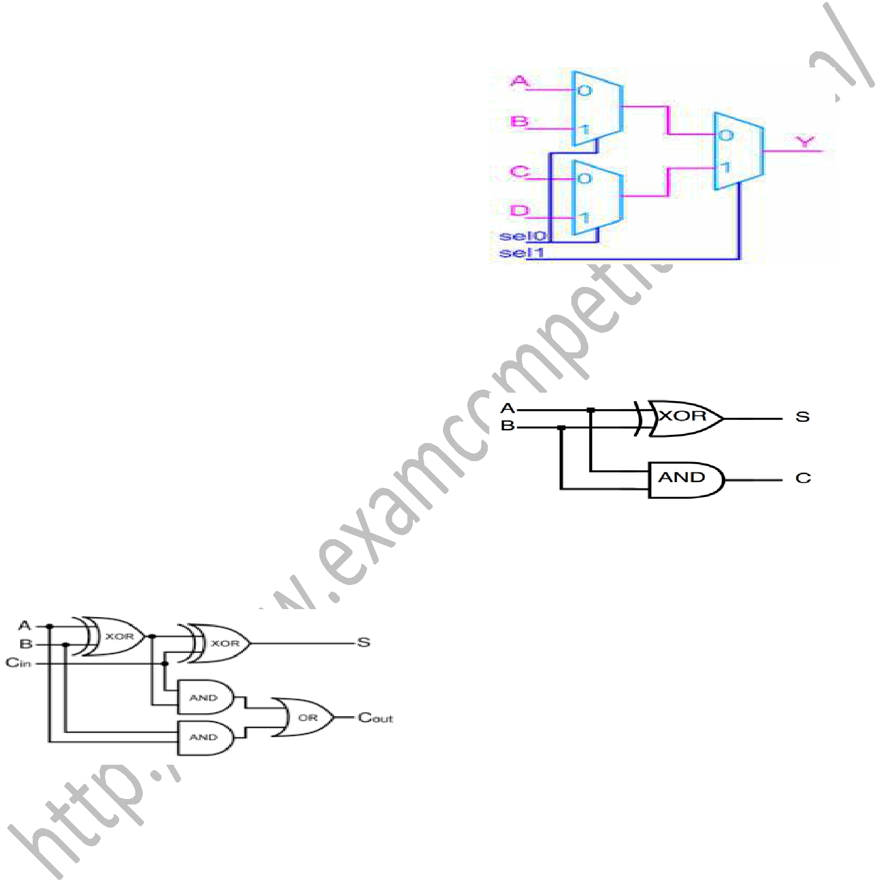
31. How many flip-flops are required to produce a divide-by-128 device?

A. 1 | B. 4
C. 6 | D. 7

32. A J-K flip-flop is in a "no change" condition when ________.

A. J = 1, K = 1 B. J = 1, K = 0

C. J = 0, K = 1 D. J = 0, K = 0

ExamCompetition.com

33. What is one disadvantage of an S-R flip-flop?

- It has no enable input.

- It has an invalid state.

- It has no clock input.

D. It has only a single output.

34. The following diagram represents :

.

A. Full Subtractor B. BCD Adder

C. Full adder D. Priority Encoder
35. The following diagram represents:
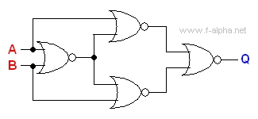

A. XOR B. X-NOR

C. Half Adder D. NAND

ExamCompetition.com

36. The following diagram represents:

A. 2 X 1 MUX B. 4 X 1 MUX

C. 8 X 1 MUX D. 4 X 1 DMUX

37. The following diagram represents:

A. Half Adder B. Half subtractor

C. XOR D. X-NOR

38. If a signal passing through a gate is inhibited by sending a LOW into one of the inputs, and the output is HIGH, the gate is a(n):

A. AND B. NAND

C. NOR D. OR

ExamCompetition.com

39. How many input combinations would a truth table have for a six-input AND gate?

A. 32 | B. 48
C. 64 | D. 128

- The output of an exclusive-NOR gate is HIGH if ________.

A. the inputs are equal

B. one input is HIGH, and the other input is

LOW

C. the inputs are unequal D. none of the above

- How many flip-flops are required to make a MOD-32 binary counter?
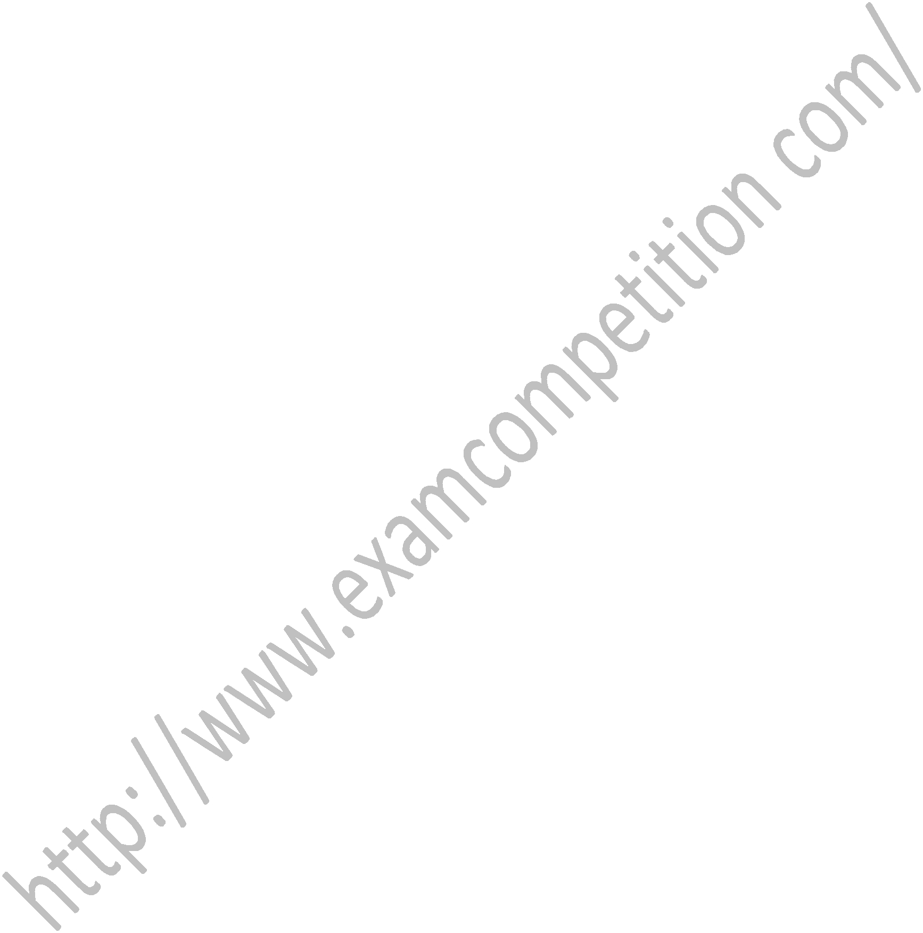
A. 3 | B. 45
C. 5 | D. 6

42. The terminal count of a modulus-11 binary counter is ________.

A. 1010 | B. 1000
C. 1001 | D. 1100

43. A modulus-12 ring counter requires a

minimum of ________.

A. 10 flip-flops B. 12 flip-flops

C. 6 flip-flops D. 2 flip-flops

44. In a 4-bit Johnson counter sequence there are a total of how many states, or bit

patterns?
A. 1 | B. 2
C. 4 | D. 8

ExamCompetition.com

45. The storage element for a static RAM is the ________.

A. diode B. resistor

C. capacitor D. flip-flop

46. How many 8 k × 1 RAMs are required to achieve a memory with a word capacity of 8 k and a word length of eight bits?

A. Eight B. Four

C. Two D. One

47. The ________ is defined as the time the output is active divided by the total period of the output signal.

A. on time B. off time

C. duty cycle D. active ratio

48. Which of the following logic families has the shortest propagation delay?

A. CMOS B. TTL

C. ECL D. DTL

- Which of the following summarizes the important features of emitter-coupled logic (ECL)?

A. low noise margin, low output voltage swing, negative voltage operation, fast, and high power consumption

B. good noise immunity, negative logic, high-frequency capability, low power dissipation, and short propagation time

C. low propagation time, high-frequency response, low power consumption, and high output voltage swings

D. poor noise immunity, positive supply voltage operation, good low-frequency operation, and low power ExamCompetition.com

- How many inputs will a decimal-to-BCD encoder have?

A. 4 | B. 8
C. 10 | D. 16

Downloaded From : ExamCompetition.com Visit this website for More notes Mock test papers Sample papers guess papers previous year papers of various exams.

If you don’t find any paper do comment us contact us. We will try our best to provide you the latest information, exam papers.

