Operating System and Data Structure Question Paper Downloaded From : ExamCompetition.com

- When determining the efficiency of algorithm, the space factor is measured by a. Counting the maximum memory needed by the algorithm

b. Counting the minimum memory needed by the algorithm

c. Counting the average memory needed by the algorithm

d. Counting the maximum disk space needed by the algorithm

- The complexity of Bubble sort algorithm is
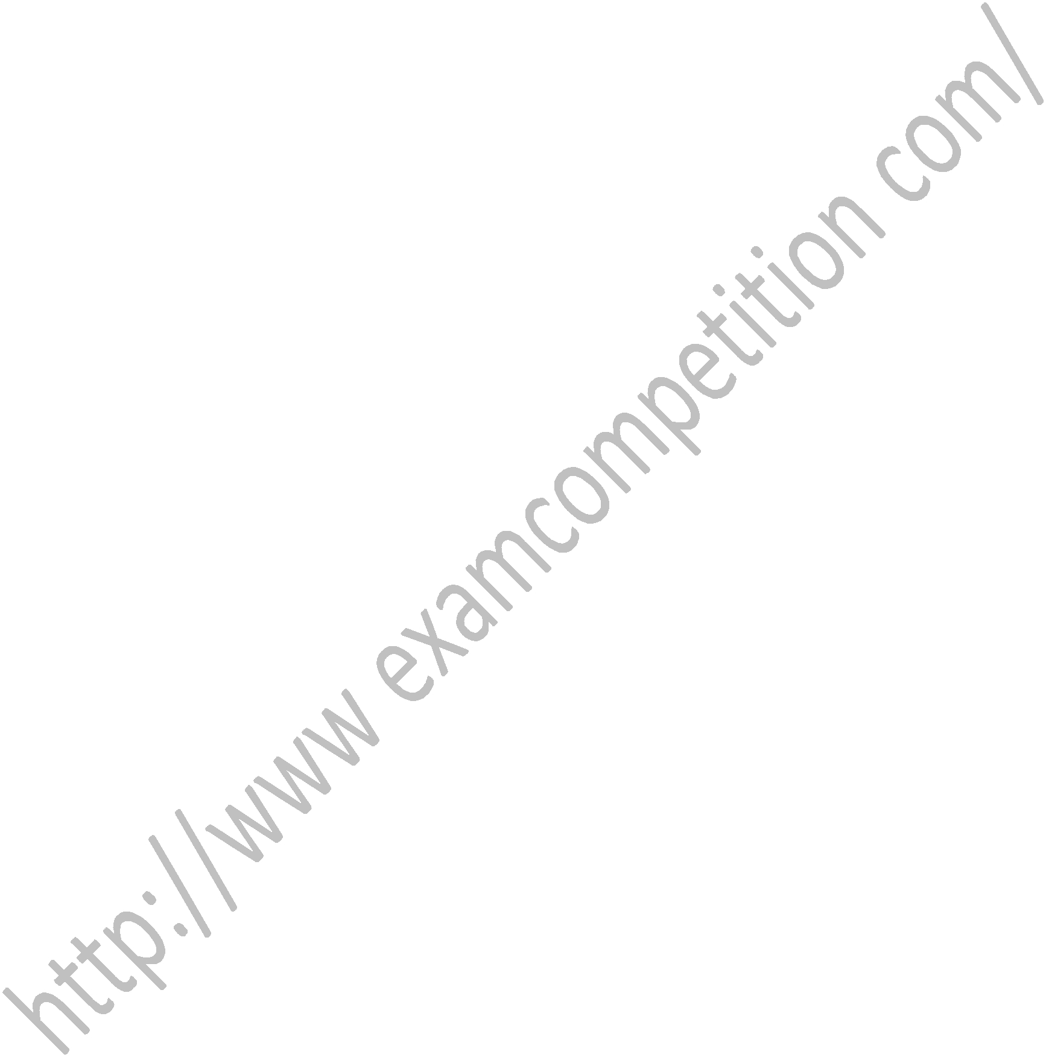
a. O(n) b. O(log n)
c. O(n²) d. O(n log n)
ExamCompetition.com

3. Linked lists are best suited
- for relatively permanent collections of data

- for the size of the structure and the data in the structure are constantly changing
- for both of above situation
- for none of above situation

4. Binary search algorithm cannot be applied
to
a. sorted linked list b. sorted binary trees
c. sorted linear array d. pointer array

- In linear search algorithm the Worst case occurs when

a. The item is somewhere in the middle of the array
b. The item is not in the array at all
c. The item is the last element in the array

d. The item is the last element in the array or is not there at all

- Which of the following statement is false? a. Every tree is a bipartite graph
b. A tree contains cycle

c. A tree with n nodes contains n-1 edges d. A tree is connected graph ExamCompetition.com

- Which of the following will contain more memory space?

a. Singly linked list b. Doubly linked list

c. Array d. Circular linked list

8. Which data structure will you use to evaluate prefix notation?

a. Queue b. Stack

c. Linked List d. Array

9. Answer of following postfix expression:

2,3,10+*8,2/-
a. 20 | b. 22
c. 23 | d. 46

10. Which of the following data structure is

linear data structure?

a. Trees b. Graphs

c. Arrays d. None of above

11.The elements of an array are stored successively in memory cells because

- by this way computer can keep track only the address of the first element and the addresses of other elements can be calculated

- the architecture of computer memory does not allow arrays to store other than serially
- both of above
- none of above
ExamCompetition.com

12. Which of the following data structure is not linear data structure?

a. Arrays b. Linked lists
c. Both of above d. None of above

13. In which notation operator is comes between operand?

a. Infix b. Prefix

c. Postfix d. None

- Example of primitive recursion is a. Tower of Hanoi

b. Ackermann’s function c. Both
d. None

- Finding the location of the element with a given value is:

a. Traversal b. Search

c. Sort d. None of above

16. An one dimensional array array[1:5] contains _________ elements.

a. 5 | b. 4
c. 1 | d. 6

17. Which are the applications of array?

a. Sparse matrix b. Ordered list

c. Both a & b d. none

18. Arrays are best data structures
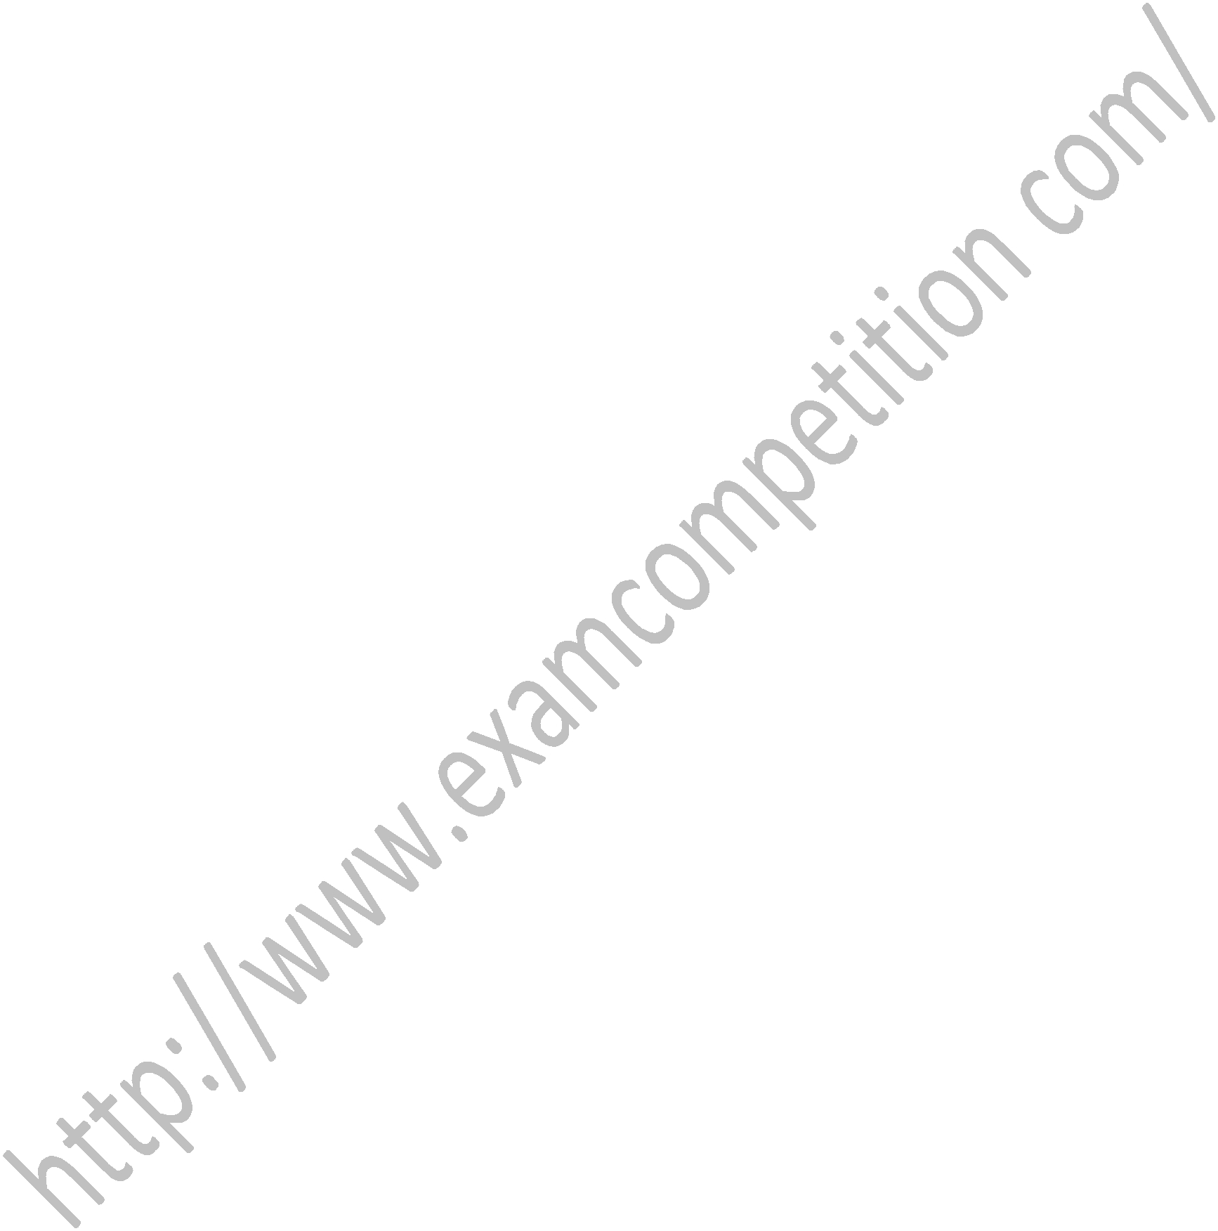
- for relatively permanent collections of data

- for the size of the structure and the data in the structure are constantly changing

- for both of above situation

- for none of above situation ExamCompetition.com

19. Each array declaration need not give, implicitly or explicitly, the information about

- the name of array

- the data type of array
- the first data from the set to be stored
- the index set of the array

20. Which of the following statements are wrong statements?

- Array is primitive data structure.
- Every element of array must be same.

- In array, Insert element is called push operation.
- All
ExamCompetition.com

21. Which of the following sorting algorithms does not have a worst case running time of
O(n²)
a. Insertion sort b. Merge sort

c. Quick sort d. Bubble sort

22. which is/are the height balancing tree
a. AVL tree b. Splay tree

c. Red Black Tree d. All of the above

23. the worst case time complexity of AVL

tree is

a. O(n) b. O(logn)
c. O(n²) d. O(nlogn)

24. A binary search tree whose left subtree and right subtree differ in hight by at most 1

unit is called ……

a. AVL tree b. Red-black tree

c. Lemma tree d. None of the above

25. The AVL must have balance factor

between

a. -1 to 1 b. -2 to -2

c. -5 to -5 d. -∞ to +∞

26. .............. refers to a situation in which a process is ready to execute but is continuously denied access to a processor in deference to other processes.
a. Synchronization b. Mutual Exclusion

c. Dead lock d. Starvation

ExamCompetition.com

- Which of the following is/ are the part of operating system?

a. Kernel services b. Library services

c. Application level services d. All of the above

- With ................ a page is brought into main memory only when the reference is made to a location on that page.

a. demand paging |  | b. main paging
c. prepaging |  | d. postpaging
29. ................. | is the ability of multiple
process to co-ordinate their activities by
exchange of information
a. Synchronization |  | b. Mutual Exclusion
c. Dead lock |  | d. Starvation
ExamCompetition.com
30. ................. | is the time required to position
the Read/Write head to the required sector.
a. Seek time b. Rotational delay

c. Latency time d. Access time

31. ............... policy selects the disk I/O

request that requires the least movement of the disk arm from its current position.
a. FSCAN b. SSTF

c. SCAN d. C-SCAN

32. .................. refers to the ability of an operating system to support multiple threads of execution with a single process.

a. Multithreading b. Multiprocessing

c. Multiexecuting d. Bi-threading
ExamCompetition.com

33. …………………. Techniques can be used to resolve conflicts, such as competition for resources, and to synchronize processes so that they can cooperate.
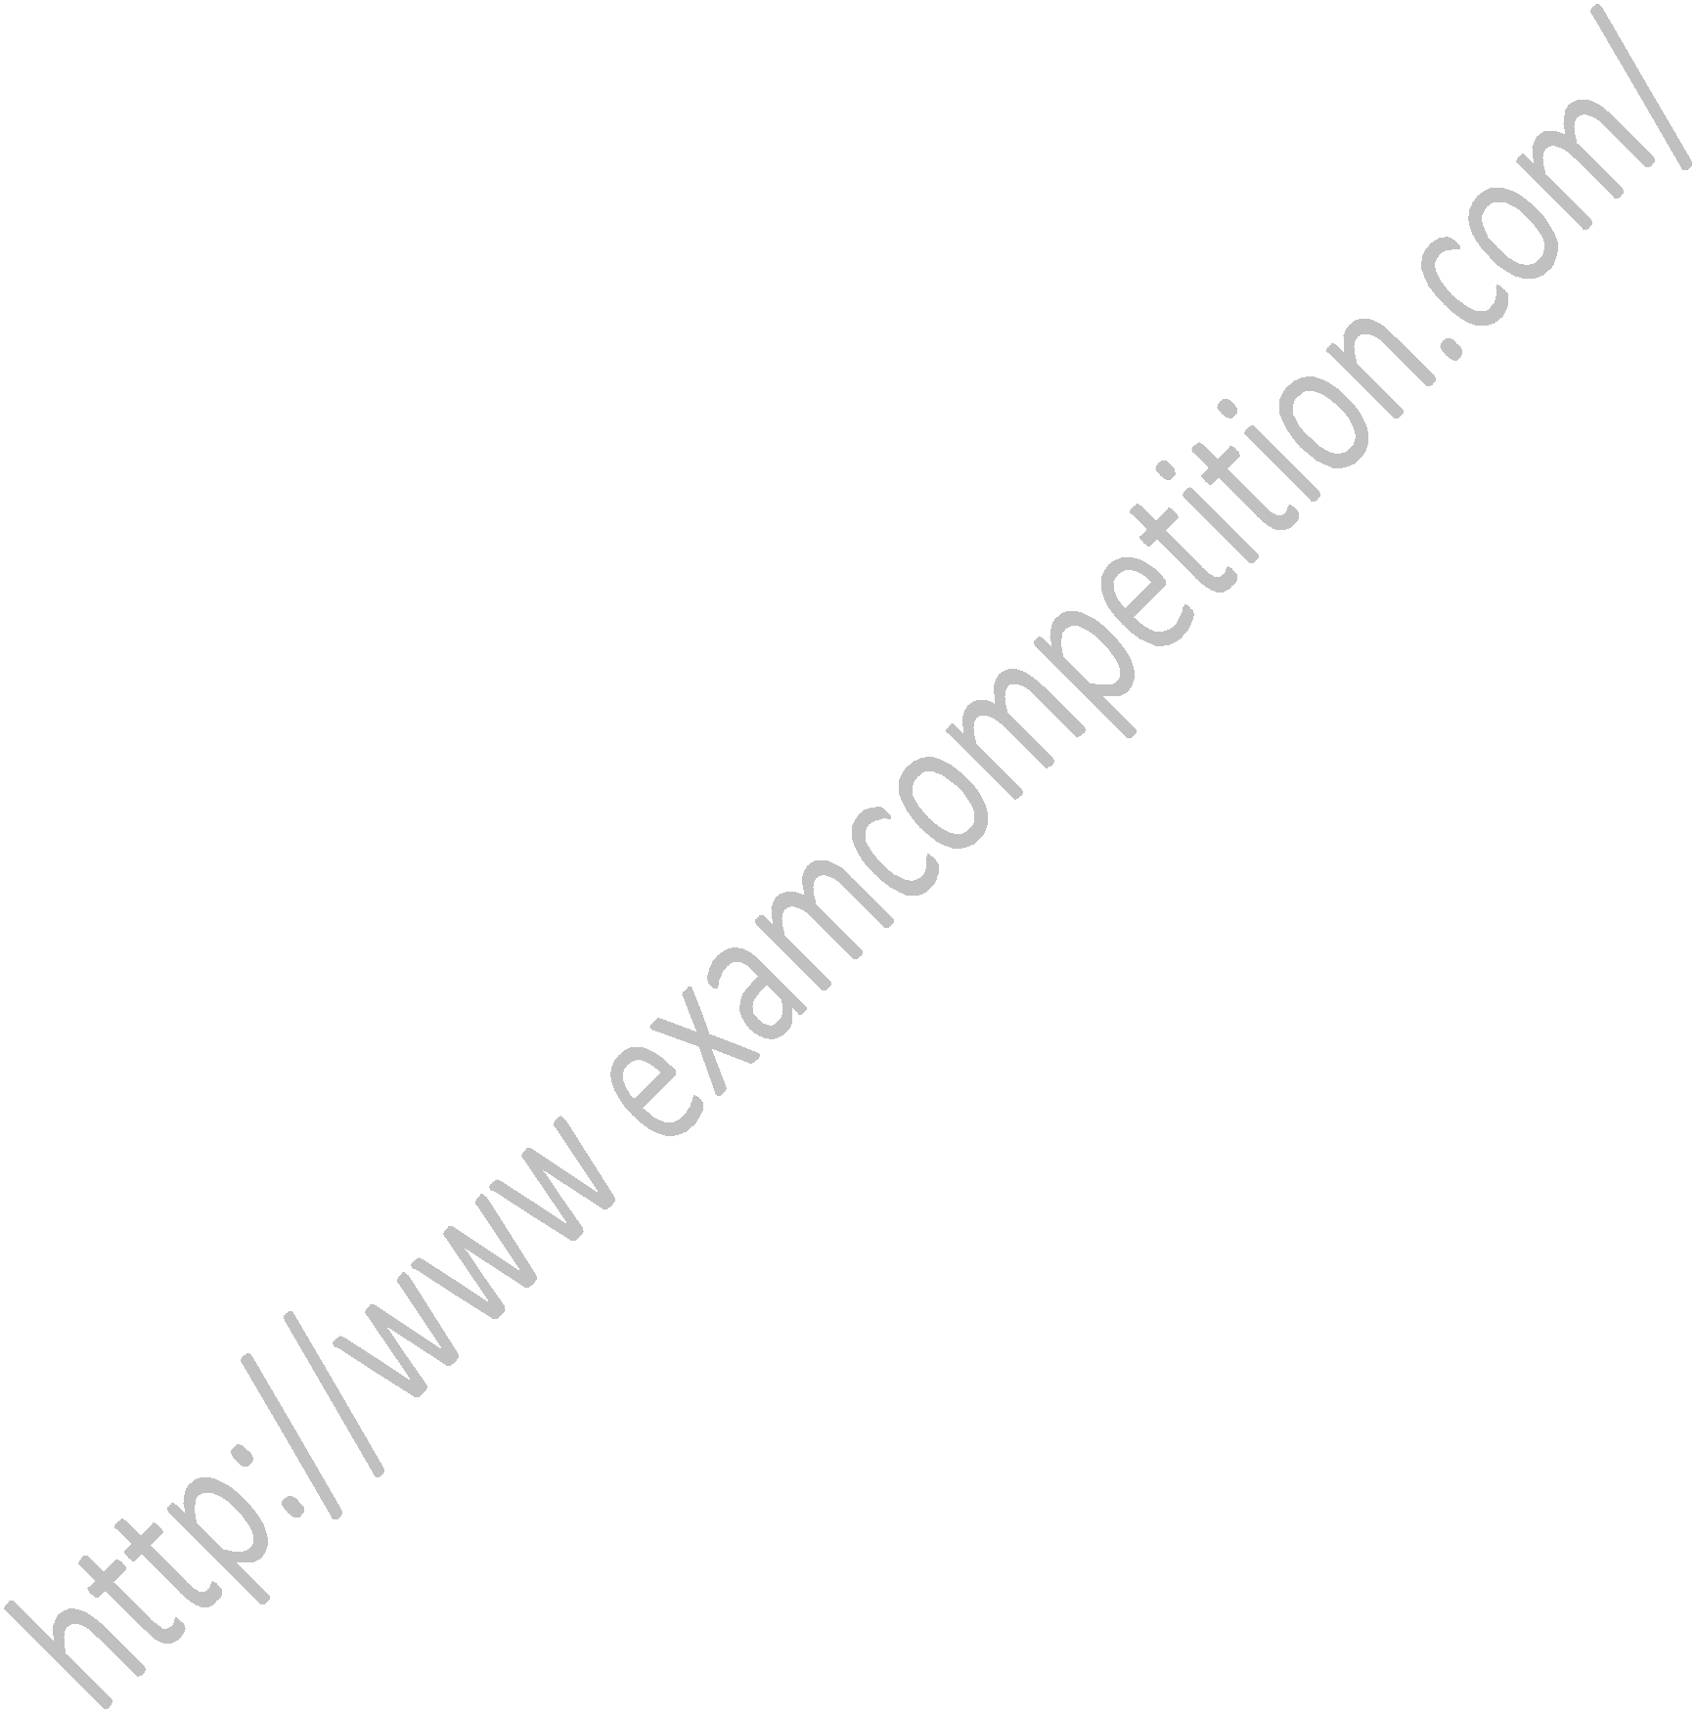
a. Mutual Exclusion b. Busy Waiting

c. Deadlock d. Starvation

- Disk scheduling includes deciding a. which should be accessed next

b. order in which disk access requests must be serviced

c. the physical location of the file d. the logical location of the file

- Which scheduling policy is best suited for time-sharing operating systems

a. Shortest job first b. Round robin
c. First come first serve d. Elevator

36. Which among following scheduling algorithms give minimum average waiting

time
a. FCFS b. SJF
c. Round robin d. On priority

37. Size of virtual memory depends on

a. size of data bus b. size of address bus c. size of main memory d. none of above

- Semophores are used to solve the problem of

a. race condition

b. process synchronization c. mutual exclusion

d. belady problem ExamCompetition.com

- In which scheduling policies, context switching never takes place

a. FCFS b. round robin
c. Shortest job first d. Pre-empitive

40. Which is single user operating system
a. MS-DOS b. UNIX

c. XENIX d. LINUX

- Multiprogramming systems Are easier to develop than single a. programming systems

b. Execute each job faster

c. Execute more jobs in the same time d. Are used only on large main frame computers

- A thread is

- lightweight process where the context switching is low

- lightweight process where the context switching is high

- used to speed up paging

d. used in dead locks

43. 26. The LRU algorithm

- pages out pages that have been used recently

- pages out pages that have not been used recently

- pages out pages that have been least used recently

- pages out the first page in a given area ExamCompetition.com
44. Semaphores function is to

- synchronize critical resources to prevent deadlock

- synchronize processes for better CPU utilization
- used for memory management
- none of above

45. To avoid the race condition, the number of processes that may be simultaneously inside the critical section is

a. 12 | b. 3
c. 1 | d. 0

46. Four necessary conditions for deadlock are non pre-emption, circular wait, hold and wait

and

a. mutual exclusion b. race condition

c. buffer overflow d. None of above

ExamCompetition.com
47. Banker's algorithm deals with
- deadlock prevention
- deadlock avoidance
- deadlock recovery
- mutual exclusion

- Which of the following statements is false?

a. Segmentation suffers from external fragmentation.

b. Paging suffers from internal fragmentation. c. Segmented memory can be paged.

d. Virtual memory is used only in multi-user systems.

- Consider a system having 'm' resources of the same type. These resources are shared by

- processes A, B, C, which have peak time demands of 3, 4, 6 respectively. The minimum value of 'm' that ensures that deadlock will never occur is
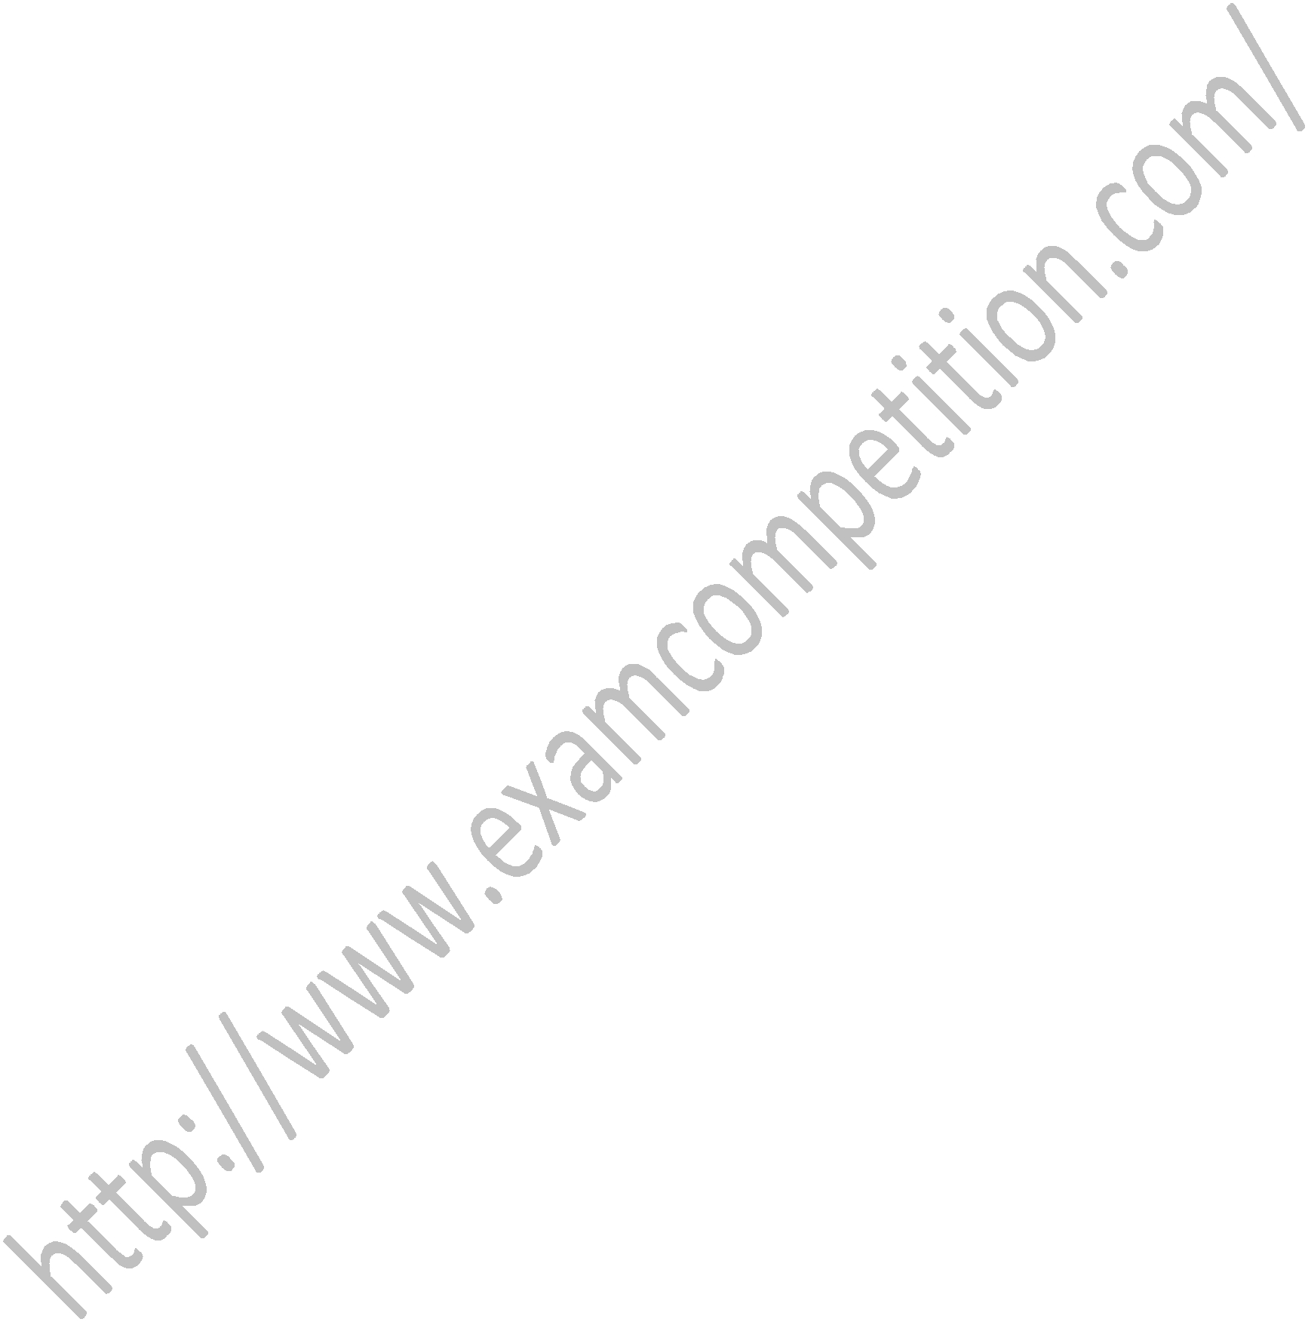
a. 11 | b. 12
C. 13 | D. 14
ExamCompetition.com

50. At a particular time, the value of a counting semaphore is 10. It will become 7

after
a. 3 V operations b. 3 P operations
c. 7 V operations d. 7 P operations

Downloaded From : ExamCompetition.com

Visit this website for More notes Mock test papers Sample papers guess papers previous year papers of various exams.

If you don’t find any paper do comment us contact us. We will try our best to provide you the latest information, exam papers.

