Detailed Approaches for Policy-Aware Purchasing AI Assistant

Approach 1: Policy Brain with Structured Policy Store

1. Overview
This approach builds a comprehensive Policy Brain consisting of two major components: a Structured Policy Rules Store and an Unstructured Policy Knowledge Base (RAG Index). Rules are extracted from policy documents, normalized, versioned, and stored in a structured form for deterministic reasoning.

2. Ingestion Pipeline (Detailed)

2.1 Source Collection
- • Global procurement policy documents
- • Regional/Country-specific guidelines (US, EU, India, etc.)
- • Plant-level SOPs
- • Category-specific rules (optical modules, RF cables, etc.)
- • ERP/Procurement system exports (vendor list, material groups)

2.2 Text Extraction
Documents are extracted into clean text using PDF parsers or OCR for scanned documents. Document structure—such as headings, section numbers, and bullet points—is preserved.

2.3 Chunking Example
Example original text:
“In the US region, buyers may approve purchase orders up to USD 10,000. Orders above this limit require Category Manager approval. Orders above USD 50,000 must be approved by the Plant Manager.”
Chunked into policy units:
- • US buyers may approve POs up to USD 10,000.
- • Orders above USD 10,000 require Category Manager approval.
- • Orders above USD 50,000 require Plant Manager approval.

2.4 LLM Policy Extraction (Structured Rules)
Example input chunk:
“US buyers may approve purchase orders up to USD 10,000.”
Structured output extracted:
{
"policy_id": "APPROVAL_US_BUYER_001",
"policy_type": "APPROVAL_LIMIT",
"scope_location": "US",
"scope_role": "BUYER",
"scope_item": "ALL",
"text": "US buyers may approve purchase orders up to USD 10,000.",
"structured_rule": {
"max_amount": 10000,
"currency": "USD"
}
}

2.5 Structured Policy Store Tables
Approval Limits Table Example:
- • Buyer | US | ALL | 10,000 USD | Policy A001
- • Category Manager | Global | Optical Modules | 50,000 USD | Policy A002
- • Plant Manager | Plant_101 | ALL | 75,000 USD | Policy A003

2.6 Vendor Eligibility Example
{
"policy_id": "VENDOR_PLANT101_OPTICAL_001",
"policy_type": "VENDOR_ELIGIBILITY",
"vendor": "Vendor X",
"scope_location": "PLANT_101",
"scope_item": "OPTICAL_MODULES",
"structured_rule": {
"approved": true
}
}

3. Multi-Agent Workflow
- • Context Parser → Extracts structured scenario (amount, location, item category, vendor)
- • Policy RAG Agent → Retrieves relevant policy text
- • Policy Rules Agent → Queries structured rules store
- • Conflict Resolution Agent → Resolves global vs regional vs plant rules
- • Compliance Agent → Produces final compliance decision with citations

4. Example End-to-End Decision
Scenario: PO for 15,000 USD of optical modules at Plant 101 using Vendor X.
Structured rule outputs:
- • Buyer limit = 10,000 USD → exceeded
- • Optical Module threshold = 5,000 USD → CM approval required
- • Vendor X = approved
- • Plant-level override → applied
Final Decision:
“Buyer cannot approve. Requires Category Manager approval. Vendor X is approved.”

Approach 2: Document-Only Policy Reasoning (No Structured Policy Store)

1. Overview
In this approach, no policy rules database is maintained. All rules are derived directly from policy documents at query time using retrieval and LLM reasoning.

2. Ingestion Pipeline
The ingestion pipeline is simpler because no structured rule extraction is required.

2.1 Extract & Chunk Policy Documents
Documents are chunked into policy paragraphs, each tagged with metadata: location, category, document name, and section reference.
Example chunk:
“Optical modules above USD 5,000 require Category Manager approval.”

2.2 Build RAG Index
Chunks are embedded and stored in a vector index for semantic policy retrieval.

3. Real-Time Policy Interpretation
Instead of querying a structured policy store, the AI interprets rules from retrieved policy text each time a user asks a purchasing question.

3.1 Example Interpretation
- • Extract '5,000 USD' threshold for optical modules
- • Deduce that 'Category Manager' is required for approval
- • Identify that vendor eligibility must be looked up from text
- • Resolve conflicts (e.g., plant overrides region) using textual instructions

4. Multi-Agent Workflow
- • Context Parser Agent → Understands scenario
- • Policy Retrieval Agent → Finds policy clauses
- • Policy Interpretation Agent → Derives rules from text
- • Compliance Agent → Generates decision & citations

5. Example Real-Time Decision
Policy snippets retrieved:
- • US buyers may approve up to 10,000 USD.
- • Optical modules above 5,000 USD require Category Manager approval.
- • Vendor X is approved for optical modules at Plant 101.
Interpreted rules:
- • Buyer limit = 10,000 USD → exceeded
- • CM approval threshold = 5,000 USD → triggered
- • Vendor X = approved
Final Decision:
“Buyer cannot approve. Requires Category Manager approval. Vendor X is approved.”

Ingestion Pipeline Diagram
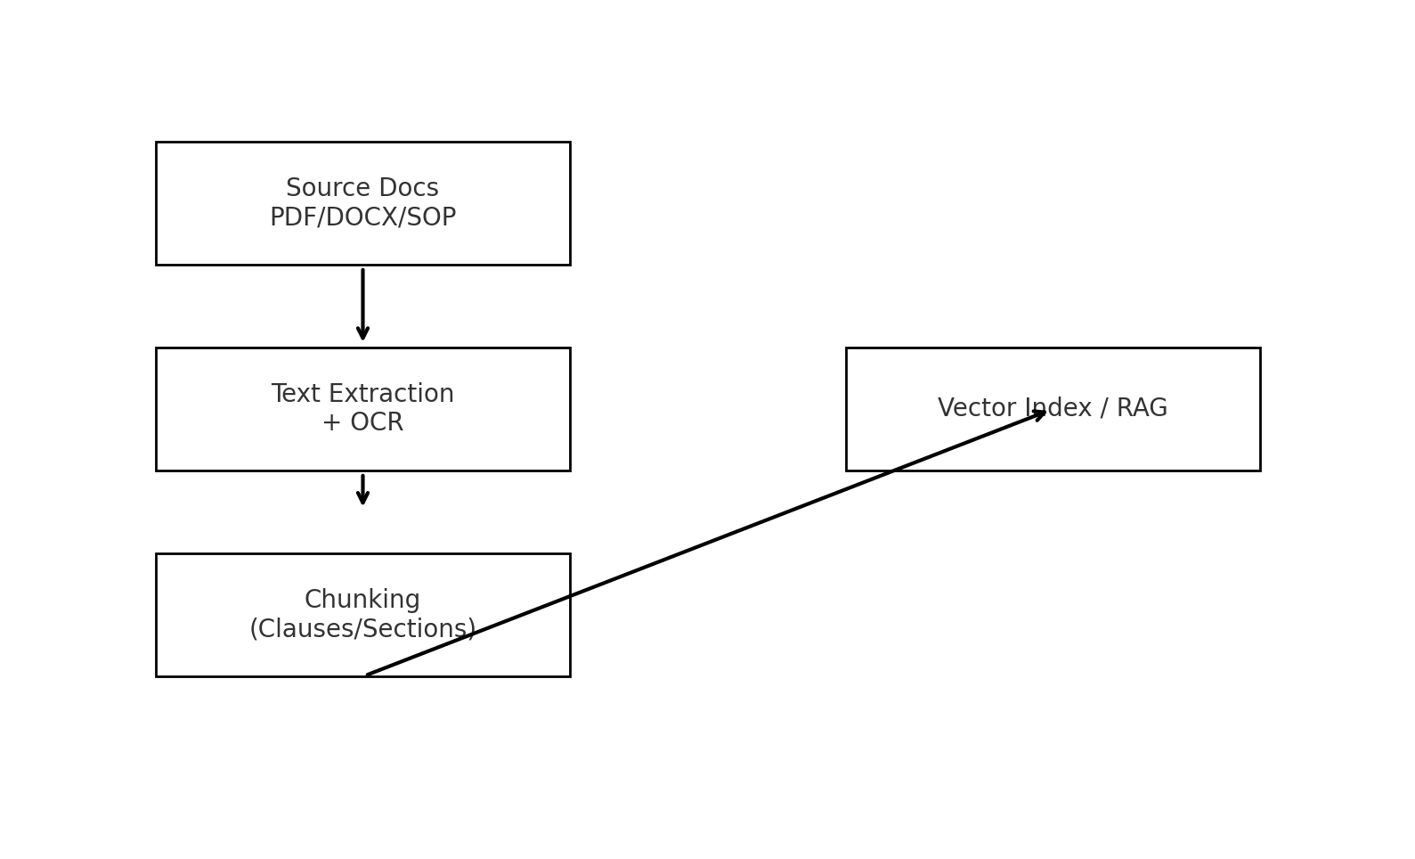

Agent Workflow Diagram
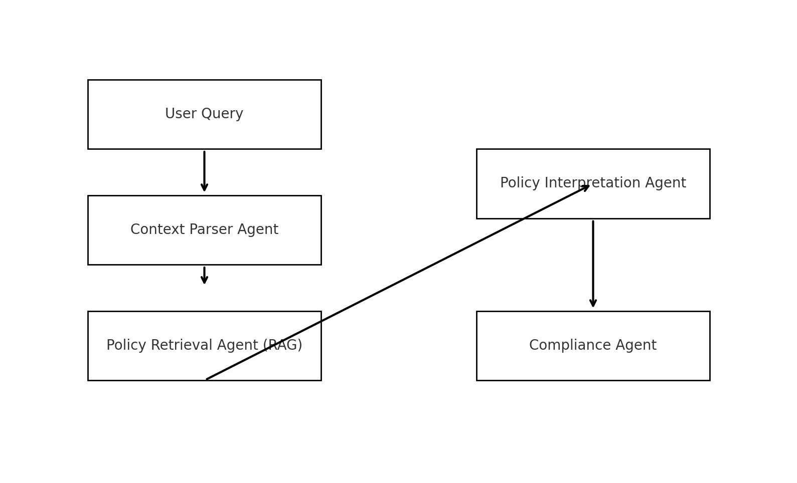

Architecture Comparison Diagram
