Policy-Aware Purchasing AI Assistant
Comprehensive Technical Approaches

Introduction
This document presents two detailed architectures for building a policy-aware Purchasing AI Assistant: (1) Policy Brain with a Structured Policy Store, and (2) a Document-Only Policy Interpretation Approach. Both architectures include ingestion workflows, agent orchestration, and examples demonstrating policy application.

Ingestion Pipeline Diagram
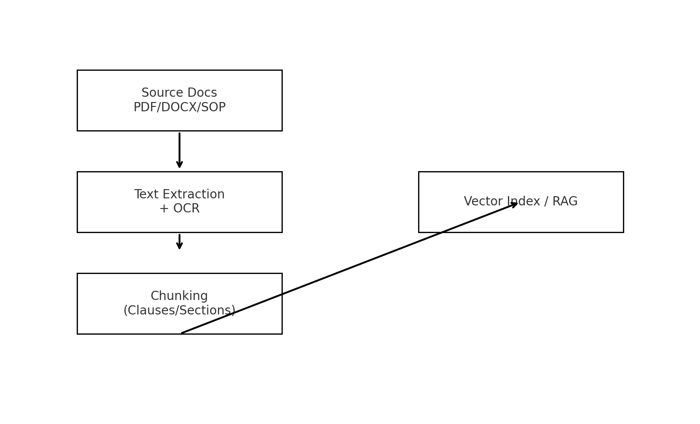

Agent Workflow Diagram
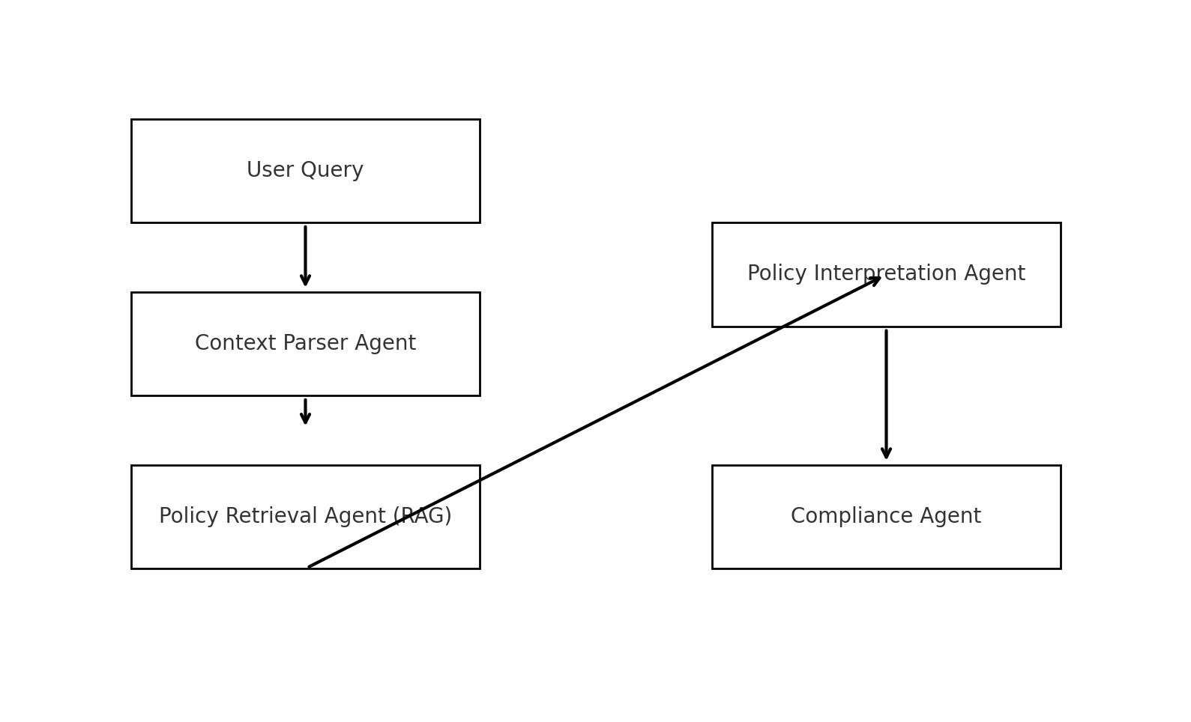

Architecture Comparison Diagram
