Structured Query Language

SQL ist eine Sprache um mit Datenbankmanagementsystemen zu kommunizieren.
C.R.U.D
Create Read Update Delete

Relationale Datenbank (SQL) | Nicht-Relationale Datenbank (noSQL)
Organisieren Daten in einer oder mehreren Tabellen  • Jede Tabelle hat Spalten und Zeilen  • Ein eindeutiger Schlüssel identifiziert jede Zeile | Organisieren Daten nicht in Form einer gewöhnlichen Tabellen  •Key-Value stores  •Dokumente (JSON,XML, etc)  •Graphen  •Flexible Tabellen

Relationale Datenbankmanagementsysteme (RDBMS)
Helfen dem User beim Erstellen und Warten einer Relationalen Datenbank
Bekannte Systeme sind:
•mySQL, Oracle, postgreSQL, mariaDB

Nicht-Relationale Datenbanken
Dokumentenbasiert | Graphenbasiert | Key-Value Hash
Objekte werden im JSON, XML, BLOB, etc…  Format gespeichert | Realtionale Knoten die miteinander verknüpft werden
  Key | Value
  „xyz“ | string
  „abc“ | JSON
  „pqr“ | BLOB
  „jkl“ | Etc..

Nicht-Realtionale Datenbankmanagementsysteme (NRDBMS)
Helfen dem User beim erstellen und verwalten von nicht-relationalen Datenbanken
Bekannte Systeme sind:
• mongoDB, dynamoDB, apache cassandra, firebase, couchDB,

NRDBMS sind Implementierungsspezifisch, d.h. es gibt keinen standartisierten Sprachenstandard.
Die meisten NRDBMS haben eine eigene Sprache um CRUD und administrative Operationen auszuführen

Tabellen und Schlüssel

Primärschlüssel:
Der Primärschlüssel wird benutz um eine Zeile(einen Datenbankeintrag) eindeutig identifizieren zu können.
Surrogatoschlüssel (Surrogate Key):
Ein Surrogatoschlüssel ist ein Datenbankschlüssel, der nicht aus den Daten in der Tabelle abgleitet werden. Surrogatoschlüssel werden in der Regel automatisch gebildet und häufig als Primärschlüssel verwendet.
Sprechende Schlüssel (Natural Key):
Ein Primärschlüssel der aus Daten in der Tabelle abgeleitet wird.
Fremdschlüssel (Foreign Key):
Ein Fremdschlüssel ist ein Attribut oder eine Attributkombination einer Relation, welches auf einen Primärschlüssel(bzw. Schlüsselkandidaten) einer anderen Relation verweist.
Er dient als Verweis zwischen zwei Relationen
Zusammengesetzte Schlüssel (Compsite Key):
Ein Primärschlüssel der durch zwei Attribute zusammengesetzt wird. In beiden Attributen kommen Werte rednundant vor, daher fast man diese zu einem Primärschlüssel zusammen.

SQL Basics

Data Manipulation Language (DML)
Erstellen, Abfragen, Ändern und Löschen von Datensätzen
Subset von DML ist Data Query Language (DQL)
Data Definition Language (DDL)
Erstellen und verwalten von Datenbankentabellen, Definition von Primärschlüsseln
CREATE DATABASE, CREATE TABLE
Data Control Language (DCL)
Befehle für die Rechteverwaltung
Transaction Control Language
Befehle für die Transaktionskontrolle

Queries
Eine Abfrage (Query) ist eine Anweisung an das RDBMS umd bestimmte Daten aus einer Datenbank zu erfragen
SELECT employee.name, employee.age
FROM employeeWHERE employee.salary > 3000;

CREATE TABLE student (
student_id INT PRIMARY KEY,
first_name VARCHAR(64),
major VARCHAR(32)
);
CREATE TABLE student (
student_id INT,
first_name VARCHAR(64),
major VARCHAR(32)
PRIMARY KEY(student_id)
);

DESCRIBE student;
SHOW columns FROM student;

DROP TABLE student;
ALTER TABLE student ADD grade DECIMAL(3,2);

SELECT * FROM student;

Datensätze einfügen
INSERT INTO student VALUES(werte in Reihenfolge der Spalten);
INSERT INTO student VALUES(2,"Peter","Sport",1.33);

Wenn man nicht alle Werte eingeben möchte, kann man
INSERT INTO student(student_id, first_name) VALUES(3,"Maria");
benutzen.
CREATE TABLE student (
student_id INT PRIMARY KEY,
first_name VARCHAR(64) NOT NULL,
major VARCHAR(32) DEFAULT ‘undecided‘
);

NOT NULL: Wert darf nicht NULL sein
UNIQUE: Ein Wert darf nicht dupliziert in einer Spalte vorkommen.
AUTO_INCREMENT

Ändern und Löschen

UPDATE student SET major = "Biology" WHERE major = "Bio";

UPDATE student
SET major= 'Computer Science'
WHERE student_id = 5 ;

UPDATE student
SET major= 'Biochemistry'
WHERE major="Biology" OR major ="Chemistry" ;
UPDATE student
SET first_name = "Tom", major = "undecided"
WHERE student_id=1;
DELETE FROM student
WHERE student_id=6;
DELETE FROM student;

Grundlegene Queries
SELECT column,column2(...) FROM table;
bzw.
SELECT table.column, table.column2 FROM table;
SELECT table.column, table.column2
FROM table
ORDER BY column; ( ORDER BY column DESC oder ASC)
SELECT table.column, table.column2
FROM table
ORDER BY column, column1 DESC;
SELECT *
FROM table
ORDER BY column ASC
LIMIT 2;
SELECT *
FROM table
WHERE column = „String“;
SELECT column
FROM table
WHERE column=“String“ OR column2 > 44;
– <, >, <=, >=, =, <>, AND, OR

SELECT *
FROM
WHERE column IN (condition);
eg:
SELECT *
FROM
WHERE name IN (“Peter“, “Lukas“);

Arbeiten mit komplexeren Datenbanken
Wichtig ist hierbei die Reihenfolge, in der die Datensätze später eingetragen werden, aufgrund der Beziehungen die untereinander herrschen!
CREATE TABLE employee (
emp_id INT PRIMARY KEY,
first_name VARCHAR(40),
last_name VARCHAR(40),
birth_day DATE,
sex VARCHAR(1),
salary INT,
super_id INT,
branch_id INT
);
CREATE TABLE branch (
branch_id INT PRIMARY KEY,
branch_name VARCHAR(40),
mgr_id INT,
mgr_start_date DATE,
FOREIGN KEY(mgr_id) REFERENCES employee(emp_id) ON DELETE SET NULL
);
ALTER TABLE employee
ADD FOREIGN KEY(branch_id)
REFERENCES branch(branch_id)
ON DELETE SET NULL;
ALTER TABLE employee
ADD FOREIGN KEY(super_id)
REFERENCES employee(emp_id)
ON DELETE SET NULL;
CREATE TABLE client (
client_id INT PRIMARY KEY,
client_name VARCHAR(40),
branch_id INT,
FOREIGN KEY(branch_id) REFERENCES branch(branch_id) ON DELETE SET NULL
);
CREATE TABLE works_with (
emp_id INT,
client_id INT,
total_sales INT,
PRIMARY KEY(emp_id, client_id),
FOREIGN KEY(emp_id) REFERENCES employee(emp_id) ON DELETE CASCADE,
FOREIGN KEY(client_id) REFERENCES client(client_id) ON DELETE CASCADE
);

CREATE TABLE branch_supplier (
branch_id INT,
supplier_name VARCHAR(40),
supply_type VARCHAR(40),
PRIMARY KEY(branch_id, supplier_name),
FOREIGN KEY(branch_id) REFERENCES branch(branch_id) ON DELETE CASCADE
);

-- Corporate
INSERT INTO employee VALUES(100, 'David', 'Wallace', '1967-11-17', 'M', 250000, NULL, NULL);

INSERT INTO branch VALUES(1, 'Corporate', 100, '2006-02-09');

UPDATE employee
SET branch_id = 1
WHERE emp_id = 100;

INSERT INTO employee VALUES(101, 'Jan', 'Levinson', '1961-05-11', 'F', 110000, 100, 1);

-- Scranton
INSERT INTO employee VALUES(102, 'Michael', 'Scott', '1964-03-15', 'M', 75000, 100, NULL);

INSERT INTO branch VALUES(2, 'Scranton', 102, '1992-04-06');

UPDATE employee
SET branch_id = 2
WHERE emp_id = 102;

INSERT INTO employee VALUES(103, 'Angela', 'Martin', '1971-06-25', 'F', 63000, 102, 2);
INSERT INTO employee VALUES(104, 'Kelly', 'Kapoor', '1980-02-05', 'F', 55000, 102, 2);
INSERT INTO employee VALUES(105, 'Stanley', 'Hudson', '1958-02-19', 'M', 69000, 102, 2);

-- Stamford
INSERT INTO employee VALUES(106, 'Josh', 'Porter', '1969-09-05', 'M', 78000, 100, NULL);

INSERT INTO branch VALUES(3, 'Stamford', 106, '1998-02-13');

UPDATE employee
SET branch_id = 3
WHERE emp_id = 106;

INSERT INTO employee VALUES(107, 'Andy', 'Bernard', '1973-07-22', 'M', 65000, 106, 3);
INSERT INTO employee VALUES(108, 'Jim', 'Halpert', '1978-10-01', 'M', 71000, 106, 3);

-- BRANCH SUPPLIER
INSERT INTO branch_supplier VALUES(2, 'Hammer Mill', 'Paper');
INSERT INTO branch_supplier VALUES(2, 'Uni-ball', 'Writing Utensils');
INSERT INTO branch_supplier VALUES(3, 'Patriot Paper', 'Paper');
INSERT INTO branch_supplier VALUES(2, 'J.T. Forms & Labels', 'Custom Forms');
INSERT INTO branch_supplier VALUES(3, 'Uni-ball', 'Writing Utensils');
INSERT INTO branch_supplier VALUES(3, 'Hammer Mill', 'Paper');
INSERT INTO branch_supplier VALUES(3, 'Stamford Lables', 'Custom Forms');

-- CLIENT
INSERT INTO client VALUES(400, 'Dunmore Highschool', 2);
INSERT INTO client VALUES(401, 'Lackawana Country', 2);
INSERT INTO client VALUES(402, 'FedEx', 3);
INSERT INTO client VALUES(403, 'John Daly Law, LLC', 3);
INSERT INTO client VALUES(404, 'Scranton Whitepages', 2);
INSERT INTO client VALUES(405, 'Times Newspaper', 3);
INSERT INTO client VALUES(406, 'FedEx', 2);

-- WORKS_WITH
INSERT INTO works_with VALUES(105, 400, 55000);
INSERT INTO works_with VALUES(102, 401, 267000);
INSERT INTO works_with VALUES(108, 402, 22500);
INSERT INTO works_with VALUES(107, 403, 5000);
INSERT INTO works_with VALUES(108, 403, 12000);
INSERT INTO works_with VALUES(105, 404, 33000);
INSERT INTO works_with VALUES(107, 405, 26000);
INSERT INTO works_with VALUES(102, 406, 15000);
INSERT INTO works_with VALUES(105, 406, 130000);

Weitere Datenbankabfragen
SELECT * FROM employee;
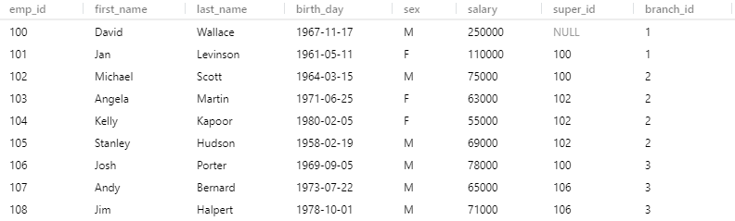
SELECT * FROM client;
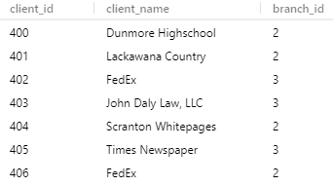

SELECT * FROM employee
ORDER BY salary DESC;
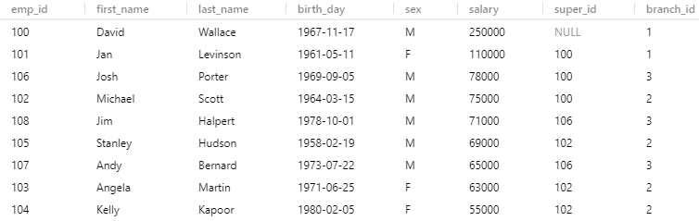
SELECT * FROM employee
ORDER BY sex, first_name, last_name;

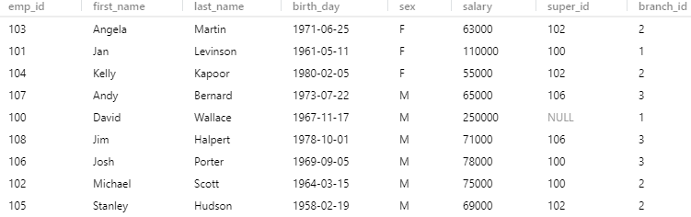
SELECT * FROM employee
LIMIT 5;
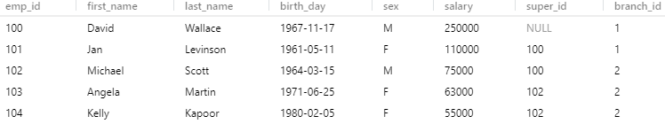

SELECT first_name, last_name FROM employee;

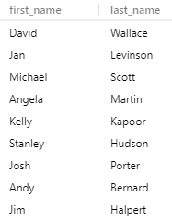

SELECT first_name AS forename, last_name AS surname
FROM employee;
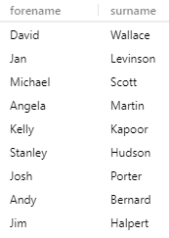

SELECT DISTINCT sex
FROM employee;
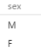

SELECT DISTINCT branch_id
FROM employee;
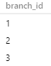

Funktionen
SELECT COUNT(emp_id) FROM employee;
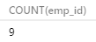

SELECT COUNT(emp_id)
FROM employee
WHERE sex = "F" AND birth_day > "1971-01-01";

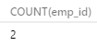

SELECT AVG(salary) FROM employee;
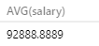

SELECT AVG(salary) FROM employee WHERE sex="F";
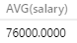

SELECT SUM(salary) FROM employee;
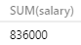

SELECT COUNT(sex), sex FROM employee
GROUP BY sex;
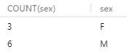

SELECT SUM(total_sales), emp_id
FROM works_with
GROUP BY emp_id;

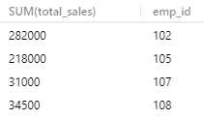

SELECT SUM(total_sales), client_id
FROM works_with
GROUP BY client_id;
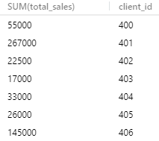

Wildcards
% = any character, _ = one character
SELECT * FROM client
WHERE client_name LIKE "%LLC";
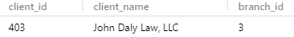

SELECT *
FROM branch_supplier
WHERE supplier_name LIKE "%Lable%";

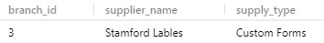

SELECT *
FROM employee
WHERE birth_day LIKE "____-10%";

SELECT *
FROM employee
WHERE birth_day LIKE "____-02%";

Union
SELECT first_name
FROM employee
UNION
SELECT branch_name
FROM branch;
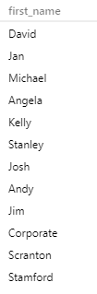

SELECT client_name
FROM client
UNION
SELECT supplier_name
FROM branch_supplier;


SELECT client_name, client.branch_id
FROM client
UNION
SELECT supplier_name, branch_supplier.branch_id
FROM branch_supplier;
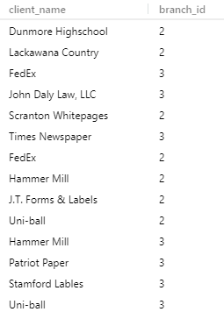

Joins

Inner Join
Joins werden benutzt um zwei Tabellen miteinander zu verknüpfen die das selbe Attribut teilen.
Find all branches and the names of their managers
SELECT employee.emp_id, employee.first_name, branch.branch_name
FROM employee
JOIN branch
ON employee.emp_id = branch.mgr_id;

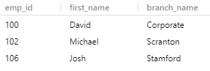

Left Join

SELECT employee.emp_id, employee.first_name, branch.branch_name
FROM employee
LEFT JOIN branch
ON employee.emp_id = branch.mgr_id;
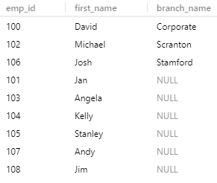

Right Join

SELECT employee.emp_id, employee.first_name, branch.branch_name
FROM employee
RIGHT JOIN branch
ON employee.emp_id = branch.mgr_id;
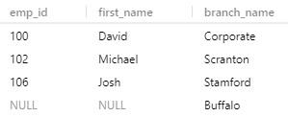

Full Outer Join

Ist ein ein Left Join kombiniert mit einem Right Join

Nested Queries
Find names of all employees who have sold over 30000 to a single client

SELECT employee.first_name, employee.last_name
FROM employee
WHERE employee.emp_id IN (SELECT works_with.emp_id
FROM works_with
WHERE works_with.total_sales > 30000);
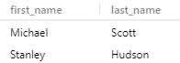

Find all clients who are handled by the branch that Michael Scott manages.
Assume you know Michael Scotts ID
SELECT client.client_name
FROM client
WHERE client.branch_id = (SELECT branch.branch_id
FROM branch
WHERE branch.mgr_id = 102
LIMIT 1
);

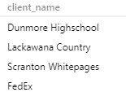

On Delete
CREATE TABLE branch (
branch_id INT PRIMARY KEY,
branch_name VARCHAR(40),
mgr_id INT,
mgr_start_date DATE,
FOREIGN KEY(mgr_id) REFERENCES employee(emp_id) ON DELETE SET NULL
);
DELETE FROM employee WHERE emp_id= 102;
SELECT * FROM branch;
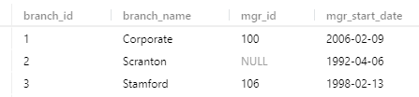

SELECT * FROM employee;

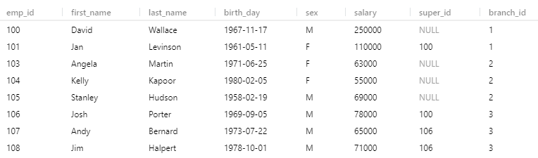
super_id => NULL

ON DELETE CASCADE
CREATE TABLE branch_supplier (
branch_id INT,
supplier_name VARCHAR(40),
supply_type VARCHAR(40),
PRIMARY KEY(branch_id, supplier_name),
FOREIGN KEY(branch_id) REFERENCES branch(branch_id) ON DELETE CASCADE
);
DELETE FROM branch
WHERE branch_id = 2;

SELECT * FROM branch_supplier;
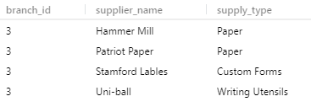

WICHTIG: Muss genutzt werden, wenn gelöschtes Attribut in einer anderen Tabelle als Primärschlüssel verwendet wird.

Trigger

DELIMITER $$
CREATE
TRIGGER my_trigger BEFORE INSERT
ON employee
FOR EACH ROW BEGIN
INSERT INTO trigger_test VALUES('added new employee');
END$$
DELIMITER;

Nützlich um Befehle zu automatisieren.
INSERT INTO employee
VALUES(109, 'Oscar', 'Martinez', '1968-02-19', 'M', 69000, 106, 3);

SELECT * FROM trigger_test;

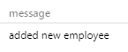

DELIMITER $$
CREATE
TRIGGER my_trigger1 BEFORE INSERT
ON employee
FOR EACH ROW BEGIN
INSERT INTO trigger_test VALUES(NEW.first_name);
END$$
DELIMITER;

INSERT INTO employee
VALUES(110, 'Kevin', 'Malone', '1978-02-19', 'M', 69000, 106, 3);

SELECT * FROM trigger_test;

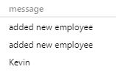

DELIMITER $$
CREATE
TRIGGER my_trigger2 BEFORE INSERT
ON employee
FOR EACH ROW BEGIN
IF NEW.sex = 'M' THEN
INSERT INTO trigger_test VALUES('added male employee');
ELSEIF NEW.sex = 'F' THEN
INSERT INTO trigger_test VALUES('added female employee');
ELSE
INSERT INTO trigger_test VALUES('added other employee');
END IF;
END$$
DELIMITER;

INSERT INTO employee
VALUES(111, 'Casandra', 'Jackson', '1988-02-19', 'F', 69690, 106, 3);

SELECT * FROM trigger_test;
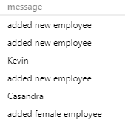

Bei Triggern kann man natürlich auch andere Aktionen als INSERT ,wie z.B.
DELETE oder UPDATE benutzen oder auch statt BEFORE, AFTER nutzen.
Um einen Trigger zu entfernen benutzt man die Syntax:
DROP TRIGGER trigger_name

ER Diagramme

Entity Ein Objekt das wir modellieren und dessen Daten wird speichern wollen

