DPSM: A Distributed PARASOL Simulation Manager

John Neilson & Pat Morin

email: neilson@scs.carleton.ca

Introduction and Overview

This document is intended as a brief users’ guide for DPSM (the Distributed PARASOL Simulation Manager) which distributes PARASOL experiment replications over a PVM (Parallel Virtual Machine) to achieve execution speedup. This manager is designed to oversee simulation experiments with the goal of achieving user-specified confidence intervals (CI’s) at minimum cost. DPSM is file driven through which it accepts user specifications for batches of simulation experiments defined by standard PARASOL simulation models, model input parameters, and target CI’s. The latter are specified by identifying one or more of the model’s statistical entities together with their maximum allowable confidence interval widths (at one of the 90%, 95%, or 99% levels). DPSM terminates an experiment when all its CI targets have been met.

We assume that the reader is thoroughly familiar with PARASOL and is at least superficially familiar with PVM. For the latter, see “PVM: Parallel Virtual Machine - A Users’ Guide and Tutorial for Networked Parallel Computing” by A. Geist et. al. MIT Press (or via netlib.org). DPSM requires PVM to be installed on each of the network nodes used, i.e., the appropriate PVM directory together with its related files and links established in the user’s home directory. It also requires that the two DPSM executables, i.e., dpsm and dpss, as well as the appropriate executable PARASOL simulation models be available on each node. Since PVM supports heterogeneous networks with respect to hardware and operating systems, this may imply the preparation of several different but equivalent versions of this software. These conditions are made simpler if the hosting network is homogeneous with respect to executables or uses a unifying file system such as NFS.

DPSM uses a master/slave distributed processing system. Experiments are controlled by a single master task which serves as the manager or controller. The slave tasks it controls are spawned on all the nodes of the virtual parallel machine. These slaves run the specified PARASOL model as a forked child process with whom they communicate via UNIX pipes. Input parameters and simulation replication results are piped via redirected standard i/o between slaves and their children. This architecture, see Figure 1, allows PARASOL models to be used without any modification.

Communication between slaves and the master is achieved through PVM IPC primitives. Figure 1 shows a five machine network with one DPSM master running on machine Alpha01 and DPSM slaves running on each of the other nodes. In fact, a slave and its child would also be running on Alpha01. As an experiment proceeds and results are passed back to the DPSM Master, it computes CI’s for each of selected statistical entities. It thus dynamically ascertains how many replications are required to meet the specified target CI’s and will terminate the experiment at the appropriate time.
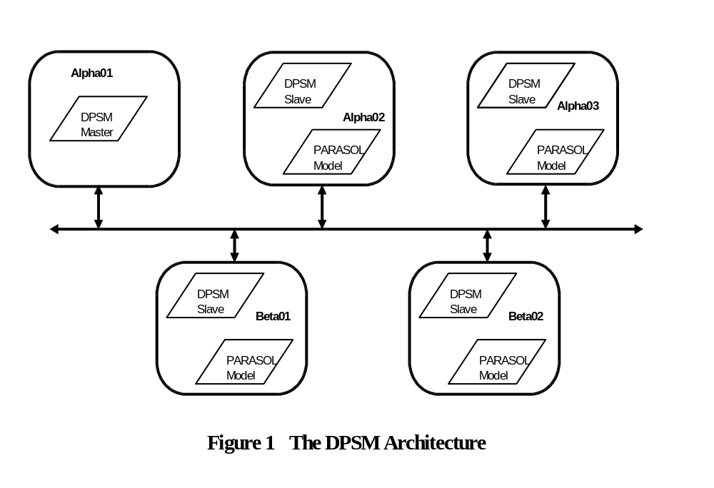The remainder of this document deals with the operational details of DPSM, specifically its user interface. Finally, a short section is devoted to user hints.

Operational Details and the User Interface

As noted, DPSM is file driven. In fact, two text files are required. The first file, called the hostfile, is used by PVM to establish its virtual machinery. It contains a list of host machines comprising the virtual machine. These are identified one per line by their IP hostnames. These machines should be rsh reachable from one another. For example, in the Network depicted in Figure 1, five machines are involved. The corresponding hostfile would identify these by name, i.e., Alpha01, Alpha02, Alpha03, Beta01, and Beta02. Note that the order is not important nor is it necessary to launch the DPSM Master on Alpha01. The recommended mechanism used to input the hostfile is a PVM executable called pvmd. This is accomplished through the following command issued from any of the PVM nodes:

% pvmd <hostfile>

The second text file for DPSM is the so-called simfile. It is here that the user scripts the batch of simulation experiments to be executed. An example simfile is shown in Figure 2 where a batch of three experiments is prescribed for the PARASOL Distributed Transaction Processing model, viz., DTP. Notice that the format of simfiles requires there be three distinct section types identified by keywords. The first section specifies the PARASOL model, i.e., the name of the executable, in this case dtp. This (or these if the virtual machine is heterogeneous) should be linked to the appropriate ~/pvm3/bin subdirectory. The second section is used to select the statistical entities for which CI’s will be specified. The beginning of this section is denoted by the keyword “STATISTICS” and it’s end is denoted by the the key word “ENDSTATISTICS”. Notice that each statistic is identified by its PARASOL name in double quotes. Each CI spec is given on one line as a pair of values, viz. the confidence level and interval half width expressed as a percent of the mean. For example, the “Client Response Time” is to have a 95% CI of ± 1%. At least one statistical entity must be so specified. Please note that if any statistical entity is mis-identified or if any CI specification is otherwise invalid, the batch of experiments associated with the bad spec will not be carried out.

MODEL: dtp # Specify PARASOL model

STATISTICS # Begin statistics section

"Client Response Time" 95 1.0
"Concentrator Node Utilization" 95 2.0
"Bus Utilization" 95 2.0

ENDSTATISTICS # End statistics section

EXPERIMENTS # Begin experiments section

DURATION: 500 # Specify replication duration

PARAMETERS # Parameters for experiment 1
50 5 .3 .7
ENDPARAMETERS

PARAMETERS # Parameters for experiment 2
100 5 .3 .7
ENDPARAMETERS

PARAMETERS # Parameters for experiment 3
200 5 .3 .7
ENDPARAMETERS

ENDEXPERIMENTS # End experiments section

Figure 2 A Simfile for DTP

Following the CI specifications is the section which specifies the experiments to be executed. This section is delimited by the keywords “EXPERIMENTS” and “ENDEXPERIMENTS”. Within this section at least one DURATION keyword headed line must be given to specify replication durations for the following experiments. Durations should be neither too short nor too long. Short replication runs may bias results due to startup transients or other short duration effects. On the other hand, long runs may waste computing resources since five replication runs will be executed before CI’s are checked. Note that experiment sections of a simfile may contain more that one replication duration spec so that it may be changed as required. In this example, however, a duration of 500 was used throughout.

Finally within the experiments section, the simfile contains one or more parameter sub-sections, each delimited by a PARAMETERS/ENDPARAMETERS pair. Each such sub-section defines the simulation parameters required to specify one experiment. Since dtp requires four input parameters aside from the customary PARASOL seed and duration parameters, there are four input values specified per sub-section. The four values specify the number of clients, the number of db workers, the cache hit probability, and the cache write probability. Apparently, this batch of experiments is to investigate the effects of client loading on response time.

This simfile gives an example for which a single “batch” of experiments is carried out using the same model, duration and monitoring the same variables, but using different parameters for three experiments. DPSM simfiles may define several such batches by simply concatenating single batch files.

On noticing that no seed values are specified, one may ask: “How are replications seeded?” The answer is simple, the DPSM Master looks after this detail by seeding each replication with its replication count number, i.e., the second replication is seeded with 2.

Having defined a simfile script, a DPSM user must now launch the manager. To do so the following command is used from any of the previously defined PVM nodes:

% dpsm <simfile>

At this point, the operation of DPSM is strictly “hands off”. Dpsm will now create and monitor slaves and produce result summaries for each experiment. These results appear on stdout and may be redirected as appropriate. Figure 3 gives the results of the experiments specified by the Figure 2 simfile script. User should be aware that, depending upon the size of the virtual machine and the mix of experiments in the simfile, it is possible for the order of the DPSM results to differ from the order in the simfile script.

******************************************************************************
Experiment#: 1
Model: dtp
Duration: 500
Input:
50 5 .3 .7
Number of replications performed: 7
Name Mean Confidence Interval
Client Response Time 0.158296 0.000579 @95% = 0.4% accuracy
Concentrator Node Utilization 0.290810 0.005692 @95% = 2.0% accuracy
Bus Utilization 0.058944 0.001164 @95% = 2.0% accuracy
******************************************************************************

******************************************************************************
Experiment#: 2
Model: dtp
Duration: 500
Input:
100 5 .3 .7
Number of replications performed: 10
Name Mean Confidence Interval
Client Response Time 0.193242 0.001834 @95% = 0.9% accuracy
Concentrator Node Utilization 0.577274 0.003727 @95% = 0.6% accuracy
Bus Utilization 0.118353 0.000741 @95% = 0.6% accuracy
******************************************************************************

******************************************************************************
Experiment#: 3
Model: dtp
Duration: 500
Input:
200 5 .3 .7
Number of replications performed: 42
Name Mean Confidence Interval
Client Response Time 1.545042 0.015423 @95% = 1.0% accuracy
Concentrator Node Utilization 0.915676 0.001419 @95% = 0.2% accuracy
Bus Utilization 0.190305 0.000325 @95% = 0.2% accuracy
******************************************************************************

Figure 3 DPSM Results for DTP

Notice that all CI targets have been met - some more so than others. This is to be expected since it would be coincidental for the three selected statistical entities to reach their specified targets simultaneously. Notice as well that the number of replications required varies from experiment to experiment. It is also worth noting that, due to the distributed nature of DPSM, users should not expect to reproduce results exactly if a second dpsm command is executed with the same simfile, even on the same virtual machine. This is true because of the non-deterministic global scheduling involved, particulalry in the presence of other loads on the host machines.

User Hints

Ignoring coarse-grained and communication overhead effects, it matters little what replication duration to choose since the product of the duration and the number of replications, i.e., the total simulated time is the primary governing factor determining CI’s. Furthermore, the speedup over simulation experiments run on a single machine realized through DPSM should approach theoretical values in most cases provided that replication durations are not poorly chosen. In these cases, the communication overheads will be very small as compared to the replication execution times. From this point of view, it would seem desirable to choose large replication durations since this strategy will mean small communication overheads and reduced chance of short replication biases. However, large durations also imply coarse-grained control and consequently processor time may be wasted when either replications are aborted, to permit diversion of processing power to another experiment, or CI’s are found that are tighter than necessary. The ideal is to strike a balance between extremes, where the required number of replications per experiment is of the order of a few dozen. In practice, this relatively easy to do, particularly when extensive experimentation is carried out with the same model. In such cases, it is appropriate to “probe” simulation parameter space before hand to gain some familiarity with it before scripting a monsterous batch of experiments.

It is possible to improve the performance of DPSM on PVMs which contain multiprocessor machines. In order to indicate to DPSM which machines are multiprocessors the string sp=<np> should be added to the host’s entry in the hostfile, where <np> is the number of processors in the machine multiplied by 1000. This will cause DPSM to spawn <np>/1000 slaves on these machines, rather than just one. Those familiar with PVM may recognize sp= as being used to indicate the relative speeds of machines, however with DPSM sp= should only be used to indicate multiprocessor machines. Using sp= will only improve performance on multiprocessor machines, and may actually cause performance to degrade if used on a single processor machine.

An alternative approach to estimating CI’s with PARASOL models is to use a single long simulation run that is “blocked” into a number of quasi independent trials. This is the so-called “blocked” statistical approach supported by the PARASOL function ps_block_stats. Its main advantage is simplicity. However, since it does not support CI targets but merely reports CI’s at the end of the simulation, it can be wasteful. Furthermore, since the “blocked” approach cannot make use of multiple hosts for each experiment or run, it cannot achieve speedups. Nonetheless, the “blocked” scheme should be considered, particularly when “probing” simulation parameter space.

Acknowledgement

The authors wish to acknowledge the work of Rob Davison who developed a first prototype version of DPSM which served as the basis for the current implementation.

