PARASOL Users’ Manual
(Version 3.1)

John Neilson

School of Computer Science

Carleton University

Ottawa, Canada

K1S 5B6

Table of Contents

1 Summary 3

2 Introduction 4

3 The PARASOL System Kernel 5
3.1 States and Transitions of a PARASOL Task 5
3.2 Hardware Configuration 7
3.3 Task Management 9
3.4 Inter-Task Communication 16
3.5 Task Synchronization 22
3.6 Statistics Capturing 24
3.7 Miscellaneous Functions 26
3.8 The Simulation Driver 28

4 PARASOL Demonstrations 31
4.1 Stochastic Rendezvous Network Model 31
4.2 Distributed Transaction Processing Model 33

5 PARASOL Operational Matters 35
5.1 PARASOL Software 35
5.2 PARASOL Opened 35
5.3 User Guidelines and Hints 37

PARASOL Users’ Manual

John E. Neilson

email: neilson@scs.carleton.ca

School of Computer Science
Carleton University
Ottawa, Canada
K1S 5B6

1 Summary

This document is intended as a users’ guide and reference manual to the PARASOL simulator system. Potential users are referred to the companion documents entitled “A PARASOL Tutorial”, which is intended to introduce readers to the capabilities of PARASOL through case studies, and to “PARASOL++: A PARASOL C++ Library”, which describes an object oriented C++ interface to PARASOL. On the other hand, this document contains a brief overview of the goals of PARASOL, a formal description of the user interface, a description of two demonstration applications, and a short guide to operational matters. Complete source code for these PARASOL demonstrations is available for reference in <PARASOL HOME >/examples.

2 Introduction

In order to make clear what PARASOL is, we will begin by explaining what it is not. It is not a general purpose discrete event simulation package aimed at a broad range of application domains. Nor is PARASOL a parallel simulation system employing time warp technology and speculative computation to speed up simulation execution. On the other hand, it is an execution-based tool aimed at performance prediction of computer systems involving concurrent and possibly cooperating software elements. Furthermore, because PARSOL is execution-based , it also provides a flexible software prototyping environment for distributed and/or parallel computer systems. Its dual capabilities in prototyping and performance prediction serve PARASOL well as a Software Performance Engineering (SPE) tool spanning the software development process from early design through to system maintenance and tuning.

Clearly PARASOL is focused on a specific modelling niche, viz., computer systems involving concurrent software executing in complex environments. PARASOL’s emulated execution environments are built from its “hardware” components, viz., processing nodes (possibly heterogeneous) interconnected with communication devices of various types and capacities. The concurrent software, which may represent both application and operating system software, is modelled explicitly with user-defined “tasks” written in C or C++. Operationally speaking, a PARASOL-based simulator runs as a single process in a POSIX compliant host environment. PARASOL is written entirely in ANSI C and is therefore highly portable and easily extended.

As stated above, a typical PARASOL application is built on a network of heterogeneous nodes. These may be of either the uniprocessor or multiprocessor persuasion. Each node has a single ready-to-run queue and is managed by either a built-in scheduler, offering a number of scheduling discipline options, or by a user-defined scheduler. Network connections are made with shared buses or dedicated point-to-point one-way links. Both of these mechanisms are user configurable. A simulated execution environment may be arbitrarily large since PARASOL imposes no limits. (The hosting POSIX machine will, however, when it runs out of memory.) Environments with more than 1000 processors have been emulated routinely.

To the execution environment, users add software, in the form of C functions or C++ objects, which define the behaviour of application tasks, often refered to as “system” tasks. Depending upon the degree of modelling detail required, this may involve, at one extreme, a detailed coding of a real application task or, at the other, the coding of a simplified and/or abstract model of a real task. From the nodeller’s perspective, the PARASOL software interface may be thought of as a sort of primitive distributed operating system. As such it supplies a number of services which are accessible for modelling the application software. Specifically, PARASOL supplies a library of “system calls” to support: task management, including dynamic task creation and destruction as well as task migration; inter-task communication, using port-based messaging and various shared memory mechanisms; and task synchronization, through spin locks and semaphores. For performance modelling, the PARASOL library also includes support for the collection and reporting of statistics and the generation of random variates.

Typically, in addition to writing the aforementioned “system” tasks, users must write a special task called “genesis” (actually ps_genesis) within which users define the execution environment and the initial configuration of the software system with respect to “system” tasks. Genesis is an example of a “non-system” or “control” task which supports the simulation but does not model application software. It and other similar tasks run on a special dedicated node, i.e., node 0, also known as the PARASOL Base Node. “Non-system” tasks serve a variety of purposes including acting as load generators, system monitors, etc. In short, they may play either active or passive roles.

The next section of this manual describes the so-called kernel and begins with a description of PARASOL task states and transitions. It then provides detail of the PARASOL kernel/user interface in a UNIX man page reference style. Following that is a section containing two PARASOL demonstrations which are intended to illustrate different model styles. As well, they demonstrate many of the features of and techniques involved with PARASOL. The final section is operationally oriented dealing with the construction of PARASOL models and giving insight into the inner workings of PARASOL for the benefit of more adventuresome users. It also contains some guidelines and hints which can make model building more productive and a brief overview of the built-in debugging features of PARASOL.

3 The PARASOL System Kernel

A PARASOL simulation involves a number of components some of which have already been mentioned. For example, the notion of processing nodes each with one or more cpu’s and communication facilities (links and buses) are essential for the construction of a host network. As well, mention has been made of elements called tasks. These are single threaded software entities that may be used to model several things including: application software; operating system software such as interrupt service routines and servers; hardware devices such as disk drives; or even exogenous load generators such as human data input operators. Other entities in the PARASOL system include: message ports (and messages); buffer pools; task synchronization spin-locks and semaphores; glocal variables; and statistics capturing objects.

This section describes the PARASOL kernel - a fairly onerous task. Because the principal modelling activity involves the design and coding of tasks, we will begin by discussing the essential nature of PARASOL tasks in terms of their states and state transitions. This approach will provide the basic understanding of the “raw material” with which the PARASOL modeller must work. Next, detailed descriptions of the kernel/user interface are presented. This presentation is organized into the following segments: network hardware configuration; task management; inter-task communication; task synchronization; statistics capturing; and, a miscellaneous segment including random number generation and glocal variable support. The last segment of the section deals with the simulation driver and the remaining kernel/user interface details.

3.1 States and Transitions of a PARASOL Task

Conventionally, when dealing with the states of tasks, one thinks of an executing or running state in which the task in question is actually executing code, a ready state for tasks which are ready-to-run but lack a processor on which to do so, and one or more other types of blocked states in which the task is blocked awaiting some event or the availability of some resource other than a processor. PARASOL is similar but because it simulates a multiprocessor environment in a single threaded application, some additional complexity is introduced.

Figure 1 shows the essential features of the state space and transitions possible for a PARASOL task. Notice first that there are several states referred to as “executing” states. In addition, there are five “non-executing” states. Let us deal with the non-executing group first. PARASOL uses a table for storage of task-related information. Unused slots in this table correspond to a task in the “free” state. Upon task creation, the state changes to “suspended” which is a useful state in which to “park” a task that may be activated later. Here it does not compete for system resources and poses no system overhead to processor scheduling, for example. The “ready” state means simply that the task is ready to run but lacks a processor. It will be considered for transition to an executing state should a processor on which it can execute become available. The “sleeping” state allows a task to take itself out of circulation. The main differences between this state and the suspended state are: (i) only an executing task can put itself to sleep (sleep is a self-induced state) whereas a task can suspend not only itself but also its descendants; and (ii) the sleep state can “time-out” but the suspended state cannot. Finally, the “receiving” state is a blocking state in which a task is awaiting the arrival of an incoming message. This is also a self-induced state that may also optionally time-out. Finally, note that the “suspended” state is used to “park” tasks which block on semaphore wait system calls.

Turning our attention now to the so-called executing states, we see that there are a total of seven. Since PARASOL itself is single threaded, it is clear that a most one task can actually be executing code at any given instant although PARASOL must be capable of creating the illusion of concurrency. The state of the task that is actually executing is “hot”. With PARASOL, time stands still while a task is hot. In order to simulate the passage of time while consuming processor tics, a hot task must execute one of a small set of “system calls” and enter one of the other executing states. In each case, the processor is logically retained while some other task may be permitted to become hot using a different cpu. The compute call causes a transition to the “computing” state. Here the task retains a processor for a specified time and cannot become hot again until simulation time has advanced appropriately. As shown on the transition diagram, scheduler transitions from the compute state to the ready state are possible should priority preemptions or quantum time-outs occur. The “sync” state is similar in that it is a self-induced executing state entered through the sync system call. The difference is that this state cannot be interrupted through preemptions or quantum time-outs. Rather it terminates by a sync time-out or transition to other sync states, viz., “sync/free” or “sync/suspend”. These two states permit a “syncing” task to be suspended or killed but only after the sync time-out event. The “blocked” state can be entered using the hold system call. Its use is appropriate for systems where processor/task assignments are static and “one-to-one” as is the case, for example, in most highly parallel systems. As will be explained later, the transition from the blocked to the hot state is quick and thus the use of this processor consumption mechanism increases the efficiency of the simulation.

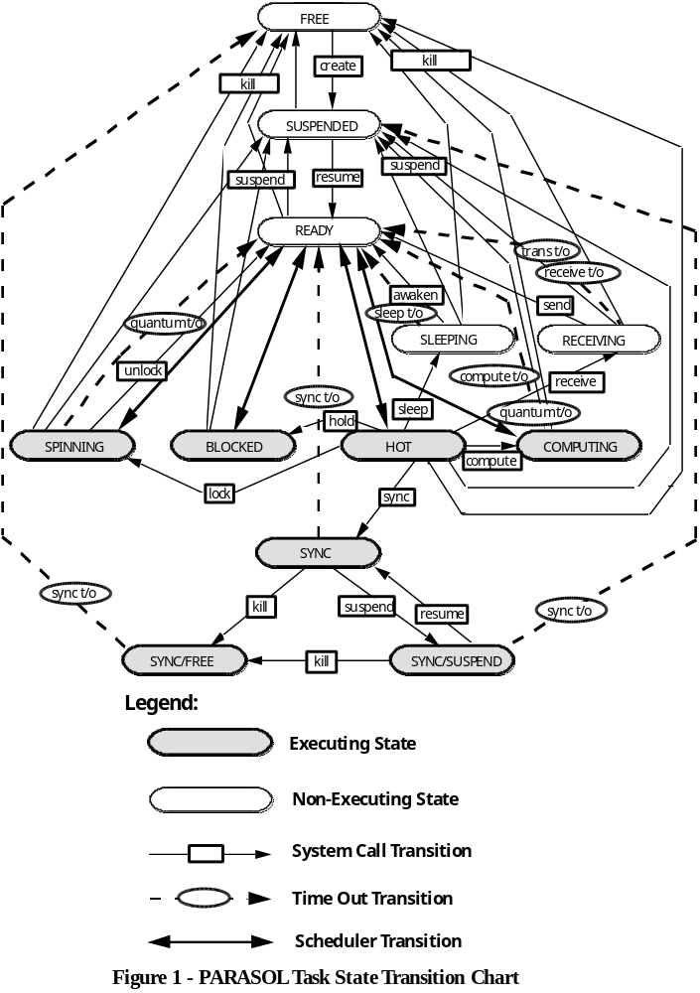
In summary, three distinct “demand” processor consumption states and system calls are needed: one to promote efficiency in cases when processors are statically allocated one to a task; a second to prohibit task preemption in “fine-grained” simulations where round robin scheduling or priority preemption might otherwise occur; and a third to provide processor sharing through preemption in situations when task execution is not tightly coupled. Besides these execution states, the “spinning” state is entered through the lock system call when a synchronizing spin-lock is required but unavailable. Since the cpu resource is held while spinning, this is an executing state. It may be interrupted by the scheduler and typically ends when a task holding the requested spin-lock releases it via the unlock system call. Notice that computing, sync, blocked, and spinning are self-induced states that typically allow another task to become hot.

As indicated above, the blocked state enables quick transitions to the hot state. This is so since these events are handled without the need of a context switch to the simulation driver, i.e., hand-off scheduling is used. For highly parallel systems this can mean a significant reduction in simulation overheads. Furthermore, for the same reasons, PARASOL internally makes extensive use of the blocked state for its task scheduling. This strategy allows tasks that would otherwise be ready to run, to claim their processor and leave the ready state while permitting the current hot task to remain so. This technique permits “hand-off” scheduling.

3.2 Hardware Configuration

The first requirement of a PARASOL user is the definition of the simulated system hardware. This is typically accomplished in the so-called genesis task by means of calls to four functions: ps_build_node, ps_build_node2, ps_build_bus, and ps_build_link. These functions construct instances of nodes, buses and links according to specifications contained in their arguments. The first of the node functions constructs PARASOL nodes that are scheduled according to built-in options while the second version allows user-defined scheduling. Clearly, since buses and links connect nodes, nodes must be constructed first. Finally, three functions, viz., ps_idle_cpu, ps_ready_queue, and ps_schedule are provided for node loading information and user scheduling. The following descriptions are in the “Unix-style” for conciseness.

NAME
ps_build_node, ps_build_node2 - PARASOL node constructors

SYNOPSIS
#include <parasol.h>

SYSCALL ps_build_node(name, ncpu, speed, quantum, discipline, stat_flags)
char *name;
int ncpu;
double speed;
double quantum;
int discipline;
int stat_flags;

SYSCALL ps_build_node2(name, ncpu, speed, scheduler_code, stat_flags)
char *name;
int ncpu;
double speed;
void (*scheduler_code)(void);
int stat_flags;

DESCRIPTION
These functions construct a PARASOL node with a name specified by the name string. The number of processors at the node is specified by the argument ncpu. A speed factor given by speed is used to scale execution times for all processors within the constructed node. Factors greater than one mean reduced execution times. Ps_build_node uses the next two arguments to specify scheduling - a non-zero value of quantum specifies the size of the time slice for round-robin (RR) scheduling. The queueing discipline for the ready queue is FCFS (first-come-first-served), HOL (head-of-the-line or non-preemptive priority) or PR (preempt/resume priority). Ps_build_node2 is intended for user-scheduled nodes - with scheduler_code specifying the user-defined scheduling function. The stat_flags should be formed by or’ing the following to select the processor utilization statistics desired:

SF_PER_HOST - on a per host basis - aggregated over tasks
SF_PER_NODE - aggregated over hosts and tasks
SF_PER_TASK_HOST - not aggregated, i.e., on a per task-host basis
SF_PER_TASK_NODE - on a per task basis - aggregated over hosts

A value of FALSE is used to indicate that no utilization statistics are desired. If the constructor call is successful, the returned value is the node id which must be used to reference to the constructed node.

NOTES
This function will return a SYSERR if invalid values of any arguments are specified.

NAME
ps_build_bus - PARASOL bus constructor

SYNOPSIS
#include <parasol.h>

SYSCALL ps_build_bus(name, ncount, node_array, trans_rate, discipline, stat_flag)
char *name;
int ncount;
int node_array[];
double trans_rate;
int discipline;
int stat_flag;

DESCRIPTION
This function constructs a PARASOL bus with a name specified by the name string. It connects ncount nodes specified in the node_array. Messages are transmitted at the rate of trans_rate characters per second. Bus arbitration is specified by discipline which may be FCFS (first-come-first-served) or RAND (random order). If the stat_flag is TRUE, bus utilization statistics will be captured and reported. If the returned value is not SYSERR, it represents the bus id that must be used when referencing the constructed bus.

NOTES
This function returns a SYSERR if invalid values of any arguments are specified. When specifying trans_rate allow for additional characters associated with overheads by either reducing the rate or expanding the message size accordingly.

NAME
ps_build_link - PARASOL link constructor

SYNOPSIS
#include <parasol.h>

SYSCALL ps_build_link(name, source, destination, trans_rate, stat_flag)
char *name;
int source;
int destination;
double trans_rate;
int stat_flag;

DESCRIPTION
This function constructs a PARASOL one-way link with a name specified by the name string. It connects the source node to the destination node Messages transmitted at the rate of trans_rate characters per second. Link arbitration is strictly FCFS (first-come-first-served). If the stat_flag is TRUE, link utilization statistics will be captured and reported. If the returned value is not SYSERR, it represents the link id that must be used when referencing the constructed link.

NOTES
This function returns a SYSERR if invalid values of arguments are specified. When specifying trans_rate allow for additional characters associated with overheads by either reducing the rate or expanding the message size accordingly.

NAME
ps_idle_cpu, ps_ready_queue - return node loading data.

SYNOPSIS
#include <parasol.h>

SYSCALL ps_idle_cpu(node)
int node;

SYSCALL ps_ready_queue(node, max_tasks, task_array)
int node;
int max_tasks;
int task_array[];

DESCRIPTION
These functions provide load balancing data to callers. Each takes an argument node specifying the node involved. Ps_idle_cpu returns the number of idle cpu hosts and ps_ready_queue returns the size of the ready queue. The latter also returns in task_array the task ids of those in the ready queue. The parameter max_tasks specifies the size of task array. Both return SYSERR if an invalid node id is specified.

NAME
ps_schedule - schedule a task to run

SYNOPSIS
#include <parasol.h>

SYSCALL ps_schedule(task, cpu)
int task;
int cpu;

DESCRIPTION
This function is designed to support user-specified scheduling and, thus, may be called only by “scheduler” tasks. Its arguments specify the id of the task to run and the host cpu on which it is to run. The node involved is implicitly defined as the node on which the caller runs. The function returns SYSERR if either argument is invalid, the caller is not a scheduler task, or the task was not created to run on the specified node.

3.3 Task Management

Within PARASOL, tasks are used to model virtually everything but nodes, buses, and links. In fact , they may be used to model variants of these objects should the user wish. Besides supplying the necessary code for task classes, it it the responsibility of the user to manage tasks. With the exception of one user task, viz., genesis, all task instances must be instantiated using the ps_create system call (or its alternate ps_create2) and activated with the ps_resume call. As shown in Figure 1, tasks may be destroyed and made free with ps_kill or merely suspended with ps_suspend. Depending on the type of task, users may also wish to model their execution times. Previously, the calls ps_compute, ps_hold and ps_sync were described which allow a task to consume simulated processor tics. Additional system calls are available to ps_sleep, ps_awaken, ps_adjust_priority, and to ps_migrate. Finally, descriptions are given of a few supporting functions and macros which may prove useful to users.

NAME
ps_create and ps_create2 - PARASOL task constructors

SYNOPSIS
#include <parasol.h>

SYSCALL ps_create(name, node, cpu, class_code, priority)
char *name;
int node;
int cpu;
void (*class_code)(void);
int priority;

SYSCALL ps_create2(name, node, cpu, class_code, priority, stacksize)
char *name;
int node;
int cpu;
void (*class_code)(void);
int priority;
double stacksize;

DESCRIPTION
These system calls construct a task with a name specified in the name string. It will execute on node id node using either any cpu host specified by a cpu value of ANY_HOST or the specified cpu index. (Indices range from 0 to ncpu-1 - see ps_build_node). The C function representing the class code is specified by name in class_code. This function should be without arguments and not return a value. If necessary, parameters and results may be passed through external variables or by message passing. The priority of the task is specified in priority. Ps_create2 has an additional argument, stacksize, which specifies an alternate stacksize to the default stacksize in relative terms, i.e., as the ratio of the desired stacksize to the default stacksize. If the returned value is not SYSERR, it represents the task id that must be used when referencing the constructed task.

NOTES
These functions return a SYSERR if invalid values of arguments are specified. Otherwise, the constructed task is in the suspended state and is a leaf in the user task creation tree rooted in genesis. This tree maintains the ancestry of all created tasks and is used to determine the validity of some system calls, e.g., ps_kill. All PARASOL tasks are created owning a single message port known as the standard port. This port can not be destroyed or passed to another since it provides the basic means of inter-task communication via messaging. See the inter-task communication system calls for further information. A particularly vexing problem with tasks is that they can overrun their stacks. This is particularly true of tasks that have a deeply nested function call behaviour, e.g., in recursive routines. By default, i.e., using ps_create, PARASOL chooses stacks that are adequate for most tasks. Should a simulation behave in a peculiar fashion or crash, it is likely that one or more tasks has blown its stack - the remedy is to enlarge it. See the description of ps_headroom for guidance in selecting stacksizes.

NAME
ps_kill - PARASOL task destructor

SYNOPSIS
#include <parasol.h>

SYSCALL ps_kill(task)
int task;

DESCRIPTION
This function destroys the task specified as task returning it to the free state for possible reuse. It will also destroy all of the descendants (direct or otherwise) of the specified task. When a task is killed, all of the resources held by it (cpu, spin-locks, ports, and messages) are returned for possible reallocation. Successful operation is indicated by a return value of OK while SYSERR indicates failure of the call.

NOTES
This function will fail if the argument identifies a free or invalid task or if the target task is not a descendant of the caller or the caller itself. The kernel of PARASOL handles a mainline return or “running off the end” through an implied call to ps_kill(ps_myself). Since killing a task removes it and all of its descendants from the task creation tree, this function refuses to kill the genesis task since that would effectively abort the simulation.

NAME
ps_resume - resumes or makes runable a suspended PARASOL task

SYNOPSIS
#include <parasol.h>

SYSCALL ps_resume(task)
int task;

DESCRIPTION
This function resumes the suspended or sync/suspend task whose id is specified as task . The resulting state of the task will depend upon the availability of a host cpu. Successful operation is indicated by a return value of OK while SYSERR indicates failure of the call.

NOTES
This function will fail if the argument identifies a free or invalid task.

NAME
ps_suspend - suspends a PARASOL task

SYNOPSIS
#include <parasol.h>

SYSCALL ps_suspend(task)
int task;

DESCRIPTION
This function suspends the task id specified as task returning it to the suspended state (or possibly the sync/suspend state). Successful operation is indicated by a return value of OK while SYSERR indicates failure of the call.

NOTES
This function will fail if the argument identifies an invalid task. Suspending a task releases any spin-locks it may hold but retains all ports held at the time of the call as well as any messages in its port queues.

NAME
ps_sleep - causes the calling task to sleep

SYNOPSIS
#include <parasol.h>

SYSCALL ps_sleep(duration)
double duration;

DESCRIPTION
This function causes the calling task to leave the hot state and enter the sleeping state. The duration of the sleep is specified by duration if its value exceeds zero. A negative or zero duration is used to release the hosting cpu and enter the ready state, if appropriate, i.e., if the queueing discipline of the host node is FCFS and a runable ready task exists, or if the discipline is HOL or PR and a runable task of equal or greater priority is ready.

NOTES
This function will never fail. Since the sleeping state is a non-executing state, this call typically frees the hosting cpu for other duty.

NAME
ps_awaken - awakens a sleeping PARASOL task

SYNOPSIS
#include <parasol.h>

SYSCALL ps_awaken(task)
int task;

DESCRIPTION
This function awakens the sleeping task whose id is specified as task returning it to the ready state or an executing state if a cpu host is available. Successful operation is indicated by a return value of OK while SYSERR indicates failure of the call.

NOTES
This function will fail if the argument identifies an invalid task.

NAME
ps_compute - causes the calling task to consume cpu tics

SYNOPSIS
#include <parasol.h>

SYSCALL ps_compute(duration)
double duration;

DESCRIPTION
This function causes the calling task to consume the cpu time specified in duration. Successful operation is indicated by a return value of OK while SYSERR indicates failure of the call.

NOTES
This function will fail if the argument is negative since this would imply rolling back time. The requested cpu time may be interrupted by higher priority tasks or through round-robin scheduling. This call causes time to advance prior to the execution of the code following the call.

NAME
ps_sync - causes the calling task to consume cpu tics

SYNOPSIS
#include <parasol.h>

SYSCALL ps_sync(duration)
double duration;

DESCRIPTION
This function causes the calling task to consume, without interruption, the cpu time specified in duration. Successful operation is indicated by a return value of OK while SYSERR indicates failure of the call.

NOTES
This function will fail if the argument is negative since this would imply rolling back time. The requested cpu time cannot be interrupted. This call causes time to advance prior to the execution of the code following the call. Furthermore, because it is not interruptible, this allows the execution of code to be bound to clock advancement while retaining the host processor. Typically, sync calls will be associated with fine-grained execution detail and involve relatively short durations as compared with compute calls.

NAME
ps_hold - causes the calling task to consume cpu tics

SYNOPSIS
#include <parasol.h>

SYSCALL ps_hold(duration)
double duration;

DESCRIPTION
This function causes the calling task to consume the cpu time specified in duration. Successful operation is indicated by a return value of OK while SYSERR indicates failure of the call.

NOTES
This function will fail if the argument is negative since this would imply rolling back time. Although the requested cpu time can be interrupted, it is typically not since this call should be reserved for situations in which processors are allocated to single tasks. If duration is positive, this call causes time to advance prior to the execution of the code following the call. Typically, hold calls will be associated with fine-grained execution detail and involve relatively short durations as compared with compute calls.

NAME
ps_migrate - migrates a PARASOL task from one node to another

SYNOPSIS
#include <parasol.h>

SYSCALL ps_migrate(task, node, cpu)
int task;
int node;
int cpu;

DESCRIPTION
This function transfers a task whose id is specified as task from its current node to that specified by node. The designated cpu specified by cpu may be any valid cpu id on the new node or ANY_HOST which permits the task to run on any cpu within the new node. Successful operation is indicated by a return value of OK while SYSERR indicates failure of the call.

NOTES
This function will fail if the argument identifies an invalid task, a syncing task, or a task which is not a descendant of the caller or the caller itself. It will also fail if the target host node and cpu arguments are invalid or if the target task is genesis. Since migration implies a different address space all spin-locks held at the time of the call are released.

NAME
ps_adjust_priority - adjusts the priority of a PARASOL task

SYNOPSIS
#include <parasol.h>

SYSCALL ps_adjust_priority(task, priority)
int task;
int priority;

DESCRIPTION
This function adjusts the priority of a task whose id is specified as task . The new effective priority is specified by priority. Successful operation is indicated by a return value of OK while SYSERR indicates failure of the call.

NOTES
This function will fail if the argument identifies an invalid task or a task which is not a descendant of the caller or the caller itself. It will also fail if the priority requested is invalid, i.e., outside the interval (MIN_PRIORITY, MAX_PRIORITY). Note that priority adjustment can cause immediate task state transitions.

The following functions are useful for identifying those buses and links associated with the tasks:

NAME
ps_buses, ps_send_links, ps_receive_links - returns bus and link information

SYNOPSIS
#include <parasol.h>

SYSCALL ps_buses(task, &bcount, bus_array)
int task;
int bcount;
int bus_array[];

SYSCALL ps_send_links(task, &lcount, link_array)
int task;
int lcount;
int link_array[];

SYSCALL ps_receive_links(task, &lcount, link_array)
int task;
int lcount;
int link_array[];

DESCRIPTION
These functions return counts and arrays of buses or links associated with the specified task. The number of associated buses (or links) are returned in bcount (or lcount) while lists of the actual bus (or link) ids are returned in the array bus_array (or link_array). A returned value of OK indicates that the call was successful.

NOTES
These functions fail and return SYSERR if the task is non-existent. Care should be exercised in using these functions since overflows can occur if the size of the bus_array (or link_array) is insufficient.

The following functions and macros are useful ancillaries to the above SYSCALL’s for task management:

NAME
ps_children, ps_siblings, ps_myself, ps_task_parent, ps_my_parent - close relations functions and macros

SYNOPSIS
#include <parasol.h>

SYSCALL ps_children(&nc, child_array)
int nc;
int child_array[];

SYSCALL ps_siblings(&ns, sibling_array)
int ns;
int sibling_array[];

int ps_myself

int ps_task_parent(task)
int task;

int ps_my_parent

DESCRIPTION
These tools are useful to determine the task id’s of close relatives. The function ps_children returns the number of children of the calling task in nc and their ids in child_array. Similarly ps_siblings returns the number of siblings of the calling task in ns and their ids in sibling_array. Ps_myself is a macro which evaluates to the caller’s id while the macros ps_task_parent and ps_my_parent yield the id of the parent of the appropriate task.

NOTES
Care should be exercised in using the ps_children and ps_siblings since overflows can occur if the size of the array is insufficient.
NAME
ps_task_node, ps_my_node, ps_task_host, and ps_my_host - node and host id macros

SYNOPSIS
#include <parasol.h>

int ps_task_node(task)
int task;

int ps_my_node

int ps_task_host(task)
int task;

int ps_my_host

DESCRIPTION
These return the node and host (or processor) ids of the associated task.

NOTES
The ps_task_node and ps_task_host macros may return misleading results if the task is non-existent.

NAME
ps_task_priority, ps_my_priority, ps_task_name, ps_my_name, ps_task_state - miscellaneous task macros

SYNOPSIS
#include <parasol.h>

int ps_task_priority(task)
int task;

int ps_my_priority

char * ps_task_name(task)
int task;

char * ps_my_name

int ps_task_state(task)
int task;

DESCRIPTION
These macros return the priority, name or state of the appropriate task. Numerical values of state can be interpreted using the definitions supplied in the para_protos.h file.

NOTES
These macros may return misleading results if the task is non-existent.

NAME
ps_headroom - returns stack headroom

SYNOPSIS
#include <parasol.h>

SYSCALL ps_headroom(void)

DESCRIPTION
This function returns the headroom (in bytes) remaining on the stack of the caller at the time of the call.
NOTES
PARASOL does not automatically detect stack overflows. One should be aware of the possibility of bizarre behaviour as a consequence of stack overflow. This function allows one to diagnose such ills. Keep in mind that the alternate PARASOL task constructor ps_create2 is available. Note, as well, that some library calls are notorious for consumption of stack space, e.g., printf. Calling this function early in the lifetime of a task will provide an estimate of its stacksize; made better if one adds the size of the first stack frame, i.e., the number of bytes required for auto variables declared in the mainline function. Subsequent calls to this function, where stack overruns are suspected, will return negative values if the stack is blown.

3.4 Inter-Task Communication

PARASOL uses a port-based style of inter-task communication. Briefly, the idea is that entities called ports are the receptors of messages. That is to say, when a message is sent, it is directed to a port rather than another task. In PARASOL, ports have a virtually unlimited capacity for queueing incoming messages. Since tasks and ports may be arbitrarily distributed over the network, a total of seven system calls are available for sending messages, viz.; ps_send, ps_resend, ps_bus_send, ps_link_send, ps_broadcast, ps_localcast, and ps_multicast. A port may be allocated to or owned by a task which alone can retrieve messages using ps_receive (for FIFO order), ps_receive_last (for LIFO order), or ps_receive_random (for random order). Besides private ports, shared ports exist where tasks perform ps_receive_shared system calls to retrieve messages. The system calls ps_allocate_port, ps_allocate_port_set, ps_allocate_shared_port, ps_release_port, ps_release_shared_port, ps_pass_port, ps_join_port_set, and ps_leave_port_set are available for port management. Tasks, by default, own one port known as their standard port. They may own an arbitrary number of other ports as well. Within the private ports belonging to any given task, ports may be grouped into port sets to facilitate message handling. As well, ports, complete with any unreceived messages that they may contain, may be passed from one task to another. Grouped with communication primitives are the buffer pool functions since these are particularly useful in message passing although they may be useful in other applications as well. These include the calls: ps_build_buffer_pool, ps_free_buffer, ps_get_buffer, and, ps_buffer_size. This section concludes with description of other supporting functions and macros relating to port identification, etc.

NAME
ps_allocate_port, ps_allocate_port_set, ps_allocate_shared_port - allocate PARASOL ports

SYNOPSIS
#include <parasol.h>

SYSCALL ps_allocate_port(name, task)
char *name;
int task;

SYSCALL ps_allocate_port_set(name)
char *name;

SYSCALL ps_allocate_shared_port(name)
char *name;

DESCRIPTION
These functions allocate ports with the name defined in the name string. In the case of ps_allocate_port, a private port is created and assigned to the specified task. For ps_allocate_port_set, a port representing a set of ports is assigned to the caller. Finally, ps_allocate_shared_port creates a shared port which is not assigned to any task. Once successfully created, a port will become the receptor of any messages directed towards it. Messages are queued FCFS and remain in the port until “received” or the port is “released”. A returned value of SYSERR indicates that a call has failed; otherwise the returned value is the port id used to reference the port.

NOTES
The ps_allocate_port function fails if the task argument specifies an invalid task argument. Ps_allocate_shared_port actually creates a special “dispatcher” task which owns the created port and relays its messages to others on demand. This dispatcher task is created on the node of the caller.

NAME
ps_release_port and ps_release_shared_port - release PARASOL ports for reuse

SYNOPSIS
#include <parasol.h>

SYSCALL ps_release_port(port)
int port;

SYSCALL ps_release_shared_port(port)
int port;

DESCRIPTION
These functions release ports whose id is specified in port freeing them for possible reuse. All contained messages are lost. Note that private ports are automatically released when the owning task is killed. Successful operation is indicated by a returned value of OK; otherwise SYSERR is returned.

NOTES
Both functions fail if the port argument specifies an invalid or free port or, in the case of ps_release_port, if the port is the standard port of its owner. With the ps_release_shared_port call, the owning “dispatcher” task is simply killed and the port vanishes.

NAME
ps_pass_port - passes a PARASOL port from one task to another task

SYNOPSIS
#include <parasol.h>

SYSCALL ps_pass_port(port, task)
int port;
int task;

DESCRIPTION
This function passes a port whose id is specified by port to a task whose id is given by task. All contained messages are retained. Successful operation is indicated by a returned value of OK; otherwise SYSERR is returned.

NOTES
This function fails if the port argument specifies an invalid or “free” port or the task argument specifies an invalid or “free” task or if the current port owner is not a descendant of the calling task or the calling task itself. Also, the call fails if the port is a standard port, a port set, or a shared port.

NAME
ps_join_port_set and ps_leave_port_set - moves ports into and out of port sets

SYNOPSIS
#include <parasol.h>

SYSCALL ps_join_port_set(port_set, port)
int port_set;
int port;

SYSCALL ps_leave_port_set(port_set, port)
int port_set;
in port;

DESCRIPTION
These functions move a specified port owned by the caller into/out of a port_set owned by the caller. All contained messages are retained either way. Ports placed within a port set are no longer accessible through ps_receive on their ids. Such ports can belong to at most one port set at a time. Successful operation of these calls is indicated by a returned value of OK; otherwise SYSERR is returned.

NOTES
These functions fail if either argument is an invalid port or a port not owned by the caller or one of its descendants. Also ps_join_port_set fails if port is already a member of a port set or a standard port. Finally, ps_leave_port_set fails if port is not a member of port_set.

NAME
ps_send, ps_resend, ps_bus_send, ps_link_send - sends a message to a PARASOL port

SYNOPSIS
#include <parasol.h>

SYSCALL ps_send(port, type, text, ack_port)
int port;
int type;
char *text;
int ack_port;

SYSCALL ps_resend(port, type, timestamp, text, ack_port)
int port;
int type;
double timestamp;
char *text;
int ack_port;

SYSCALL ps_bus_send(bus, port, type, size, text, ack_port)
int bus;
int port;
int type;
int size;
char *text;
int ack_port;

SYSCALL ps_link_send(link, port, type, size, text, ack_port)
int link;
int port;
int type;
int size;
char *text;
int ack_port;

DESCRIPTION
These functions create and send messages to the port identified as port. They never block the calling task. In each case the message carries a type code, type, and, for the bus and link sends, a size in characters, size, of the simulated message. The ps_resend function asks for a timestamp which is affixed to the message in lieu of the current time which is used by all other message sending functions - its use is primarily for forwarding messages without destroying the original sender’s timestamp. The message may be real in the sense that is can contain an arbitrary string of text in text which may be the null string if there is no useful information to send. By using the C functions sprintf and sscanf to encode and decode respectively, arbitrarily complex messages may be exchanged using the text field. Finally, the sender may supply a port id for acknowledgement or reply called ack_port. This port may be the NULL_PORT if no reply is wanted. The four variants of send are used as follows: If realistic bus or link timing delays are desired between inter-nodal communicating tasks, either bus_send or link_send should be used. Neither will work successfully unless the specified bus or link connects the sending node to the destination node. Notice that these calls provide only single hop communication. The basic send call as well as the resend call is appropriate for local sends or more globally when bus and link delays are not important. Successful operation is indicated by a returned value of OK; otherwise SYSERR is returned.

NOTES
These functions fail returning a SYSERR if the port is invalid or specifies a free port or if the message size is negative. N.B. Realize that any text sent is passed by reference only, i.e., it should not be corrupted prior to the recipient reading or copying it. For this reason it is often wise to use ps_get_buffer and ps_free_buffer (by the sender and recipient, respectively) to “manage” message texts. Note that the size of the simulated bus or link message need not bear any resemblance to the size of the PARASOL message. Simulated size is important though since it will determine the transmission delays in buses and links. Although multiple hop communication is not supported directly by the PARASOL kernel, it may be supported by relay tasks situated at intermediate nodes.

NAME
ps_broadcast, ps_localcast, ps_multicast - atomically sends a message to several PARASOL ports.

SYNOPSIS
#include <parasol.h>

SYSCALL ps_broadcast(type, text, ack_port)
int type;
char *text;
int ack_port;

SYSCALL ps_localcast(type, text, ack_port)
int type;
char *text;
int ack_port;

SYSCALL ps_multicast(type, text, ack_port)
int type;
char *text;
int ack_port;

DESCRIPTION
These functions create and send messages to a number of ports at once. The message type, text, and acknowledge port are specified in the arguments type, text, and ack_port, respectively. The function ps_broadcast sends the message globally to all existing tasks. The function ps_localcast sends the message locally to all existing tasks which are on the same node as the sending task. Finally, ps_multicast sends the message to all descendants of the sending task. Descendants may be either direct or indirect. In all cases, messages are sent to the “standard ports” of the tasks in question. Since none of these functions uses either buses or links to communicate, communication is without delay and does not impose traffic on communication facilities.

NOTES
As with the send functions, care must be exercised to avoid the premature destruction of the message text, if any, since message passing involves only the passing of a pointer to the text.

NAME
ps_receive, ps_receive_last, ps_receive_random and ps_receive_shared - receive messages from a PARASOL port

SYNOPSIS
#include <parasol.h>

SYSCALL ps_receive(port, time_out, &type, &ts, &tp, &ack_port)
int port;
double time_out;
int type;
double ts;
char *tp;
int ack_port;

SYSCALL ps_receive_last(port, time_out, &type, &ts, &tp, &ack_port)
int port;
double time_out;
int type;
double ts;
char *tp;
int ack_port;

SYSCALL ps_receive_random(port, time_out, &type, &ts, &tp, &ack_port)
int port;
double time_out;
int type;
double ts;
char *tp;
int ack_port;

SYSCALL ps_receive_shared(port, time_out, &type, &ts, &tp, &ack_port)
int port;
double time_out;
int type;
double ts;
char *tp;
int ack_port;

DESCRIPTION
These functions fetch messages from the port specified by port if available and return the following information to the calling task: the message type in type; a time-stamp (when the message was sent) in ts; the text contained by pointing tp at the text defined by the user; and the acknowledge or reply port id in ack_port. The time_out argument is used to alter the blocking behaviour of this call. For example, a value of NEVER means that the calling task will not time-out and will block indefinitely if a message is not available in the specified port. A value of IMMEDIATE, on the other hand, means that the caller will not block if a message is not available, rather it will return a FALSE value. Other positive values of time_out specify the time-out delay after which time, PARASOL will generate a special ACK_TIMEOUT message to unblock the caller. Successful completion of this call is indicated by a return value of other than SYSERR. Ps_receive is used with private ports and port sets, i.e., unshared ports, while ps_receive_shared is used with shared ports. Both retreive messages in FIFO order. Ps_receive_last and ps_receive_random are used with unshared ports and retrieve messages in LIFO and random order, respectively.

NOTES
These functions fail returning SYSERR if the port is invalid, free, or (in the case of an unshared port call) not owned by the caller. N.B. Since tp is merely a pointer to the passed text, senders should avoid destroying or altering the message before it is received. To avoid problems in overwriting message text one of two strategies should be employed: (i) have the sending task await a reply before reusing a text buffer or (ii) have the sender copy the text into a single-use buffer that the receiver disposes of. N.B. PARASOL supports buffer pools which are ideal for the second of these strategies. Note that with timeouts, a receive timeout message will arrive should another message fail to do so when a time_out is specified. It is the responsibility of the receiving task to test the type of the message received to distinguish between timeout messages and other messages.

As noted above, PARASOL supports buffer pools. The concept of a buffer pool is useful when a dynamic set of buffers of fixed size is needed. The pool provides an efficient mechanism for acquiring and releasing buffers as required.

NAME
ps_build_buffer_pool - constructs a pool of buffers.

SYNOPSIS
#include <parasol.h>

SYSCALL ps_build_buffer_pool(size)
int size;

DESCRIPTION
This function constructs a PARASOL buffer pool, returning its index, having buffers of specified size in bytes. The capacity of the pool is unbounded except by finite memory. Ps_build_buffer_pool returns SYSERR if size < 1.

NAME
ps_get_buffer and ps_free_buffer - acquires and releases buffers from pool.

SYNOPSIS
#include <parasol.h>

char *ps_get_buffer(pool)
int pool;

SYSCALL ps_free_buffer(bp)
char *bp;

DESCRIPTION
These functions are used to acquire and release buffers, ps_get_buffer and ps_free_buffer, respectively. The former will fail returning SYSERR if the pool index is invalid or if memory is exhausted. The later will fail and return SYSERR if the buffer pointer is invalid, i.e., does not point to a buffer obtained with ps_get_buffer.

NAME
ps_buffer_size - returns the size of a buffer.

SYNOPSIS
#include <parasol.h>

SYSCALL ps_buffer_size(bp)
char *bp

DESCRIPTION
This function returns the size (in bytes) of the buffer specified by bp provided the buffer was obtained from a pool. Otherwise, it returns SYSERR.

In addition to the foregoing, several useful port-related functions and macros are available. These include the functions ps_my_ports and ps_owner, and two macros ps_my_std_port and ps_std_port which are described below:

NAME
ps_my_ports, ps_my_std_port, ps_std_port - port function and macros

SYNOPSIS
#include <parasol.h>

SYSCALL ps_my_ports(&pcount, port_array)
int pcount;
int port_array[];

int ps_my_std_port

int ps_std_port(task)

DESCRIPTION
These tools are useful to determine the port id’s of selected tasks. The function ps_my_ports returns in pcount the number of all of the ports currently allocated to the calling task as well as their ids in port_array. Similarly, the macro ps_my_std_port evaluates to the port id of the caller’s standard port. Finally, the macro ps_std_port evaluates to the standard port id of the task specified by task.

NOTES
Care should be exercised in using the ps_my_ports since overflows could occur if the size of the port_array is insufficient.

NAME
ps_owner - identifies the owner of a PARASOL port

SYNOPSIS
#include <parasol.h>

SYSCALL ps_owner(port)
int port;

DESCRIPTION
The function returns the task index of the owner of the specified port. It returns SYSERR if the port is unallocated or invalid.

3.5 Task Synchronization

Besides the synchronization mechanism provided by message passing, PARASOL provides arrays of spin-locks and counting semaphores which can be used directly for fine-grain mutual exclusion synchronization or as building blocks to construct more elaborate synchronization mechanisms. The locks are intended to simulate busy waiting mechanisms commonly used in shared memory multiprocessor systems while the semaphores provide a non-busy waiting mechanism. A lock is acquired through the ps_lock system call and released through the ps_unlock system call. Semaphore operations include ps_reset_semaphore, ps_wait_semaphore, and ps_signal_semaphore.

NAME
ps_lock and ps_unlock - PARASOL spinlock operations

SYNOPSIS
#include <parasol.h>

SYSCALL ps_lock(lock)
int lock;

SYSCALL ps_unlock(lock)
int lock;

DESCRIPTION
These functions both operate on a spinlock with a specified non-negative lock index. Ps_lock blocks the caller until the lock is available at which time that lock is acquired in a mutual exclusive sense by the caller. All locks are initially available. While awaiting a lock, the caller enters the spinning state which consumes cpu tics until the lock becomes available or the task gives up its cpu through preemption, task suspension or destruction. Ps_unlock releases the lock making it available for others which may cause some other task to become active and possibly preempt the caller. Successful call completion is indicated by the return value OK; otherwise SYSERR indicates failure.

NOTES
In highly competitive situations where several tasks compete for the same lock, a released lock is assigned randomly to an active “spinner”, i.e., a task in the spinning state. Furthermore, since the lock table grows to accommodate the largest lock index used, it is wise to use lock id’s contiguously starting with zero.

NAME
ps_reset_semaphore, ps_wait_semaphore, and ps_signal_semaphore - semaphore operations

SYNOPSIS
#include <parasol.h>

SYSCALL ps_reset_semaphore(semaphore, value)
int semaphore;
int value;

SYSCALL ps_wait_semaphore(semaphore)
int semaphore;

SYSCALL ps_signal_semaphore(semaphore)
int semaphore;

DESCRIPTION
These system calls all operate on a specified non-negative semaphore index. Ps_reset_semaphore resets it to a state with no waiting tasks and a counter having the specified value. By default all semaphores have empty waiting queues with initial counter values of unity at startup. Ps_wait_semaphore performs a “wait” operation which decrements the counter and suspends the caller if the counter becomes negative. Finally, ps_signal_semaphore, increments the counter and resumes one waiting task , if present.

NOTES
Semaphores, like locks, are not allocated, i.e., they are simply referenced. Furthermore, since the semaphore table grows to accommodate the largest semaphore index used, it is wise to use semaphore id’s contiguously starting with zero.

3.6 Statistics Capturing

More often than not, distributed system simulations are undertaken for performance prediction. When this is the case, a means of capturing relevant statistics is required. PARASOL provides for the automatic capture of hardware device utilization statistics by means of the stat_flag arguments of the ps_build_node, ps_build_bus, and ps_build_link constructors. Although these statistics are useful, they are rarely adequate. To cater to the users’ needs for data capture, PARASOL provides mechanisms for three types of statistical data. First there is the type used to capture device utilization statistics. This type is referred to as VARIABLE since users are interested in tracking some system variable over time and measuring its mean value, e.g., queue length, cpu utilization, etc. The second type of statistic is referred to as a SAMPLE statistic. In this case, users will collect population observations during the course of the simulation and be interested in sample means, e.g., mean response time, mean waiting time, etc. The third type of statistic is known as RATE since it is associated with the measurement of rates of occurrence. Typically these rates are tied to events which are counted with this type of statistic. To collect any of these statistics, users are required to open a statistic using ps_open_stat. Thereafter, they collect data using ps_record_stat or ps_record_rate_stat. Users may also reset statistics as they wish using ps_reset_all_stats or ps_reset_stat. Should a user need access to mean values of statistics during the course of the simulation, a system call is available: ps_get_stat. A summary of all collected statistics is sent to stdout by default with standalone simulators on completion of the simulation - users may also explicitly call for this by the ps_stats function. In addition, by calling ps_block_stats, typically as the last act of genesis, users can replace the default summary supplied by ps_stats with one which contains confidence interval estimations produced by blocking the simulation run into quasi independent blocks and applying a Student-t analysis.

NAME
ps_open_stat - opens a PARASOL statistic

SYNOPSIS
#include <parasol.h>

SYSCALL ps_open_stat(name, type)
int type;
char *name;

DESCRIPTION
This system call creates a statistic data type with a specified name and type. Valid statistic types are VARIABLE, SAMPLE, and RATE. Successful completion of this call is indicated by a non-negative return value which serves as an index for future reference; SYSERR indicates failure.

NOTES
This function fails if an invalid statistic type is specified or if it is called after the specified delay for a previous ps_block_stat call.

NAME
ps_reset_all_stats, ps_reset_stat - resets PARASOL statistics

SYNOPSIS
#include <parasol.h>

SYSCALL ps_reset_all_stats(void)

SYSCALL ps_reset_stat(stat)
int stat;

DESCRIPTION
These functions reset all PARASOL statistics or the statistic indexed by the stat. Resetting a statistic effectively “forgets” all the capturing calls for the specified statistic made previously. Successful completion of these calls is indicated by a return value OK; SYSERR indicates failure.

NOTES
The ps_reset_stat function fails if the statistic index is invalid or unused.

NAME
ps_record_stat, ps_record_rate_stat - record data for a PARASOL statistic

SYNOPSIS
#include <parasol.h>

SYSCALL ps_record_stat(stat, value)
int stat;
double value;

SYSCALL ps_record_rate_stat(stat)
int stat;

DESCRIPTION
Ps_record_stat records either a changed value of a variable tracked by a VARIABLE statistic or a sample value of a SAMPLE statistic. Ps_record_rate_stat records an occurance of an event associated with a RATE statistic. In all cases the statistic is referenced by the index stat. Successful completion of these calls is indicated by a return value OK; SYSERR indicates failure.

NOTES
These functions fail if the statistic index is invalid, i.e., has not been previously “opened”.

NAME
ps_get_stat - returns the mean value of a PARASOL statistic

SYNOPSIS
#include <parasol.h>

SYSCALL ps_get_stat(stat, &mean, &other)
int stat;
double mean;
double other;

DESCRIPTION
This function returns in mean the current average value of the statistic referred to by index stat. It also returns in other either the length of time over which the statistic was observed (VARIABLE or RATE type) or the number of observations (SAMPLE type). Successful completion of this call is indicated by a return value of OK; SYSERR indicates failure.

NOTES
This function fails if the statistic index is invalid.

NAME
ps_stats - reports a summary of PARASOL statistics

SYNOPSIS
#include <parasol.h>

void ps_stats(void);

DESCRIPTION
This function sends a summary of all current PARASOL statistics, including any automatic device utilization statistics, to stdout. It may be called at any time during a simulation.

NOTES
With non-customized or standalone simulations, this function is called by default by the simulation driver upon successful completion of the simulation unless ps_block_stats has been called by the user.

NAME
ps_block_stats - reports a summary of PARASOL statistics including confidence intervals.

SYNOPSIS
#include <parasol.h>

SYSCALL ps_block_stats(num_blocks, delay)
int num_blocks;
double delay;

DESCRIPTION
This function sends a summary of all PARASOL statistics, including confidence intervals, to stdout at the completion of the simulation replacing the standard summary. It estimates confidence intervals on the assumption that the means of num_blocks equal duration blocks of the simulation run are independent. Users may specify a delay to exclude startup transients if they desire. Ps_block_stats will return SYSERR if its arguments are invalid. It should be called once by a task, typically genesis, at the beginning of the simulation.

NOTES
The validity of the confidence intervals estimated is dependent upon the degree to which block means are independent. That is, if many short blocks are specified, confidence intervals could be erroneous. For this reason, it is wise to be conservative and use relatively small values for num_blocks. Experimenting with this variable should indicate if confidence intervals are sensitive to it - if so use a smaller value (i.e., larger block size). The delay parameter should be sufficient to avoid startup transients and to allow for “slow opening” statistics.

3.7 Miscellaneous Functions

This section describes several functions and macros associated with random number generation, glocal variables, and one function to abort a simulation with a simple error reporting mechanism. Random variates are important for most discrete simulations. PARASOL borrows heavily on the Unix random number generator drand48 which it uses for three forms generators of uniform variates, viz., ps_random, ps_uniform, and ps_choice, as well as other common variate generators, viz., ps_exponential and ps_erlang. PARASOL supports the notion of glocal variables. These allow PARASOL to model systems more accurately with respect to data that must not be volatile (as declared on a stack) nor public (as declared externally) Such data is often referred to as glocal, i.e., local to a task but globally accessible from any function called by that task. Glocal variables are grouped in sets to which tasks may subscribe using ps_subscribe_glocal. Each set contains one or more glocal variables which are cloned for each subscriber, i.e., each subscriber sees the same set but with different and private values. To provide additional flexibility, tasks may share subscriptions, i.e., two or more tasks may share glocal values, through the ps_share_glocal. To add variables to a set the macro ps_declare_glocal is called while the macro ps_glocal supplies a convenient l-value reference mechanism. Finally, ps_abort provides a simple means to abort a PARASOL run with a message.

NAME
ps_random, ps_uniform, ps_choice, ps_exponential, ps_erlang - PARASOL random number generators

SYNOPSIS
#include <parasol.h>

double ps_random

double ps_uniform(low, high)
double low, high;
int ps_choice(n)
int n;

double ps_exponential(mean)
double mean;

double ps_erlang(mean, kernel)
double mean;
int kernel;

DESCRIPTION
The macros ps_random and ps_uniform return a uniform variate in the intervals (0, 1) and (low, high), respectively. The macro ps_choice returns an integer variate in the range (0, n-1) which is useful for decision making. The macro ps_exponential returns an exponential variate from a distribution with a mean of mean. Finally, the function ps_erlang returns an erlang variate from a distribution with a mean of mean and a kernel of kernel.

NOTES
Presently, for efficiency, PARASOL uses a single random number generator stream which is seeded on start-up by a user supplied seed.

NAME
ps_subscribe_glocal - subscribes to a glocal set

SYNOPSIS
#include <parasol.h>

SYSCALL ps_subscribe_glocal(set)
int set;

DESCRIPTION
This call establishes the caller as a subscriber to a set of glocal variables declared within the specified set. It returns OK if successful; SYSERR otherwise. It may be called more than once without ill effect.

NOTES
This function returns SYSERR if the value of set is less than zero.

NAME
ps_share_glocal - shares a subscription to a glocal set

SYNOPSIS
#include <parasol.h>

SYSCALL ps_share_glocal(set, task)
int set;
int task;

DESCRIPTION
This function permits the caller to share access to the glocal variable set of another task. It returns OK if successful; SYSERR otherwise. It may be called more than once without ill effect.

NOTES
This function returns SYSERR if the value of set is less than zero, task refers to a non-existant task or one that has not yet subscribed to the set, or if the caller has previously subscribed to the same set through ps_subscribe_glocal (or ps_share_glocal with a different task).

NAME
ps_declare_glocal - declares members of a glocal set.

SYNOPSIS
#include <parasol.h>

int ps_declare_glocal (set, C-type)
int set;

DESCRIPTION
This macro provides the declaration mechanism for glocal variables of type C-type. The arguments to this macro are set; the glocal set involved and C-type; the type of variable being declared. C-type can be any valid C language type including struct and typedef types. It returns an index which must be used to reference the variable declared.

NAME
ps_glocal - provides l-value of a declared glocal variable.

SYNOPSIS
#include <parasol.h>

type ps_glocal(set, index, C-type)
int set;
int index;

DESCRIPTION
This macros allows users to reference glocal variables within a set by declaration index. C-type can be any valid C language type including struct and typedef types. Users may reference to read from or to assign values to declared glocal variables using this macro.

NAME
ps_abort - aborts a PARASOL run

SYNOPSIS
#include <parasol.h>

SYSCALL ps_abort(error_string)
char *error_string;

DESCRIPTION
This function causes the PARASOL simulation to halt immediately printing the error_string.

3.8 The Simulation Driver

The PARASOL engine which drives the simulator is worthy of some comment at this stage. As noted previously, PARASOL runs as a simple application task in a conventional uniprocessor computing environment. Since it is written in C, this means that it must contain a main function that will provide the “anchor point” for the system including user written tasks. Although this main function may appear almost trivial to the PARASOL user, in fact, it and a collection of support routines forms the PARASOL simulation driver. The driver is responsible for initializing the simulation as well as shutting it down when done. More importantly it orchestrates the changes of system state and decides when to execute user code. Fortunately for the PARASOL user, most of the user interfaces to this complex machinery have already been described. Only a few, relatively simple details remain to be discussed.

Figure 2 shows, in a task creation tree, the typical parent/child relationships between the driver, the grim reaper, and the user written tasks. The grim reaper task has but one function, viz., to assist in suicides! When a user task issues a ps_kill(ps_myself), the PARASOL kernel enlists the aid of the grim reaper to perform the killing to prevent an otherwise serious memory leak involving the stack of the deceased. The importance of genesis, the user written controlling task is clear. As the first and only user written task parented directly by the reaper, it provides the initial bridge to the user code and serves as the root of the user task creation tree. To the PARASOL driver and its cohort the grim reaper, genesis is vitally important as it is the only user task known at startup. The driver initiates startup by first building the base node 0 and then it ps_resume/ps_create’s the grim reaper. The driver then enters its operational loop in which it oversees the simulation by handling events and advancing simulated time accordingly. Although the reaper’s function is inherently a negative one, before it enters this mode, it performs a ps_resume/ps_create call to launch genesis. As the latter’s parent, it has the authority to kill any user defined task. Subsequently, it is the responsibility of user through genesis to build any additional “hardware” and “software” required by means of the execution of appropriate system calls and then, typically, to bow gracefully out of the picture.

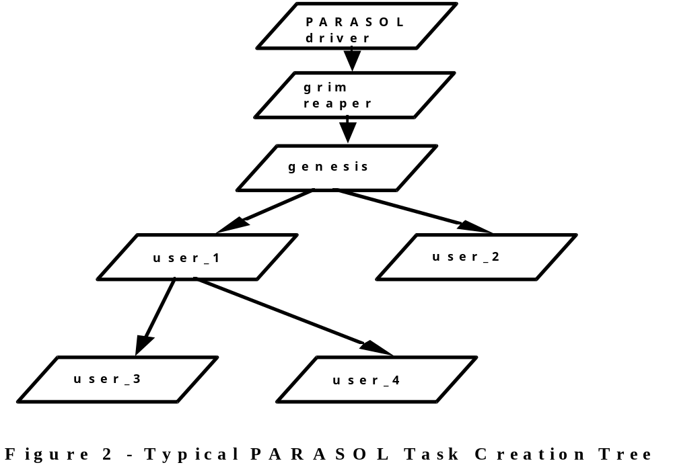

Some care is required to achieve this graceful exit. Genesis cannot simply commit suicide since this would kill all its dependents as well! Two solutions are common: a) simply return or “run off the end” which, for genesis, is handled as an implicit ps_suspend(ps_myself) - this will leave the simulation completely in the hands of the driver/wrapper; or b) sleep for an appropriate time and then awaken to attend to whatever. The latter approach is typically used when the user wishes to play a more active role in managing the simulation.

The “standard” PARASOL library, i.e., libparasol.a, contains a “standard wrapper” or main function which is usually employed by PARASOL users. When users opt for this approach, they are required to supply only a function called ps_genesis and its supporting cast of task functions. The standard wrapper ensures that needed simulation parameters are acquired as runtime inputs. Mention was made previously that users are prompted to supply a seed for the random number generators. They are also prompted to supply a simulation “run time” or duration. Both of these quantities can be supplied as command line arguments to the simulator in the order: seed - run time. Alternatively, they can be supplied in the same order via stdin as the first inputs to the simulator. These are the only inputs expected by the PARASOL driver although a command line option may be specified to initiate the PARASOL interactive debugger. Any additional application dependent simulator inputs must be handled by user tasks - typically by ps_genesis.

An alternative strategy is for users to create their own custom wrapper for PARASOL. This approach allows users to embed PARASOL within the application of their choice or simply to “front-end” their application more appropriately. Here users supply ps_genesis and supporting task functions as before but, in addition, they provide the main function so that PARASOL may be embedded within the system of their choosing. They are also required to use the “custom” library, i.e., libparasolc.a - see Section 5.2 for details. Here the interface between the user written main and the PARASOL driver is a function called ps_run_parasol which looks after initialization of the simulation and invoking the driver.
NAME
ps_run_parasol - initializes the simulation and starts the driver and the grim reaper

SYNOPSIS:
#include <parasol.h>
#include <para_internals.h>

SYSCALL ps_run_parasol(duration, seed, run_flags)
double duration;
long seed;
int run_flags;

DESCRIPTION
This function is required by users who prefer to write their own “custom wrapper” for PARASOL, e.g., to embed PARASOL into another system. They must write a main function which either directly or indirectly calls ps_run_parasol and supplies the required simulation parameters and flags. Initialization involves zeroing the clock so that the simulation duration effectively specifies the simulation time at which the simulation ceases. Seed is the value used to initialize the random number generator. Runs replicated with the same seed will produce identical results. The run_flags argument specifies the runtime options and is formed by by or’ing the desired option flags. The option flags are RPF_WARNING, which causes warning messages to be written to stderr whenever inappropriate arguments to PARASOL library functions result in error returns, RPF_TRACE, which turns on the execution trace option writing a detailed log of execution events to stderr, and RPF_STEP, which causes the interactive PARASOL debugger to be invoked (see Section 5.3 for details) and allow users to interact with the simulator and to step the simulation forward one driver interaction at a time. This mode of operation is analogous to using most software debuggers in a single step mode and allows users to examine the state of the simulation as it unfolds, to trace task states, and to set time break points.

NOTES
Use of this function implies use of the “custom” PARASOL library, viz., libparasolc.a. Note that besides supplying the main function, users of this library are responsible for defining seven “event handlers” as described in Section 5.2. Also note that the para_internals.h file must be included and that the CUSTOM compile flag must be employed. Users of the interactive PARASOL debugger will find that a simple help menu is available for it once it is invoked. This menu may be seen by typing a “?” following the debugger prompt. All debugger actions are triggered by typing single characters, i.e., no returns or enters should be used unless to supply secondary input values, e.g., the value of a time break point.
4 PARASOL Demonstrations

As indicated, this document will describe two PARASOL demonstrations. The first of these is a highly abstract model of distributed processing commonly referred to as a “Stochastic Rendezvous Network Model” or SRVN. This illustrates the ability of PARASOL to support highly abstract models in a flexible manner where model configuration is largely specified at run-time. The second demonstration involves a “Distributed Transaction Processing Model” or DTP with considerably more realism and detail. This demonstrates the use of PARASOL tasks for purposes other than modelling software. To facilitate reader understanding, the scale of both of these demonstrations, in terms of the amount of code, is quite small. One should note, however, that PARASOL itself imposes few limits on the scale of models - a tradeoff between complexity and execution speed is, however, inevitable.

4.1 Stochastic Rendezvous Network Model

The basic concepts in the so-called SRVN model are: (i) all inter-task communication is based on the synchronous send/receive/reply paradigm in which senders block until receivers reply, (ii) the operation cycle of most tasks is bi-modal including a first phase (rendezvous) delimited by an activating message reception and the act of replying to the sender, and a second phase (post-rendezvous) which begins after the reply and continues until the task is ready to receive the next activating message. See Figure 3 for a time-line depiction of the execution cycle of an SRVN task.

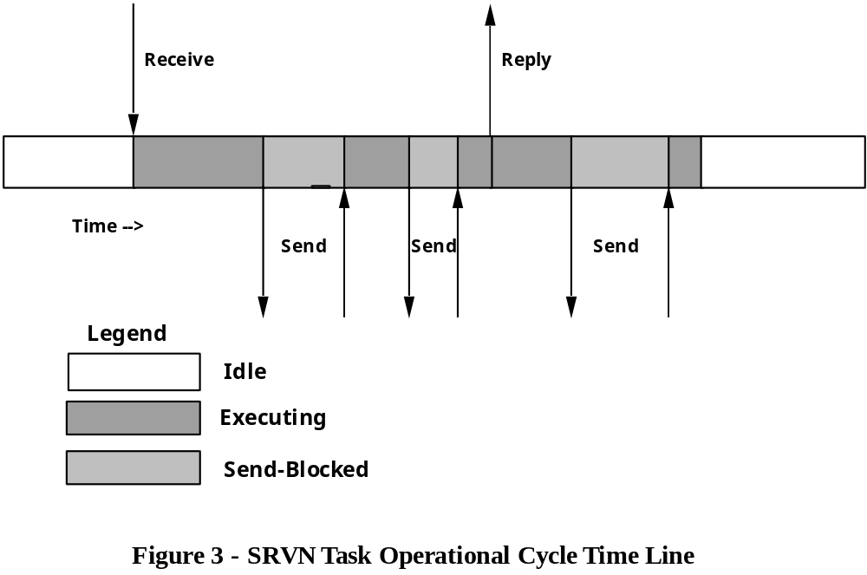

In both operational phases, tasks intersperse execution with service requests, in the form of synchronous message sends, which temporarily block the requesting task. A stochastic model of a rendezvous network sees the phase execution times and messaging specified in terms of expected values with the model realized by memory-less probabilistic messaging and execution activities.

Figure 4 shows an example of an SRVN network consisting of four tasks. Task A is a so-called reference task which, unlike the other tasks, is uni-modal since it neither receives messages from a higher level client nor replies. Reference tasks serve as load generators and there may be several of them in an SRVN network. Tasks B, C, and D are two phased with Task C having two distinct behaviours (often called entries) depending upon how it is activated. The figure is annotated with tuples labelling each node segment (task entry) and directed arc between the sender and the receiver. These tuples show: (i) in square brackets, the total expected execution service time for each phase, and (ii) in parentheses, the expected number of messages sent (often called server visit ratios) for each phase. These tuples together with the network graph are sufficient to define an SRVN model.

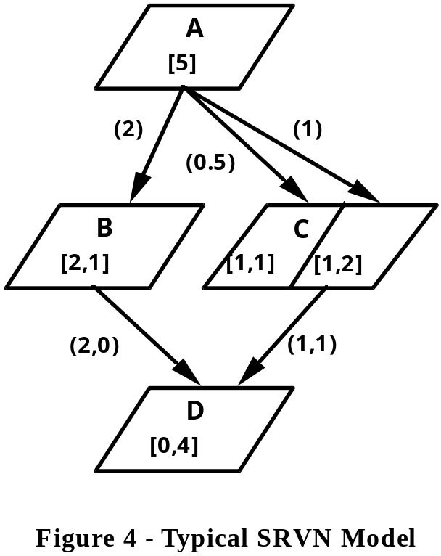

In the PARASOL demonstration, processors are not shared, i.e., each task executes on its own dedicated processor node. We have chosen to arbitrarily limit SRVN networks to a maximum of 100 tasks (and nodes). Furthermore, tasks are limited to a maximum of 10 entries with up to 10 message send targets per phase.

Reference is made to the code found under <PARASOL HOME>/examples/srvn2.c. To realize a PARASOL simulator, one must first identify the task classes that are required. In this case only two classes are needed in addition to the controlling task genesis, viz., the uni-modal reference task class, srvn_ref_task, and the bi-modal non-reference task class, srvn_task. Let us examine these closely. Each operational cycle consists of execution service slices interspersed with messages sent to “supporting” tasks on a probabilistic basis. As indicated above, we expect that these characteristics will be defined by the total expected execution service per cycle (e.g., In Figure 4, Task B shows a values of 2 and 1 for phase 1 and phase 2, respectively) together with the visit ratios to supporters (e.g., Figure 4 shows that Task B visits Task C twice per cycle, both times during the rendezvous or first phase). The stochastic model is constructed by “computing” exponentially distributed “slices” interspersed with “sends” to tasks selected at random from the supporting set. Notice that the synchronous nature of rendezvous communication requires that each send be followed immediately by a “receive” to accept the ensuing “reply”. Notice too that SRVN tasks require a second port besides the standard port, to support the reply mechanism.

The srvn_ref_task code begins with a short initialization pre-cycle phase in which it acquires the acknowledge port and establishes a SAMPLE statistic for measuring task cycle time. Incidentally, the current simulated time is referenced by PARASOL’s global variable, ps_now. The basic operational cycle makes use of data stored in an external augmented task table, srn_task_tab, which contains the defining parameters for each task. This table is created by user input at run-time via the ps_genesis control task. See the typedef’s at the beginning of the code for details. Notice that the operational cycle contains a “compute” slice sub-phase followed by a multi-way decision based on the generation of a (0, 1) random variate, followed by a send/receive sub-phase. To differentiate between entries, sending tasks use the PARASOL message type field to index the entry desired.

The corresponding non-reference task class, srvn_task, is very similar except that a VARIABLE statistic for task utilization is established in lieu of the cycle time statistic. The other major difference is that these tasks are two-phased and have activation “receives” and reply “sends” in their operational cycles.

To this point the two distinct task classes have been described briefly. What remains is a description of the mechanism for constructing an SRVN network, i.e., the number of tasks of each type together with their interconnecting messaging relationships and task parameters. Since PARASOL requires a ps_genesis task in any case, this task was chosen to provide the model/user interface and allow users to flexibly define networks at run-time. Since genesis is the first user task to run, it is straightforward to interactively acquire network descriptions, creating nodes and tasks “on-the-fly”. Genesis is also responsible for converting raw input data, i.e., service times and visit ratio tuples, to service slice means and decision making probabilities. As mentioned above, all the pertinent information is stored in the global augmented task table for use as the simulation unfolds. Ps_genesis concludes by printing a summary of input values and calling ps_block_stats to provide confidence interval estimation on the statistics gathered.

4.2 Distributed Transaction Processing Model

The DTP model chosen for this demonstration offers considerably more realism than the SRVN model. In the interests of brevity, we have had to sacrifice generality. This “quick and dirty” approach is, in general, less desirable than the modular approach that promotes software reusability. In short, this is a sort of “do as I say - not as I do” example. Nonetheless, it does illustrate a number of techniques including the use of PARASOL tasks to model “skinware” and hardware as well as software. Source code is available under <PARASOL HOME>/examples/dtp2.c. Figure 5 shows the DTP network components involved including six different PARASOL task classes.

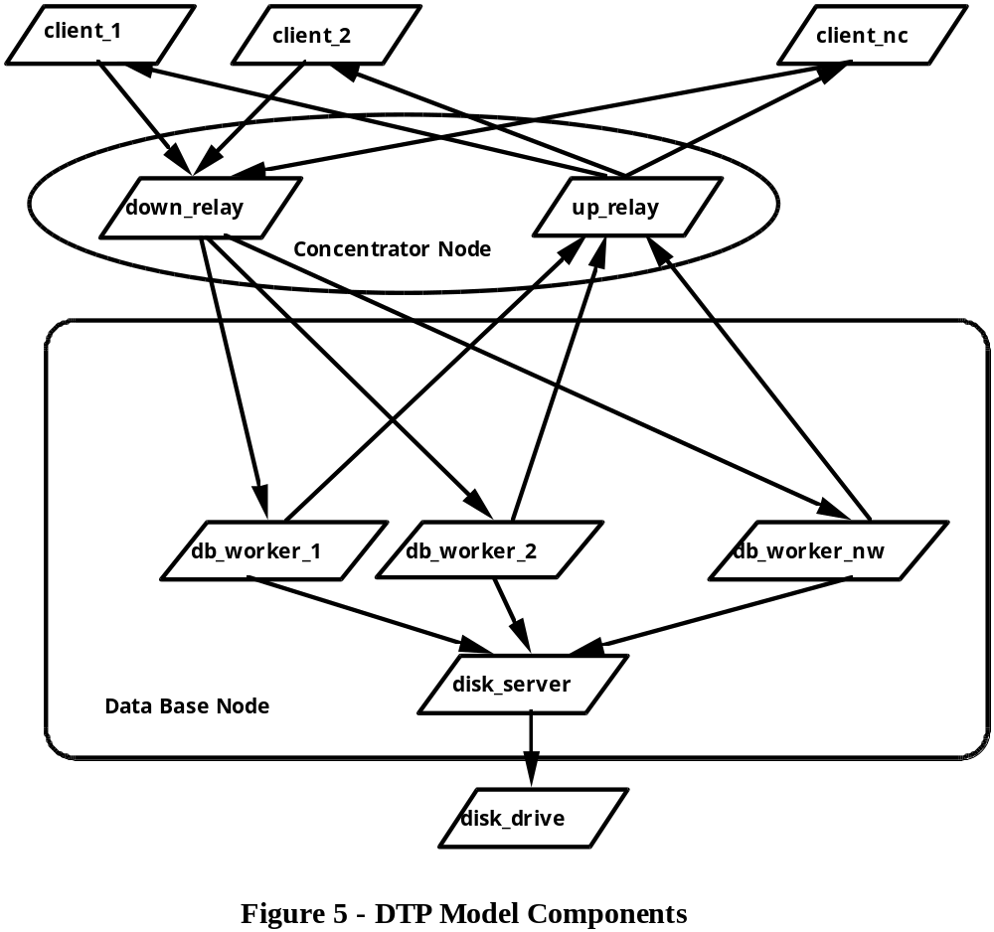
The model uses a number of instances of the client class to generate the transaction traffic. Since these are merely simple controller-type tasks that we do not wish to model in detail, they will be run on the PARASOL node, node 0, that is used to run the grim reaper and genesis. The two relay tasks, down_relay and up_relay, model the concentrator node software which accepts transaction processing requests from clients and relays these to a data base node via an Ethernet-like bus. The concentrator software also relays the returned result to the requesting client Two task classes represent the software on the data base node, viz., the db_worker and the disk_server. The DTP model assumes that these run on a suitable multiprocessor with one processor dedicated to run the disk server task for data base file access. A spin-locked data base cache is assumed to exist. This cache is written to disk only when a “dirty” cache slot is to be overwritten. The actual data base access (either cache or disk) and related processing is performed by a set of db_worker tasks which receive transaction requests over the bus via a shared port. Transaction processing results are returned by the db workers via the bus. Finally, a disk_drive controller task is needed to simulate the delays associated with physical disk i/o. The structure of the disk server task, which tolerates asynchronous disk i/o with the queuing activity associated with incoming requests, demands this special controller task. Like the other non-system tasks, it will be run on node 0.

We will begin our examination of the PARASOL code with the genesis task. As is typical with such tasks, its principal concerns are the construction of the network and the start-up of the initial tasks involved. As indicated at the outset, in the interests of brevity, generality is sacrificed. This simplifies the external data structures needed. The demonstration uses of a single uniprocessor concentrator node, c_node, and a data base node with six processors. Since one of these processors is to be dedicated to the disk server task, this node will actually be modelled by two PARASOL nodes, a 5 cpu multiprocessor, d_node1, and a uniprocessor, d_node2. The concentrator and data base nodes are interconnected by a Ethernet-like bus, bus. The entire network is constructed by four lines of C code! Next, tasks are “resume/created” as appropriate with their “standard” ports posted in global variables. Genesis then steps aside by suspending itself.

Four of the six other task classes are very simple and require little explanation. Notice that the two controller task classes, client and disk_drive have cycles involving no computation. Although they could be run on any node without changing results, their presence in either of model node queues is undesirable from the point of view of simulation efficiency. The down_relay and up_relay concentrator tasks are equally simple although they do consume cpu tics via the “compute” system call.

The remaining tasks classes are relatively complex and will not be described in detail. Some artistic licence has been taken in the interests of modelling efficiency.

Worker tasks await transaction requests by using ps_receive_shared calls to the shared port created by the first worker to run. A simple cache model using a set of spin-locks for mutual exclusion synchronization is employed with disk i/o requests as needed sent synchronously to the disk_server. Results after an erlang distributed processing service are sent via the bus to the up-relay task.

The disk_server task models approximately, with a simple random queue, typical seek time reduction strategies employed in most disk drivers. To permit simulated disk i/o to be overlapped with other processing, the special disk driver task sends an i/o complete message to the disk server task when appropriate. Thus the server accepts two types of messages and responds accordingly.

We conclude this discussion by pointing out that class statistics are easily collected as exemplified by the client response time and the active worker statistics that are gathered for the client and worker classes respectively.

5 PARASOL Operational Matters

This section of the manual deals with operational concerns. As this document is concerned primarily with the details of the PARASOL kernel, the operational details on the use of PARASOL++ and other PARASOL related entities are found elsewhere. The first segment contains information necessary for the creation of PARASOL simulators. Specifically, it describes the use of the PARASOL libraries and include files. The second segment provides additional insight into the inner workings of PARASOL and discusses some advanced concepts such as event handlers and the use of the “custom” PARASOL library. Finally, a segment is devoted to providing guidelines and hints to facilitate PARASOL model building and use of the built-in debugger.

5.1 PARASOL Software

Basic PARASOL support software comes in two forms: the PARASOL libraries and the PARASOL include files. Two versions of the library are provided; the “standard” library (libparasol.a) for “standalone” applications in which the user employs the standard mainline “wrapper”, and the second (libparasolc.a) for “customized” applications where the user supplies a customized main function and user-defined “event handling” functions. Reference is made to the Makefile in the <PARASOL HOME>/examples directory for guidance in forming PARASOL simulators. In particluar note the compiler options required to locate the necessary include files and libraries. Note as well that besides the appropriate PARASOL library, the math library must be linked (with the -lm option).

The PARASOL include files consist of the file parasol.h, which #include’s all the other “standard” include files, i.e., para_version.h, para_protos.h, para_types.h, etc. Although these files are required, most users need not concern themselves with their details except, perhaps, the prototype/macro file, para_protos.h. The include files do, however, provide valuable insight into the inner workings of PARASOL. These may be necessary to take advantage of some of the advanced features of PARASOL. For those who wish to create a “custom” PARASOL application, the include file para_internals.h provides the necessary additional information required.

5.2 PARASOL Opened

The goal of this segment is to describe the essential inner workings of PARASOL so that an advanced user can take full advantage of it. In particular we will discuss the reasoning behind the data structures of PARASOL and describe how users may conceive and handle events of their own design.

Since PARASOL is intended for the simulation of systems of considerable size and complexity, it was necessary to pay particular attention to efficiency while at the same time providing size flexibility. Consequently, PARASOL makes extensive use of dynamic tables for storage of PARASOL objects, e.g., nodes, buses, links, tasks, ports, etc. In each case, instances are typically referred to by table indices which remain invariant as the simulation proceeds and tables grow. Consequently, users should avoid using pointers to PARASOL objects as they may not be invariant through the course of a simulation!

PARASOL models do tend to make sizable memory demands on the host system. PARASOL applications should abort cleanly should insufficient memory be available. Memory demands are particularly high with models having many task instances since each requires its own execution stack. Default task stack sizes range from 4KB to 16KB depending upon the host system. Users may find that smaller stacks are satisfactory when task code is simple or, in some situations, that larger stacks are required. Ps_create2 is available for customizing stack size of individual tasks. The system call ps_headroom should be used to verify that stacks are not “blown” or to estimate the stack size required. PARASOL offers no other stack protection mechanism!

The operation of PARASOL, at least in part, is essentially that of a typical discrete event simulator. Mention has already been made of the calendar which is a sorted list of all future events. When the driver finds no user task to execute, it plucks the next event from the calendar and advances simulation time, ps_now, to the time of that event. It then identifies the type of the event and calls the appropriate event handler to deal with it. That handler is responsible for altering the system state, perhaps scheduling one or more future events as it does so. An altered state may also give rise to the resumption of execution of user code. Presently, PARASOL includes handlers for the following events:

Event Code Event Handler

END_BLOCK end_block_handler
END_COMPUTE end_compute_handler
END_QUANTUM end_quantum_handler
END_RECEIVE end_receive_handler
END_SLEEP end_sleep_handler
END_SYNC end_sync_handler
END_TRANS end_trans_handler

BUS_FAILURE bus_failure_handler
BUS_REPAIR bus_repair_handler
LINK_FAILURE link_failure_handler
LINK_REPAIR link_repair_handler
NODE_FAILURE node_failure_handler
NODE_REPAIR node_repair_handler
USER_EVENT user_event_handler

The first seven of these handlers should be considered sacred and modified only at one’s peril. On the other hand, the last seven are merely space fillers and are designed to be replaced by users, if necessary. Replacement of any of these handlers will require the use of the “custom” PARASOL library (libparasolc.a). When the “custom” library is used, either for user defined event handlers or for embedded applications requiring a user written main, the following rules must be followed:

1) Eight functions must be user supplied since they are not contained in the “custom” library; viz., main, bus_failure_handler, bus_repair_handler, link_failure_handler, link_repair_handler, node_failure_handler, node_repair_handler, and the user_event_handler.

2) Source file(s) for the above functions must include the header para_internals.h after parasol.h and be compiled with the CUSTOM flag, i.e., using -DCUSTOM.

3) Main must call (directly or indirectly) ps_run_parasol with appropriate parameters to initiate model execution.

4) Null event handlers are sufficient if unused. However, they should conform to the prototype having a single event pointer argument. For example, if no bus_failure_handler is needed, it suffices to write:

void bus_failure_handler(event_t *ep) {}

Non-null event handlers are invoked whenever the “corresponding event” occurs, i.e., is extracted from the calendar. The passed event pointer allows the handler code to gain access to the details of the event - see the event_t struct defined in para_types.h. Notice that only one user event type is defined. This need not be restrictive since the structure of the event data type includes a generic pointer that is typically used to point to an event appendage containing whatever additional event information may be required including a possible sub-type field. Thus, while only a single user_event_handler can exist for any given application, a secondary level of interpretation is clearly possible.

In order to schedule and, perhaps, to deschedule events, users should use the PARASOL scheduler routines add_event and remove_event. These are used to schedule a future event and deschedule a future event, respectively, and are not available without the CUSTOM compile flag. Unix-style descriptions follow:

NAME
add_event - schedules a future PARASOL event to occur

SYNOPSIS
#include <parasol.h>
#include <para_internals.h>

event_t *add_event(time, type, gp)
double time;
int type;
int *gp;

DESCRIPTION
This function adds an event of type, type, to the calendar of future events. This event will occur at time, time. A generic pointer, gp, is recorded in the event. This may point to anything of use to the event handler. The function returns an event pointer to the newly created and scheduled event. This pointer may be used to deschedule the event if need be.

NOTES
The current simulated time is available in the global ps_now. To ensure that events are scheduled in the future, the argument time should take this value into account and not refer to the past. The PARASOL driver will detect any attempt to move time backwards and abort the simulation. Note, as well, that this “internal” function requires the inclusion of the para_internals.h file and the CUSTOM compile flag.

NAME
remove_event - deschedules a future PARASOL event

SYNOPSIS
#include <parasol.h>
#include <para_internals.h>

void remove_event(ep)
event_t *ep;

DESCRIPTION
This function removes the event specified by the event pointer ep from the calendar of future events.

NOTES
This function will detect if the specified event is not in the calendar and abort the simulation if this is so. It also requires the inclusion of the para_internals.h file and the CUSTOM compile flag.

5.3 User Guidelines and Hints

Any simulation is apt to be tedious to develop and, particularly, to debug. PARASOL users will doubtlessly find this true as well. At present the PARASOL system contains a simple, easy-to use, interactive debugger. As well, all PARASOL system calls are well “guard coded” and some built-in features do ease the pain. For example, virtually all PARASOL entities may be named. Users will find this useful not only for constructing statistic names that identify statistical results but for tracing system activities as well. In general, careful coding, including system call SYSERR checks, sensible use of the built-in debugger, and, as a last resort, the use of a powerful debugging tool such as dbx are sufficient to locate and fix bugs.

The built-in PARASOL debugging facilities are typically activated through the use of command-line options. With the present “standard” wrapper, there are three: the warning option (activated by a “-w” flag on the command line), the trace option (activated by a “-t” flag) and the step option (activated by an “-s” flag). Embedded applications invoke these options by means of the run_flags argument to ps_run_parasol. The warning option reports errors caused when inappropriate arguments are detected. The trace option produces a detailed chronlogical log of sytem events, e.g., messages sent or received, etc. Both of these options write to stderr. Finally, the step option invokes the interactive debug interpreter and allows users to set a “time break point”, to step through a simulation eventwise, and to examine the state of “hardware” and “software” entities, the ready-to-run and message queues, and the calendar of future events. When activated by the command line option, the interactive debugger also activates tracing which may be toggled off and on interactively. The debugger prompts for user input each time the simulation driver is called upon to select the “next” event from the calendar. It has a simple help system invoked with a ‘?’ command which fully describes its user interface.

As indicated above, users will find the debugging features more helpful if they give unique and meaningful names to PARASOL entities. Users are cautioned that the trace feature can produce extremely verbose output and thus, by itself, should be used with short duration simulation runs. However, when traces are redirected through filters to visualization tools such as ParaGraph or XTG, debugging and model validation is usually made much easier and greater volumes of execution traces are worthwhile. It is useful to note that when used with the step option, tracing can be toggled on or off as the user wishes as the simulation progresses. Finally, one should note that “standard wrapper” users should specify either none, one, or two of the debugger options and that these must precede the command-line seed and run-time arguments, if present. Keep in mind that the -s flag activates the trace as well as the step option.

Most simulations consume large quantities of machine time. PARASOL is no exception although care has been taken to make it efficient - it outperforms other systems that rely on interpretation rather than compiled code. Nonetheless, users should exercise good judgment when writing applications. For example, the collection of statistics is not without overhead since floating point arithmetic is involved. Consequently, one should select carefully which statistics to gather and, when constructing reusable PARASOL components, make them flexible enough that statistics gathering may be disabled, as for example is done with PARASOL nodes, buses, and links. Studies of PARASOL have revealed that much of its execution time can be devoted to overheads associated with context switching and scheduling related matters. At times, users can reduce this overhead, for example, by aggregating “execution” calls such as ps_compute and making use of ps_hold when appropriate. Minimizing the use of round robin scheduling disciplines or at least avoiding the use of very small quanta can also realize significant simulator performance improvements. In short, try to simplify model operation in the interests of running more economically. This may require some experimentation to see what simplifications one can get away with but the payoffs can be significant. In general, users should find the source code provided under <PARASOL HOME>/examples useful in guiding the model building process - see the document entitled “A PARASOL Tutorial”.

Presently, the official PARASOL release consists of the kernel in the form of the standard and custom ANSI C libraries, a first-level C++ class library, a PARASOL simulation manager called DPSM, and trace filters for the visualization tools ParaGraph and XTG. User inputs on all matters pertaining to PARASOL are solicited, particularly in the area of porting to new platforms, the further development of the kernel, the C++ class library, and debugging/visualization facilities. Finally, users are encouraged to share their modular, reusable code with others. In time, one can hope for a library of “off-the-shelf” PARASOL “goodies” that are well tested and allow for the rapid construction of a variety of PARASOL models.

