A PARASOL Tutorial
(Version 3.1)

John Neilson & Pat Morin

School of Computer Science

Carleton University

Ottawa, Canada

K1S 5B6

Table of Contents

1 Summary 3

2 Introduction 4

3 PARASOL Modelling 5
3.1 The Structure of PARASOL Models 5
3.2 Identifying Model Components 7
3.3 Prescription for Writing Genesis Tasks 8
3.4 Gathering Statistics 10

4 PARASOL Case Studies 12
4.1 Simple M/M/1 Queueing Model 12
4.2 Multithreaded Data Base Server Model 13
4.3 Disk Drive Model 14
4.4 Star LAN Based Client Server Model 16
4.5 User Defined Node Scheduling Model 18
4.6 A C++ Client Server Model 20
4.7 A C++ Remote File System Model 21

5 PARASOL Operational Matters 23
5.1 Debugging Strategies 23
5.2 Towards Efficiency 25
5.3 Embedded PARASOL Applications 26

A PARASOL Tutorial

John Neilson & Pat Morin

email: neilson@scs.carleton.ca

School of Computer Science
Carleton University
Ottawa, Canada
K1S 5B6

1 Summary

This document is aimed at the prospective PARASOL user as a quick introduction to the techniques of computer system model building using PARASOL. Since PARASOL itself is described in the companion document entitled “A PARASOL Users’ Manual” (which provides a detailed description of the system), only a brief description of PARASOL will be given here. A third document entitled “PARASOL++: A PARASOL C++ Library” provides the details of the C++ class library used here. On the other hand, this document emphasizes the PARASOL model building process and provides guidelines and hints on the use of PARASOL in modelling computer systems. This is done primarily through examples using a series of small case studies to demonstrate the facilities available to the PARASOL model builder.

2 Introduction

PARASOL was designed for and is particularly well suited to support modelling of computer systems. It specifically was aimed towards modern distributed and/or parallel computer systems in which the software as well as the hardware involved must be adequately represented. In point of fact, PARASOL is a library of C software which may be used by C and C++ programmers. Its main paradigm involves user written “tasks” with which the modeller constructs either a simulator or an emulator. A distinction is made between these here since PARASOL supports two distinctly different types of modelling activity. The former term will be used to identify those activities in which performance questions are paramount and modelling is concerned with the measurement of performance through statistical analysis of modelling results. The second term will be applied to those studies in which system prototyping is the main thrust and functionality is the primary concern. As will be demonstrated, PARASOL serves both venues very well.

Besides the usual array of tools, e.g., random number generators, statistics gathering mechanisms, event manipulation routines, etc. typically found in a discrete simulation library, PARASOL contains a number of component constructors to facilitate the definition of the system “hardware” and its network topology. As well, since PARASOL relies heavily on a concurrent task paradigm for model construction, it contains a number of “system calls” which mimic a distributed operating system to facilitate task management, inter-task communication, task synchronization, etc. PARASOL may seem somewhat overwhelming at first glance since there is a good deal to learn. This is compounded by the fact that modelling computer systems is rarely an easy enterprise regardless of the tools employed. However, assuming that users are well versed in writing concurrent software, PARASOL is not difficult to learn, since many of its primitives resemble those of thread packages and distributed operating systems, such as Mach.

It is the goal of this document to assist a new PARASOL modeller in getting started. The next section examines the structure of PARASOL and its models and provides a sort of “cookbook” for model construction. Following that, a series of small case studies are presented which demonstrate good modelling technique. Finally, a section addresses several of the “operational” issues associated with the use of PARASOL including perhaps the most important one, i.e., debugging.

3 PARASOL Modelling

It goes without saying that a model builder’s first concern is a clear visualization of the system to be modelled. It is assumed that this is a given and that the issue addressed in this document is how to translate that vision into a PARASOL model. We begin by describing the modelling entities available within PARASOL as only with an understanding of these can model building begin. Next, we discuss the process of identifying the PARASOL components required to build a particular model. This leads to a discussion of the design of the “root” user task known as “genesis”. Finally, this section ends with an examination of some of the issues associated with gathering simulation statistics within a PARASOL model.

3.1 The Structure of PARASOL Models

A simplified view of a PARASOL-based simulator or emulator suggests that it consists of a “driver” or supervisor which looks after running the model according to the user’s wishes, an “execution environment” comprised of a set of “hardware” components that the user created through PARASOL constructors, and a set of “user-defined tasks” that run within the defined execution environment. An example of a small PARASOL model is shown in Figure 1 below:

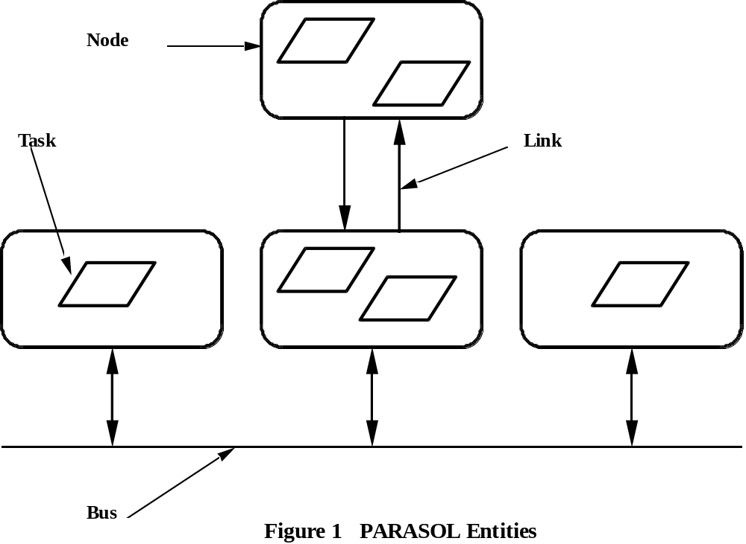
PARASOL tasks are perhaps the most important component type while at the same time they are most difficult to describe. They may used for a number of purposes. First and most obvious, PARASOL tasks can be used to model real system tasks. In emulation modelling, these tasks can be thought of as prototypes of the target software. On the other hand, in simulation modelling, they are usually simpler and more abstract but they can, nonetheless, bear a resemblance to real software often with some details omitted. PARASOL tasks are also frequently used to perform peripheral duties as opposed to modelling software, e.g., to perform system initialization, to serve as workload generators by modelling user behaviour, and to perform housekeeping chores such as garbage collection and statistics capture, etc. With a few exceptions, PARASOL tasks are user written.

The execution environment on which all PARASOL tasks execute is constructed using “processing nodes”, one-way “communication links”, and multi-way “communication buses”. These entities are not user defined per se but are user configurable in limited ways. They should be viewed as “primitives” that can be replaced by more realistic user defined components should the need arise. However, in the majority of cases, this set of primitive “hardware” component types is sufficient. Extending PARASOL by constructing more elaborate components is the user’s prerogative. For example, the Disk Model case study shows how a generic disk component can be built using a pair of PARASOL tasks and a few simple data structures.

The remaining “major player” in the PARASOL world is the “driver”. It serves several functions but can be thought of as a sort of distributed operating system under which user tasks execute. As such, the driver provides a rich set of “system calls” with which the user can manage tasks, send messages, synchronize with other tasks, etc. Other roles for the driver include the management of both task and message queues, the capture of performance statistics, and the overall management of the execution environment and simulated time.

To this point we have described a PARASOL model in terms of tasks, an execution environment, and the driver. A finer grained view of a PARASOL model reveals other details including ready-to-run queues, communication queues, messages and message ports, buffer pools, spinlocks, semaphores, statistical counters, glocal variables, etc. It is important for PARASOL users to understand at least the concepts behind these entities as well.

Each of the primitive “hardware” components, i.e., the node, the link, and the bus has a finite capacity to handle workload. Inevitably, queues are formed for these services. In the case of processing nodes, queues contain PARASOL tasks which are ready to execute. The choices available in built-in node queueing disciplines are: First-come-first-served (FCFS), head-of-the-line (HOL), i.e. non-preemptive priority, and preemptive-resume (PR), i.e., preemptive priority. Each of these comes in two variants: “plain vanilla” or “round-robin” (RR) in which quanta of processing times are allocated. Each node has a single ready-to-run queue even if it is a multiprocessor node. Tasks may be assigned to specific processors within a multiprocessor node should the user desire. In addition, user defined node scheduling is supported and demonstrated in the User Scheduling case study (see Section 4.5).

Communication link and bus queues contain messages rather than tasks. Queueing here is typically FCFS although random queueing is available for buses to loosely model the CSMA/CD style of arbitration. In addition, messages queue at their destinations known as “ports”. Messages in port queues may be accessed FIFO, LIFO, or random order. A port is really a “mailbox” from which the owning task can retrieve messages. Tasks are created with one “standard port” but may own more if appropriate. See Figure 2. “Extra” ports may be passed from task to task along with any queued messages or grouped into “port sets” to enable a task to “listen” on several ports at the same time. As well, a global type of port, known as the “shared port”, is available which permits any task to retrieve messages from it.

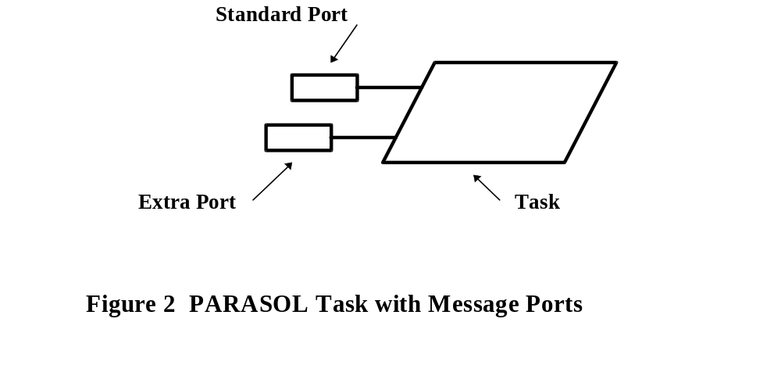
Messages in PARASOL may be very abstract and consist essentially of just a timestamped token or they may be the genuine article containing an arbitrary amount of information. Users must be aware, however, that, in the interests of efficiency within the shared memory environment in which PARASOL operates, PARASOL message text is passed by reference and NOT by value. This can lead to problems should the sender of a message reuse its message buffer before the recipient acquires that message. This point cannot be made too strongly since it is a frequent source of modelling errors in PARASOL.

Hint When inter-task communication is inherently asynchronous, i.e., when the sender doesn’t block awaiting an acknowledgement, users should avoid clobbering previously sent messages by using “new” message buffers for each message. This can be done, for example, by the sender using a PARASOL buffer pool and the ps_get_buffer function to acquire a new buffer and then copying or building the message in it. In this scenario, the recipient would use the ps_free_buffer function to release the buffer when it is no longer needed.

At this point, we will describe only one other “lesser PARASOL players”, i.e., synchronizing mechanisms. This includes a set of simulated shared-memory primitive synchronizing devices whose “random selection” of winners in competitive situations closely resembles “busy waiting” spinlock mechanisms. These components are particularly useful in modelling multi-processor systems where spinlocks are often employed to synchronize tasks and avoid the overhead of context switching system calls. As well, PARASOL provides a set of general, counting semaphores to model “non-busy” waiting primitives. Either mechanism can be used to model mutual exclusion devices but the latter is more general and is demonstrated in the Data Base case study, see Section 4.1.

3.2 Identifying Model Components

The first step in building a PARASOL model is the identification of the types or classes of PARASOL tasks involved. As stated earlier, PARASOL tasks are used for a variety of purposes and the need for some may not be apparent at the outset. Generally, it is prudent to begin by examining the system under study without reference to workload generation or housekeeping chores but to concentrate on identifying software elements, i.e., processes, threads, interrupt service routines, etc. Once the real system software elements are identified, it is relatively easy to map these onto their PARASOL counterparts. We will refer subsequently to such PARASOL tasks as “system” tasks.

Having identified the system task classes, one must next decide on the number of instances of each of the task classes, if they are to be dynamically created and destroyed, their ancestor-child relationships, etc. The latter consideration is important because some PARASOL “system calls” are effective only on the calling task or its descendants. For example, a task can only change its own priority or those of its descendants. These factors may dictate the need for “manager” tasks which may serve no purpose other than to maintain the appropriate task creation tree relationships so that task management can be carried out. Figure 3 shows how a typical PARASOL model might be constructed. It involves a bus connecting three nodes which support four system tasks. In addition, a single node is set aside to support non-system tasks.

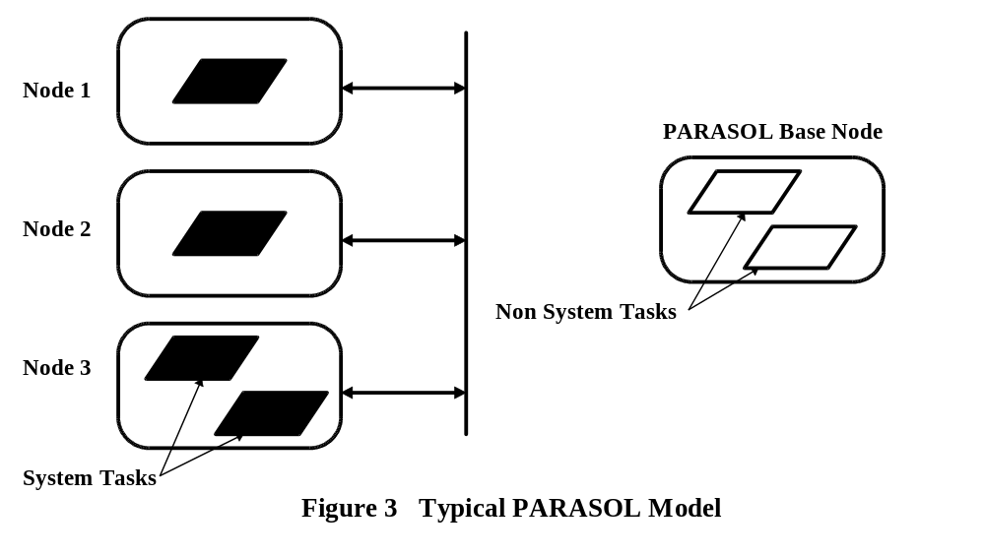A variety of non-system tasks are found in PARASOL systems. Besides the aforementioned task managers, it is common to employ non-system tasks for workload generators and statistics gatherers. These tasks like all PARASOL tasks must be assigned a PARASOL node on which to execute. Every PARASOL simulation has one such node that is usually ideal for such non-system tasks, viz., PARASOL’s Base Node, Node 0. This node is a part of every PARASOL system and is usually augmented with nodes which represent the actual processing nodes involved in the target system. Virtually all non-system tasks can be assigned to the base node since they never need to consume simulated execution time and thus do not logically contend for this resource.

Hint Determine carefully those tasks that are system tasks and those which are not. The former must be assigned to execute on user-built nodes while the latter should be assigned to the PARASOL “base node” provided care is taken to ensure that they never consume processor time. If delays are required in non-system tasks, calls should be made to ps_sleep or ps_receive and never to call ps_compute, ps_hold, ps_sync, or ps_lock.

As indicated above, the process of PARASOL task identification may not be completed with a single design pass. Rather, what tends to happen is a kind of iterative process in which tasks are identified and then revised as finer grained details are considered. At some point refinement stops and it should be possible to identify the execution environment components, i.e., the processing nodes on which the system tasks execute together with the communication links and buses involved. As part of the identification process, it is generally wise to associate a name with each of the tasks, nodes, links, and buses since PARASOL supports naming these entities and names will prove useful in interpreting results and debugging.

One essential, non-system task has not been discussed. That task is named genesis since it is the first user-defined PARASOL task to execute and thus becomes the root of the user’s task creation tree. Another way to look at this task is to see that it provides the connection between the PARASOL driver and the user defined task code. PARASOL users must therefore write a ps_genesis task and use it to launch all other tasks either directly or indirectly. This task and the PARASOL Base Node on which it runs are “created” by the driver. Since genesis is the key to starting a PARASOL simulation, the next section is devoted to examining the issues of writing such a task.

3.3 Prescription for Writing Genesis Tasks

As noted, since genesis provides the bridge between PARASOL driver and the user written task code, all PARASOL simulations must contain one user written ps_genesis task. On startup, the driver first builds the PARASOL Base Node on which it launches a task known as the reaper, which in turn launches genesis. Thus, it is the user’s responsibility to see that genesis gets the rest of the simulation machinery underway. As seen above, the Base Node should be reserved for non-system tasks. Thus, it is rarely an adequate execution environment and is usually augmented with other nodes, and optionally, with communication links and buses. Since tasks are launched onto nodes and communication entities are tied to nodes, there is an implied order for entity creation in establishing a PARASOL model, i.e., nodes must be established first, then links and buses. Once a suitable execution environment is established, global statistical entities, buffer pools, and glocal variables should be created and then all non-volatile tasks may be launched. Finally, genesis must be terminated in some way. We will address these points in turn.

Creating the execution environment typically begins with a series of ps_build_node calls which return int node ids. It is often good form to store or to “post” these ids in appropriate extern variables to make these parameters “well-known”, i.e., so that they may be accessed globally by all tasks. This, of course, does not necessarily model reality but it is efficient and saves a good deal of startup message passing code to achieve the same goal.

Once all nodes are built, calls can be made to ps_build_link and ps_build_bus to forge the communication channels. Again, it is appropriate to “post” their ids in appropriate extern variables to facilitate access. Similarly, any statistical entities that are to be accessed by more than one task should be established at this time with calls to ps_open_stat. Like the other constructors, this function returns an index identifier which should be “posted” so that other tasks may access it. Buffer pools as well as glocal variables are typically established similarly through appropriate calls within genesis. The following code fragment illustrates the techniques involved.

#define USER_ENVIRONMENT 1

int stat;
int pool;
int birth_date_index;
int special_port_index;

void ps_genesis(void)
{
.
.
.
stat = ps_open_stat(“Response Time”, SAMPLE);
pool = ps_build_buffer_pool(POOL_SIZE);
birth_date_index = ps_declare_glocal (USER_ENVIROMENT, double);
special_port_index = ps_declare_glocal(USER_ENVIRONMENT, int);

At this stage genesis should become involved with the launching of other tasks. In cases where tasks are static and a shallow task creation tree is appropriate, genesis could launch all other tasks, system and non-system alike. Because inter-task communication is important and all tasks have a standard communication port, it is good form to post port id’s as extern variables to facilitate communication and simplify startup coding. For example,

int server;
int server_port;

void ps_genesis(void)
{
void server_class(void);
.
.
.
ps_resume(server = ps_create(“Server”, server_node, ANY_HOST, server_class, server_priority));
server_port = ps_std_port(server);

Notice that task launching is a two-stage process involving two PARASOL system calls, viz., ps_create and ps_resume. Since PARASOL tasks are launched without arguments are passed to them, it is common for genesis to send an initialization message immediately after the launch. Such messages contain information specific to particular instantiations. For example, suppose two double arguments and two int arguments are needed. The first of the following fragments shows the genesis code used to pass the four parameters in a message while the second fragment shows how the child task would receive them and dispose of the text buffer.
Genesis:
char *arg;
.
.
arg = ps_get_buffer(pool_100);
sprintf(arg, “%lf %lf %d %d”, double1, double2, int1, int2);
ps_send(child_port, 0, arg, NULL_PORT);

Child:
char *tp;
double arg1, arg2;
int arg3, arg4;
.
.
ps_receive(MY_STD_PORT, NEVER, &type, &ts, &tp, &ap);
sscanf(tp, “%lf %lf %d %d”, &arg1, &arg2, &arg3, &arg4);
ps_free_buffer(tp);

The foregoing illustrates a general technique for packing message data into message text buffers. This is useful not only for task intialization but more generally when the two integer message fields of type and ack_port are insufficient. Besides using sprintf encoded strings, users may use arrays or structures of their own choosing provided they are careful about casting.

At this point, there may be nothing else for genesis to do. If this is the case, it can simply “run off the end” or explicitly return and PARASOL will suspend it. Alternatively some “monitoring” role could be started. It is important to note that there is a major problem with genesis terminating itself. Since terminating or killing a task kills all of its descendants, killing genesis effectively stops all simulation activity. Clearly this is not wanted and is why genesis must not and cannot be user terminated and is suspended instead. Note, however, with all other user-defined tasks, “returning” implies suicide not suspension.

To sum up, the prescription for writing a “generic” genesis task typically includes the following:

1) Accept inputs of all needed simulation parameters.
2) Build the execution environment with nodes, links, and buses posting indices as
required.
3) Open global entities, such as shared ports, statistical counters, pool buffers, and
glocal variables, posting indices as required.
4) Launch “first-level” user-defined tasks posting port and/or task id’s as required.
5) Optionally, begin a monitoring role and/or call ps_block_stat.

3.4 Gathering Statistics

The raison d’etre for simulation studies, as opposed to emulation studies, is performance prediction. If steady state performance values are sought, the PARASOL statistical tools will be useful. PARASOL provides for three types of statistical entities, viz., SAMPLE, VARIABLE, and RATE statistics. The first is used to record samples drawn from some population of observations, e.g., response time, time in queue, etc., while the next records fluctuations over time of some discrete system or state variable, e.g., number queued, device utilization, etc. The last is used to count “rate-events”, e.g., service completions, aborted services, etc., from which mean rate statistics may be computed. These statistical entities are created as required on user demand by means of statistical flags set in the various ps_build_<entity> calls or explicitly with the ps_open_stat call.

Modellers should note that PARASOL will by default, except for embedded applications, report a simple summary of all gathered observations showing mean or average values of all the statistical entities used. In general, if confidence intervals on measurements are desired, two approaches are possible. The first involves replicating experiments by using different random number generator seeds and using PARASOL’s default statistic reporting mechanism. The second approach involves the use of a single long simulation run which is blocked into quasi-independent sections. PARASOL caters to both approaches with the tool DPSM (Distributed PARASOL Simulation Manager) for the former and the ps_block_stats call for the latter. Both use a Student-t analysis to estimate confidence intervals.

The blocked run approach is frequently used as it is so easily done - all one needs to do is arrange for a task, typically genesis, to make a call to ps_block_stats at the beginning of the simulation. On the other hand, the replication approach is somewhat safer in the sense that sample independence is relatively easy to guarantee by simply choosing different random number seeds. Furthermore, comparable results may be obtained in a shorter elapsed time if multiple computers are available to produce replication results concurrently. DSPM is based on PVM (Parallel Virtual Machine) for precisely that reason. It is described in the companion document “DPSM: A Distributed PARASOL Simulation Manager”. PVM is available through http://www.netlib.org.

The following remarks are directed specifically at those modellers who choose the blocked statistical approach although they do have relevance to those choosing to replicate. In performing blocked experiments one needs to decide on the duration of blocks and whether startup transients are likely to bias results. Often some informal experimentation will indicate approximate answers to these questions. For example, suppose we are particularly interested in estimating a response time and a few short runs have produced the following results:

Simulation Duration Mean Response Time
1000 5.2
5000 11.4
10000 10.3
20000 12.7

These admittedly rough results suggest that there is a startup transient that does appear to bias results low, however, its effects seem to have largely dissipated after 5000 time units. Notice that steady state response times are of the order of 10 time units.

Hint Sample statistics inevitably involve time measurement samples. Experience has shown that if block or replication run durations are equal in size, they should be at least three orders of magnitude larger than the largest sample mean to avoid biasing results. For these reasons, it is wise to roughly estimate results and then to choose block or replication durations at least 1000 times greater than the largest SAMPLE statistic measured. Note that VARIABLE and RATE statistics do not suffer from this bias problem.

Returning to the above example, it would seem that the startup transient is relatively short and over with by 5000 time units. This suggests that the system “time constant” is such that block durations of that order such be relatively independent. As well, it seems likely that the steady state response time will be between 10 and 20 which suggests a block duration of approximately 20000 be used to avoid bias. An initial experiment involving a small number of blocks, say 5, is a good starting point. The following ps_block_stat call should give reliable estimates for a simulation duration of 100,000 time units:

ps_block_stat(5, 5000.0);

Should this experiment produce results with acceptably tight confidence intervals, the job is done. Otherwise, it will be necessary to repeat the experiment with a longer simulation run. The question is - How long need the run be to yield results with acceptable accuracy? The answer lies in an “inverse square law” that says to reduce the width of the confidence interval by a factor of K, i.e., to 1/Kth times its original size, the total duration of the simulation should be increased by roughly K2. Suppose one wished to reduce the confidence interval on response time to 1/5th of that indicated by the run of duration 100,000. The experiment should be repeated with a simulation duration of 2,500,000, i.e. 25 times the duration. Since it is wise to use larger blocks to reduce the possibility of both SAMPLE statistic bias and sample interdependence, a practical upper limit for the number of blocks argument is about 25 since from the point of view of the Student-t distribution, there is little to be gained from using more blocks.

It is important to comment briefly on the use of ps_record_stat call. When used for recording population samples, which are usually time intervals, its use typically involves remembering some previous event time at the beginning of the time interval, say start, and calling ps_record_stat when the interval ends with the sample calculated as the difference, ps_now - start. When using ps_record_stat for VARIABLE statistics, the call must be equally timely since it involves the time integration of the relevant state variable. In short, it must be called every time the variable changes in value. Thus, although it is not critical to capture every sample of a given SAMPLE statistic, it is vital that all changes in VARIABLE monitored variables and all RATE monitored events are recorded by ps_record_stat calls if reliable results are to be obtained.
4 PARASOL Case Studies

This section presents seven short case studies which demonstrate PARASOL modelling techniques. We begin with a simple queueing model which is perhaps not truly representative of models typically constructed with PARASOL but provides a gentle introduction. The second case study illustrates the use of PARASOL’s custom library which allows users to embed PARASOL in applications rather than use the standard library for stand-alone PARASOL applications. This case study also shows how system tasks can model multithreaded software and interrupt service routines. The third case study introduces the concept of user-defined PARASOL extensions by the creation of a generic disk device. Next, a simple star LAN network model is presented as an example of how a PARASOL emulation model may be used to prototype a distributed computer system. The fifth case study illustrates how users may implement customized node scheduling disciplines - in this case with variable sized quantums. Finally, two case studies are presented which demonstrate the use of the PARASOL C++ class library for those who prefer the C++ programming paradigm.

Throughout the section, readers are advised to refer to source listings of the relevant models. These are available in the <PARASOL HOME>/examples directory . Since the source code is available, readers are free to use and/or modify it as they choose.

4.1 Simple M/M/1 Queueing Model

The M/M/1 queue is well known with exact analytical solutions available. One may ask - Why build a PARASOL model of it? We do so for demonstration purposes only. It is a sufficiently simple that we are able to demonstrate a few key concepts without extraneous details getting in the way. Simply stated this model represents a single server servicing a FCFS queue of customers. Both the interarrival time and service time distributions are memoryless exponential distributions. Our task is to estimate mean system time, i.e., the time from arrival to departure including queueing time and service time. See the source code in simple_queue.c.

In order to construct a PARASOL model we must first identify components of the model. Since service and arrival processes are asynchronous, it would seem that two concurrent PARASOL tasks will be required: a load generator and a queue server. In thinking of queueing models, it is customary to think of “tokens” flowing to the service centre, moving through a queue, then into service, and finally out of the system. Our problem is in representing the waiting line of queued customers.

PARASOL provides a number of queues, e.g., node queues for tasks, port queues for messages, etc. Either of these can be FCFS but the latter is most appropriate for efficiency considerations. Whatever is to be queued in this model must be generated dynamically but the overhead of task creation and destruction is greater than of messages. Consequently, we chose to represent the “tokens” as messages and the token queue as a port queue.

Since ports are owned by tasks, it is reasonable to associate the token queue with the port owned by the server task. The server task will exhibit a cyclic behaviour - first it must await a message or token on its port, then it must service it, which consumes time. An examination of the code, shows the server task eventually cycles by entering an infinite loop in which it does three things. First it ps_receive’s on its standard port, i.e., ps_my_std_port. The NEVER argument in the ps_receive call indicates that the server is prepared to wait and will NEVER timeout. Next, to simulate the service delay it calls ps_sleep. This call was chosen over other possible candidates since it was clear that the excess baggage of modelling processing nodes was not needed. Thus the server task becomes a “non-system” task. The final operation in the loop is a call to ps_record_stat which is used to capture a sample system time delay using the difference ps_now - ts and that a statistical entity index defined before the operational loop was entered. Note that ps_now is a global system variable containing the current simulated time and ts is the message timestamp returned by ps_receive. PARASOL timestamps are like postmarks and indicate when messages were sent, and, in this case, when they were created and joined the port queue.

The load generator is the simpler half of the model. It also cycles forever in a loop including a sleep delay, to provide the appropriate interarrival times, followed by the transmission of a message to the queue server port.

We’ve discussed the “business end” of the model. Now it is time to investigate its “front end”. We know that all PARASOL models require a ps_genesis task and this one is no exception. It begins by accepting inputs to define arrival and service rates, the parameters of the model. After validating the parameters, it sets about launching the other tasks. Notice inputs include the model parameters as well as a flag to indicate if confidence intervals (CI’s) are to be estimated. The model parameters are stored externally (i.e., are posted) so that the other tasks may access their values. Notice that in launching the server, care is taken to remember its task id so that its standard port can be determined and posted globally. This is used by the load generator to direct messages to the queue server. The CI flag is tested before the end to optionally call ps_block_stats. If this call is not made, PARASOL reports the default mean values without CI’s.

In summary, this case study shows how an M/M/1 queueing model may be constructed with three non-system tasks which communicate using shared global memory for parameter passing and through messages to model a FCFS queueing system. Notice that only the functions defining these tasks are needed for this PARASOL application since the standard PARASOL library is used. That library supplies the main function and all of the other underpinnings for a standalone application. Note that standalone PARASOL applications accept two universal input parameters, viz., the random number generator seed value and the simulation duration measured in simulated time. This example illustrates the roles that genesis typically plays, i.e., additional input parameter acquisition and the launch of other non-volatile tasks. Finally, it shows how simulation statistics can be gathered and reported either simply, by default, or with confidence intervals through ps_block_stats.

4.2 Multi-Threaded Data Base Server

The second case study aims to demonstrate how users may embed PARASOL in their own applications through the use of the custom PARASOL library. Here we chose to model a multi-threaded data base server operating on a processor node attached to a disk drive. The latter is modelled through the use of an interrupt service routine. This model is a more accurate representation of typical PARASOL applications in which concurrent software entities play major roles, often in multiple cpu environments.

In the case of embedded PARASOL applications, i.e., where users employ the so-called custom PARASOL library, users are required to write a main function as well as seven “event handler” functions. In this case, the latter are trivial empty functions shown at the end of the code but the former requires some explanation. Users electing the custom library approach typically utilize their “front-end” code to provide the user interface, i.e., to accept user inputs, etc. Here the interface is very simple - a few printf/scanf combinations. This is followed by a call to ps_run_parasol which invokes the PARASOL driver and runs the simulation for the specified duration using a seed value of 1. This is followed by an explicit call to ps_stats to cause the normally “default” statistical summary to be printed. Notice that, unlike the standard library used for standalone applications, the custom library does not produce the default statistical report. The ps_get_stat function is available to retrieve statistical results for customized reporting if desired.

Consider now the model proper. It involves a multiprocessor node created within genesis called db_node. This is scheduled on a preemptive-resume basis. Genesis also creates a SAMPLE statistical entity called rt_stat for collecting response time statistics, a shared port called db_port, and launches specified instances of client and db_thread tasks as well as a single disk_isr task. Client tasks serve as synchronous load generators, i.e., they generate a db request only after the previous one is satisfied. These tasks run as non-system tasks on node 0. On the other hand, the thread tasks are to model executing software and thus are system tasks. Consequently, they are run symmetrically at the lowest priority on any of the cpu’s of the newly created data base node. The last task is used to represent albeit rather crudely, a disk and its interrupt service load on the data base node - notice that this task is restricted to run on cpu host number 0 (reflecting its interrupt service routine nature) with priority 1 so that it can interrupt any data base thread running when necessary.

Client tasks operate in endless loops involving cycles of ps_sleep, ps_send, and ps_receive calls to model think time delays, requests for data base service, and waits for results, respectively. Two types of request are modelled, viz., READ and WRITE which are chosen randomly according to a specified input probability. Notice that the type of request is encoded in the type field of the request message and that this message is sent to the shared db_port. To model the waiting for a response to a data base request, clients block on the ps_receive call (using the NEVER timeout value). This causes them to become descheduled until the reply message arrives. Note that the reply message can be directed back to the appropriate client because its standard port id (ps_my_std_port) was included in the requesting message. This technique, viz., a blocking receive after a send, is the common way to simulate synchronous message passing in PARASOL. The remainder of the client function is associated with the measurement and collection of response time samples. A sample is measured by recording the beginning of a response time interval (in start using ps_now) and subtracting this from the time when the response interval ends. The ps_record_stat call records the sample value in rt_stat.

As noted above, the data base server is modelled by a set of db_thread tasks. A shared port is used to provide a common pick-up point for request messages. Thus, all threads begin their cycle with a ps_receive_shared call to db_port. and use the message type to distinguish the service requested. The model assumes a write-through cache which allows multiple concurrent readers with mutually exclusive write access. A classic “Weak Reader Preference” solution to the Readers and Writers Problem is used involving two semaphores, viz., W_SEM and R_SEM as well as a shared reader count, r_count. Notice that unlike most other PARASOL entities, semaphores need not be “created” before use and that by default they are initialized with counter values of unity. Calls to ps_compute are used to explicitly model the consumption of the cpu cycles required to perform the actions, in this case we’ve used erlang-3 distributions. Notice that WRITE’s give client responses immediately after the cache is updated and thus disk WRITE accesses are asynchronous. On the other hand, READ’s are modelled with probabilistic cache hit which, if a miss occurs, require synchronous disk READ requests.

The final element of the model is the disk interrupt service routine task, disk_isr. Its operation cycle begins with a blocking receive on its standard port, i.e., the port to which threads sent disk i/o requests. In this way, it will be descheduled when it awaits requests, despite its higher priority and the PR scheduling discipline. The cycle continues with both ps_compute and ps_sleep calls to model cpu cycles consumed and disk i/o delays respectively. Notice the the request type is needed to decide if a reply is needed.

In summary, the data base model illustrates the concept of embedded PARASOL applications as opposed to the simpler standalone variety. It shows how the details of concurent software, including both application level and system level software can be modelled in PARASOL. Specifically, it illustrates how several modes of IPC can be modelled using PARASOL primitives. Also, it demonstrates that the accuracy with the model is built rests largely with the user as nearly arbitrarily fine-grained logical detail may be incorporated.

4.3 Disk Drive Model

The previous case study uses built-in PARASOL primitives directly to develop a fairly abstract performance model. In this case study we investigate a more realistic model and demonstrate the extensibility of PARASOL by creating a “generic” disk component that may be easily incorporated into other PARASOL models. See the source file, disk.c.

Our task is to construct a model of a generic disk drive. Specifically we aim to develop a model of a conventional multiheaded drive in which the heads are moved as one and i/o is performed on a sector basis. We will parametrize the model so that disks with various specifications, i.e., rotational speeds, seek times, etc., can be easily modelled. One of the difficulties in modelling such devices is the fact that behaviour is dependent on history as head positioning delays are significant. Thus, our model must represent the state of the device in ways that are unique to disks. For example, disk requests are often queued in an order to minimize seek delays.

We begin by examining two data structures associated with the disk drive model. These are needed if we are to construct an interface that is similar to other PARASOL “hardware” device interfaces. The first of these struct’s is the disk request structure, d_req_t. It has four fields: a reply port, a disk block id, an i/o operation flag, and a next pointer to facilitate building lists and queues. The reply port field, reply, is there to permit requests to be acknowledged at an appropriate time. The block id field, block, identifies the disk block on which the sector i/o is to be performed. To make life easier for the modeller, blocks are numbered sequentially and mapped internally to cylinder, head, and sector. The third field, ioop, is used to indicate whether the operation is READ or WRITE. A second structure, disk_t, is used to construct a disk device table that contains the operational characteristics of each disk drive together with its relevant state information. Notice that provision is made to name the device, to specify the following disk characteristics: the capacity in blocks; the number of surfaces or heads; the number of sectors per track; the buffer copy delay; the rotational delay (one revolution); the head loading delay; and the head inter-track stepping delay, to store the disk state: current head position; and request queue, and finally a few “housekeeping” fields: a request free-list, and the port ids of the two tasks associated with a disk drive. Notice that the disk_tab is a static (or fixed size) device table permitting users to refer to disk devices by a simple index into the table.

Consider next the user interface functions, viz., build_disk and req_disk_io. The first of these allows users to create disk table entries and thereby create logical disk devices. Much of this code is straightforward as function parameters are simply plugged into the appropriate row of disk_tab. The function ends by creating two non-system tasks which provide the model logic. One of these is the disk_manager task which is used to accept and reply to disk requests from other tasks, to queue these requests in such a way as to minimize head movement, and to pass these requests onto the other disk task. The second task is the disk_server which is responsible for modelling the actual disk service delay associated with satisfying disk requests and changing the head position. Notice that two tasks make it easy to develop the logic associated with these essentially asynchronous activities. Before we leave the build_disk function, notice that it is necessary to ps_send the newly created disk tasks the disk table index. This is passed in a message as the type field. Finally, notice that the same index is returned to the calling task for future reference.

The second of the disk interface routines enables a user to simulate disk i/o activity on a drive constructed previously using build_disk. The req_disk_io system call allows modellers to specify disk i/o simply by specifying the disk device index, the block index, and the type i/o, i.e., READ or WRITE. Note that no i/o data is involved since the disk devices are simulated!

The req_disk_io code begins with a call to ps_subscribe_glocal(0) which permits the caller to access glocal variables within set 0. The rationale for this is somewhat complex and readers may wish to skip this detail unless they are interested in glocal variables. We note that disk requests are to be sent synchronously to the disk_manager. We have seen that this means the sender must block on a ps_receive. However, if the caller’s standard port were used for this purpose, messages other than the expected reply could unblock it. The solution is to create a dedicated port whose id is sent to the disk_manager as a reply port. However, the overhead of allocating and releasing a port with each disk operation is high. Instead, we will allocate just one such port per task and detect whether or not this has happened previously by examining a variable containing the dedicated port id. Since port id’s of 0 or less not valid for user tasks, a zero initial value assigned to it will enable one to determine whether or not a call to ps_allocate_port is required. The problem lies having the value of this variable persist across calls to req_disk_io. Clearly, declaring it an automatic variable within that function would mean that it resides on the task stack and would therefore not persist across calls. If declared externally or statically, however, it would be shared by all tasks making requests - this is not satisfactory since concurrent calls are possible. One solution is the so-called glocal variable - a private variable that is local (i.e., private to a single PARASOL task) but globally accessible (from all functions within the task) and hence persistent. Returning to the beginning, the “subscribe” call simply gives the caller access to the specified set of glocals defined here in the following statement, viz.,

if(my_port_index == -1) my_port_index = ps_declare_glocal(0, int);

Since the variable my_port_index is declared as static and initialized to -1, the first caller will see that an int declaration is required but successive callers will not since the declarion call redefines my_port_index. From this point on tasks can access glocal variable instances using calls to ps_glocal (0, my_port_index, int) as though it were an int variable called my_port - many glocal variable users will prefer to write simple macros to define glocal variables as we have done in this case, i.e.,

#define my_port (ps_glocal(0, my_port_index, int))

In the code the macro is used to check if the caller’s dedicated port has been allocated and, if not, to store its port id after the call to ps_allocate_port. Users should be aware that all glocal variables are initialized to zero.

Returning to the main story, after the guard code, the req_disk_io function passes the request to the appropriate disk_manager task. The message type field is used to encode both the block requested and the i/o operation. Negative block numbers imply WRITE operations. Since block numbers begin at zero, they are biased upwards by one to disambiguate the i/o operation on the first block. At first glance this ploy seems unnecessary since the ack_port message field would seem suitable for the i/o flag. However, this field must be used to pass the reply port id since the request function must await a reply indicating that the i/o is complete (in the case of a READ) or that the block has been copied (in the case of a WRITE).

Now it is time to examine the two disk tasks. Both begin by receiving the startup message from the build_disk caller. This allows them to learn which disk is involved. Next they fall into infinite loops describing their cycles.

We will examine the simpler disk_server first. Its cycle begins by a ps_receive action on its standard port to obtain a service request. Since this has come from the disk_manager the only significant message field is the type field which contains the block number. This information together with the current head position (actually block number) is sufficient to determine service delay taking into account rotational, seek and head loading delays. A ps_sleep call sees to the delay prior to the cycle ending with the disk_server sending an “i/o complete” message to the disk_manager.

The disk_manager task is considerably more complex. Its cycle begins with a ps_receive action on its standard port. In this case it must determine whether the message is a service request from a disk user or an i/o completion message from the disk_server. This is determined using the type field with messages of the latter type indicated by a zero or false value. Handling requests involves getting a d_req_t structure from either the free list or through a call to malloc, stuffing it with request information, and queueing the request in the request queue. The logic here is quite complex but queueing order is such that head movement is minimized. Sometimes this is referred to a SCAN scheduling. WRITE requests cause queueing to be delayed to simulate buffer copying. In these cases, the disk user is released from the rendezvous request as soon as the copy is done and the disk service proceeds asynchronously. Should the request be the only one pending, a “startup” message is sent to the disk_server task. When an “i/o complete” message is received, the manager dequeues the first pending request since it is the one completed and releases the disk user from the rendezvous request if the i/o operation was READ. If other requests are pending it sends a “startup” to the server. Finally, the manager adds the spent d_req_t to the free list. Using a free list in this manner reduces the overheads of C functions malloc and free - alternatively a buffer pool could have been used.

To this point we have examined the data structures, user interface routines, and the tasks needed to simulate disk drives in a PARASOL environment. This software could be lifted from this case study and transplanted into PARASOL. A better alternative would be to create one or more complementary sister libraries of non-kernel PARASOL abstractions for particular types of PARASOL applications. The disk software shown here could, for example, be augmented with disk cache software and with file or data base software and form a library that would facilitate modelling transaction processing systems, for example. Thus extensions to the PARASOL kernel are not only possible but probably desirable although it may be useful to keep the kernel itself “lean and mean”.

We have not completed the examination of this case study although the parts remaining are relatively pedestrian in comparison to the foregoing. In fact, the remainder is essentially a simple test harness for the disk drive package. Clearly there must be a ps_genesis task. It accepts inputs describing disk user behaviour and disk drive specifications. The latter are used in a build_disk call to create a test disk. Next a statistical entity is created to record “disk wait” and a specified number of user tasks of the non-system persuasion are launched. The user task instances are very simple in operation. Their cycle consists of a ps_sleep followed by a disk request where the block and i/o operation are chosen randomly. Finally, the delay in the performing the disk i/o is measured and recorded.

This study was considerably more elaborate that the preceding ones. It has illustrated the inherent extensibility of PARASOL. It has also demonstrated how the kernel primitives of PARASOL can be used to create new abstractions with quite complex behaviours. Although here, for simplicity, all of the tasks were non-system tasks running on the base node that could easily be altered. For example, some of the ps_sleep delays associated with disk i/o could be replaced with ps_compute or ps_sync delays and the tasks run as system tasks on system nodes. This would allow for more accuracy in modelling cpu scheduling and the additional delays associated with cpu contention.

4.4 Star LAN Based Client Server Model

This case study presents a client server scenario within the context of a star network LAN. Unlike the previous case studies which involve simulation models, here we seek to develop an emulation or prototyping model where functionality of the software components is stressed over performance prediction. In fact, there will be no attempt to gather performance statistics. Consequently this case study should be viewed as an early “snapshot” of the design of a distributed system - a kind of executable prototype that would see further development in the future. Prototypes of this sort are particularly valuable in distributed system design where questions associated with inter process comunication, synchronization, and resource allocation and scheduling must be addressed. PARASOL emulation models provide flexible “breadboarding” environments to explore alternatives and to develop designs and code. Besides this role, emulation models are easily converted into performance simulation models that can further guide design and implementation decisions.

Consider the star LAN based system shown in Figure 4 and described below. At the network hub is a multiprocessor node on which reside the server tasks which serve clients who reside on the uniprocessor satellite nodes. These nodes are connected with bidirectional links to the hub. Four types of task are resident at the hub. One is a “dispatcher” which receives all client requests and dispatches these to a set of “servers”. This PARASOL task structure might accurately reflect reality or it might be required to model a single multithreaded server task. The remaining hub tasks represent the “link drivers” which are part of the resident operating system. Since all of these tasks reside on a multiprocessor node, true parallelism is possible. At each client node, several “client” tasks operate on a single processor, i.e., cpu contention is possible. Furthermore, these nodes also require “link drivers”. Inter-nodal communication delays over the links are to be modelled assuming serial interconnections.

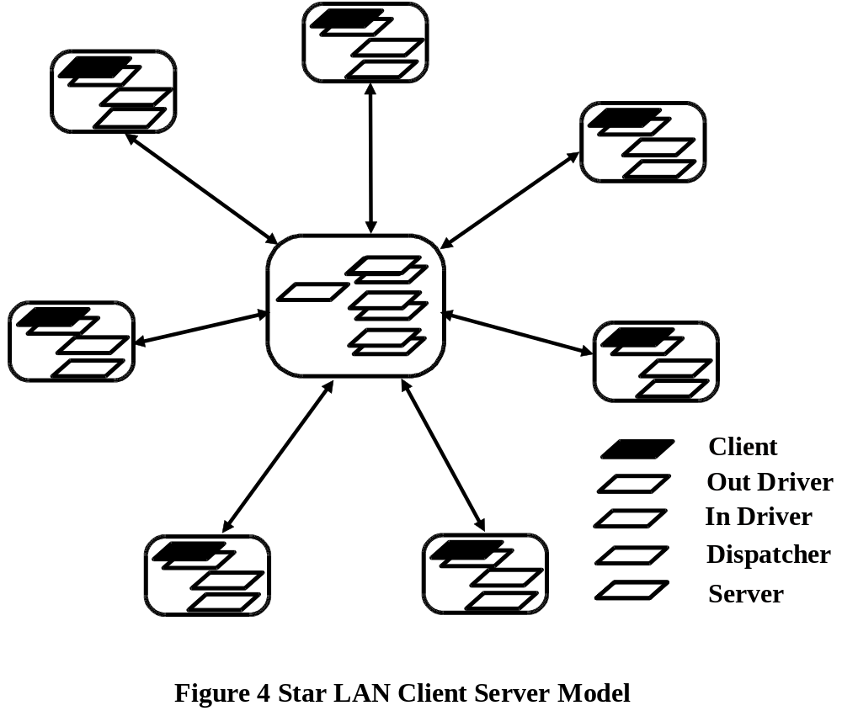

PARASOL provides building blocks that are nearly ideal for modelling this system. Clearly its nodes, links, and tasks map directly onto this problem space. There is relatively little involved in writing ps_genesis code to construct the LAN and launch the system tasks. The main challenge will be in writing the code for the tasks to achieve the functionality desired. This is precisely the value of emulation, i.e., to prove the design of current system by providing a means to execute prototypes and verify design approaches and concepts.

The emulator code is to be found in star_lan.c. Typical of emulators it pays little heed to performance issues with only a few nominal time delays sprinkled into to lend some degree of realism. In this form it will not report any statistics. One may ask - What value is it when it produces nothing? The answer is that is can produce very useful and detailed trace output. That output is “turned on” by merely requesting an execution trace using the so-called command line “trace option”. Use of this option and the “step” option will be discussed further in the next section of this document.

Examination of the code reveals that six relatively short PARASOL task definitions. Beginning with ps_genesis, the only non-system task, we see it first creates the hub node and then enters a loop which creates with each iteration: a satellite node, two links (an up_link from the satellite to the hub and a down_link in the reverse direction), four link driver tasks (an up_driver for the source end of each link and a down_driver for the destination end of each link), and a number of satellite resident client tasks to act as load generators. Finally ps_genesis creates a single hub resident dispatcher task. Notice that in about fifty lines of code, it is possible to construct an elaborate execution environment and launch over forty tasks.

The system task classes include the client, the up_driver, the down_driver, the dispatcher, and the server. In fact, a client/server interaction involves communication between the following task pairs: client - satellite up_driver, satellite up_driver - hub down_driver, hub down_driver - dispatcher, dispatcher - server, server - dispatcher, server - hub up_driver, hub up_driver - satellite down_driver, and, finally, the satellite down_driver - client. Understandably, with all these interactions going on in addition to the fact that, with the exception of the dispatcher task, there are multiple instantiations of classes, there is ample opportunity for coding errors in the system classes. The code given in star_lan.c represents a fairly primitive generation of a prototype model since many details, particularly at the server end are missing. Nonetheless, this model does capture the essence of the inter-tasking communication required. Also, assuming the target system employs a similar style of IPC, i.e., asynchronous, port-based communication, the emulator details of the IPC could be very close to reality.

As stated earlier, the up_driver and down_driver tasks are used to model the action of the satellite and hub operating systems in transferring data between machines. In reality, these actions would likely be performed using kernel-level interrupt service routines. We have chosen to model such entities as high priority tasks running on PR scheduled nodes. Notice that their execution is triggered by the reception of a message representing the arrival of data to be transmitted or passed to another task. This technique can readily be extended to multi-level priority interrupt i/o systems. In fact, complete operating systems may be modelled using PARASOL tasks to provide application software interfaces that are arbitrarily accurate in detail. If carried out to extreme, this can lead to the extension of PARASOL emulation to the point where there is little distinction between PARASOL and production application software.

While none of the task classes in this demonstration are complex, in true emulation studies one would expect to find one or more quite complex tasks. A candidate here might be the dispatcher task which now manages what amounts to a pool of servers that can grow without bound. More realistically, an adaptive strategy may be used in certain circumstances to reduce the size of the pool. A more detailed model might also involve specialized servers to handle various types of transactions. This would add complexity to both the dispatcher and server classes. The server class is presently very simple with both a compute and a sleep sandwiched between messaging to represent system execution delays and other exogenous delays. A more accurate representation could see a data base model, perhaps built on top of the generic disk model of the previous case study, serving a transaction server process.

This case study has demonstrated the use of PARASOL in emulation modelling. It suggests that emulation modelling be iterative with more and more detail added until a satisfactory “proof of concept” is established. Unlike simulation models, these models are not overly concerned with accurate execution timings although it is usually appropriate to use execution calls such as ps_compute to emulate the interleaving of concurrent activities. Not discussed here, is the matter of interpretation of emulator results, i.e., the execution traces available through the “t” or trace option. Readers are referred to the next section for that discussion.

One of the great advantages of PARASOL over separate emulation and simulation tools is the fact that it can do both. For example, emulation modelling, such as exemplified by this case study, can be easily entended to performance simulation once the “proof-of-concept” phase of a design is complete. Not only can this be carried out by the same personnel, since the same tool is involved, but much, if not all, of the emulation model can be used directly in the simulation model saving a good deal of labor.

4.5 User-Defined Node Scheduling Model

Our sixth case study illustrates the user-defined node scheduling features available to the PARASOL user. See the source file quantum.c. The case study involves a multi-processor system with many tasks running at different priorities. For demonstration purposes, we have chosen a scheduling discipline called a random-serve, variable-length-quantum round-robin. The “random-serve” means that the next task to be scheduled is chosen at random from the node’s ready to run queue, while the “variable-length-quantum round-robin” means that the scheduling is timesliced in a round-robin fashion, but the length of the quantum increases with the priority of the task.

Before we delve into the code, a discussion of the user-defined scheduling mechanism is in order. In order to build a node with a user defined scheduling discipline the user must define a scheduler task that performs the node scheduling. In the case of a multiple host (cpu) node, each host must have one of these tasks running on it. Scheduler tasks are notified via messages whenever significant events occur. The three types of notification messages provided are: SN_READY which indicates that a new task has been added to the node’s ready queue, and SN_IDLE which notifies the appropriate scheduler that it’s associated host has become idle (because the task executing on that host called ps_sleep, was suspended, became receive blocked etc), and ACK_TIMEOUT (in this example, retyped to SN_QUANTUM) sent when a quantum has expired. One difference between these messages should be noted, and this is that SN_IDLE and ACK_TIMEOUT messages are sent to the scheduler task associated with the host that has become idle, while SN_READY messages are always sent to the “master” scheduler associated with host 0.

As usual, we begin our study by examining ps_genesis. The first few lines simply fetch parameters and allocate arrays with sizes based on these parameters. The arrays allocated are: atids which is used by the schedulers to map hosts onto the application task currently executing on them, sids which maps hosts onto their associated scheduler tasks, and stats which is used to hold statistical entity identifiers. SAMPLE statistics are then opened and their ids placed in the stats array. Next, the node is built with a call to ps_build_node2. This call resembles a call to ps_build_node, but no quantum is specified and instead of specifying a scheduling discipline, a scheduling function is specified in the form of the code for a scheduling task. Thus, this call effectively builds the node and launches an instance of the scheduler on each host. Finally, genesis launches the “pseudo-application” tasks, in particular ntasks are created for each of the nclasses priority classes.

Next we examine the code for the pseudo-application tasks, viz., task. These are the tasks that provide the load for the user defined scheduling node we created in ps_genesis. The life cycle of these tasks is quite simple; they sleep for an exponentially-distributed amount of time with mean 1.0 and then compute for an exponentially-distributed amount of time with mean 1.0. While doing this they record observations on the their compute:elapsed time ratio by priority level. These observations are recorded on the statistics allocated in ps_genesis in the stats array.

We’ve now reached the meat of this case study, namely the scheduler task. Recall that one instance of this task runs on each host of the node. Upon entry, the scheduler sets it’s local quantum variable to NEVER, allocates an array of integers called rtrq of size ntasks*nclasses, places a NULL_TASK at it’s position in the atids array signifying that no task is currently running on that host, and puts it’s own id (ps_myself) at the appropriate position in the sids array. Now the task enters it’s main loop. The loop, like the loop of all user defined scheduling tasks simply waits for a notification message on it’s standard port and takes appropriate action. Notice that the call to ps_receive uses quantum as it’s timeout value, and that if the receive times out, the type variable is set to SN_QUANTUM, #define’d at the top of the program.

The handling of SN_IDLE notification messages is reasonably straightforward. First the ready to run queue is obtained with a call to ps_ready_queue2. If there are any tasks ready, one is chosen at random, the atids array is updated to show that the task is running on the current host, quantum is set to base_quantum times the task’s priority and the task is scheduled to run with a call to ps_schedule. If there are no tasks ready, the atids array is updated to show that the current host is idle with NULL_TASK and quantum is set to NEVER. Scheduling a NULL_TASK is vital since it prevents further SN_IDLE messages from being sent, i.e., not scheduling a NULL_TASK will result in the system hanging by continuously sending SN_IDLE messages.

The handling of SN_READY messages is slightly more complex. Recall that SN_READY messages are sent only the scheduler on host 0, so the first thing the scheduler does is check if it’s host is available. If it is, the atids array is updated to show that the newly-readied task is running, quantum is set according to the task’s priority, and the task is scheduled to run with a call to ps_schedule. If the scheduler’s host is busy, it searches the atids array for an available host, if one is found then the SN_READY message is forwarded to the scheduler associated with that host. If no hosts are available, nothing is done and the task is left in the ready queue. The value of quantum is then adjusted because by this time, the task which was running on the host has already used a portion of it’s quantum.

The last message type we have to handle are SN_QUANTUM messages. The reason for the careful handling of the quantum variable above was so that the call to ps_receive at the top of the while loop will timeout when an executing task’s quantum has expired. First the ready to run queue is checked with a call to ps_ready_queue2. If there are any tasks ready, one is chosen at random, the hosts array is updated to show that the task is running on the current cpu, quantum is set appropriately and the task is scheduled to run on the current node with a call to ps_schedule. If there are no tasks ready, the value of quantum is reset, and the current task is allowed to continue executing.

User-defined scheduling is a new addition to PARASOL which we hope will increase the number of systems for which PARASOL simulations can be written. This case study demonstrates the use of this new functionality by designing a simulation containing a node with a custom (albeit odd) scheduling discipline. It also illustrates a method of implementing round-robin style timeslicing by calling ps_receive with a timeout value equal to the quantum size.

4.6 A C++ Client Server Model

Included in the PARASOL distribution is the C++ interface, which we call the PARASOL++ library. This interface consists of a collection of C++ classes which are used to encapsulate PARASOL entities such as tasks, nodes and links. By using PARASOL++, a simulation programmer need not and in fact should not make use of 95% of the original PARASOL functions, as nearly all the functionality of PARASOL is included in PARASOL++ by means of C++ classes. This case study (see the source file cs.cc) and the next provide two examples of C++ applications built on the PARASOL++ library.

Before we look at the code for this example, we should first give an overview of some of the classes available in the PARASOL++ library. For a complete description of these classes and others which make up the PARASOL++ library, the reader is referred to “PARASOL++: A PARASOL C++ Library”. The most used class by far from the PARASOL++ user’s perspective is the abstract class PS_UserTask. By subclassing this class and overriding the virtual member function PS_AbstractTask::code(), the user defines tasks. The subclass inherits quite a bit of functionality from PS_UserTask and it’s ancestor classes including functions for sleeping, computing, suspending etc. The virtual member function code() is called once the task is created and resumed and defines the task’s behaviour. In order to create a task, the user then simply creates an instance of one of these subclasses. Other classes included in the library are classes representing nodes (PS_ParasolNode, PS_UserNode), ports (PS_Port, PS_SharedPort, PS_PortSet), semaphores and spinlocks (PS_Semaphore, PS_Spinlock), statistics (PS_VariableStatistic, PS_RateStatistic, PS_SampleStatistic), buses (PS_Bus), links (PS_Link) and a universal message transportation medium called ether (PS_Ether), not to be confused with Ethernet. Ether is used to represent the zero delay/infinite rate communication medium, i.e. messages sent via ether arrive at the same time they are sent. For the PARASOL user sending messages via the ether is analagous to doing a ps_send as opposed to a ps_bus_send or ps_link_send. Only one instance of the PS_Ether class can be created, and it is a global variable created on startup called, appropriately enough, PS_ether. PARASOL++ contains two other global variables, PS_parasol_node and PS_genesis_task. PS_parasol_node is the only instance of the PS_ParasolNode class, and is the base node that is created on startup (node 0 for PARASOL users). PS_genesis_task is the only instance of the PS_GenesisTask class and represents the genesis task. The definition of the PS_GenesisTask class is not complete however, since the user must define the function void PS_GenesisTask::code() which becomes the simulation entry point. The role of void PS_GenesisTask::code() to the PARASOL++ programmer is the same as that of the ps_genesis function to the PARASOL programmer.

With this background we can now begin looking at a sample program. This program simulates a simple client/server system in which several clients make requests to a single server. The program displays the statistics on the mean response time of the server, where response time for a single request is defined as the time elapsed between the time the request is sent to the server and the time the response is received. We will begin our case study by looking at the task classes involved in this simulation. As you would expect there are two such classes ClientTask and ServerTask.

The ClientTask class is necessarily a subclass of PS_UserTask, it’s public derivation means that the it inherits all the protected and public methods of PS_UserTask. The ClientTask class has three instance variables: think_time; the client’s mean think time, server_port; a pointer to a PS_Port which is the server’s port, and r_stat; a pointer to a PS_SampleStatistic used to keep track of the mean response time. The ClientTask class has only two member functions, it’s constructor and the virtual ClientTask::code() function. The constructor is fairly simple, it initializes the PS_UserTask base class so that the task is created on PS_parasol_node to run on ANY_HOST with priority 1, it then sets it’s instance variables to the values supplied as the constructor arguments, and finally resumes itself with a call to the inherited member function Resume(). The other function is void ClientTask::code(), as mentioned earlier it is this function that defines the behaviour of the task. This function is quite simple, it simply enters a loop in which it calls the inherited function Sleep() to sleep for an exponentially-distributed period of time with mean think_time. It then sends a request to the server_port via PS_ether of type REQUEST of size 0 with no text and the id of it’s standard port as the other parameter. It then waits for the server to send a response to it’s standard port and records the time elapsed since sending the request on the r_stat statistic.

The ServerTask is again a publically derived subclass of PS_UserTask. It has only one instance variable, service_time which represents the mean service time. Like the ClientTask class it also has only two member functions, a constructor and ServerTask::code(). The constructor is similar to that of the ClientTask in that it simply initializes the base class, uses the parameters to set the values of its instance variables and calls the inherited function Resume() to resume itself. The function void ServerTask::code() is also quite simple, it simply waits to receive a request on it’s standard port, once one is received it sleeps for an exponentially-distributed amount of time with mean service_time, and then responds to the request by constructing a PS_Port out of the other data sent with the request, which we know is the id of a client’s standard port and sending a RESPONSE message to it.

With these two classes defined, writing the void GenesisTask::code() function becomes a trivial matter, viz., prompt the user for the simulation parameters, create a PS_SampleStatistic for the mean response time, create an instance of the ServerTask class, and create a number of instances of the ClientTask class. The simulation is then underway. Note that all the entities were dynamically allocated using the operator new. The reason for this is that objects allocated this way are persistent, i.e., have a lifetime lasting longer than then current scope. If we had just created our objects as local variables they would have been destroyed when void GenesisTask::code() returned. In the case of the tasks involved this would have meant that they would have been killed, and the simulation would be over before it even began.

This case study has shown a simple example of the use of PARASOL++. It should be noted that this example is “quick and dirty” in that it is used for illustration purposes only because of it’s simplicity. The real power of PARASOL++ comes from writing modular reusable code which comes in the form of reusable parameterized objects, as well as abstract classes which can later be specialized into more concrete classes. The next case study gives an example of just such a design.

4.7 A C++ Remote File System Model

This goal of this case study is to show, by example, a method of developing modular reusable classes for use in PARASOL++ based simulations. The case study (see the source file rfs.cc) models a local area network in which a number of workstations are connected by an Ethernet-like bus to a file server. The workstations periodically make requests to read or write data to the file server. Again, we begin our case study by looking at the classes involved.

Looking at the declaration of the FileServerTask class we see that it inherits from the PS_UserTask class. The FileServerTask class has two data members: dt_rate; the disk transfer rate in bytes per second, usage_stat; a pointer to PS_VariableStatistic that is used to gather utilization statistics if requested. The FileServerTask constructor takes four arguments: name; the name of the task, node; the node on which the task is to execute, idt_rate; the disk transfer rate, and sf; a flag indicating whether or not to collect utilization statistics. The constructor initializes the PS_UserTask base class to create a task with the given name and node, that has priority MAX_PRIORITY and is allowed to run on any host, dt_rate is initialized with the value of idt_rate and usage_stat is initialized to a new PS_VariableStatistic if sf is set. The function void FileServerTask::code() sits in a loop handling I/O requests as they are sent. Requests are expected to be sent with the type of request (READ/WRITE) sent as the type parameter and a pointer to an fs_req_t structure sent as the text parameter. For simplicity, an fs_req_t structure has just three members: carrier; the transportation medium to use when returning the result, port; the port to send the result to, and bytes; the number of bytes to read or write. Requests are handled by calling FileServerTask::HandleReadRequest(fs_req_t*) or FileServerTask::HandleWriteRequest(fs_req_t*) as appropriate. The last thing done before returning to the top of the loop is delete the fs_req_t structure that was sent with the message so as not to leak memory. FileServerTask::HandleReadRequest(fs_req_t*) simply sleeps to simulate reading data from a disk and then sends a response of the appropriate size. FileServerTask::HandleWriteRequest(fs_req_t*) first sends a response of a fixed size, then sleeps to simulate writing the data to the disk.

Now we move to the FileServer class. This is the interface to the FileServerTask class, it provides functions for creating a file server, for reading from a file server and for writing to a file server. From it’s declaration we see that it has only one data member named fst which is a FileServerTask. Looking at the FileServer constructor we see that it takes the same arguments as the FileServerTask constructor, and that these arguments are used to initialize the fst data member. The Read(PS_AbstractCarrier&,int) member function takes as arguments a PS_AbstractCarrier reference which is the carrier to be used for making the request and transferring the data, and an int which is the number of bytes to read. The function definition is quite simple, it simply creates a temporary port, allocates an fs_req_t structure using new (remember that it must be allocated with new because FileServerTask::code() deletes it with delete), fills in the fs_req_t structure and sends a READ message to fst. The last thing it does is receive on the temporary port to wait for a reply from the server task. The Write(PS_AbstractCarrier&,int) member function is very similar to the Read(PS_AbstractCarrier&,int), the only difference being that the message sent is of type WRITE rather than READ, and the size of the message is the number of bytes to write rather than NOMINAL_SIZE.

The third class written for this case study is the WorkstationTask class. Like other task classes written by users, it inherits from PS_UserTask. The WorkstationTask class has four data members: carrier; The network communications medium, file_server; the file server on the network, think_time; the mean time between requests to file_server, and read_prob; the probability that a request to the file_server will be a read request. The WorkstationTask constructor has name and node parameters which are used to initialize the PS_UserTask base class, as well as initial values for it’s data members. The last thing the WorkstationTask constructor does is to resume itself with a call to the inherited Resume() function. The WorkstationTask::code() function follows a simple cycle: It sleeps for an exponentially-distributed period of time with mean think_time, then calls file_server->Read with probability read_prob, otherwise it calls file_server->Write.

The only unexamined code left in this case study is the simulation entry point, namely PS_GenesisTask::code(). It begins by reading parameters from the user. Then a node for the file server to run on is created, as well as a file server. PS_parasol_node and the newly created server node are then joined by a PS_Bus. The last step is to create a number of WorkstationTask instances that run on PS_parasol_node. The simulation is then underway. The reason we are able to get away with executing all the WorkstationTask instances on PS_parasol_node is that WorkstationTask instances never consume CPU cycles, so while we could have built one node for each instance, it would have no effect on the results obtained.

This case study presents a simulation of a simple LAN like those found in many offices today. While the WorkstationTask class is strongly coupled with this particular simulation, there is nothing which ties the FileServer/FileServerTask combination to this simulation. In fact the FileServer/FileServerTask code could be lifted from this simulation and used in any other for which a file server is needed. This case study also introduces the concept of task/interface pairs where an entity is designed as a task that takes requests in the form of messages (in this case the FileServerTask class), and an interface to this task (in this case the FileServer class), that handles communication between the users of the entity and it’s associated task. Finally it should be noted that the FileServer/FileServerTask combination used in this case study is not intended to be a very realistic model of a file server, rather it is a simplification used to demonstrate the concepts mentioned above.

5 PARASOL Operational Matters

This part of the tutorial deals with getting the most from a PARASOL simulator/emulator. A primary concern to any modeller is the accuracy or viability of his model. The discovery and elimination of bugs in complex concurrent systems is rarely easy. Added to the problems of sequential software are critical races, deadlock, and other difficulties which are rarely easy to detect and to remedy. Consequently, there is a strong need for debugging tools within PARASOL. These will be presented in the following section. After that, attention will be drawn to techniques of improving the efficiency of simulation models. Finally, this document concludes with a discussion of embedded PARASOL applications illustrating how PARASOL may be embedded into an application rather than used in its customary standalone mode.

5.1 Debugging Strategies

PARASOL comes with several built-in debugging aids. First there is the “warning” option which can be activated either by the “w” flag on the command line of a standalone PARASOL application or with the RPF_WARNING flag in an embedded application. When so armed, the application writes a log of warning messages to stderr noting all occurances of failed PARASOL library calls due to inappropriate arguments.

Another debugging aid, mentioned previously, is the execution trace specified by a “t” flag or with the RPF_TRACE flag depending upon the type of application. It was noted that this feature is particularly useful in emulation modelling. Its main purpose, whether in emulation or simulation, is model verification since it allows one to follow the state of the model through time. We will illustrate by showing trace outputs from the Star LAN Based Client Server Model of Section 4.4.

Owing to the bulk of typical traces, it is wise to use them in moderation. For example, running star_lan for a duration of 10 time units yields a trace of more than 2400 events including more than 160 of these events occurring at time zero as the emulation gets underway. The following is a short excerpt of the beginning of the trace:

Time: 0; Node: 0; Task 1 (Genesis) created (suspended).
Time: 0; Node: 0; Task 1 (Genesis) ready.
Time: 0; Node: 0; Task 1 (Genesis) executing.
Time: 0; Node: 2; Task 2 (Satellite Up Driver) created (suspended).
Time: 0; Node: 2; Task 2 (Satellite Up Driver) executing.
Time: 0; Node: 2; Task 3 (Satellite Down Driver) created (suspended).
Time: 0; Node: 2; Task 3 (Satellite Down Driver) ready.
Time: 0; Node: 1; Task 4 (Hub Down Driver) created (suspended).
Time: 0; Node: 1; Task 4 (Hub Down Driver) executing.
Time: 0; Node: 1; Task 5 (Hub Up Driver) created (suspended).
Time: 0; Node: 1; Task 5 (Hub Up Driver) executing.
Time: 0; Node: 2; Task 6 (Client[1][1]) created (suspended).
Time: 0; Node: 2; Task 6 (Client[1][1]) ready.

At this stage of the emulation only the reaper (the parent of genesis which handles kill requests but doesn’t appear in traces) and genesis have actually executed code although other tasks are logically executing in parallel. However, some tasks do not start to execute at this stage and are queued ready since their node is presently logically occupied. It is instructive to look ahead in the trace to the point at which genesis suspends itself.

Time: 0; Node: 0; Task 1 (Genesis) suspended.
Time: 0; Node: 7; Task 37 (Satellite Up Driver) receiving (blocked) on port 37.
Time: 0; Node: 7; Task 38 (Satellite Down Driver) executing.
Time: 0; Node: 7; Task 38 (Satellite Down Driver) receiving (blocked) on port 38.
Time: 0; Node: 7; Task 41 (Client[6][1]) executing.
Time: 0; Node: 7; Task 41 (Client[6][1]) sleeping.
Time: 0; Node: 7; Task 42 (Client[6][2]) executing.
Time: 0; Node: 7; Task 42 (Client[6][2]) sleeping.
Time: 0; Node: 7; Task 43 (Client[6][3]) executing.
Time: 0; Node: 7; Task 43 (Client[6][3]) sleeping.

Notice that time does not advance immediately because there is so much pent up activity ready to be unleased by the other tasks. Here a pair of satellite drivers begin execution and immediately block awaiting a message. Next, client tasks start and immediately take naps. Although the detail can be excruciating at times, it is clear that an execution trace can reveal much about the behaviour, both expected and otherwise, of a system. Users should note that the interpretation of these traces is facilitated to a considerable degree by the fact that user assigned task names appear. That is to say, it is prudent to name all PARASOL entities. Let us examine one more excerpt still later in the trace.

Time: 2.95833; Node: 3; Task 10 (Satellite Down Driver) sending message 100 to task 13 via port 13.
Time: 2.95833; Node: 3; Task 13 (Client[2][1]) ready.
Time: 2.95833; Node: 3; Task 10 (Satellite Down Driver) receiving (blocked) on port 10.
Time: 2.95833; Node: 3; Task 13 (Client[2][1]) executing.
Time: 2.95833; Node: 3; Task 13 (Client[2][1]) receives message 100 on port 13.
Time: 2.95833; Node: 3; Task 13 (Client[2][1]) sleeping.

Here one sees the interaction between a satellite down driver and a client task as the server response makes its way back to the client. Notice the fine detail here, viz., the client is readied as a result of the driver sending to it but does not start executing until the driver stops executing by blocking on its port. Notice as well that messages carry sequence numbers to facilitate interpretation.

What is often lost in a trace such as the one shown where many tasks are involved is the cyclic behaviour of a particular task. A UNIX tool such as grep is particularly useful in these occasions. For example to trace the cycle of a particular client task, we could filter the trace with the command star_lan -t 1 10 | grep “Task 22” and get the following trace excerpt:

Time: 0; Node: 4; Task 22 (Client[3][3]) created (suspended).
Time: 0; Node: 4; Task 22 (Client[3][3]) ready.
Time: 0; Node: 4; Task 22 (Client[3][3]) executing.
Time: 0; Node: 4; Task 22 (Client[3][3]) sleeping.
Time: 1; Node: 4; Task 22 (Client[3][3]) ready.
Time: 1.22; Node: 4; Task 22 (Client[3][3]) executing.
Time: 1.32; Node: 4; Task 22 (Client[3][3]) sending message 28 to task 16 via port 16.
Time: 1.32; Node: 4; Task 22 (Client[3][3]) ready.
Time: 1.33; Node: 4; Task 22 (Client[3][3]) executing.
Time: 1.33; Node: 4; Task 22 (Client[3][3]) receiving (blocked) on port 22.
Time: 3.42833; Node: 4; Task 22 (Client[3][3]) ready.
Time: 3.42833; Node: 4; Task 22 (Client[3][3]) executing.
Time: 3.42833; Node: 4; Task 22 (Client[3][3]) receives message 157 on port 22.
Time: 3.42833; Node: 4; Task 22 (Client[3][3]) sleeping.

Now it is a good deal more obvious that the client is cycling as one would expect. Notice that the execution of the task is interrupted immediately after its sends. This occurs because the up_driver is used to model a high priority interrupt service routine that preempts the client briefly on the uniprocessor satellite node.

While much can be learned by examining a trace, tracing a complete run manually is usually overwhelming without some tool to assist. One such tool is ParaGraph from ORNL which is available from the netlib repository at http://www.netlib.org/. This a visualization tool designed to work with multicomputer execution traces. A special filter is available to prepare PARASOL traces for input to ParaGraph. This is a awk filter scripted as pgfilter.awk and is found in <PARASOL HOME>/tools directory. To use it one simply pipes PARASOL trace output through the filter for input into ParaGraph. For example, using star_lan and the Cshell one would type:

% star_lan 1 10 |& awk -f <PARASOL HOME>/tools/pgfilter.awk > <PG_Trace_File>

ParaGraph can be very useful in debugging and verifying PARASOL models although it does have some limitations. For example, it assumes an execution environment in which each task runs on its own dedicated processor and computes processor utilizations accordingly. Thus, its utilization “views” may not be meaningful, depending upon the structure of the PARASOL model. On the other hand, its “Space-Time” view is very useful showing the message passing history in a graphical form.

A third debugging feature of PARASOL is the interactive stepping debugger available with the “s” command line option (or the ps_run_parasol RPF_STEP flag set). When invoked, this option starts an execution trace but causes the simulation to halt issuing an interactive debugger prompt, viz., (time)->, before each time advancement. At the prompt, the modeller may chose to advance the simulation to the next event time or to set a time break point and run the simulation to the first event after that time. It is possible to turn the trace on and off at will to eliminate unwanted tracing. The modeller may also examine the status of tasks, the future events list or calendar, as well as, the status of “hardware” entities. This debugger, although somewhat primitive, is very easy to use since it is interactive and has a modest built-in help system which is invoked with the “?” debugger command. It provides modellers with a means to monitor a simulation closely without the need of a more general debugger such as dbx or gdb.

Although the three aids described above are individually selectable via the or’ed RPF flags of the ps_run_parasol call, i.e., may be selected in any combination in embedded applications, standalone applications accept a maximum of two flags specified on the command line before the seed and duration parameters, if these are present. However, since the “s” flag also activates tracing, users have several useful combinations of flags to work with. Notwithstanding the existance of the warning log, execution tracer, and the interactive debugger, modellers should pay particular attention to the PARASOL system call arguments when they write code. Many PARASOL programming errors are attributable to errors in supplying call arguments. Since more often than not these errors are detected by built-in PARASOL guard code and are signified either by SYSERR return values or warning messages if the warning log is activated, a sound debugging strategy is to begin by activating the warning log.

5.2 Towards Efficiency

Efficiency in simulation is usually very important because it often becomes the governing factor in determining the scope of simulation studies. On the other hand, efficiency in emulation is rarely a concern since the speed of production of execution traces, which often require a good deal of human interpretation, is rarely a problem. Consequently, this section is aimed at the simulation modeller who seeks accurate results at minimum cost.

PARASOL is inherently efficient with respect to the execution of software models because they are compiled and executed and, therefore, interpretation overheads are eliminated. Furthermore, every attempt has been made to make PARASOL primitives efficient. Thus, to a considerable degree, the efficiency of a PARASOL simulation is in the hands of the modeller. Modellers should be aware of the relative costs of performing various system calls. Also they should be conscious of the effects of choosing various configuration alternatives. Let us begin by examining some of the “heavyweight” system calls. These calls can impose relatively heavy computation loads and, therefore, should be used sparingly.

In the task management category, the ps_create and ps_kill calls are heavyweights. For this reason, it may be advantageous to employ a pool of ps_suspend’ed tasks that may be quickly brought back to life with a ps_resume call. There is often a considerable gain to be made in making the right choice of a delay mechanism in PARASOL. With respect to tasks, the choices are all heavyweights although some are more so than others. They include: ps_sleep, ps_compute, ps_sync, and ps_hold. If processor contention need not be modelled, the ps_sleep call should be considered even if modelling processor execution since this call reduces the size of the ready-to-run queue and makes scheduling more efficient. An alternative, in cases when contention is not present is the ps_hold call which manages the ready-to-run queue in an efficient way while facilitating the computation of utilization statistics and providing nodes on which to specify appropriate networks. In cases where processor contention enters the picture, the ps_compute or ps_sync calls must be used. These are, relatively speaking, heavyweight calls since the PARASOL scheduler has more to do, particularly when priority queueing is involved. For these reasons, modellers should “instrument” their task code very carefully with these calls, e.g., avoid making two or more calls when one will do. Task delay calls should be made between events in which the global system state changes, e.g., when messages are sent, etc. On the other hand, there is little reason to employ several compute delay calls within the execution of a task which modifies only its own local state, no matter how much it may do so unless the total delay is large and a PR node discipline is in effect and there are candidate tasks of higher priority that could become active over the delay period. The ps_sync call is slightly more costly than the ps_compute call and should be used only where necessary. It is useful to model the delays in several equal priority, non-interrruptable tasks running with a RR discipline, e.g., to model interrupt service running on a node with round robin scheduling of application tasks.

Within the inter-task communication and the task synchronization sets of calls there no heavyweights that need to be used sparingly. Users should be aware, however, that message traffic using links or buses is more costly than without. In many situations, modellers may find that simple delays may be a preferable alternative to the use of links or buses. Statistics gathering can, however, impose a significant computational load. Modellers should their plan data capture needs carefully and avoid setting “hardware” statistics flags from force of habit.

With respect to “hardware” configuration choices, the effects small bus- or link-based messages and of RR scheduling with small quanta should be clear. Effectively, these mechanisms can add enormously to the number of PARASOL events that must be handled over a given simulation period. At a minimum, events require context switches to and from the PARASOL driver to handle these events between the execution of task code. Context switch overheads in PARASOL can be substantial on some hardware.

A final note on simulation efficiency should mention the use of guard code to check for error conditions, etc. Generally speaking, this practice should be encouraged as it makes debugging and model verification much easier. It does, however, impose a small penalty in execution efficiency. Modellers are urged to take full advantage of C’s compilation features including the use of conditional compilation and optimization improve the execution of “proven” models.

5.3 Embedded PARASOL Applications

All but one of the case studies included here as well as most of the examples found under <PARASOL HOME>/examples use PARASOL in its “standalone” mode. This mode requires modellers to supply only task code since a “built-in” PARASOL main function is employed to input simulation parameters and flags and initialize the system. Within the “PARASOL Users’ Manual” documentation, this approach is said to use the “standard wrapper” for PARASOL. Should modellers wish to embed a PARASOL simulator/emulator into some application or merely to alter the wrapper interface, e.g., to permit the input of model parameters before genesis is active, an alternative is available.

In this case modellers are required to call ps_run_parasol either directly or indirectly from their own main function. This function is passed the usual PARASOL startup parameters, viz., duration, seed, and flags and looks after all of the PARASOL initialization duties including the launching of the reaper and genesis. It thus permits a user to embed PARASOL into an environment of their own choosing. Please note that with embedded applications there is no default statistical summary reported although such a summary is easily produced with a call to ps_stats. Users who elect the embedded route will find that PARASOL is equally viable since it is essentially identical although it requires linking to the “Custom” version of the library - readers are referred to the “PARASOL Users’ Manual” for operational details and to the Data Base example included here in Section 4.2.

