Psychopy installation:

http://www.psychopy.org/installation.html

https://sourceforge.net/projects/psychpy/files/latest/download?source=files

Code is in:

Setting up:
Include Path of GeneralTools in Phsychopy→Perferences→General→paths:[u'/Users/huberl/Documents/Python/PsychoPyParadigms/GeneralTools']

Backup is on Dropbox:

Users/huberl/Documents/Python/PsychoPyParadigms/TappingWithTrTiming

The Prompt Text is given in subfolder Text

The file to run with Psychopy it “TappingWithTrTiming_Movie_d3.pyc”

Durations of activity and rest
number of Blocks,
initial rest
are all defined arround line 30

The frame rates of the different tapping frequencies. Are given on Line 50.
Note, he speed maxes aout at arronf 0.3 Hz. I.h. any value above 30 will appear slower.

Fix for lost window:
Sometimes in mac the wondow is of screen:
t getit back on screen,
1.) select the program in the task bar.
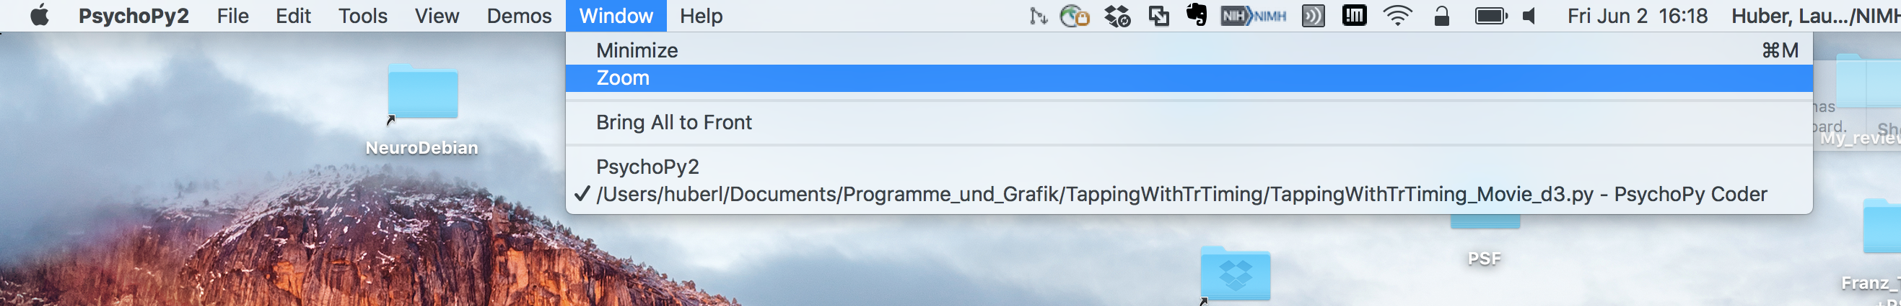
2.) in the top bar go to Window → zoom.

