**Power test of 2.2.24 and 2.1.70**

**SDCv2.2.24:**

**CF10AG:**

|  |  |  |  |  |
| --- | --- | --- | --- | --- |
| CF10AG | CAM | MAXIMUM | FAST | NOT ASSOCIATED |
| TRANSMIT | 381 | 403 | 384 | 409 |
| RECEIVE | 181 | 194 | 185 | 186 |
| STANDBY |  | 17 | 16 | 16 |

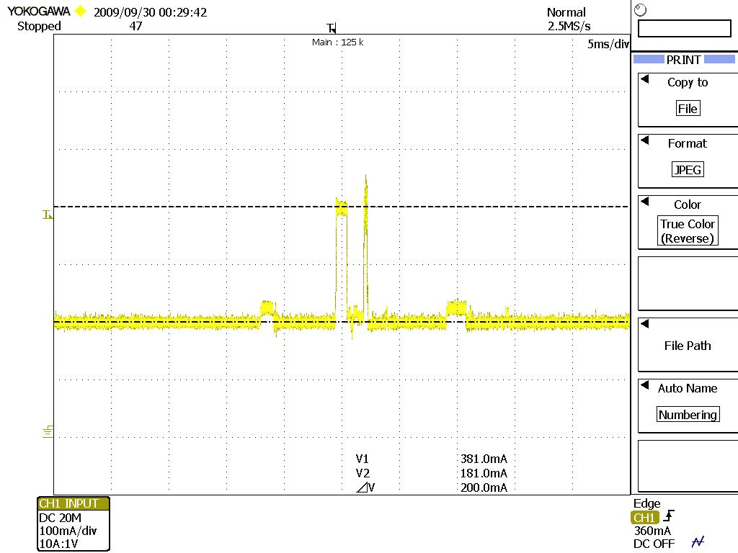

*Figure 1-CAM of CF10AG*

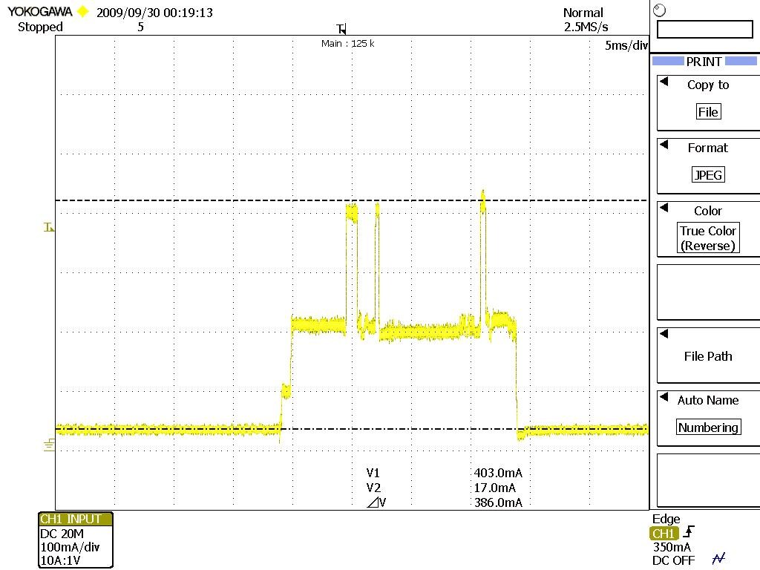

*Figure 2-Maximum of CF10AG*

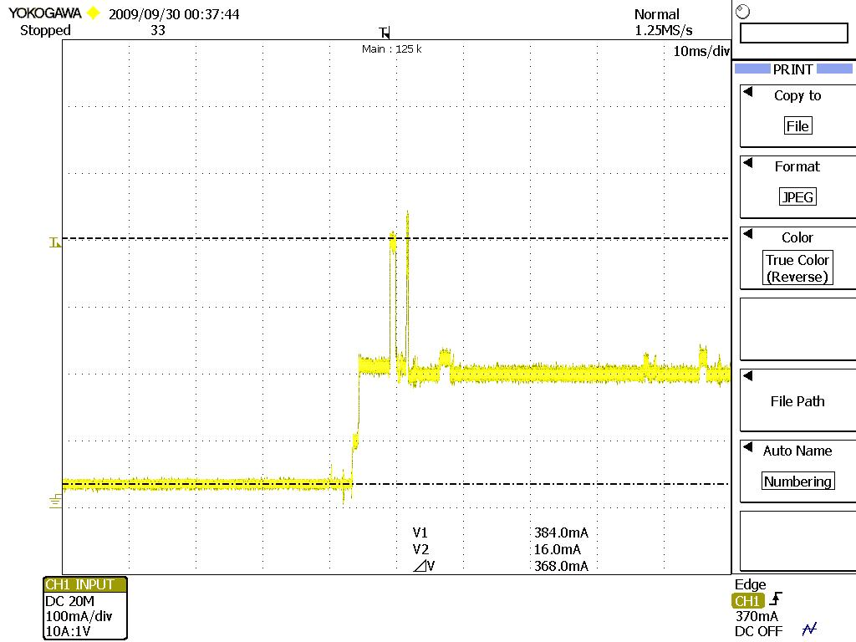

*Figure 3-Fast of CF10AG*

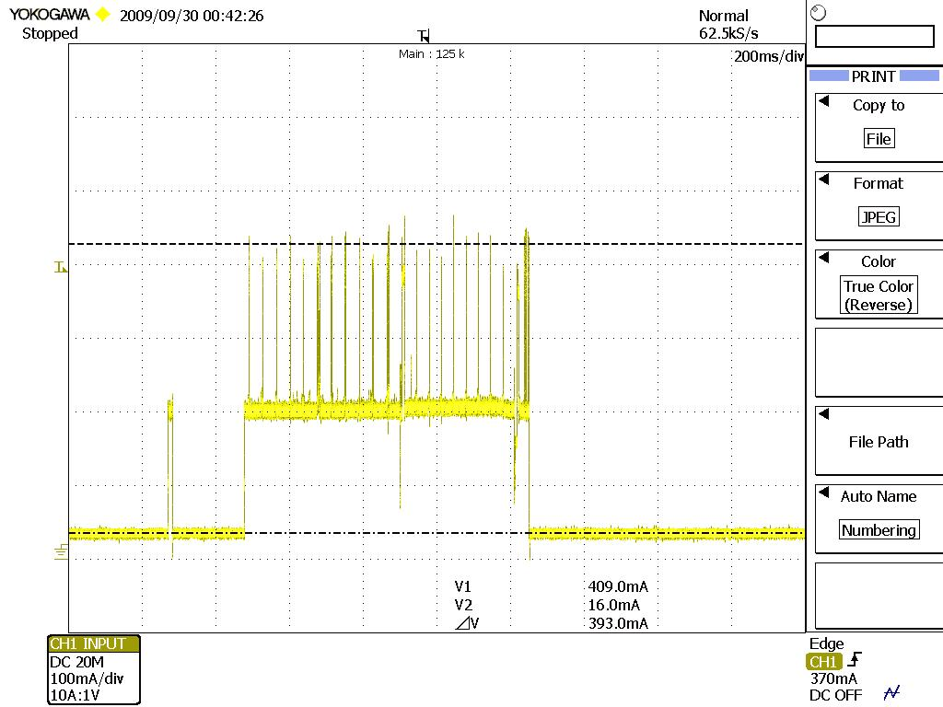

*Figure 4-Not associated of CF10AG*

**MCF10AG:**

|  |  |  |  |  |
| --- | --- | --- | --- | --- |
| MCF10AG | CAM | MAXIMUM | FAST | NOT ASSOCIATED |
| TRANSMIT | 380 | 360 | 383 | 384 |
| RECEIVE | 181 | 191 | 194 | 185 |
| STANDBY |  | 16 | 17 | 16 |

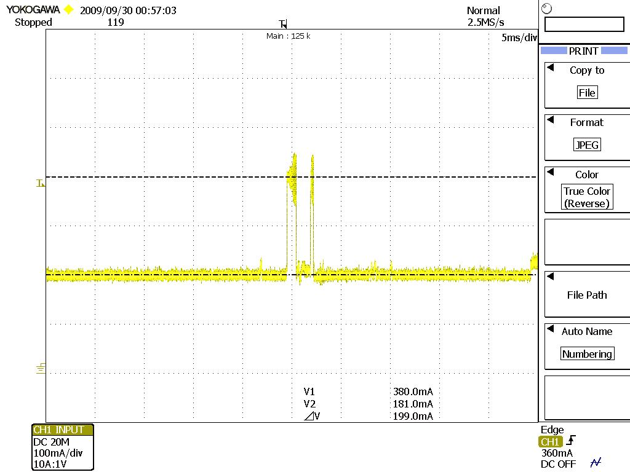

*Figure 5-CAM of MCF10AG*

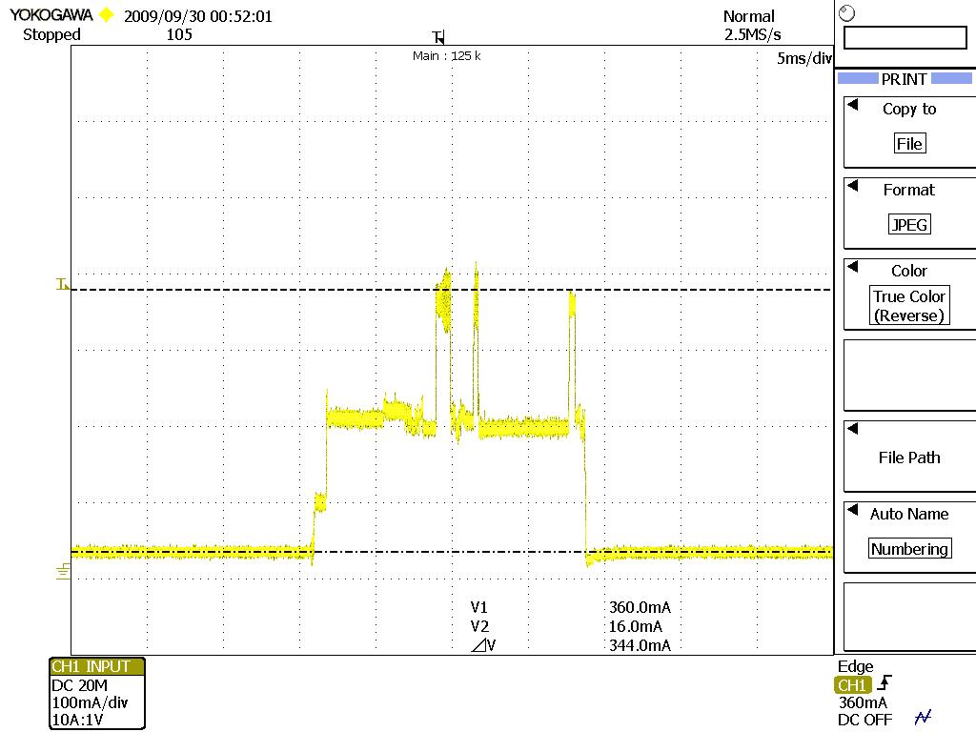

*Figure 6-Maximum of MCF10AG*

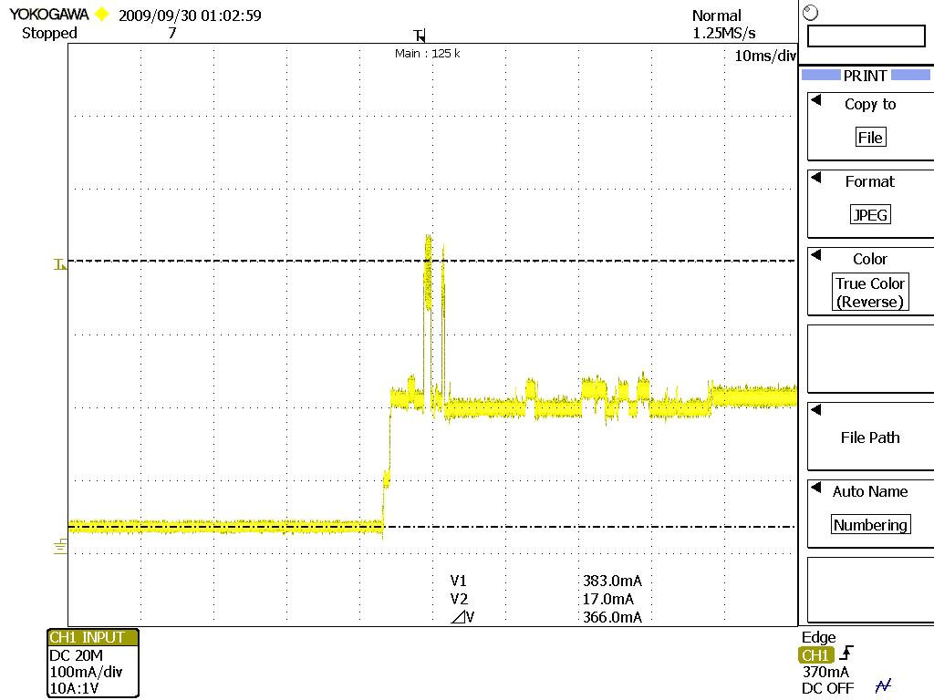

*Figure 7-Fast of MCF10AG*

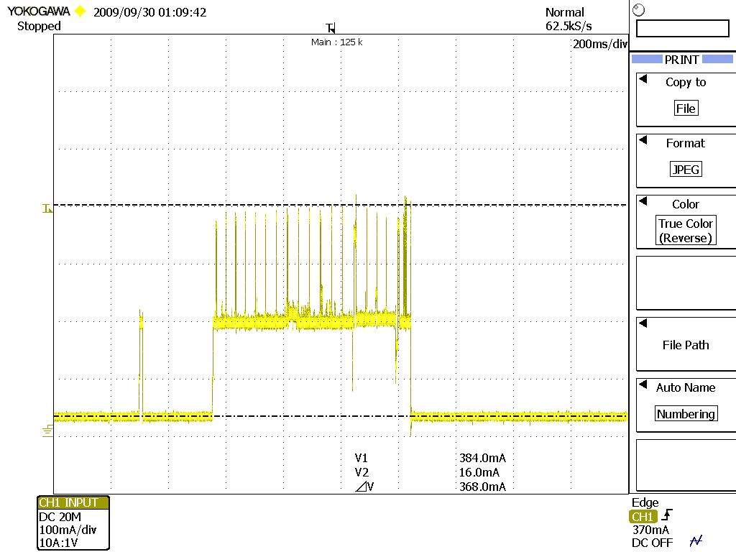

*Figure 8-Not associated of MCF10AG*

**SDCv2.1.70**

**MSD10G:**

|  |  |  |  |  |
| --- | --- | --- | --- | --- |
| MSD10G | CAM | MAXIMUM | FAST | NOT ASSOCIATED |
| TRANSMIT | 429 | 436 | 444 | 388 |
| RECEIVE | 177 | 176 | 176 | 169 |
| STANDBY |  | 11 | 9 | 11 |

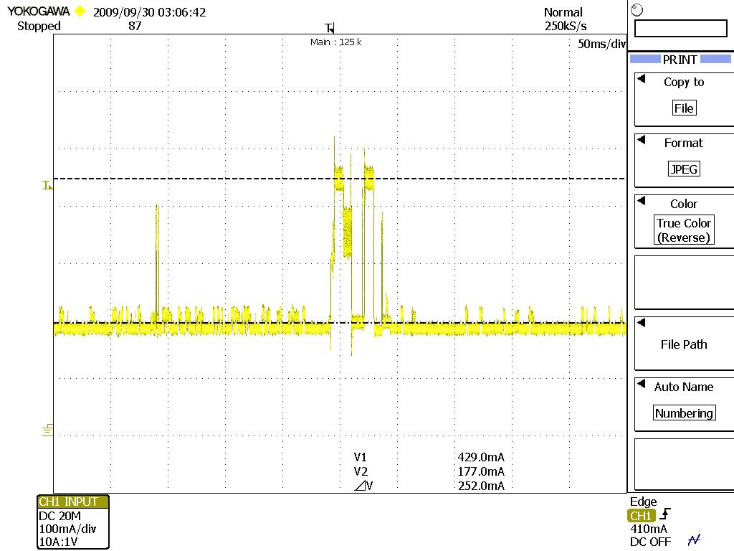

*Figure 9- CAM of MSD10G*

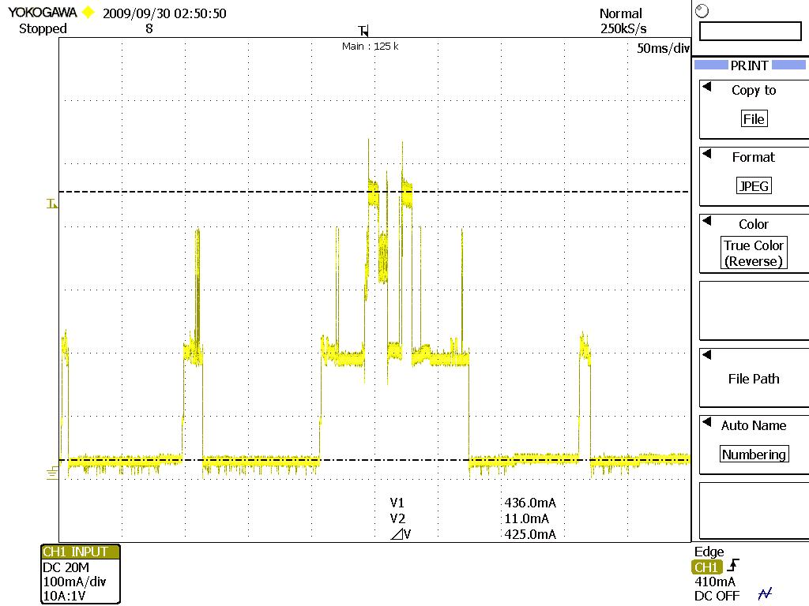

*Figure 10- Maximum of MSD10G*

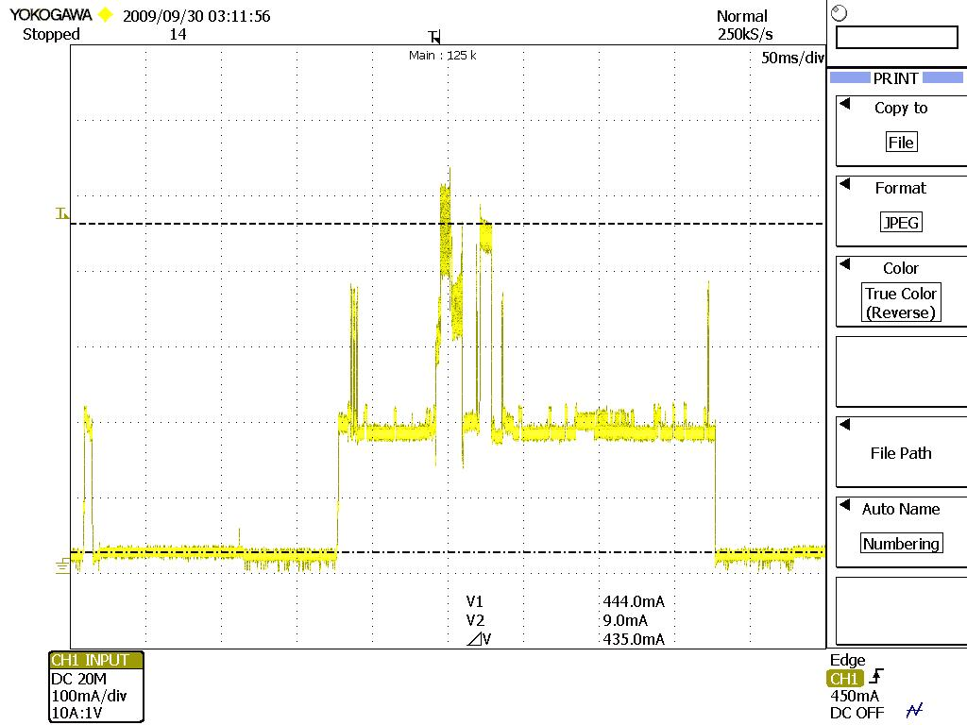

*Figure 11- Fast of MSD10G*

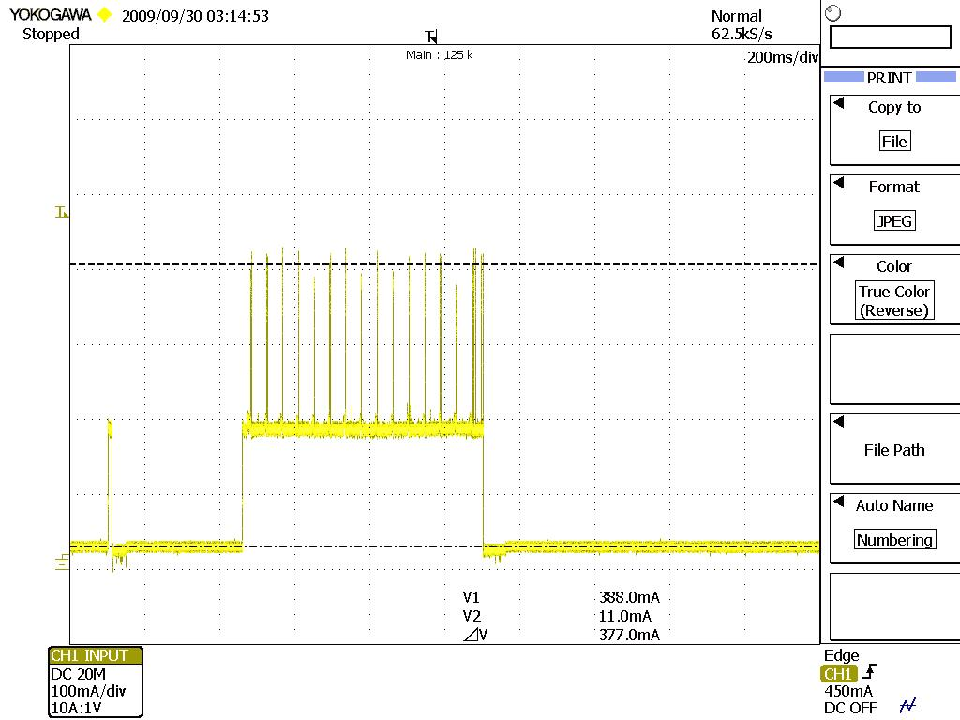

*Figure 12- Not associated of MSD10G*

**MSD10AG:**

|  |  |  |  |  |
| --- | --- | --- | --- | --- |
| MSD10AG | CAM | MAXIMUM | FAST | NOT ASSOCIATED |
| TRANSMIT | 434 | 440 | 434 | 428 |
| RECEIVE | 186 | 183 | 179 | 188 |
| STANDBY |  | 15 | 14 | 15 |

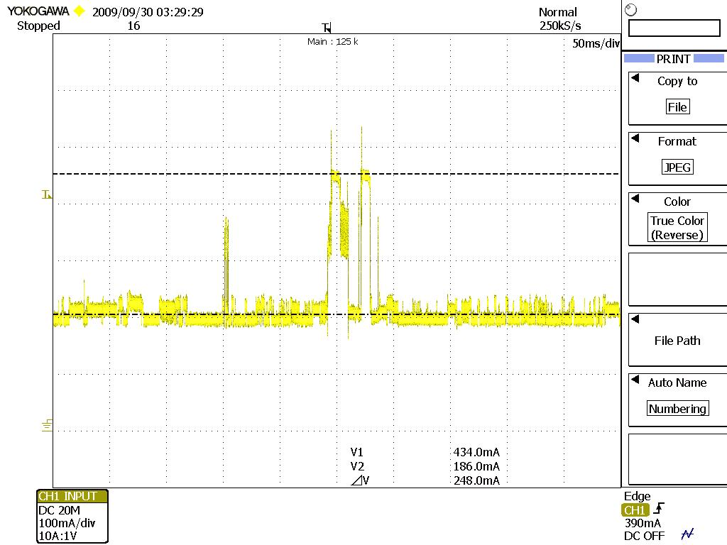

*Figure 13- CAM of MSD10AG*

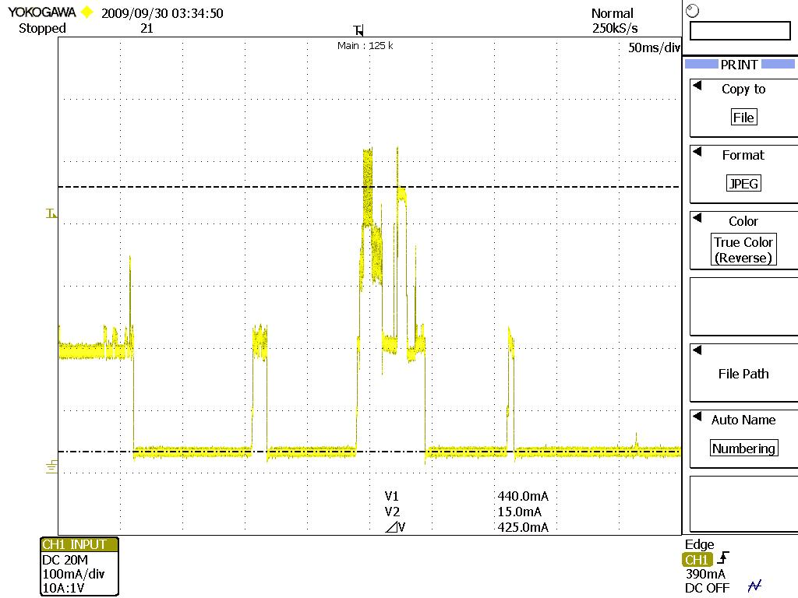

*Figure 14- Maximum of MSD10AG*

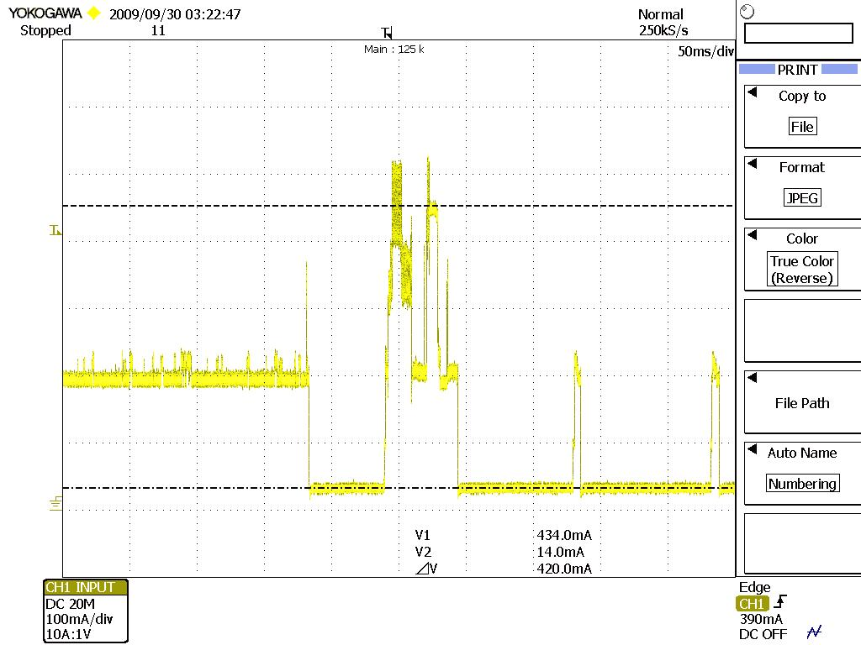

*Figure 15- Fast of MSD10AG*

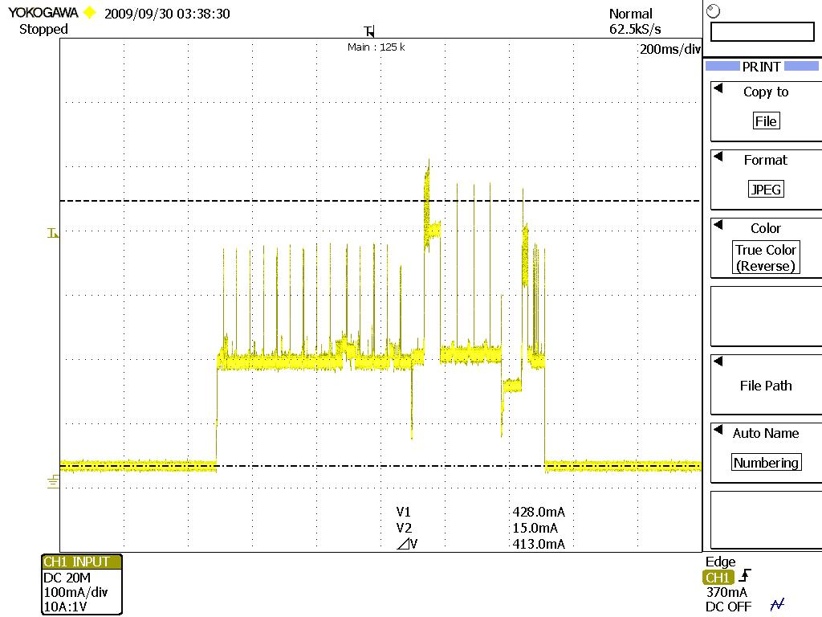

*Figure 16- Not associated of MSD10AG*