**Measurement of the power savings of radio cards and modules**

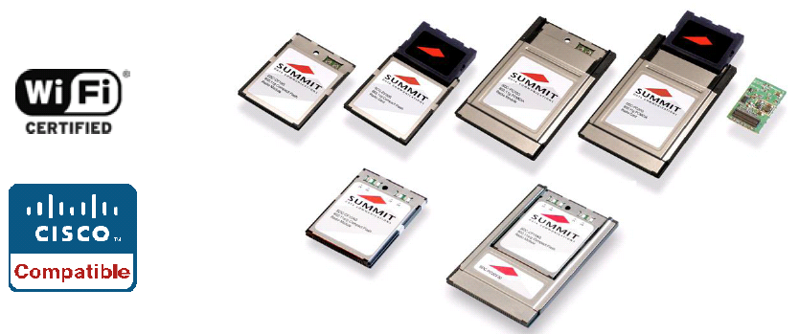

**Overview:**

This measurement mainly focuses on the following products from Summit Data Communications, Inc.:

* SDC-CF10G 802.11g compact flash radio module with antenna connectors
* SDC-CF20G 802.11g compact flash radio module with integrated antenna
* SDC-CF10AG 802.11a/g compact flash radio module with antenna connectors
* SDC-MCF10G 802.11g mini compact flash radio module with antenna connectors
* SDC-MCF10AG 802.11a/g mini compact flash radio module with antenna connectors
* SDC-MSD10G 802.11g Secure Digital Input/Output Module with Antenna Connectors
* SDC- MSD10AG 802.11a/g Secure Digital Input/Output Module with Antenna Connectors

**Tools:**

* YOKOGAWA DL9140 Digital Oscilloscope
* YOKOGAWA current probe
* HP iPAQ
* SYCARD Technology Compact Flash Extender
* SYCARD Technology SD Card Extender

**Drivers:**

* MCF10AG, MCF10G, CF10AG: mobile.armv4_2_2_8
* MSD10G: mobile.armv4_2_1_51SD

For details of how to get started, go to:

<http://www.summitdatacom.com/Documents/Summit_Quick_Start_Guide_2.01.pdf>

**Introduction:**

The working current is desired as the parameter of power consumption for this testing. For each card, there are three power saving modes—CAM, maximum, fast-- and the not associated status for measuring, and three signals for each status—transmit, receive, standby. But for CAM status, the device never goes to sleep, so there is no standby signal for CAM. As a result, normally there are eleven values need to be measured. Following is a brief introduction of the three power-saving modes and not associated status.

**CAM (Constantly Awake Mode):**

Keeps the client adapter powered up continuously so there is little lag in message response time. Consumes the most power but offers the highest throughput. CAM is recommended for desktop computers and devices that use AC power.

**Max PSP (Max Power Savings):**

Causes the access point to buffer incoming messages for the client adapter, which wakes up periodically and polls the access point to see if any buffered messages are waiting for it. The adapter can request each message and then go back to sleep. Conserves the most power but offers the lowest throughput. Is recommended for devices for which power consumption is the ultimate concern (such as small battery-powered devices).

**Fast PSP (Power Save Mode):**

Switches between PSP mode and CAM mode, depending on network traffic. This mode switches to CAM when retrieving a large number of packets and switches back to PSP after the packets have been retrieved. Is recommended when power consumption is a concern but you need greater throughput than that allowed by Max PSP.

**Not associated status:**

The data under not associated status is also required for this testing. Under this status, the signals of the three power saving modes are normally the same. The client adapter probes about every 10 seconds, and then go back to sleep. Since then, the transmitting and receiving signals appear every 10 seconds, and the standby signal should be seen in the interval.

**Measurement:**

The device with summit radio module or card can communicate to a computing network using the IEEE 802.11 protocols that the Summit radio supports:

* G radio: 802.11b and 802.11g
* AG radio: 802.11a, 802.11b, and 802.11g

In this testing, we use the 2.4G (802.11b and 802.11g) band.

To get started for testing, you will perform the following five steps:

1. Install the Summit software on your mobile computing device.
2. Install the radio module or radio card in your device.
3. Check the radio status.
4. Configure the profile settings.
5. Get the testing results and keep them.

Following is the detail of each step.

* First of all, install the summit software—the corresponding .cab file—on the mobile computing device. A Summit *.cab* file contains all software components, including the device driver and the Summit Client Utility (SCU). Compact Flash cards and modules use version 2.2, and SD cards and modules apply version 2.1. Both of the .cab file should have a file name begin with mobile. Single click the file to run it. If asked to replace any existing files on the device, answer “Yes to all”.
* Secondly, install the radio module or radio card via an extender. Have the power jumper connected with a wire instead of header. Then the current probe can obtain signals from the wire. To install a 20G series radio card, simply insert the card in an external card slot. As for a 10G series radio module, besides of inserting the module in an external slot, an antenna-to-module connection is needed. Since only one antenna is used in this test, and we are using the 2.4G (802.11b and 802.11g) band, we always connect the antenna to the most right connector (main connector) for both 10G and 10AG modules.
* Thirdly, check the radio status. If the status is down, it means there may be some problem in the device, the radio, or the connection between them. Try to restart the device, check the connection, and reinstall the radio. After fix the problem, the radio status should turn to authenticated, associated or not associated.
* Next, configure the profile settings. Before configuration, Make sure you have logged into Summit Client Utility (scu).The testing can be separated into two section. One is the testing of three power save modes, and the other one is the test under not associated status.

For the test of three power saving modes, “sdc” is chosen as the active profile and edit profile for this test. In profile tab, select “power save” in radio menu, and the three power save modes are selectable on the right. Here I will take maximum mode as an example. Select maximum, and click the commit button at the end of profile tab. Wait for seconds, and switch to Diags tab. There is always an IP address that the server assigned. Use it to start ping or type in your specific IP address to start ping. Stay in this tab, and watch the signal on the oscilloscope. The procedure of CAM and fast modes is similar. But for fast, about 20 seconds are needed to get the desired signal.

For the test of not associated status, first, create a new profile. Then select the new generated profile as active profile and edit profile. Meanwhile, the radio status should turn to not associated. And click on power save, choose CAM, maximum or fast on the right, and commit the change. Normal tx trigger on the oscilloscope can be used because the device should probe every 10 seconds.

* Finally, Keep the data from oscilloscope, and compare it with the given parameters.

**Test Results:**

The typical power consumption of Summit Data communications’ product at maximum power setting is:

Transmit: 400 mA (1320mW)   
Receive:  180 mA (594mW)   
Standby:   10 mA (33 mW)

All the testing results have the unit of milliampere (mA). And the testing results are shown below.

**SDC-CF10G:**

The real power consumption from this testing is:

|  |  |  |  |  |
| --- | --- | --- | --- | --- |
| SIGNALS\STATUS | CAM | MAXIMUM | FAST | Not associated |
| TRANSMIT | 430 | 400 | 400 | 380 |
| RECEIVE | 190 | 190 | 200 | 170 |
| STANDBY | N/A | 10 | 10 | 40 (10 for a while) |

Table 1- Data of CF10G

Chart 1- data of CF10G

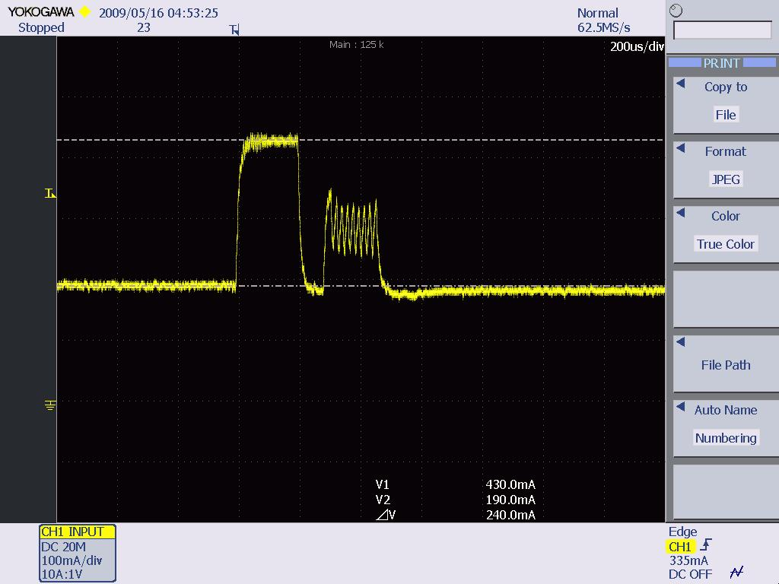

*Figure 1- The CAM mode of SDC-CF10G*

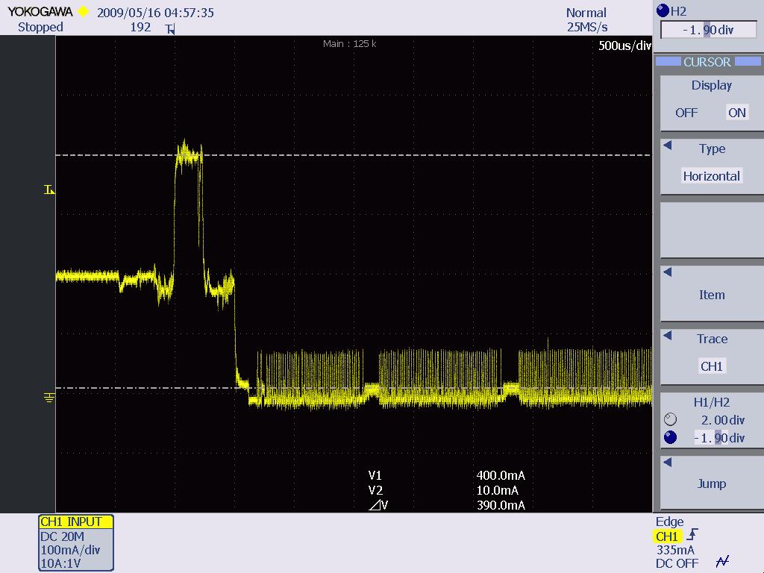

*Figure 2- the maximum mode of SDC-CF10G*

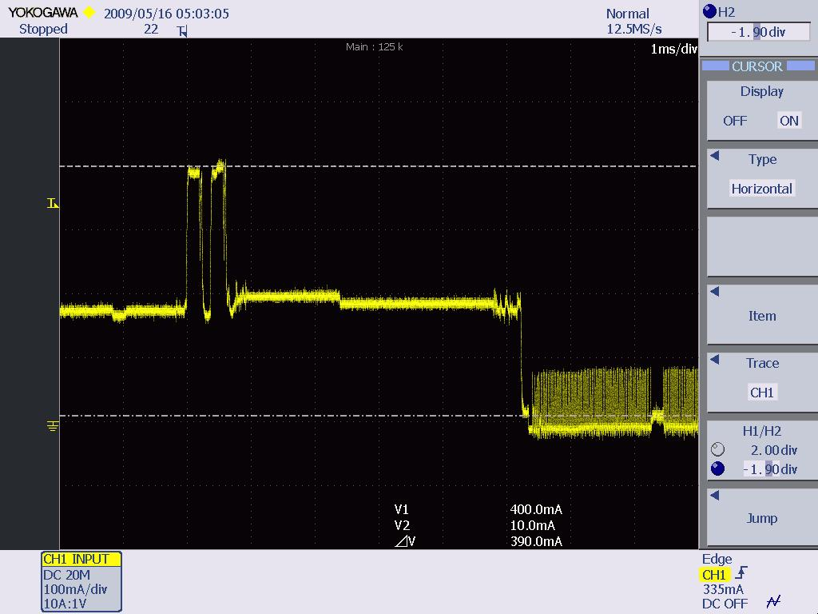

*Figure 3- the fast mode of SDC-CF10G*

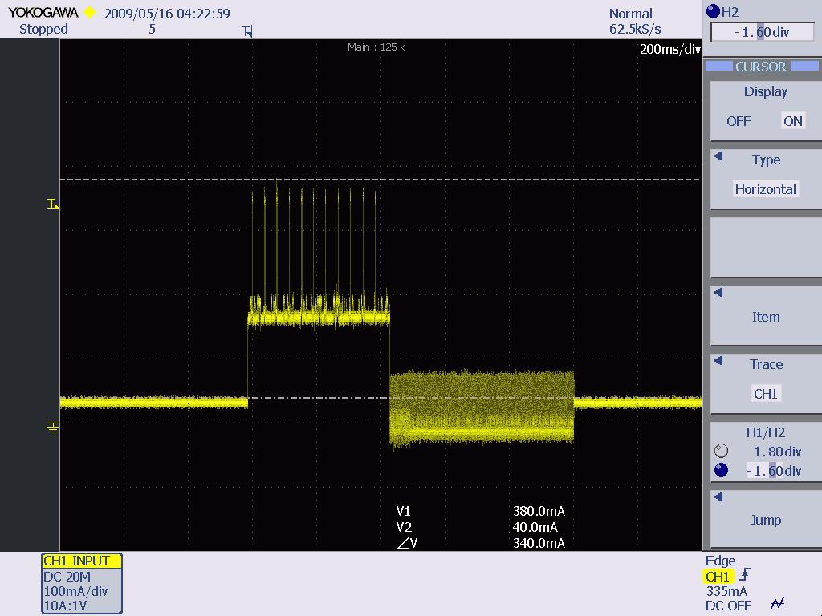

*Figure 4- The not associated status of SDC-CF10G*

**SDC-CF20G:**

The real power consumption is shown below:

|  |  |  |  |  |
| --- | --- | --- | --- | --- |
| SIGNALS\STATUS | CAM | MAXIMUM | FAST | Not associated |
| TRANSMIT | 420 | 410 | 400 | 380 |
| RECEIVE | 180 | 200 | 200 | 170 |
| STANDBY | N/A | 10 | 10 | 40 (10 for a while) |

Table-2 Data of SDC-CF20G

Chart 2- Data of SDC-CF20G

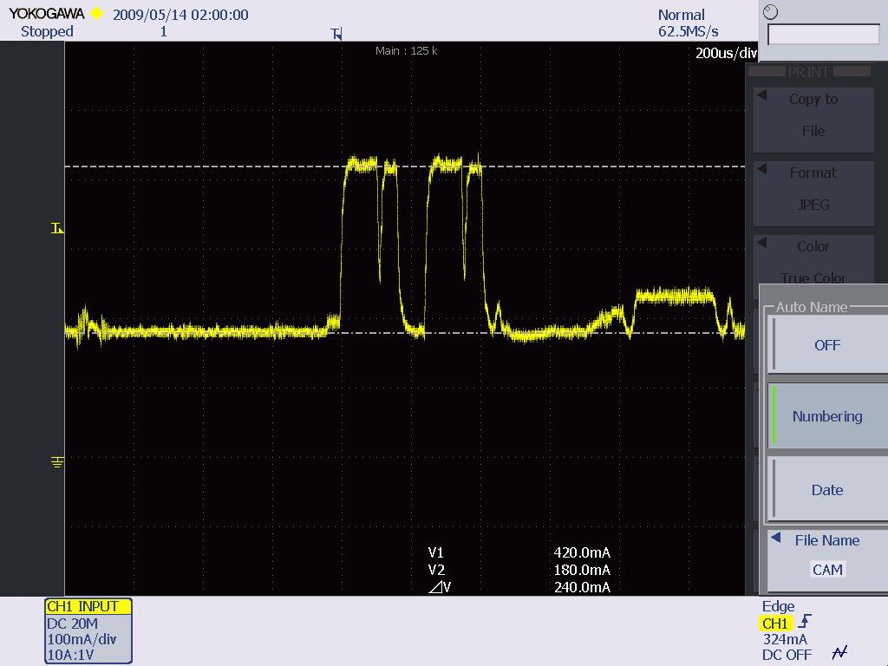

*Figure 5- The CAM mode of SDC-CF20G*

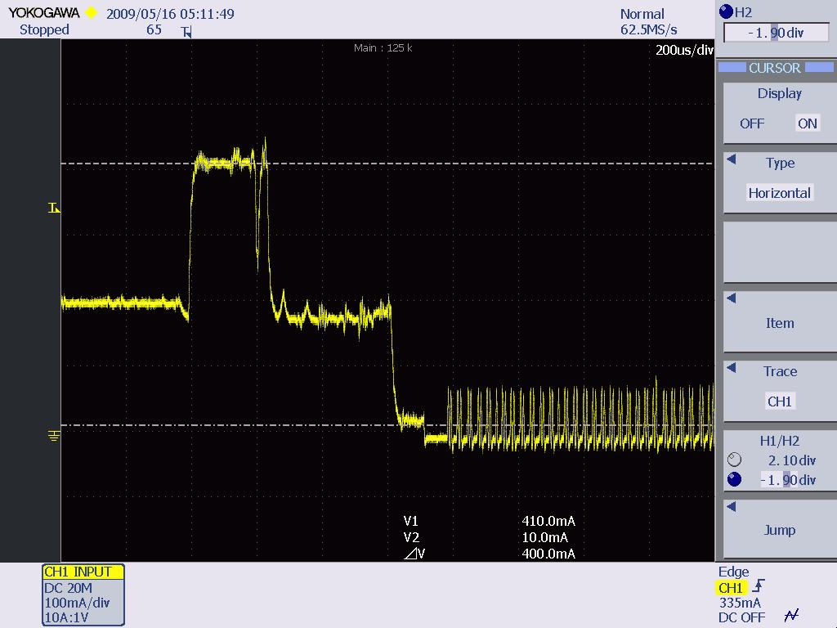

*Figure 6- The maximum mode of SDC-CF20G*

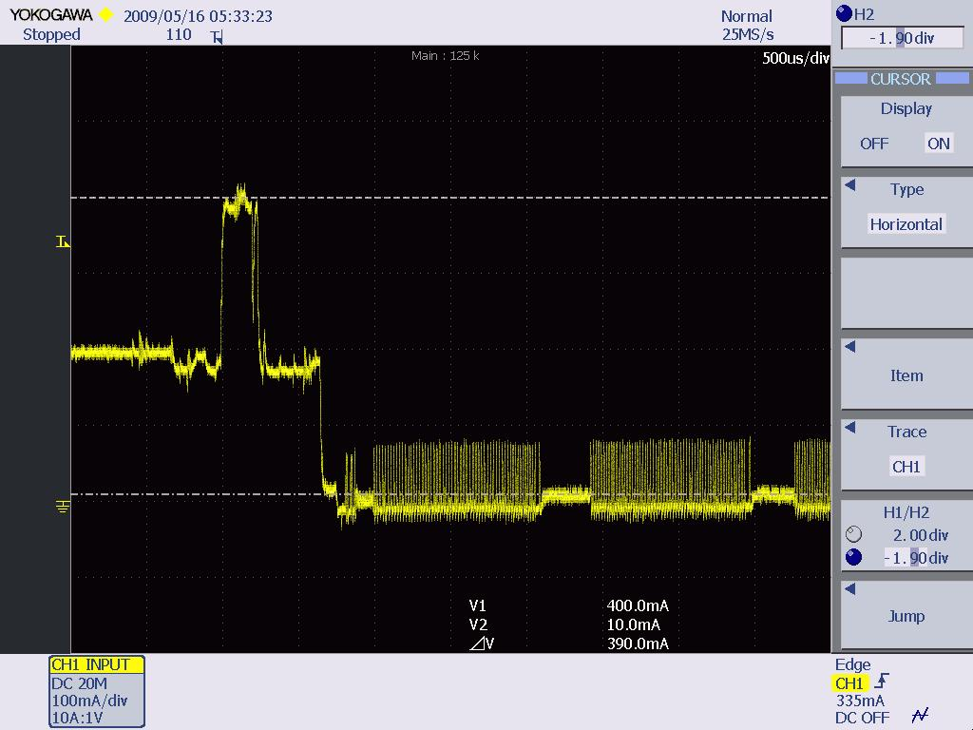

*Figure 7- The fast mode of SDC-CF20G*

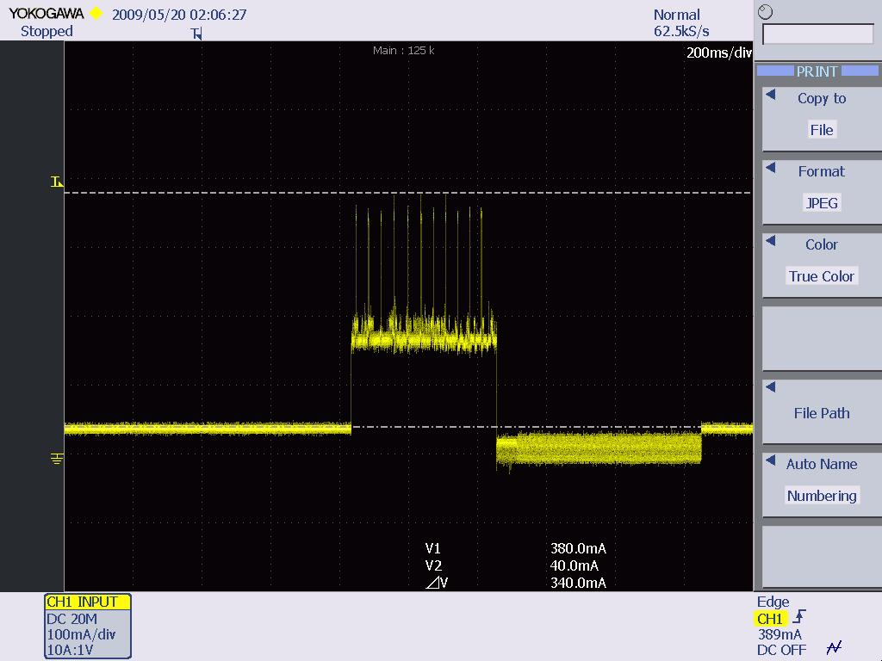

*Figure 8- The not associated of SDC-CF20G*

**SDC-CF10AG:**

The real power consumption is shown below:

|  |  |  |  |  |
| --- | --- | --- | --- | --- |
| SIGNALS\STATUS | CAM | MAXIMUM | FAST | Not associated |
| TRANSMIT | 380 | 360 | 360 | 500 |
| RECEIVE | 190 | 190 | 190 | 200 |
| STANDBY |  | 20 | 20 | 50 (20 for a while) |

Table-3. Data of SDC-CF10AG

Chart 3- Data of SDC-CF10AG

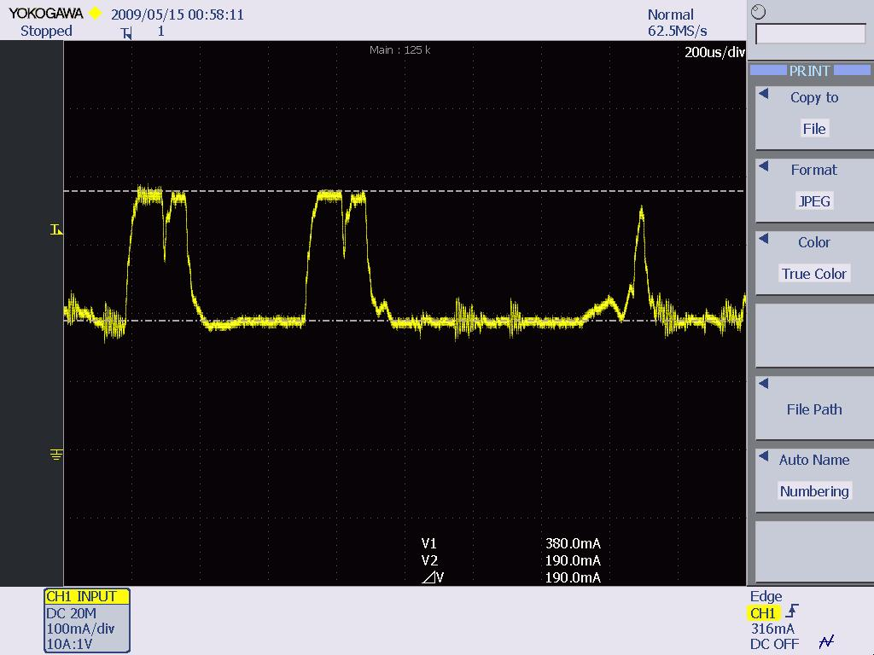

*Figure 9- The CAM mode of SDC-CF10AG*

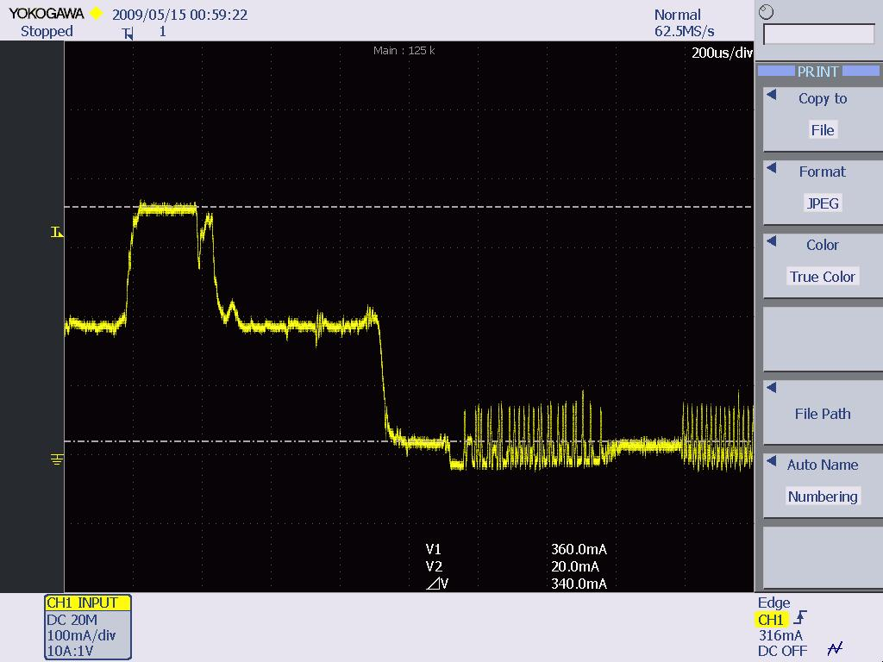

*Figure 10- the maximum mode of SDC-CF10AG*

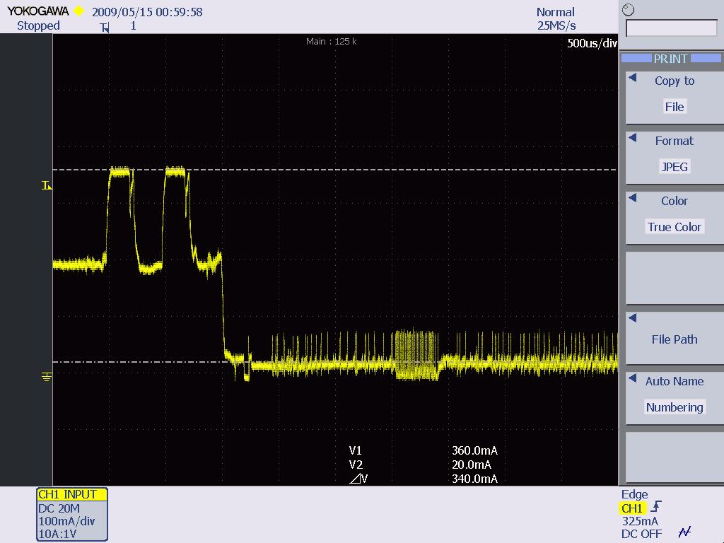

*Figure 11- the fast mode of SDC-CF10AG*

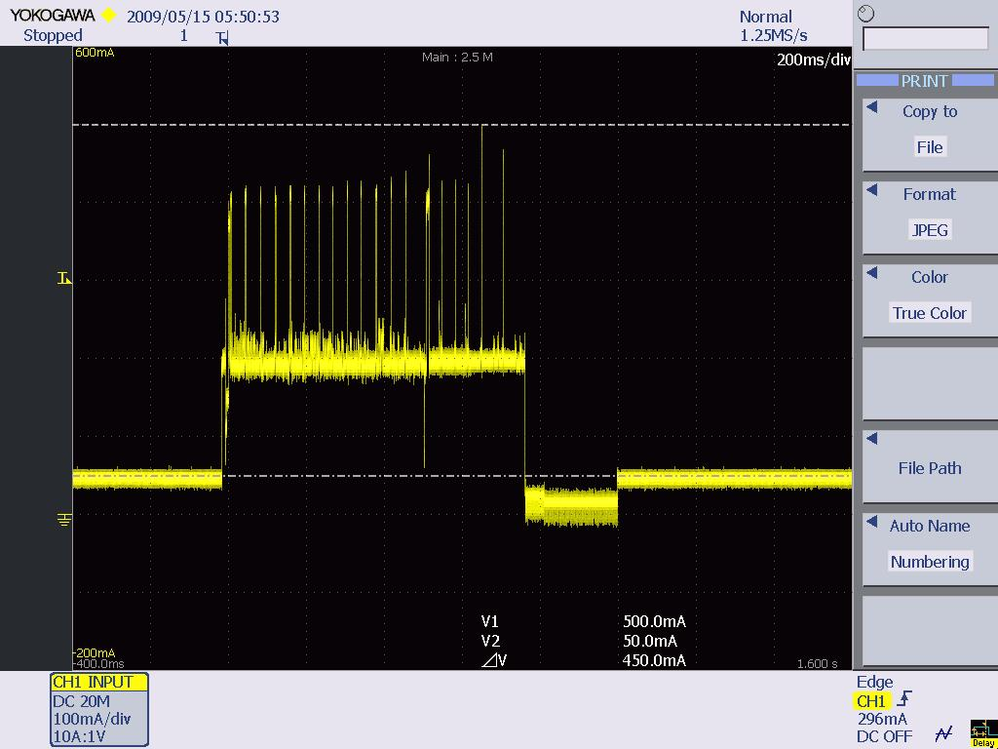

*Figure 12- the not associated status of SDC-CF10AG*

**SDC-MCF10G:**

The real power consumption is shown below:

For this module, the standby signal never shows up under not associated status.

|  |  |  |  |  |
| --- | --- | --- | --- | --- |
| SIGNALS\STATUS | CAM | MAXIMUM | FAST | Not associated |
| TRANSMIT | 350 | 330 | 320 | 340 |
| RECEIVE | 180 | 180 | 180 | 180 |
| STANDBY |  | 10 | 10 | 70 (10 for a while) |

Table-4 Data of SDC-MCF10G

Chart 4- Data of SDC-MCF10G

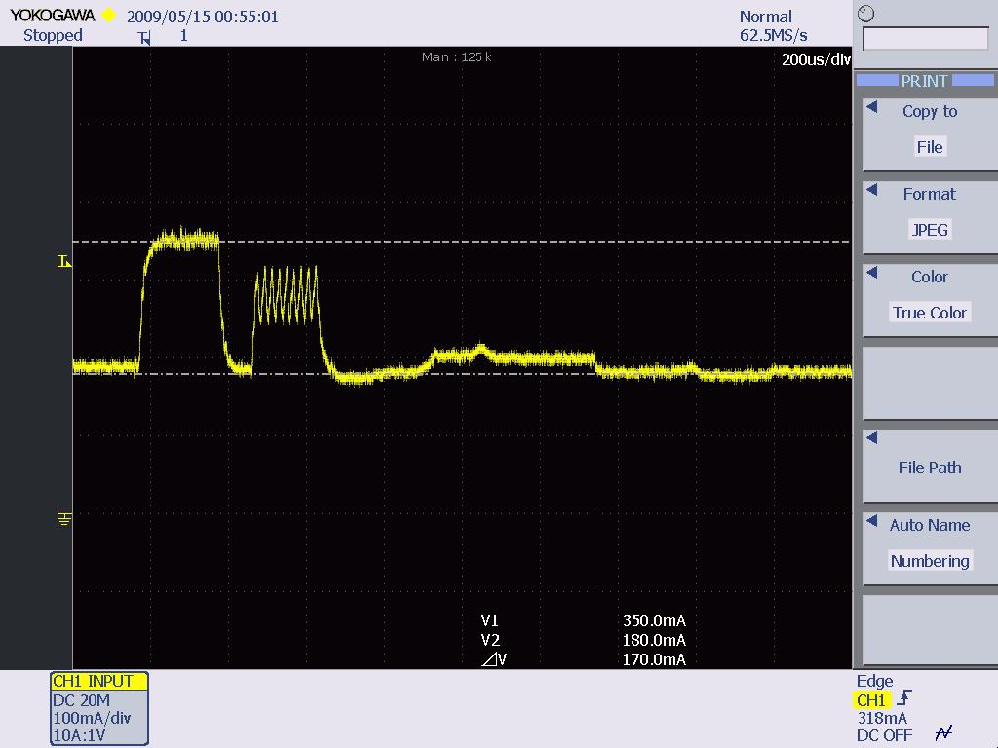

*Figure 13- The CAM mode of SDC-MCF10G*

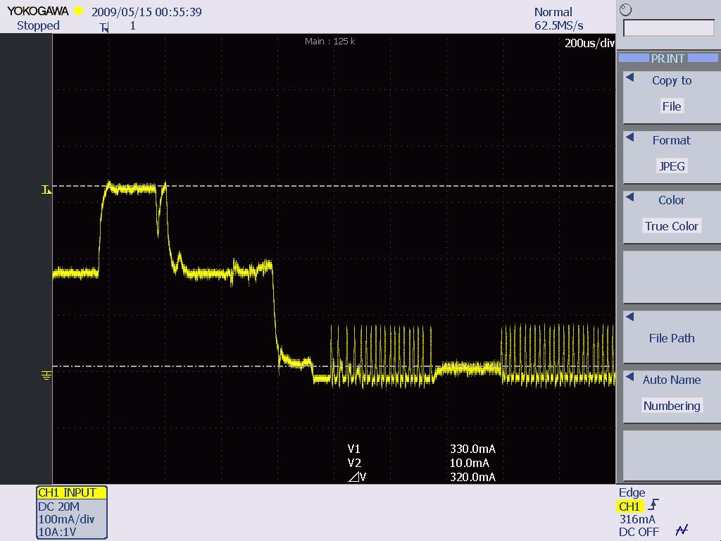

*Figure 14- The maximum mode of SDC-MCF10G*

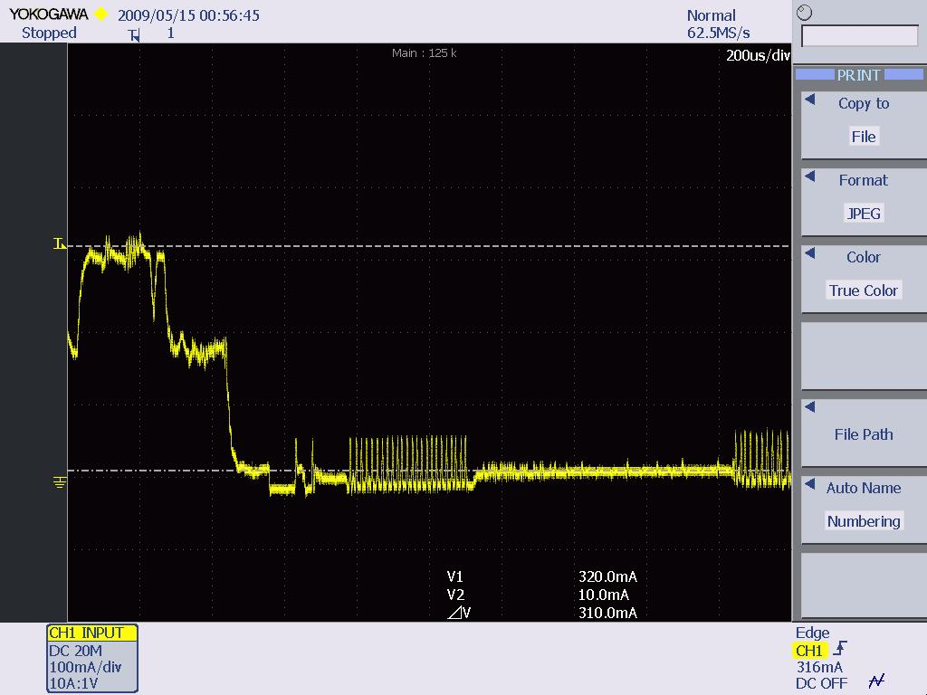

*Figure 15- The fast mode of SDC-MCF10G*

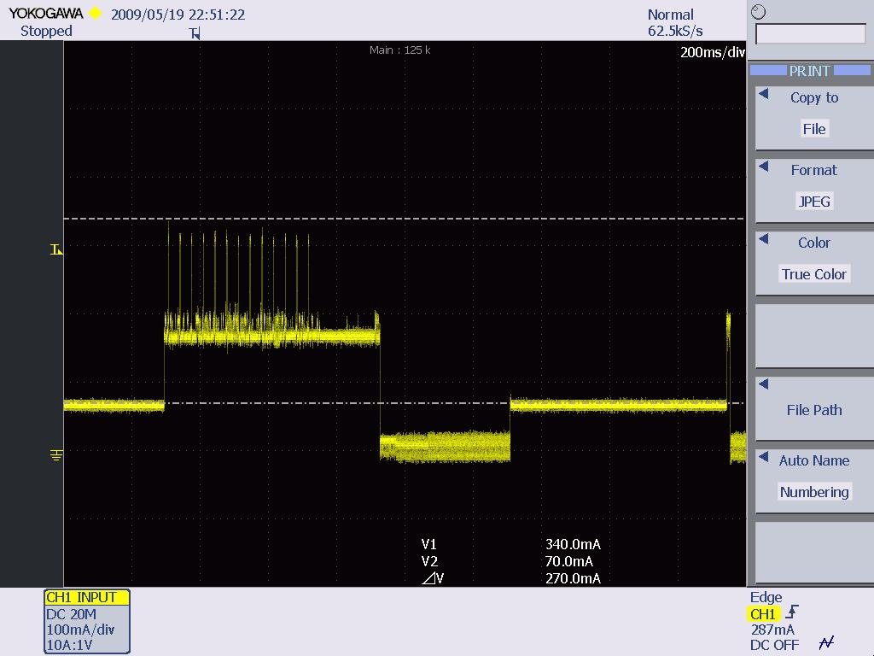

*Figure 16- The not associated status of SDC-MCF10G*

**SDC-MCF10AG:**

The real power consumption of SDC-MCF10G is shown below:

|  |  |  |  |  |
| --- | --- | --- | --- | --- |
| SIGNALS\STATUS | CAM | MAXIMUM | FAST | Not associated |
| TRANSMIT | 370 | 370 | 380 | 470 |
| RECEIVE | 240 | 240 | 240 | 250 |
| STANDBY | N/A | 70 | 70 | 100 (70 for a while) |

Table-5. Data of SDC-MCF10AG

Chart 5- Data of SDC-MCF10AG

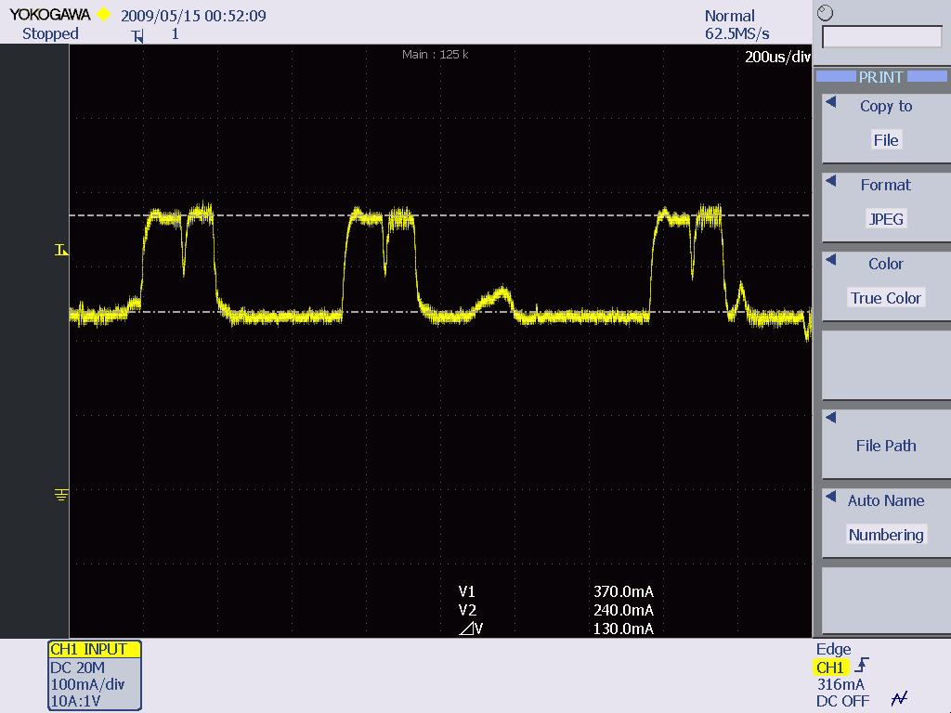

*Figure 17- The CAM mode of SDC-MCF10AG*

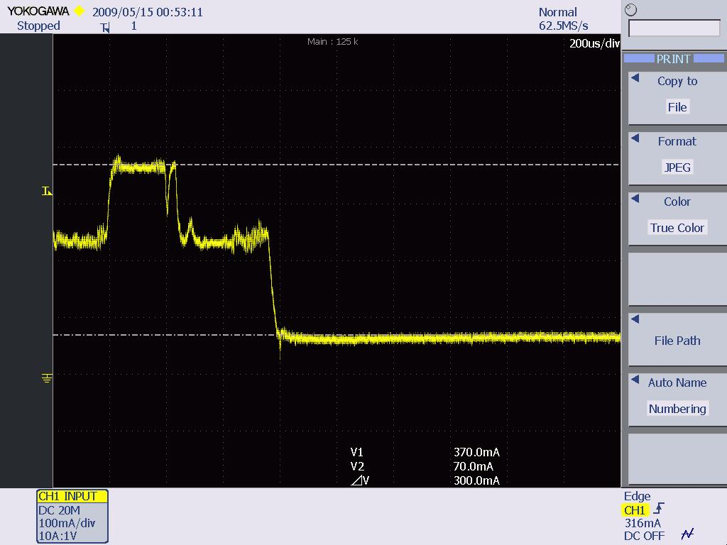

*Figure 18- The maximum mode of SDC-MCF10AG*

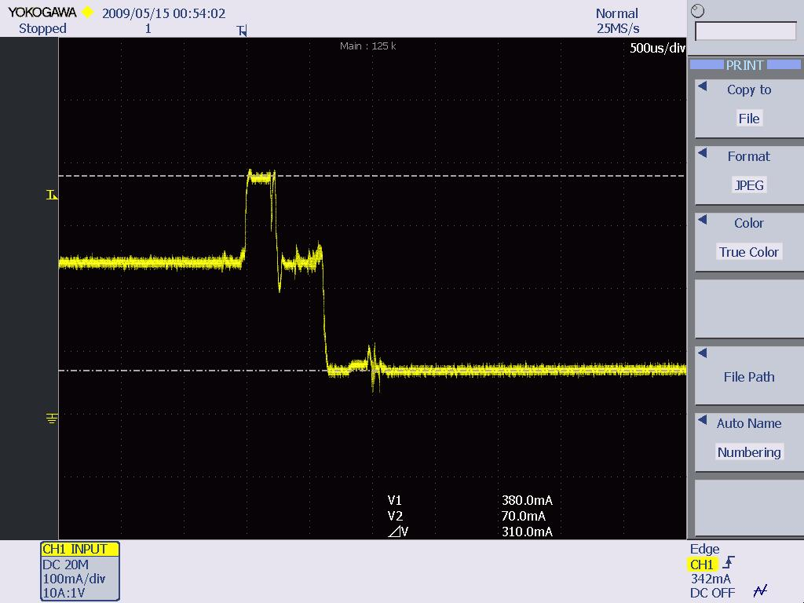

*Figure 19- The fast mode of SDC-MCF10AG*

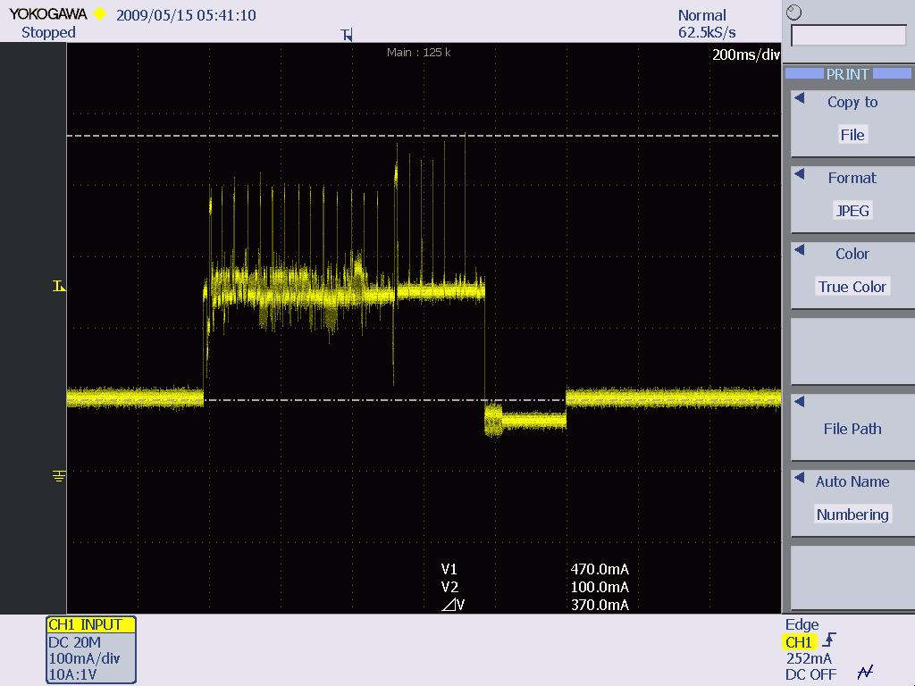

*Figure 30- The not associated status of SDC-MCF10AG*

**SDC-MSD10G:**

The real power consumption of SDC-MSD10G is shown below:

|  |  |  |  |  |
| --- | --- | --- | --- | --- |
| SIGNALS\STATUS | CAM | MAXIMUM | FAST | Not associated |
| TRANSMIT | 480 | 450 | 470 | 330 |
| RECEIVE | 180 | 180 | 180 | 180 |
| STANDBY | N/A | 10 | 10 | 70 (10 for a while) |

TABLE-6. Data of SDC-MSD10G

Chart 6-Data of SDC-MSD10G

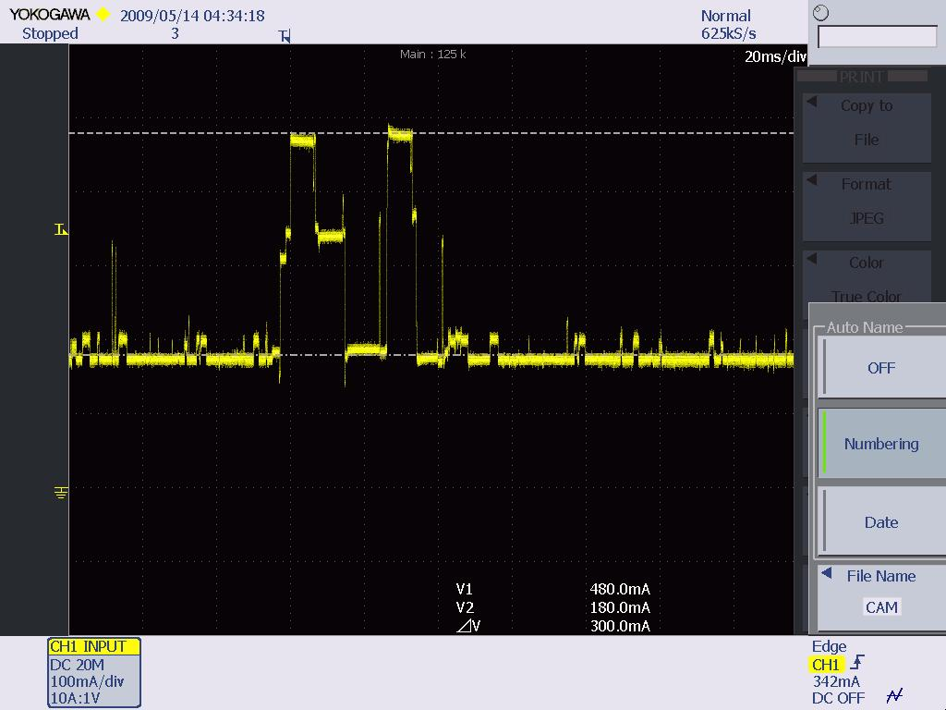

*Figure 21- The CAM mode of SDC-MSD10G*

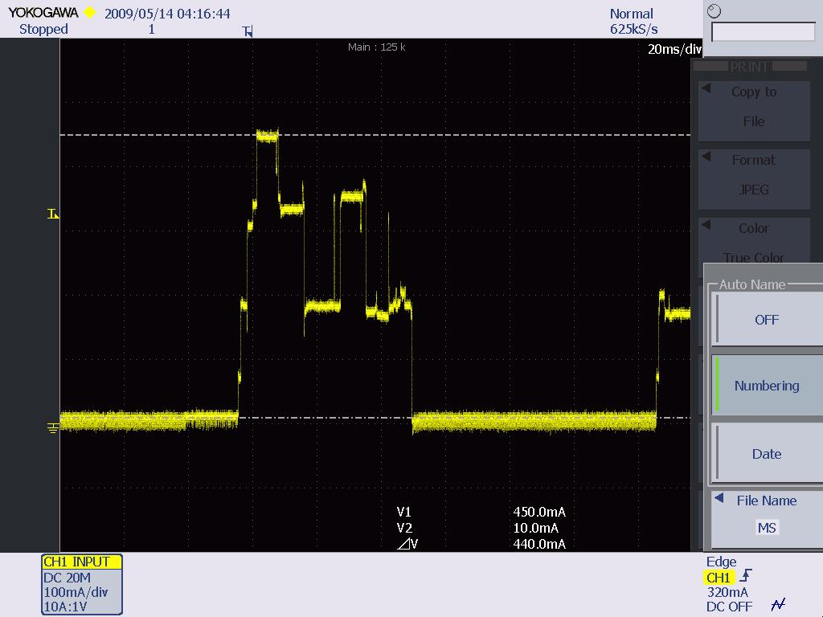

*Figure 22- The maximum mode of SDC-MSD10G*

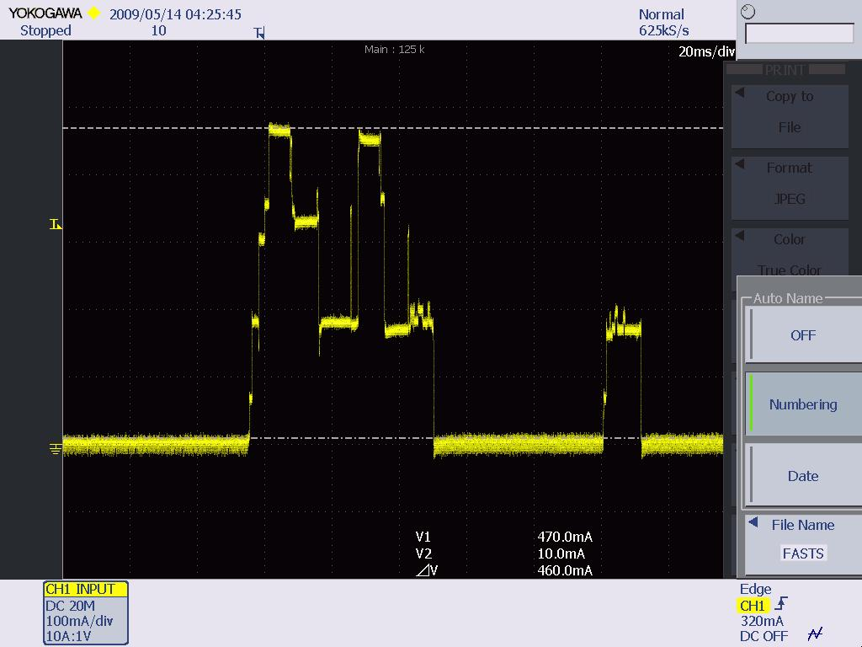

*Figure 23- The fast mode of SDC-MSD10G*

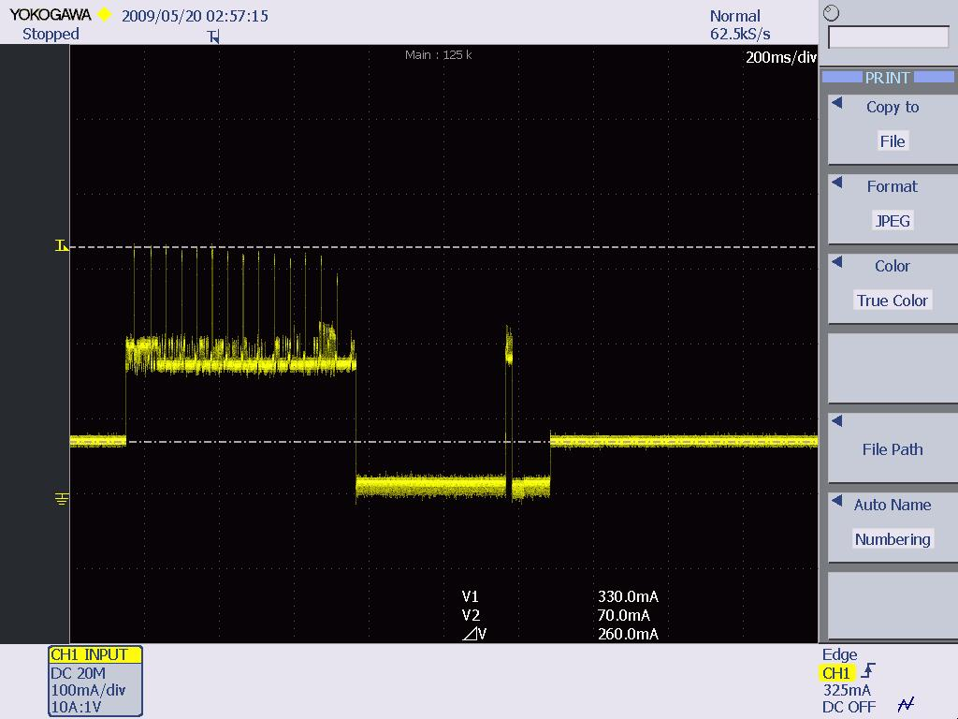

*Figure 24- The not associated status of SDC-MSD10G*

**SDC-MSD10AG:**

The real power consumption of SDC-MSD10AG is shown below:

|  |  |  |  |  |
| --- | --- | --- | --- | --- |
| SIGNALS\STATUS | CAM | MAXIMUM | FAST | Not associated |
| TRANSMIT | 480 | 470 | 480 | 460 |
| RECEIVE | 240 | 240 | 240 | 250 |
| STANDBY | N/A | 70 | 70 | 110 (80 for a while) |

Table-7 Data of SDC-MSD10AG

Chart 7-Data of SDC-MSD10AG

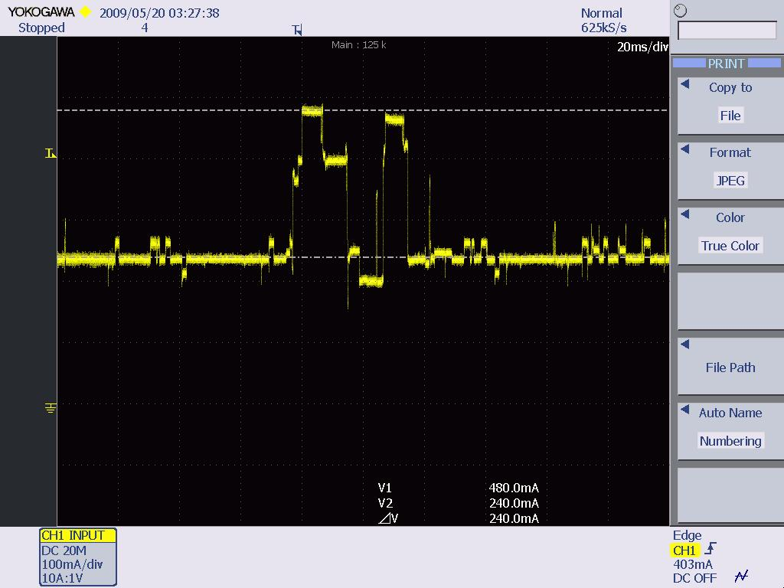

*Figure 25- The CAM mode of SDC-MSD10AG*

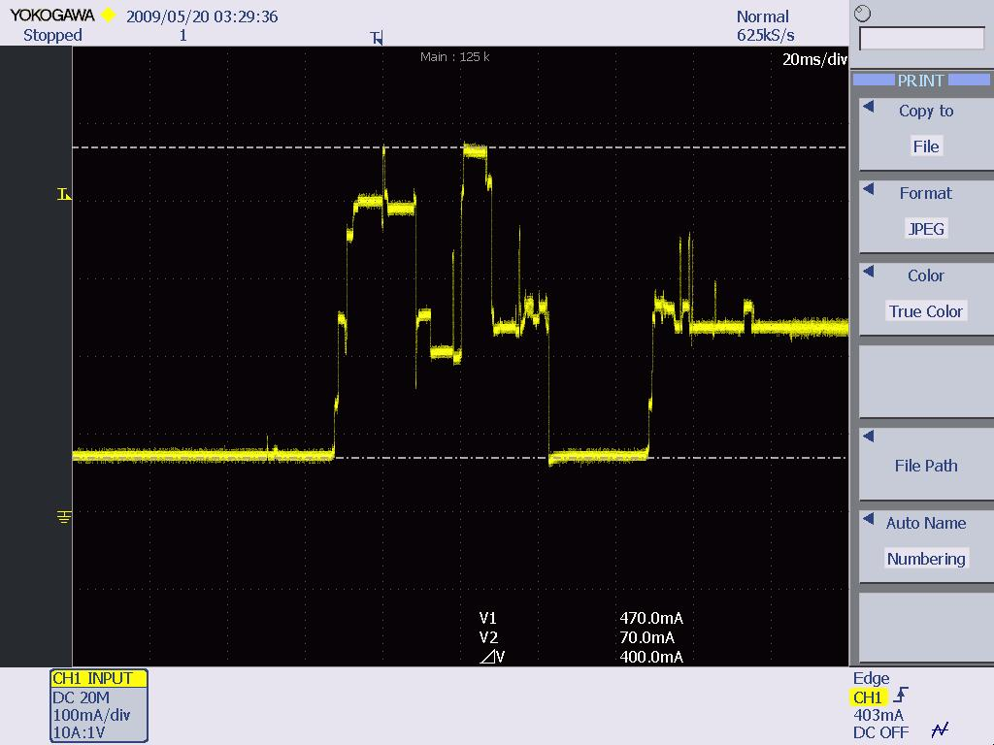

*Figure 26- The maximum mode of SDC-MSD10AG*

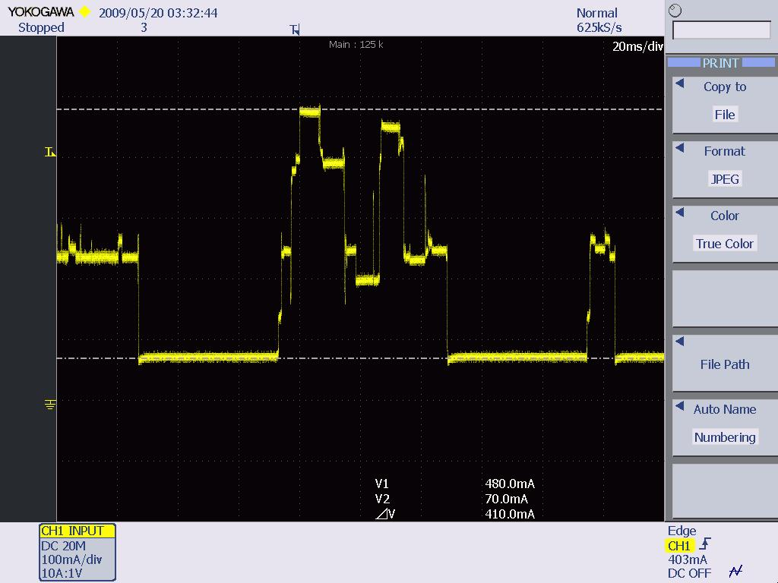

*Figure 27- The fast mode of SDC-MSD10AG*

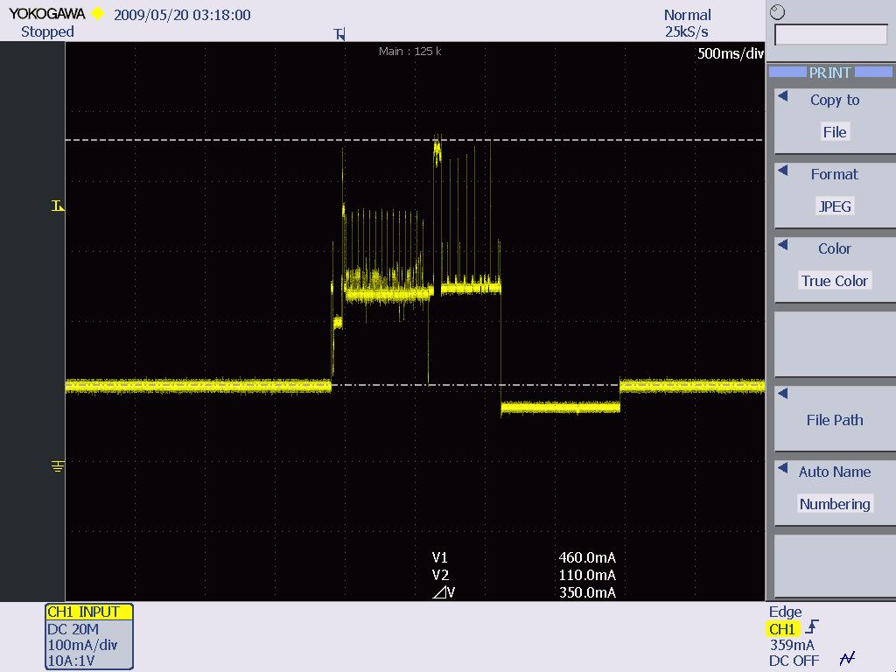

*Figure 28 - The not associated status of SDC-MSD10AG*

**Conclusion:**

From the results shown above, it seems the standby level under not associated status is a little bit higher—normally 30mA higher—than the level of other statuses.