Dystopian Media Consumption and Affective Polarization
Among Undergraduate Students at UNC Charlotte
POLS Lab Student Omnibus • Fall 2025

Abstract
This paper explores the relationship between liking dystopian media — TV shows, films, and books — and affective polarization among undergraduate students at UNC Charlotte (N = 777, Fall 2025). Respondents rated nine dystopian works and completed validated batteries measuring partisan aversion, othering, moralizing, feeling thermometer gaps, and free speech attitudes. Dystopian media liking consistently correlates with lower partisan aversion (β = −0.27, p < .001) and reduced partisan polarization, while simultaneously predicting greater free speech permissiveness. Literary works (1984, The Giver, Fahrenheit 451) show stronger and broader polarization associations than TV/film equivalents. Party differences in liking are modest — most works cross party lines — with Democrats rating Black Mirror, Last of Us, and Fahrenheit 451 somewhat higher.

1. Introduction
Affective polarization — the tendency to view members of the opposing political party with distrust, dislike, and social distance — has intensified in the United States over recent decades. Research has documented rising out-party animus across measures ranging from feeling thermometers to social distance. Less is known, however, about whether cultural consumption habits relate to this phenomenon.
Dystopian fiction presents an interesting test case. Works such as 1984, The Hunger Games, and Black Mirror dramatize authoritarian control, loss of civil liberties, and societal collapse — themes that resonate across the political spectrum. If exposure to these narratives cultivates perspective-taking or reinforces civic vigilance, they might be associated with lower partisan hostility. Alternatively, if audiences interpret dystopian warnings through a partisan lens, they could amplify polarization.
This paper reports six analyses linking dystopian media preferences to affective polarization among UNCC undergraduates, drawing on data from the Fall 2025 Political Polarization Study.

2. Data and Methods

Sample
The sample consists of undergraduates enrolled in political science courses at UNC Charlotte in Fall 2025 (N = 777 total rows; n = 603 shown the dystopian section). Party composition: approximately 55% Democrat-leaning, 17% Republican-leaning, 28% Independent. Mean age: 27 years.

Dystopian Media Battery
Participants rated nine works on a 5-point scale (1 = Dislike a great deal to 5 = Like a great deal), with an option for “I am unfamiliar with this work” (coded as missing). Works included: The Hunger Games, Divergent, The Maze Runner, Black Mirror, The Last of Us, and The 100 (TV/film); and 1984, The Giver, and Fahrenheit 451 (books). A composite dystopian index was computed as the mean across all answered items.

Affective Polarization Measures
Six validated indices were used: (1) Aversion Index — social avoidance of out-partisans (1–5); (2) Othering Index — perceived difference from the out-party (1–5); (3) Moralizing Index — moral identity tied to party (1–5); (4) Partisan Polarization Index (1–7); (5) Feeling Thermometer Gap, in-party warmth minus out-party warmth (0–100); (6) Free Speech Permissiveness (1–7, higher = more permissive).

3. Familiarity and Liking
Of respondents shown the dystopian section (n = 603), The Hunger Games was the most recognized work (87.7% familiar), followed by The Maze Runner (73.1%) and Divergent (63.5%). Literary works clustered around 57–59% familiarity. Republicans and Democrats showed similar familiarity rates.

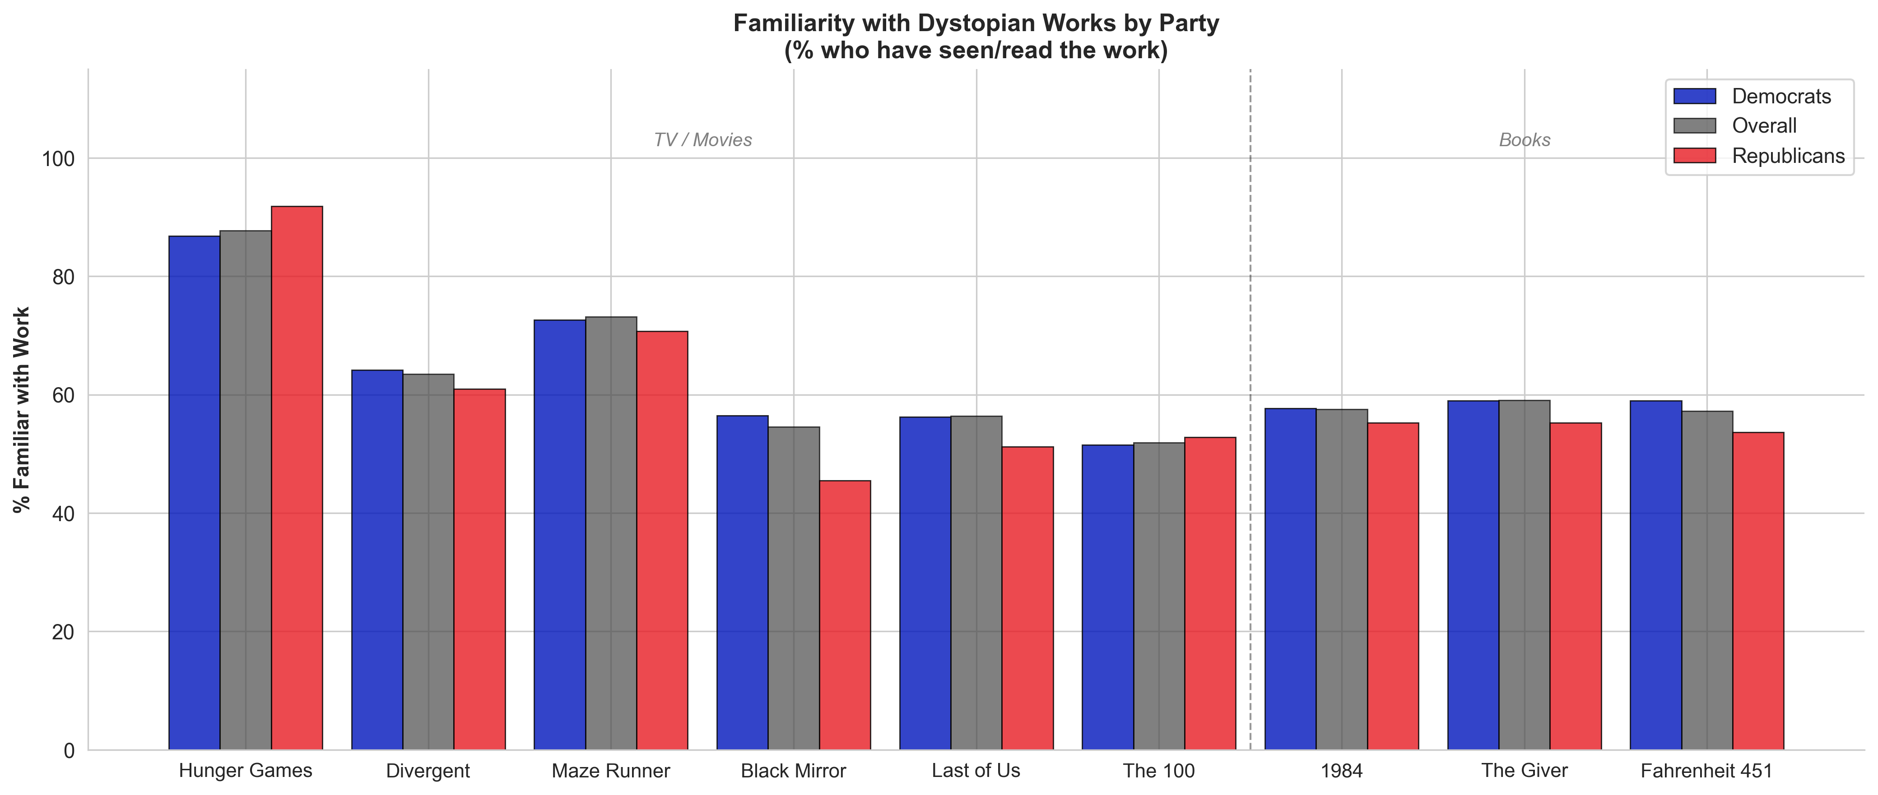
Figure 1. Percentage of respondents familiar with each dystopian work, by party (denominator = respondents shown the section, n = 603). The Hunger Games is by far the most widely known work across both parties.
Mean liking scores were uniformly positive (all above the neutral midpoint of 3). The Hunger Games was liked most overall (M = 4.27), followed by The Maze Runner (M = 4.18). Books and films were rated similarly.

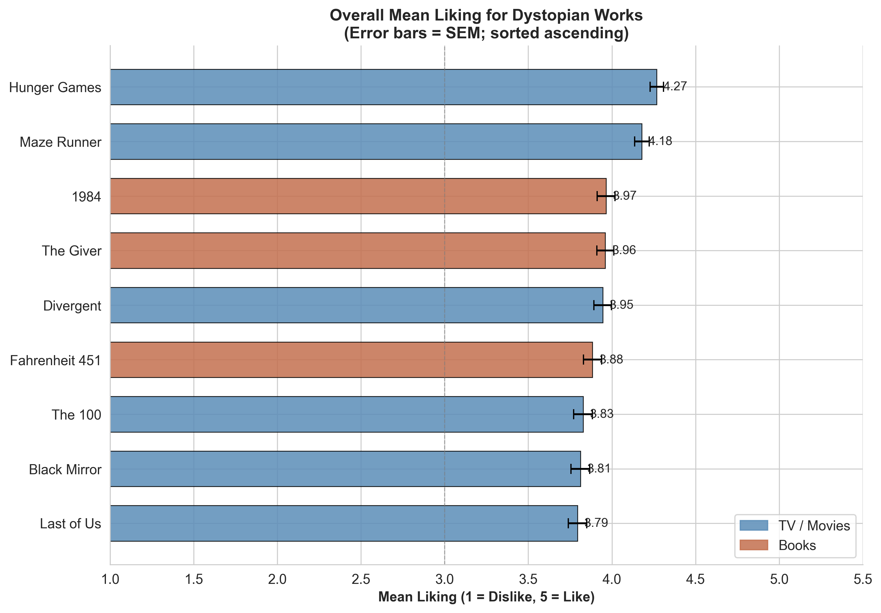
Figure 2. Overall mean liking for all nine dystopian works (1 = Dislike, 5 = Like; error bars = SEM; sorted ascending). All works are rated above the neutral midpoint of 3. Blue = TV/films; brown = books.

4. Party Differences in Dystopian Media Preferences
Most works were liked similarly across party lines. Three works showed statistically significant differences, with Democrats rating them higher: Black Mirror (d = 0.33, p < .05), Last of Us (d = 0.35, p < .01), and Fahrenheit 451 (d = 0.30, p < .05). The politically neutral reception of most works suggests dystopian fiction functions as a broadly shared cultural touchstone rather than a partisan artifact.

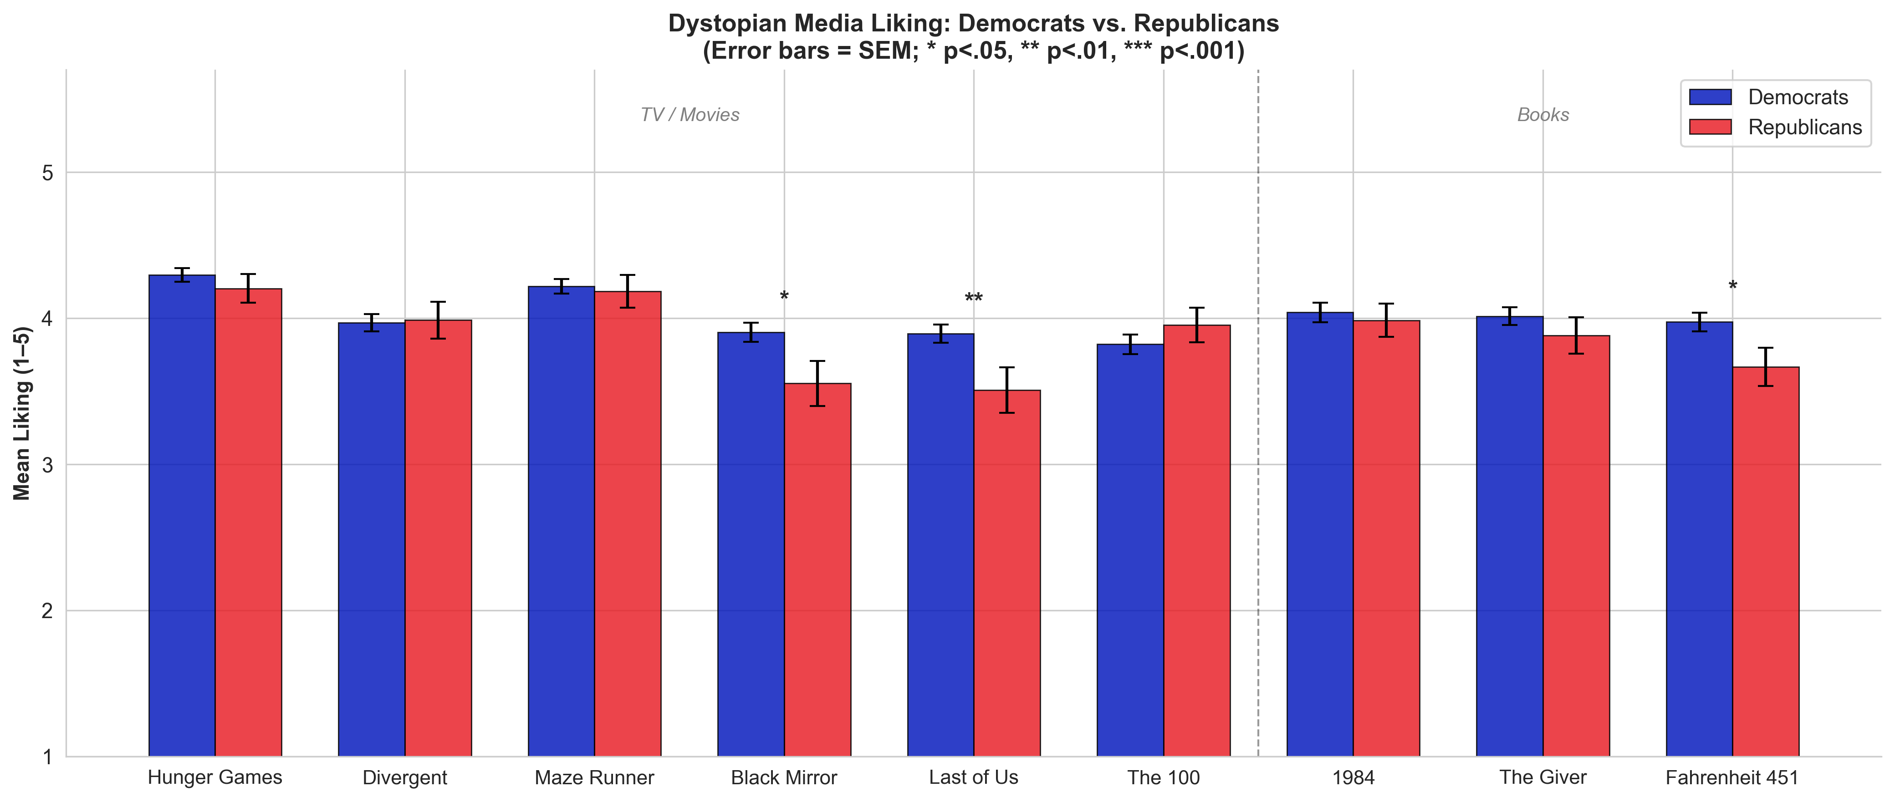
Figure 3. Mean liking for all nine dystopian works by party (error bars = SEM; * p < .05, ** p < .01). Only three works show significant party differences; the remaining six are statistically indistinguishable between Democrats and Republicans.

5. Correlations: Dystopian Liking and Polarization
Pearson correlations were computed between each of the nine works (and the composite index) and all six polarization measures. Of 60 total pairs, 31 (52%) were statistically significant. Key patterns emerged:
Free speech: Every single work correlated positively with free speech permissiveness (r = .12 to .26, all p < .05). This is the strongest and most consistent association across the entire battery.
Aversion: 1984 (r = −0.19***) and The Giver (r = −0.14*) showed the strongest inverse links. Higher liking predicts less social avoidance of out-partisans.
Partisan Polarization: Multiple works linked to lower polarization (r = −.13 to −.17**), especially 1984 and The Giver.
Othering: Weakest domain overall. Only one noteworthy finding: among Republicans specifically, dystopian liking correlated with lower othering (r = −0.30***).

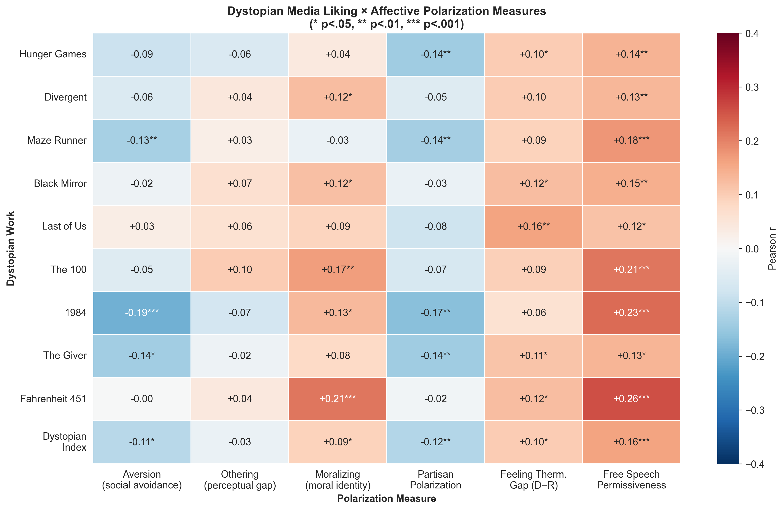
Figure 4. Heatmap of Pearson r correlations between all nine dystopian works and the composite index (rows) and six polarization measures (columns). Red = positive correlation, blue = negative. Annotated with significance stars. Free speech (rightmost column) shows the most consistent positive pattern across all works.

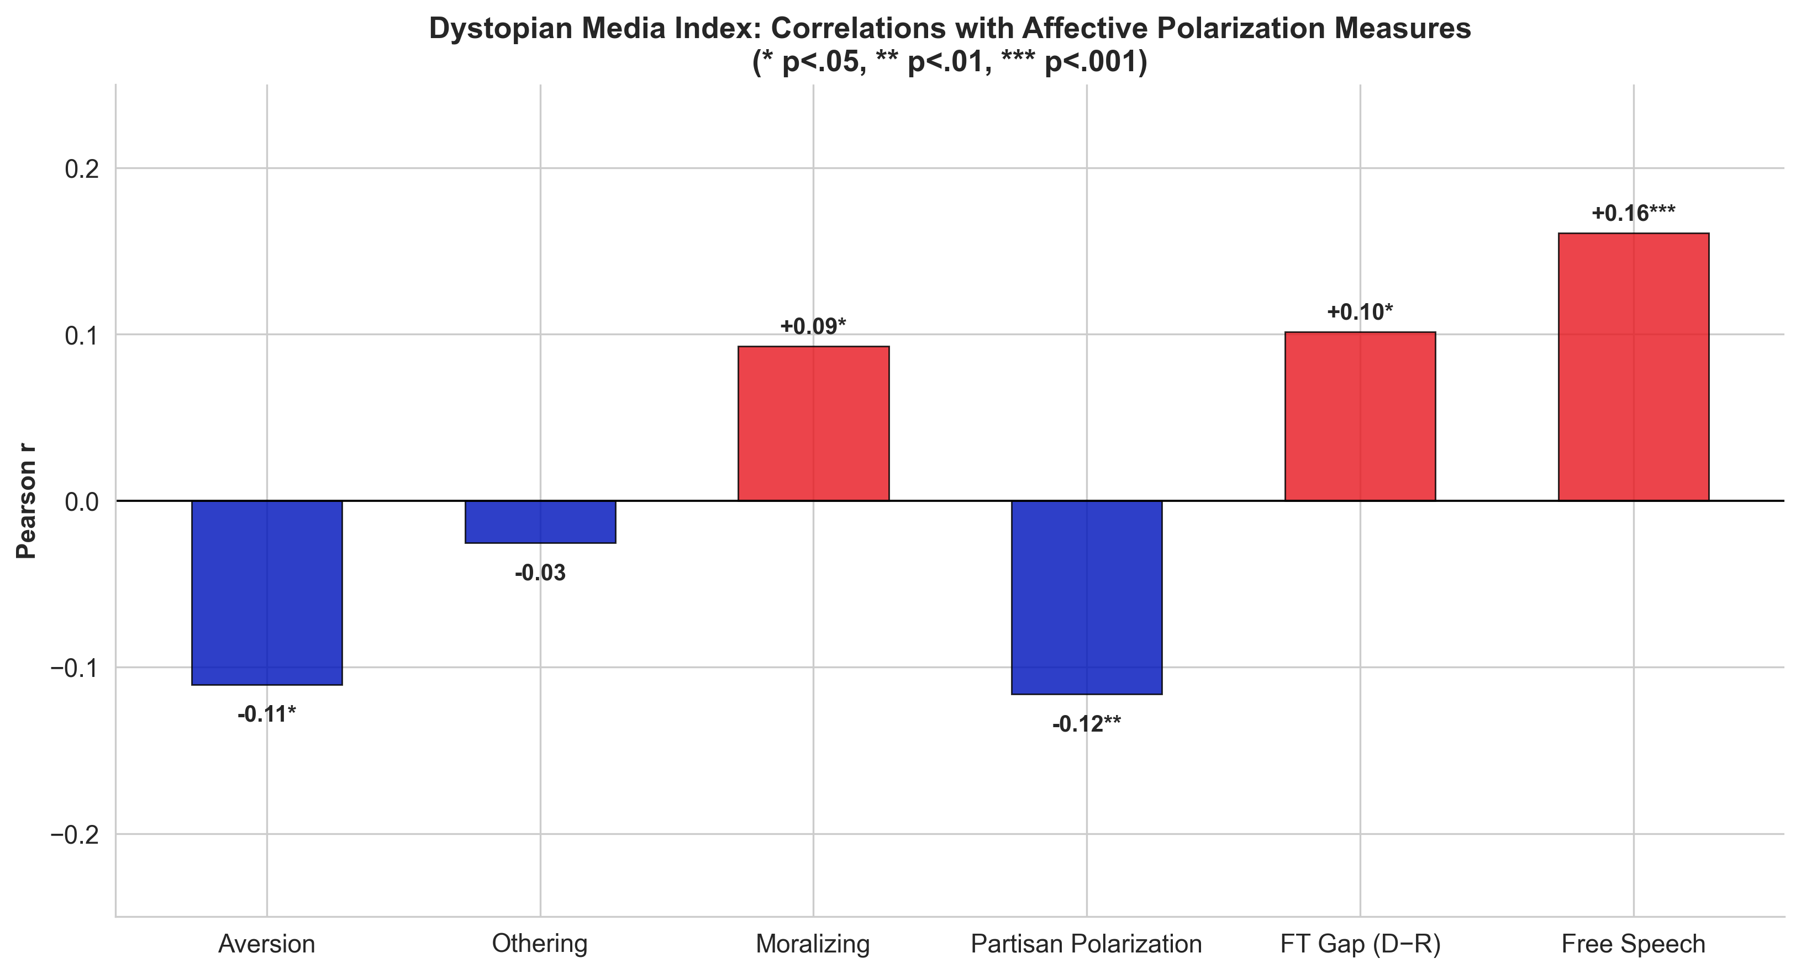
Figure 5. Summary bar chart: correlations between the composite Dystopian Index and each of the six polarization measures. Dystopian consumption is associated with lower partisan aversion and polarization (negative r), and higher free speech permissiveness (positive r).

6. Affective Polarization Components by Party
Prior to examining the dystopian–polarization link, baseline party differences on the three core components are reported. Democrats scored higher than Republicans on all three — aversion, othering, and moralizing — consistent with prior research on asymmetric polarization.

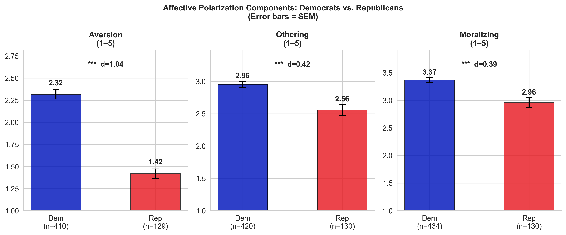
Figure 6. Mean scores on three affective polarization components by party (error bars = SEM; Cohen’s d annotated). Democrats score significantly higher on aversion and othering; both groups show similar moralizing tendencies.

7. High vs. Low Dystopian Consumers
Respondents were split at the median dystopian index (Mdn = 4.17) into High (n = 294) and Low (n = 298) consumer groups. High consumers scored significantly higher on moralizing (M = 3.40 vs. 3.18, p < .05, d = 0.21) and free speech permissiveness (M = 5.28 vs. 5.05, p < .01, d = 0.26). Differences on aversion, othering, partisan polarization, and the feeling thermometer gap trended in expected directions but did not reach conventional significance.

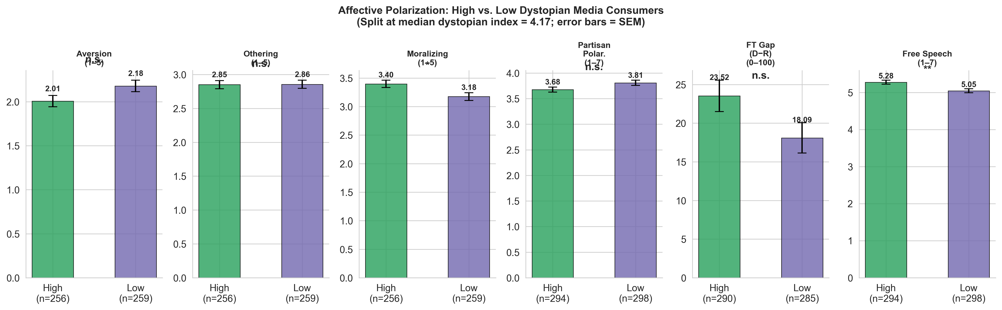
Figure 7. Affective polarization profiles for High vs. Low dystopian media consumers (median split; error bars = SEM). Significant differences (* p < .05; ** p < .01) emerge for Moralizing and Free Speech Permissiveness only.

8. Multivariate Regression
Two OLS models assessed whether dystopian consumption independently predicts polarization, controlling for party identification (1–Dem to 5–Rep), ideology (1–liberal to 7–conservative), age, gender, and religiosity.

Model 1 — Social Aversion (R² = .29, n = 485)
The dystopian index significantly predicted lower aversion (β = −0.27, SE = 0.06, p < .001), even after all controls. More conservative ideology also predicted lower aversion (β = −0.23, p < .001). Women showed higher aversion than men (β = +0.40, p < .001). Party identification was not independently significant after ideology was controlled.

Model 2 — Feeling Thermometer Gap (R² = .55, n = 517)
The dystopian index did not independently predict the thermometer gap after controlling for party and ideology (β = +1.69, p = .26). Party (β = −11.66, p < .001) and ideology (β = −7.60, p < .001) dominated, as expected.

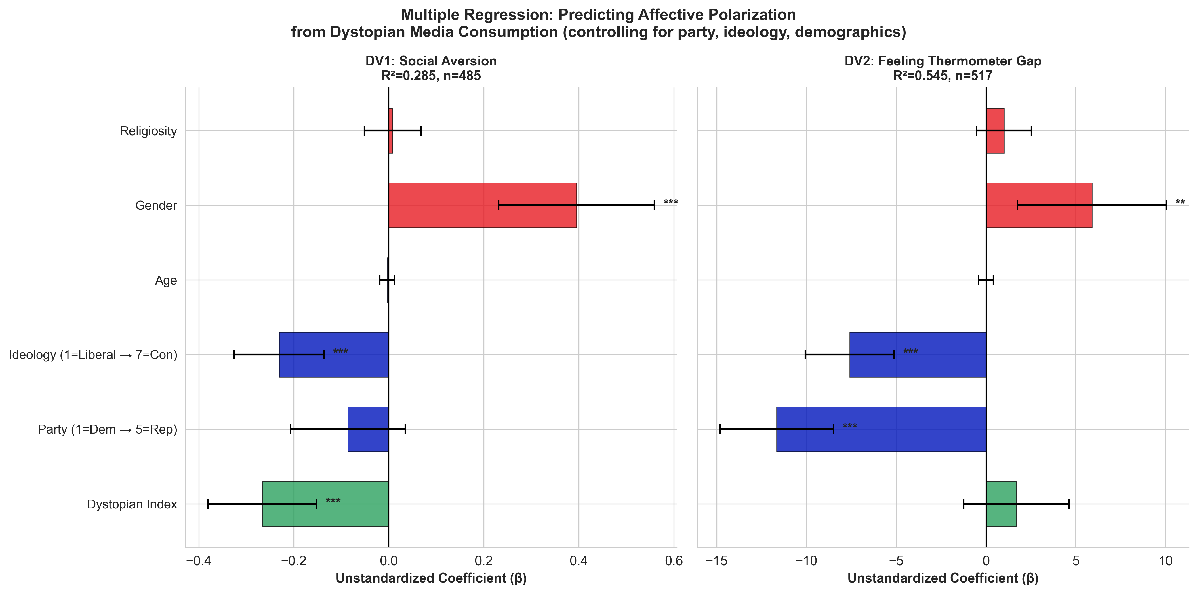
Figure 8. OLS regression coefficient plots (unstandardized β with 95% CI). Green bar = dystopian index predictor. Left panel: Aversion (R² = .29) — dystopian consumption is a significant independent predictor of lower social aversion. Right panel: Feeling Thermometer Gap (R² = .55) — party and ideology dominate; dystopian index is non-significant.

9. Summary of Key Findings
Finding | r / β | p | n | Notes
Dystopian index → Free speech permissiveness | +.16 | <.001 | 603 | Consistent across all 9 works
1984 → Social aversion | −.19 | <.001 | 300 | Strongest aversion link
Fahrenheit 451 → Free speech | +.26 | <.001 | 345 | Strongest single correlation
1984 → Partisan polarization | −.17 | <.01 | 347 | Books > TV/film
Last of Us: Dem vs. Rep liking | d=.35 | <.01 | 289 | Sig. party difference
Black Mirror: Dem vs. Rep liking | d=.33 | <.05 | 283 | Sig. party difference
Regression — Aversion: dystopian β | −0.27 | <.001 | 485 | Controls: party, ideology, gender
High vs. Low: moralizing | d=.21 | <.05 | 592 | Median split at 4.17
High vs. Low: free speech | d=.26 | <.01 | 581 | Most pronounced group difference

10. Conclusion
Dystopian media consumption is modestly but consistently associated with a less polarized civic orientation among UNCC undergraduates. The strongest and most replicable finding is the link with free speech permissiveness: regardless of which specific work, students who enjoy dystopian fiction are more tolerant of speech they disagree with. The inverse association with social aversion survives multivariate controls, indicating a small but independent effect beyond party and ideology.
Several caveats apply. The data are cross-sectional, so causality cannot be established. The sample is student-based and not nationally representative. Effect sizes are modest (r ≈ .10–.26). Nonetheless, the pattern is consistent and theoretically coherent: dystopian narratives warn of authoritarian control and the suppression of dissent — themes that may prime readers toward civic openness regardless of partisan identity.
Future work should use experimental designs to isolate whether dystopian exposure causes changes in polarization, and whether the literary vs. cinematic distinction (books show stronger effects) reflects depth of engagement or thematic content.

Key Takeaway: Students who like dystopian fiction — especially literary works like 1984 and Fahrenheit 451 — show lower partisan aversion (β = −0.27***) and greater free speech permissiveness (r = .16***) even after controlling for party, ideology, and demographics. Party differences in liking are minimal for most works, suggesting dystopian fiction crosses political lines.

