For Starters follow these instructions to access file on GitHub repository

1. Copy this link and paste it in browser: [**https://github.com/layj4155/KTSS_L3SOD_Notes**](https://github.com/layj4155/KTSS_L3SOD_Notes)

Like this: after press **enter** on your keyboard

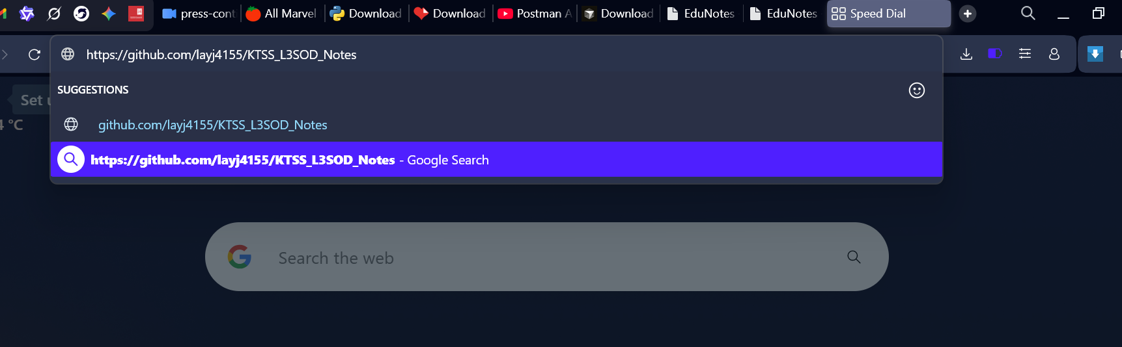



1. After pressing enter you will see this



1. In that previous picture you will see in blue colour the name of repository named **KTSS_L3SOD_Notes** And bellow you can seea document **JavaScript work.docx** in blue colour too, Click on it



1. After clicking on that file or document it will open something like this

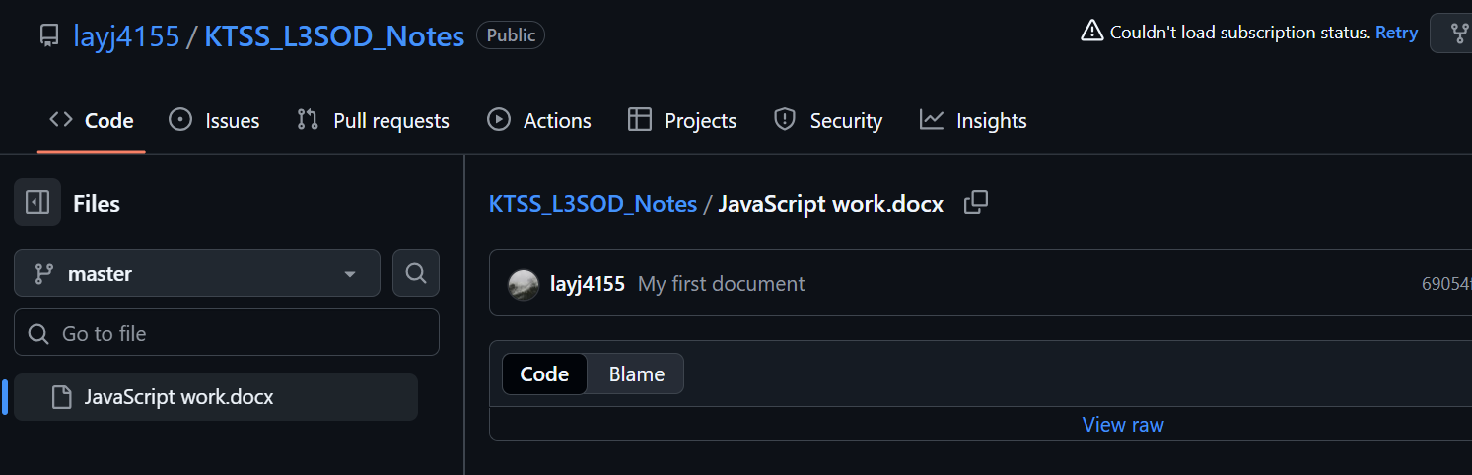



1. What you have to do click on **View raw** in blue colour down right after clicking on it will download or open the file

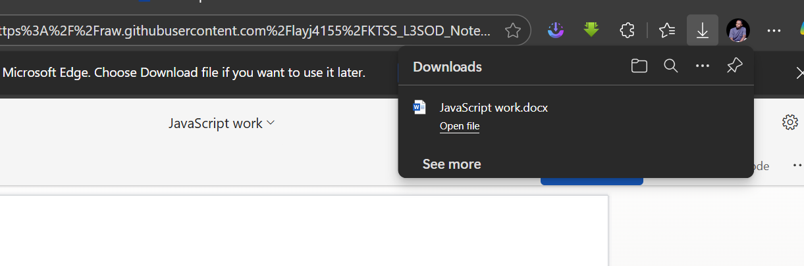

1. After the download is complete you will open the file explorer and go to download folder and open the file downloaded

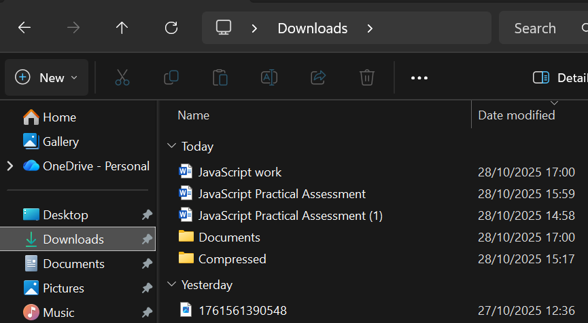



1. And then Start your work