Dental Supply Inventory Manager

Demo link: https://youtu.be/L40LMqxw8DQ
Application Description
This Java application will be a dental supply inventory tracker. The application will allow users to add new supplies, view current inventory, update supply quantities, and delete items. The application will also help identify supplies that are low in stock and need to be reordered. Users will interact with the application through a terminal window and supply information will be stored in a SQLite database.
Purpose
The purpose of this application is to help a dental office manage and monitor its supply inventory. The value of this application is that it will simplify and organize the process. It’s important that a dental office has the supplies they need to provide quality care to patients and without an organized system, it may be difficult or cumbersome if the practice is busy. Sometimes supplies can be ordered in excess or too little, which can be frustrating. This application will make tracking inventory more efficient and accurate.
Output
The application will display a menu in the terminal that allows users to select different options, such as adding new supplies, viewing all supplies, updating quantity of an existing supply, deleting a supply, and showing supplies low in stock. For example, if the user selects to view a dental supply, it will show the SupplyID, name, category, and quantity in stock. The application will also have confirmation messages for when a supply is added, updated, or deleted. It will also have error handling if invalid selections are entered.
Data Storage
The application will use a SQLite database to store supply information. Each supply record will have a unique identifier such as a SupplyID, supply name, category, current quantity, and minimum quantity allowed (to help identify when stock is low). Java will connect to the SQLite database using JDBC to create, retrieve, update, and delete supply records (CRUD operations). The database will preserve supply information even when the application closes. I plan to use Maven to manage dependencies, including the SQLite JDBC driver, which will make it easier to configure and maintain the libraries used in this project.

Week 2
Class Definitions
Class name: App (main application class)
- Class properties:
  - None planned
- Methods:
  - main(String[] args) – Starts application
  - displayMenu() – displays menu options, accepts user’s input, uses switch statement to determine what happens next
- Special considerations:
  - The app class will be the starting point of the application. It will have a terminal-based menu that allows the user to view, search, add, update, or delete supplies. It will also allow the user to view supplies that are low in stock.
Class name: Supply
- Class properties:
  - private String SupplyID – String type, unique identifier for each supply
  - private String Name – name of supply
  - private String Category – Labels supply category (restorative, hygiene, PPE, disinfection, instruments, etc)
  - private int CurrentQuantity – Current number available
  - private int MinimumQuantity – Identifies the minimum quantity needed
- Methods:
  - getSupplyType() – Abstract method, tells 2 child classes to identify their supply type (reusable or disposable)
  - isLowStock() – boolean value is return to indicate if a supply is low in stock
  - getter and setter methods
  - toString() – Will be overridden so that a formatted display is returned
- Special considerations:
  - I realize that next week we’ll be going over abstract classes. So, I googled what it meant after reviewing the requirements for this project. I believe this class will be the abstract parent class for the next 2 classes I’ll define. This class will hold common information for those 2 classes as listed above and I’ll use an abstract method that each child class will provide their own information. This class along with the next 2 classes will demonstrate inheritance and polymorphism. This is the parent class and it tells the other 2 classes (child classes) that they need to use the getSupplyType() method, but it doesn’t tell them what to return (polymorphism).
Class name: DisposableSupply
- Properties:
  - Will inherit properties from Supply super/parent class.
  - No new properties planned
- Methods:
  - Constructor to initialize parameters from parent class
  - getSupplyType() – Will be overridden to provide a returned value of “Disposable”
- Special considerations:
  - This is a child/sub class of the Supply super/parent class. It will inherit the super class’s properties and methods. The items in this class will be things like masks, gloves, gauze, saliva ejectors, etc. No toString() method will be used as it’s used in the Supply super class and holds all the information needed.
Class name: ResuableSupply:
- Properties:
  - Will inherit properties from Supply super/parent class.
  - No new properties planned
- Methods:
  - Constructor to initialize parameters from parent class
  - getSupplyType() – Will be overridden to provide a returned value of “Reusable”
- Special considerations:
  - This is a child/sub class of the Supply super/parent class. It will inherit the super class’s properties and methods. The items in this class will be things that can be sterilized and used again, such as dental instruments, handpieces, burs, etc. No toString() method will be used as it’s used in the Supply super class and holds all the information needed.
Class name: InventoryOperations
- Properties:
  - None planned
- Methods:
  - addSupply(Supply supply) – Add item to inventory
  - getViewSupplies() – Views all supplies
  - findSupply(String supplyID) – Searches inventory by SupplyID
  - updateSupply(Supply supply) – updates existing supply information
  - deleteSupply(String supplyID) – deletes an item from the inventory
  - getLowStock() – Gets items lows in stock (equal to or below minimum required)
- Special considerations:
  - This is an interface class. It will define all the methods for managing the inventory. The next class will implement this class and override how each method will behave.
Class Name: InventatoryManager
- Properties:
  - private DatabaseManager databaseManager – an object that allows this class to talk to the SQLite database to save, retrieve, update, or delete items
- Methods:
  - addSupply(Supply supply) – Add item to inventory
  - getViewSupplies() – Views all supplies
  - findSupply(String supplyID) – Searches inventory by SupplyID
  - updateSupply(Supply supply) – updates existing supply information
  - deleteSupply(String supplyID) – deletes an item from the inventory
  - getLowStock() – Gets items lows in stock (equal to or below minimum required)
- Special considerations:
  - This class will implement the InventoryOperations interface and use the interface’s methods to perform CRUD operations. It will use the DatabaseManager object to retrieve or modify data in the database. Because this class also uses an object from another class, it demonstrates composition.
Class name: DatabaseManager
- Properties:
  - I’ll need to use JDBC to connect the application to the SQLite database. I’ll use import java.sql.Connection, then use Connection as the data type.
    - private Connection DatabaseConnection
- Methods:
  - connectDatabase() – connects to the database
  - createTable() – creates a table for new inventory that isn’t in the system yet
  - addSupply(Supply supply) – Add item to inventory
  - getViewSupplies() – Views all supplies
  - findSupply(String supplyID) – Searches inventory by SupplyID
  - updateSupply(Supply supply) – updates existing supply information
  - deleteSupply(String supplyID) – deletes an item from the inventory
  - getLowStock() – Gets items lows in stock (equal to or below minimum required)
- Special considerations:
  - This class will handle the database connecting to the application using JDBC.

UML Class Diagram
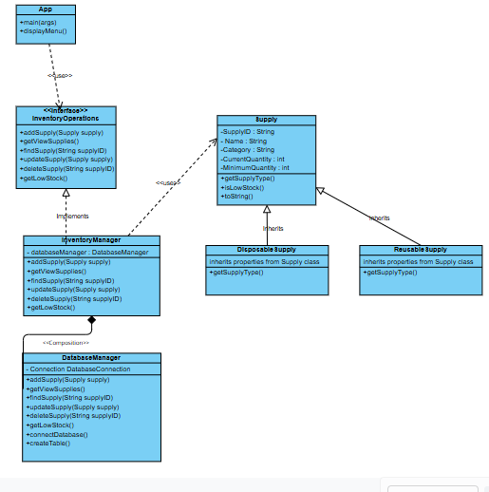
Data Storage
Table name: Supplies
- Field names + data types
  - SupplyID : String
  - Name : String
  - Category : String
  - SupplyType : String
  - CurrentQuantity : int
  - MinumumQuantity: int
- Table relationships: None. I will only need one table for my database. It will contain all the supplies. I don’t need any other table, despite having disposable and reusable supplies. SupplyType is a field to separate those two, so I wouldn’t need other tables to separate them.

