Rolodex Management System

User Interaction
Application
This application will be on a console. The program will organize and manage contact information. There will be 3 contact types: Family, Friends, and Business.
The application will start by greeting the user and presenting the user with a menu and asking the user to select an option. The options include the following:
- View All Contacts
- Search Contacts by Last Name Initial
- Add a Contact
- Update a Contact
- Remove a Contact
- Exit
Below the menu, the user will be allowed to enter their selection. There will also be error handling in case the user enters an invalid option.
When the user selects option 1 or 2, the full contact information will be displayed. When the user selects option 3 or 4, the information that will be displayed is a numbered list of each the contact’s first and last name only. The application will then ask the user to select which contact they want to view. It will also give the user an option to return to the main menu by enter 0.
For example:
If the user selects 4 to update a contact, the output would be:
Business Contacts
- Jane Doe
- John Ellis
- Alex Smith
Enter the number of the contact you want to update:

Then when they select a contact, the whole information will be displayed and the user will be asked what information they want to update.
For example, if the user selects option 3 to see Alex Smith, the output would be:
Update Contact
1. Update Name
2. Update Phone Number
3. Update Email
4. Update Company Name
5. Return to Contact Details
Enter your selection:

When the user enters an option, they will be asked to enter the new information. For example, if they chose to update the phone number:
…………
Enter your selection: 3
Enter a new phone number:

When the user wants to delete a contact, the application will confirm if they want to delete firstName and lastName.
To exit the application all together, the user will select option 7 from the main menu.

Design
Classes
Class Name: App
The App class will be where the user interacts with the application. It will display the menu, get user input, and calls methods from the Rolodex class based on what the user’s input. It also creates initial contact objects.
Class Name: Contact
The Contact class stores common information for all contacts, such as first name, last name, phone number, email address, and contact type (business, family, and friend). This is a parent class. This class will have a toString to display contact information and getters/setters.
Class Name: Family
This class represents family contacts. This class is a child class and will inherit information and functionality from the Contact (parent) class.
Class Name: Friend
This class represents friend contacts. This class is a child class and will inherit information and functionality from the Contact (parent) class.
Class Name: Business
This class is a child class and will inherit information from the Contact (parent) class. It will override the toString() method to add the company name with the rest of the contact information.
Class Name: Rolodex
This class manages the collection of contacts. It contains an ArrayList and has methods to add contacts, retrieve all contacts, and filter contacts by first initial of their last name. I’ll also add methods for updating and deleting contacts as the project develops.
Class Name: RolodexOperaterations
This is an interface. I’ll have the methods used/implemented by the Rolodex class to manage contacts.
Class name: SQLiteDatabase
This class will handle the connection to the database so that the application can connect to it.
Class name: RolodexDb
This class will manage the database operations and SQL statements to view, add, remove, or update things in the database.
Inheritance
Base/parent/super class: Contact
Child/sub classes: Business, Family, and Friend.
Logic: This is because these three classes share the same basic information in the Contact class. The shared functionality is storing contacts’ first name, last name, phone number, email address, and contact type. The subclasses will inherit getters/setters and the toString() method from the superclass.
The Family and Friend classes don’t need additional properties because everything is provided by the Contact class. However, the Business class will include a property called Company and will override the toString to add the company name to the contact information when it’s displayed.
The three subclasses inherit shared properties and methods from the superclass. This helps prevent rewriting the same code for each class.
Composition
The Rolodex class has a collection of Contact objects in an ArrayList from the Contact class. This demonstrates composition.
Polymorphism can be used with the collection of contacts with how it manages the different contact types through the Contact class. An example of polymorphism is the addContact() method, it can add any three of the contact types without needing a new method for each contact type.
Interface
I have added the class RolodexOperations to be the interface, which will hold the methods for managing contacts, such as adding, updating, or deleting contacts. The Rolodex class will then implement this class to use these methods. The interface will provide methods that are available without telling the classes how to use them.
Conclusion
How the classes will interact:
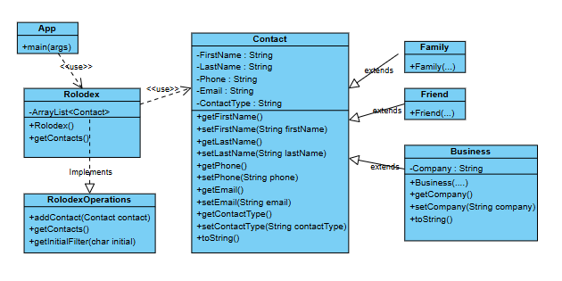
Screenshots and video:
Link: https://youtu.be/C9aTT0ppuWY
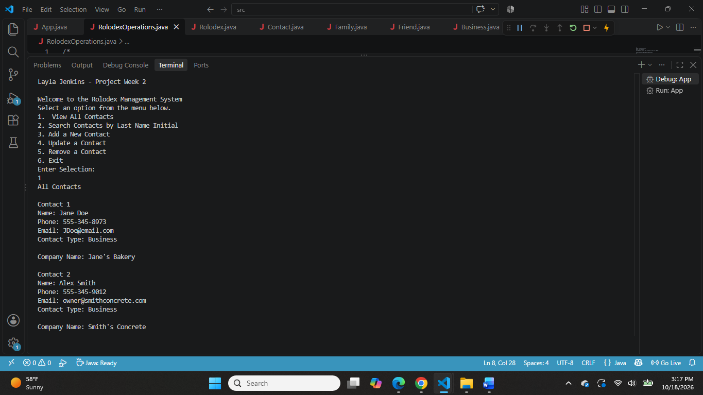
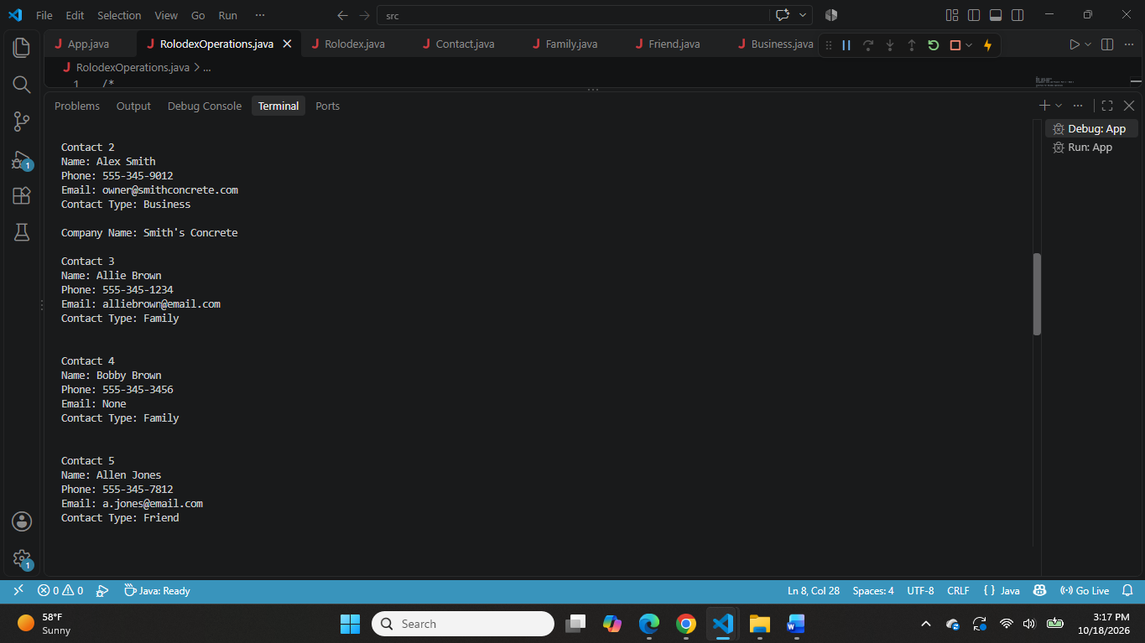
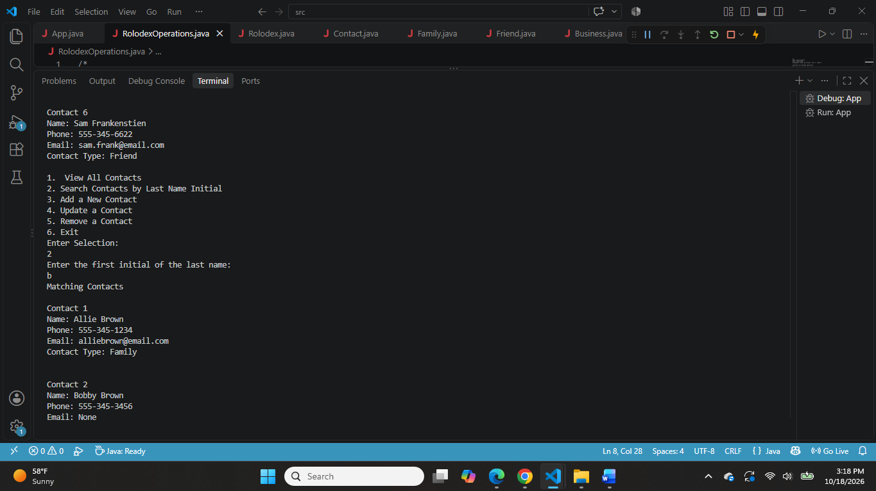
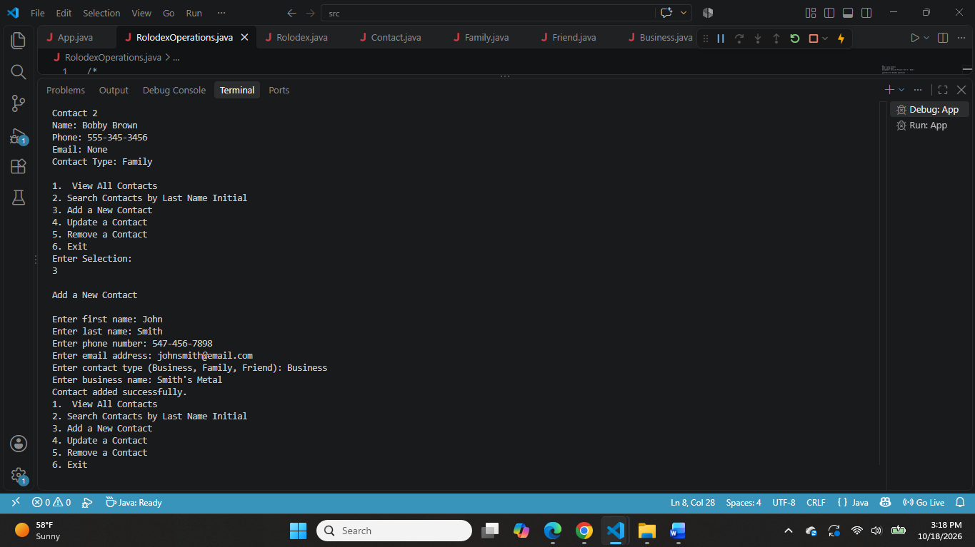
Week 3 Screenshots
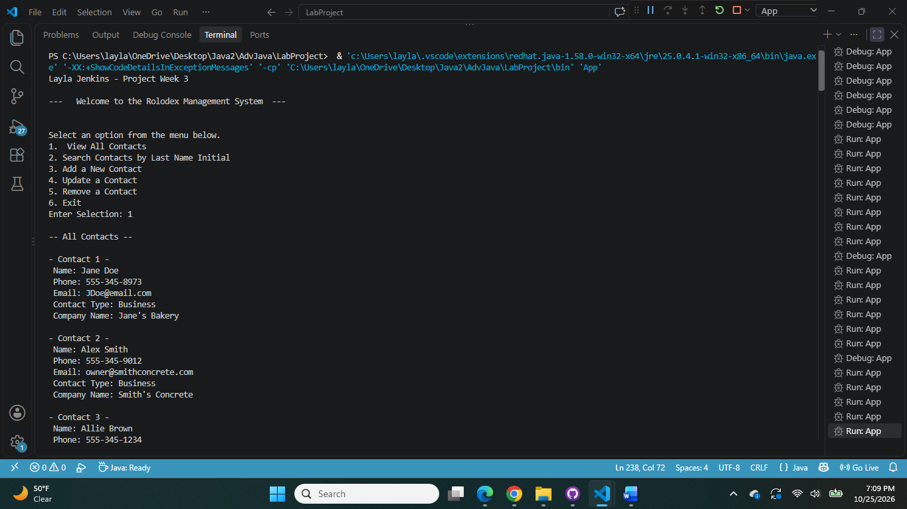
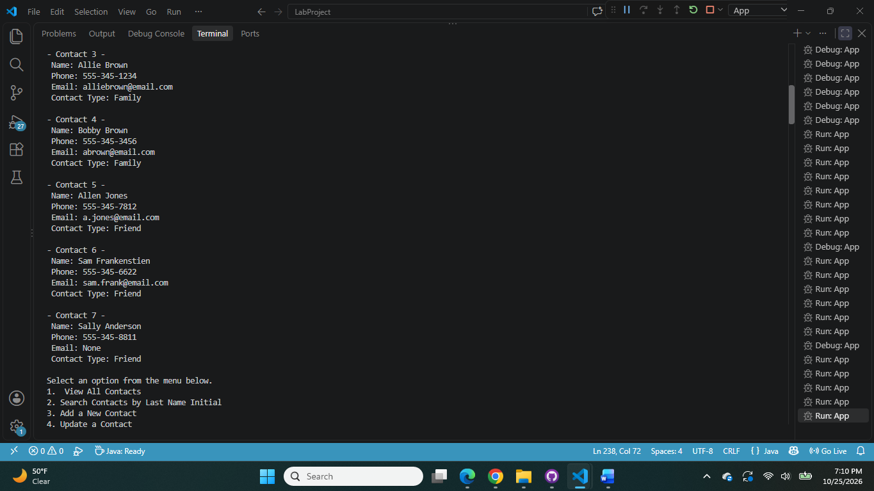
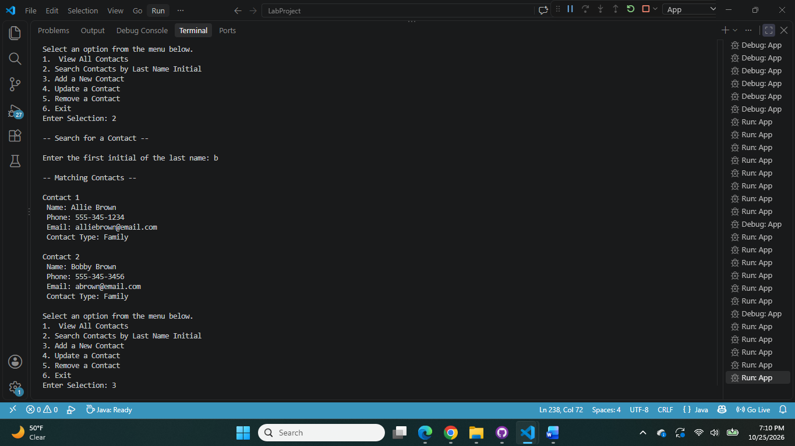
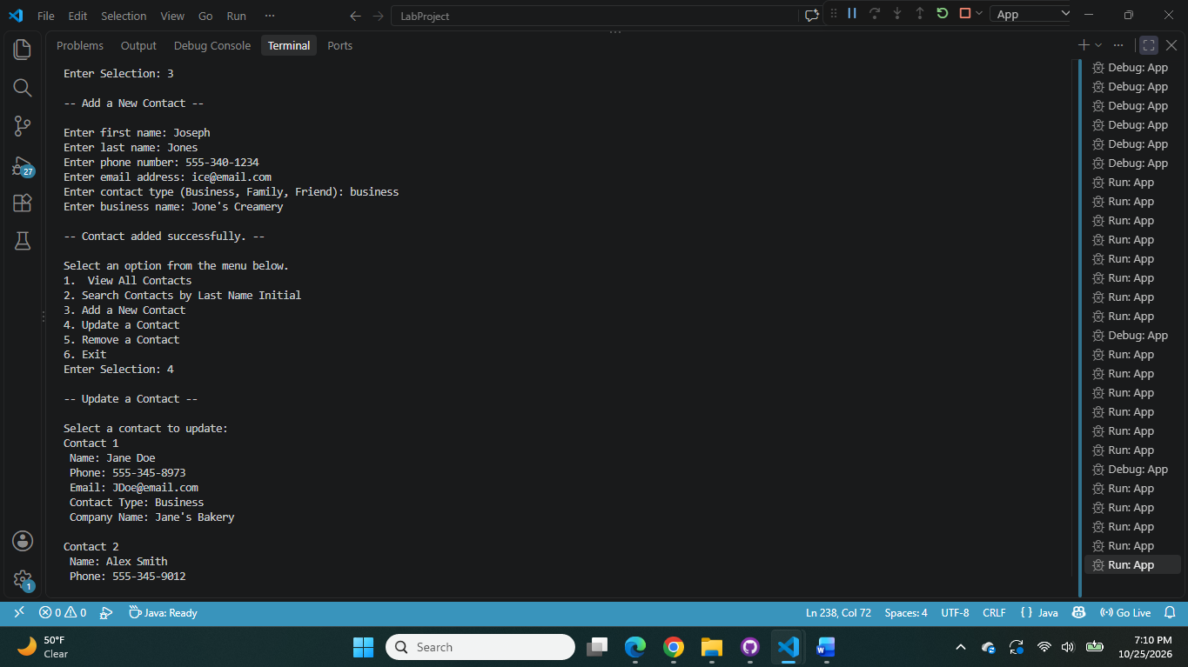
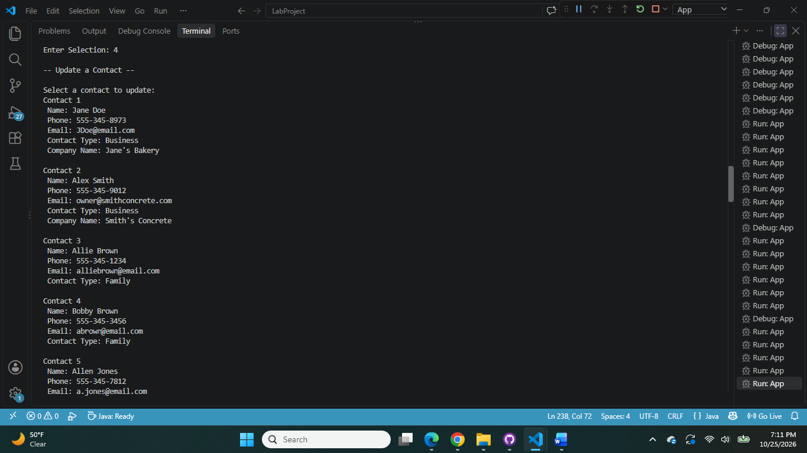
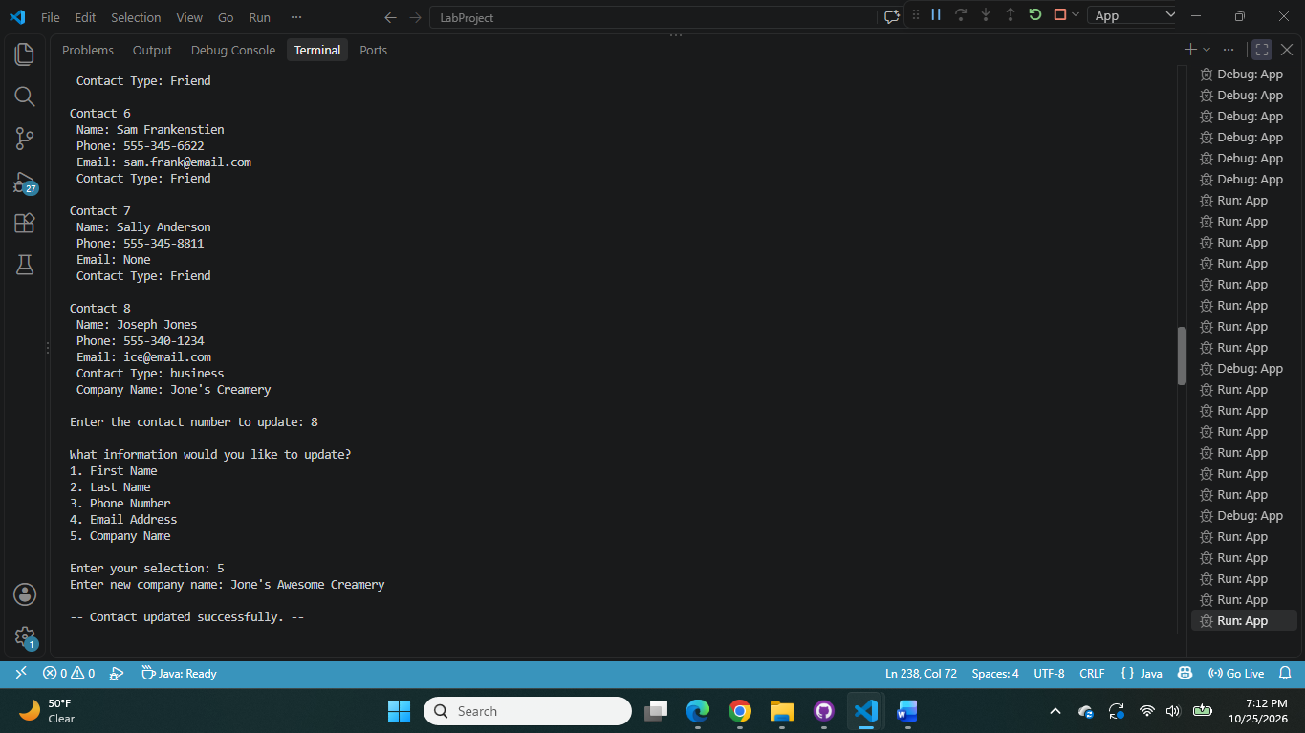
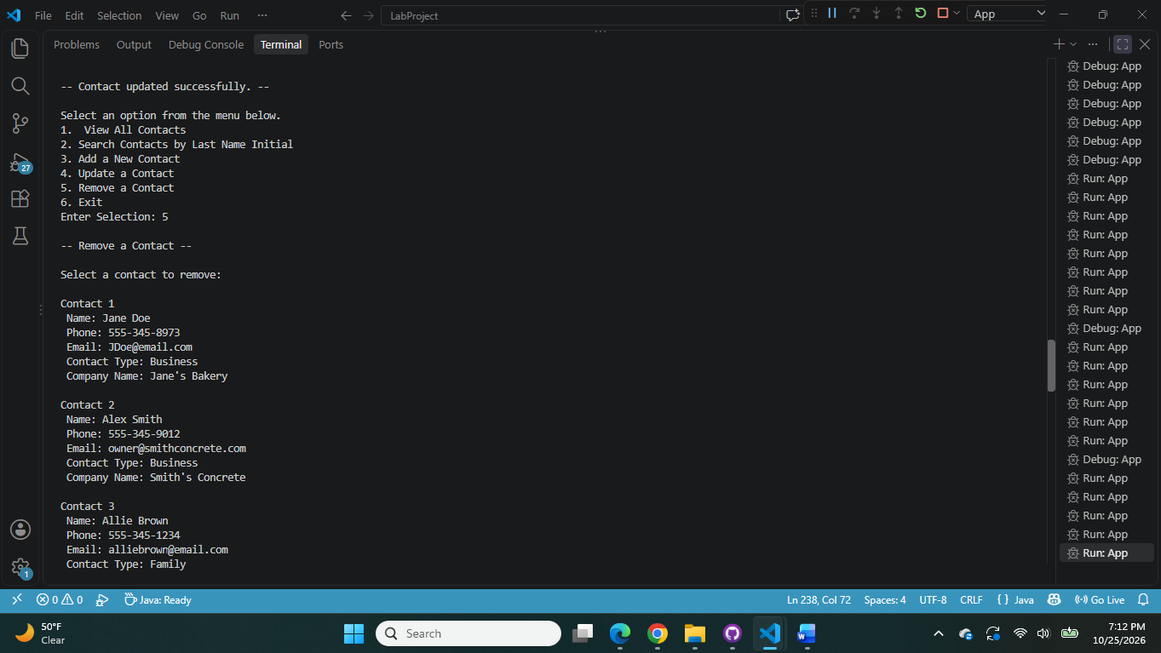
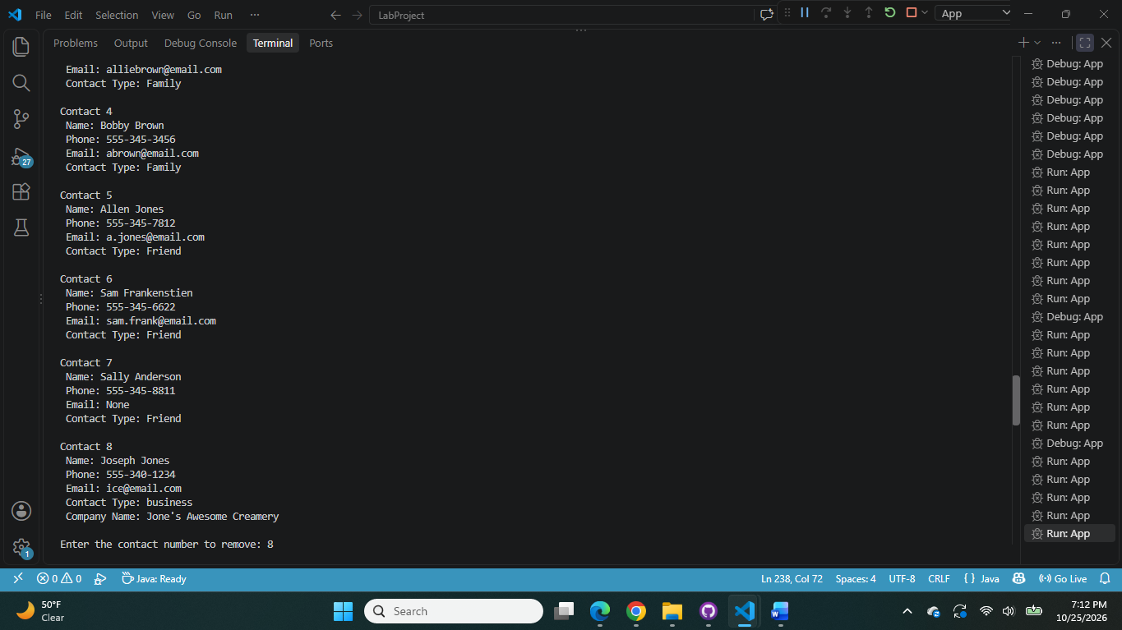
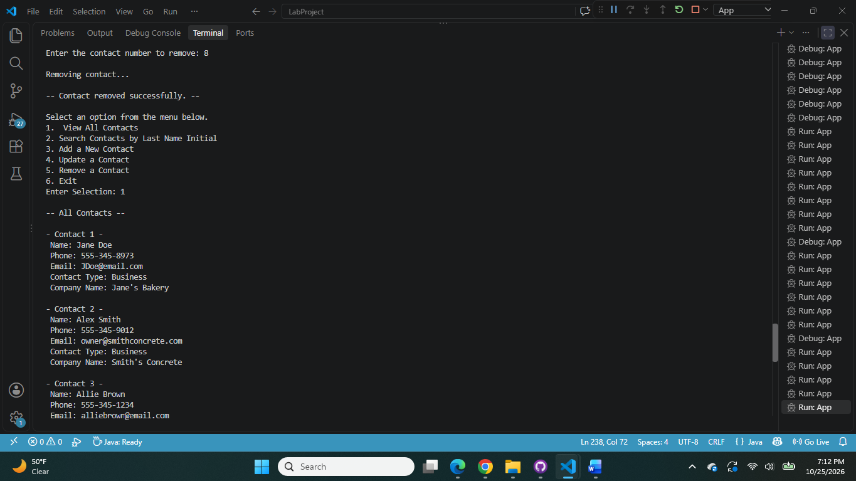
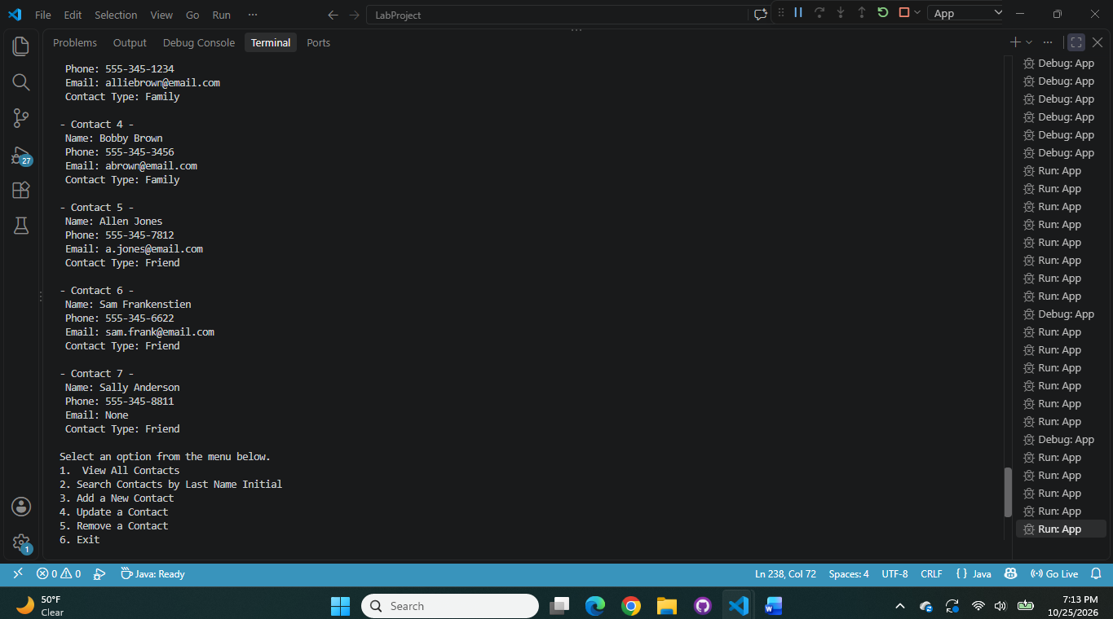
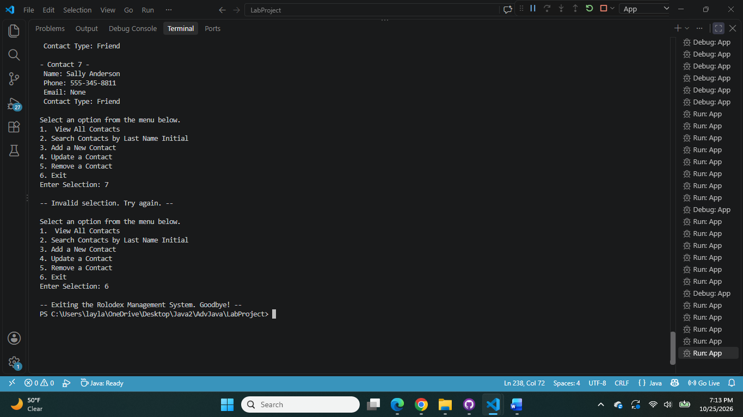
Week 4 Screenshots:


