In [74]:

*# 2.1* 히스토그램 *, p20* **import** seaborn **as** sns **import** matplotlib.pyplot **as** plt *#* 패키지 선언

degree **=** [23.5, 23.5, 23.5, 28.5, 28.5, 28.5, 33.5, 33.5, 33.5, 33.5, 33.5, 38.5, 38.5, 38.5, 38.5, 38.5, 38.5, 38.5, 43.5, 48.5]

sns**.**distplot(degree, bins**=**5, color**=**'purple', kde**=False**, rug**=True**) plt**.**show()

C:\Users\starl\AppData\Local\Temp\ipykernel_32480\920187669.py:8: UserWarning:

`distplot` is a deprecated function and will be removed in seaborn v0.14.0.

Please adapt your code to use either `displot` (a figure-level function with similar flexibility) or `histplot` (an axes-level function for histograms).

For a guide to updating your code to use the new functions, please see https://gist.github.com/mwaskom/de44147ed2974457ad6372750bbe5751

sns.distplot(degree, bins=5, color='purple', kde=False, rug=True)

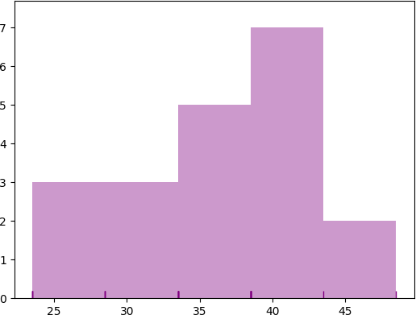

In [2]:

*#* 최신문법

**import** seaborn **as** sns

**import** matplotlib.pyplot **as** plt

degree **=** [23.5, 23.5, 23.5, 28.5, 28.5, 28.5, 33.5, 33.5, 33.5, 33.5, 33.5, 38.5, 38.5, 38.5, 38.5, 38.5, 38.5, 38.5, 43.5, 48.5]

sns**.**displot(degree, bins**=**5, color**=**'purple', kde**=False**) sns**.**rugplot(degree)

plt**.**show()

c:\Users\starl\AppData\Local\Programs\Python\Python311\Lib\site-packages\seaborn\axisgrid.py:118: UserWarning: The figure layout has changed to tight self._figure.tight_layout(*args, **kwargs)

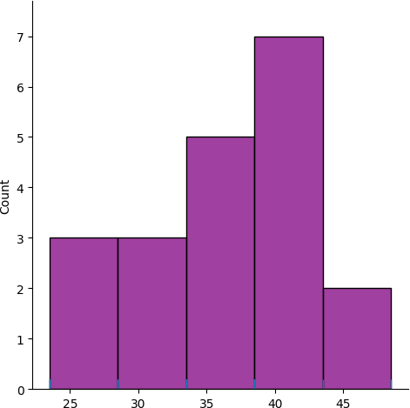

In [1]:

*# 2.1* 히스토그램 *, p20, matplotlib ( seaborn* 미사용 *)*

**import** matplotlib.pyplot **as** plt

*#* 패키지 선언

degree **=** [23.5, 23.5, 23.5, 28.5, 28.5, 28.5, 33.5, 33.5, 33.5, 33.5, 33.5, 38.5, 38.5, 38.5, 38.5, 38.5, 38.5, 38.5, 43.5, 48.5]

plt**.**hist(degree, bins**=**5, color**=**'pink', alpha**=**0.9, edgecolor**=**'black') plt**.**show()

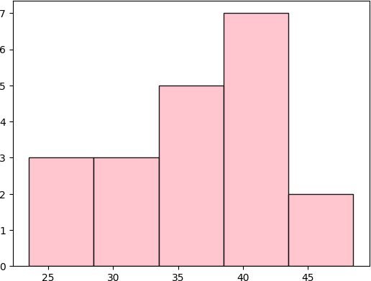

Loading [MathJax]/jax/output/CommonHTML/fonts/TeX/fontdata.js