In [1]:

*#* 연습문제 *3.1, p40*

**import** pandas **as** pd

speed **=** [1.28, 1.36, 1.24, 2.47, 1.94, 2.52, 2.67, 1.37, 1.56, 2.66, 2.17, 1.57, 2.10, 2.54, 1.63, 2.11, 2.57, 1.72, 0.76, 1.02, 1.78, 0.50, 1.49 label **=** ['0.45~0.89','0.90~1.34','1.35~1.79','1.80~2.24','2.25~2.70']

speed_cut **=** pd**.**cut(speed, 5, labels**=**label) pd**.**value_counts(speed_cut)**.**sort_index()

Out[1]:

0.45~0.89 2

0.90~1.34 6

1.35~1.79 11

1.80~2.24 5

2.25~2.70 6

Name: count, dtype: int64

In [2]:

*#* 연습문제 *3.2, p40*

**import** matplotlib.pyplot **as** plt

speed **=** [1.28, 1.36, 1.24, 2.47, 1.94, 2.52, 2.67, 1.29, 1.56, 2.66, 2.17, 1.57, 2.10, 2.54, 1.63, 2.11, 2.57, 1.72, 0.76, 1.02, 1.78, 0.50, 1.49

plt**.**hist(speed, color**=**'pink', edgecolor**=**'black') plt**.**show()

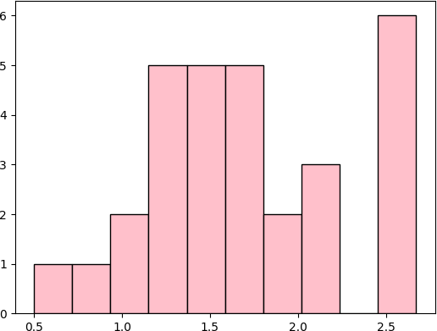

Loading [MathJax]/jax/output/CommonHTML/fonts/TeX/fontdata.js