In [1]:

*#* 연습문제 *4, p40*

**import** stemgraphic

value **=** [20, 18, 25, 26, 17, 14, 20, 40, 18, 15, 22, 15, 17, 25, 22, 12, 52, 27, 24, 41, 34, 20, 17, 20, 19, 20, 16, 20, 15, 34, 22, 29, 29, 34, 2

*#* 데이터 입력

stemgraphic**.**stem_graphic(value, scale**=**10)

*#* 데이터 출력

Out[1]:

(<Figure size 750x225 with 1 Axes>, <Axes: >)

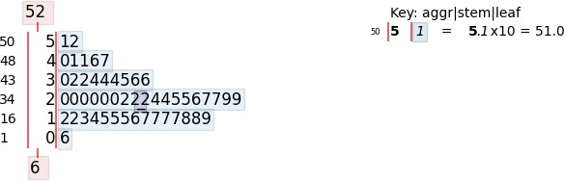

Loading [MathJax]/jax/output/CommonHTML/fonts/TeX/fontdata.js