In [ ]:

**from** statistics **import \***

temp **=** [15.2, 11.0, 16.8, 23.2, 14.3, 21.9, 22.4, 20.5, 15.0, 17.0, 12.8, 21.0, 27.7, 28.0, 18.8, 16.4, 14.9, 20.0, 23.5, 23.9, 24.0, 13.2, 13.6,

print(f"최대 : {max(temp)}")

print(f"최소 : {min(temp)}") print((max(temp) **-** min(temp)) **//** 5)

In [8]:

*#* 연습문제 *5, p41*

data **=** [15.2, 15.3, 16.8, 23.2, 14.3, 21.9, 22.4, 20.5, 15.0, 17.0, 12.8, 21.0, 27.7, 28.0, 18.8, 16.4, 14.9, 20.0, 23.5, 23.9, 24.0, 13.2, 13.6,

bins **=** [10,15,20,25,30,35]

labels **=** ['10 ~ 14', '15 ~ 19', '20 ~ 24', '25 ~ 29', '30 ~ 34']

freq_table **=** {}

**for** label **in** labels:

freq_table[label] **=** 0

**for** value **in** data:

**for** i **in** range(len(bins)**-**1):

**if** bins[i] **<=** value **<** bins[i**+**1]:

freq_table[labels[i]] **+=**1

break

print(freq_table)

{'10 ~ 14': 5, '15 ~ 19': 7, '20 ~ 24': 10, '25 ~ 29': 6, '30 ~ 34': 3}

In [9]:

*#* 연습문제 *5.1, p41* **import** matplotlib.pyplot **as** plt **import** numpy **as** np

x **=** np**.**arange(5)

label **=** ['10 ~ 14', '15 ~ 19', '20 ~ 24', '25 ~ 29', '30 ~ 34']

values **=** [5, 7, 10, 6, 3]

fig, ax1 **=** plt**.**subplots()

ax1**.**plot(label, values, '-s', color**=**'red', markersize**=**7, linewidth**=**5, alpha**=**0.7, label**=**'Count') ax1**.**set_xlabel('degree')

ax1**.**set_ylabel('Count') ax1**.**tick_params(axis**=**'both', direction**=**'in')

plt**.**bar(x, values) plt**.**xticks(x, label)

plt**.**show()

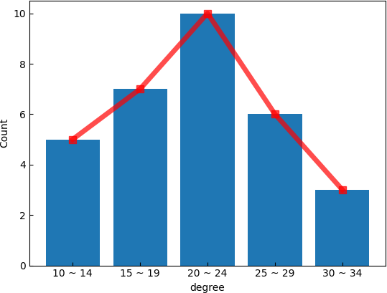

Loading [MathJax]/jax/output/CommonHTML/fonts/TeX/fontdata.js