In [2]:

*#* 연습문제 *8, p43*

**import** stemgraphic

time **=** [5.9, 5.3, 1.6, 7.4, 9.8, 1.7, 8.9, 1.2, 2.1, 4.0, 6.5, 7.2, 7.3, 8.4, 8.9, 6.7, 9.2, 2.8, 4.5, 6.3, 7.6, 9.7, 9.4, 8.8, 3.5, 1.1, 4.3, 3.3, 3.1, 1.3

stemgraphic**.**stem_graphic(time, scale**=**1) Out[2]:

(<Figure size 750x300 with 1 Axes>, <Axes: >)

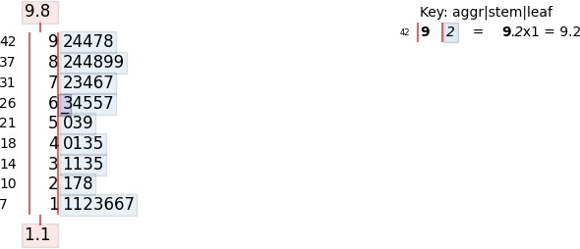

In [3]:

*#* 연습문제 *8.1, p43*

**from** statistics **import \***

time **=** [5.9, 5.3, 1.6, 7.4, 9.8, 1.7, 8.9, 1.2, 2.1, 4.0, 6.5, 7.2, 7.3, 8.4, 8.9, 6.7, 9.2, 2.8, 4.5, 6.3, 7.6, 9.7, 9.4, 8.8, 3.5, 1.1, 4.3, 3.3, 3.1, 1.3

print("평균: ", mean(time))

print("중위수(중앙값): ", median(time))

print("최빈수(최빈값): ", mode(time))

평균: 5.523809523809524

중위수(중앙값): 6.1

최빈수(최빈값): 1.6

In [14]:

*#* 연습문제 *8.2, p43*

**from** statistics **import \***

time **=** [5.9, 5.3, 1.6, 7.4, 9.8, 1.7, 8.9, 1.2, 2.1, 4.0, 6.5, 7.2, 7.3, 8.4, 8.9, 6.7, 9.2, 2.8, 4.5, 6.3, 7.6, 9.7, 9.4, 8.8, 3.5, 1.1, 4.3, 3.3, 3.1, 1.3

print("범위: ", max(time) **-** min(time))

print("표준편차: ", stdev(time))

범위: 8.700000000000001

표준편차: 2.863036893844863

In [19]:

*#* 연습문제 *8.3, p43* **import** matplotlib.pyplot **as** plt **import** numpy **as** np

time **=** [5.9, 5.3, 1.6, 7.4, 9.8, 1.7, 8.9, 1.2, 2.1, 4.0, 6.5, 7.2, 7.3, 8.4, 8.9, 6.7, 9.2, 2.8, 4.5, 6.3, 7.6, 9.7, 9.4, 8.8, 3.5, 1.1, 4.3, 3.3, 3.1, 1.3

plt**.**style**.**use('default')

*#* 플롯 스타일 설정

plt**.**rcParams['font.size'] **=** 12

*#* 폰트 사이즈 지정

fig, ax **=** plt**.**subplots()

*#* 서브플롯 할당

ax**.**boxplot([time], notch**=False**, whis**=**2, vert**=False**)

*#* 박스플롯 생성

ax**.**set_xlim(**-**10.0, 10.0) ax**.**set_xlabel('Pass Time')

plt**.**show()

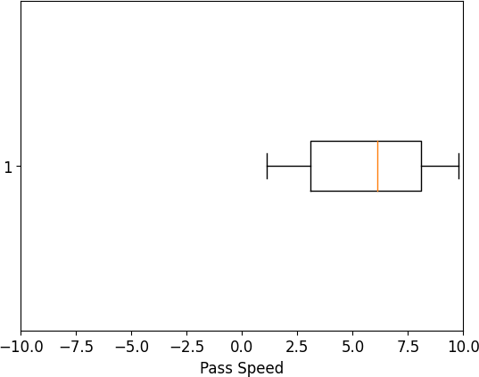

Loading [MathJax]/jax/output/CommonHTML/fonts/TeX/fontdata.js