In [27]:

*#* 연습문제 *1, p55*

*# d type = low, middle, high*

**from** matplotlib **import** pyplot **as** plt

non_serious_heart_attack **=** [29, 17, 18]

serious_heart_attack **=** [19, 20, 9] values, re_values, tx_values **=** [], [], [] label **=** ['낮음', '중간', '높음']

*#* 콜레스테롤 수치에 따른 막대그래프*,* 주변 분포 구하기

*# serious_heart_attack*의 변수 수를 계산하여 반복하여 더해 저장

**for** i **in** range(len(non_serious_heart_attack)):

xs **=** non_serious_heart_attack[i] **+** serious_heart_attack[i] values**.**append(xs)

*#* 토탈 값 구하기

total **=** sum(non_serious_heart_attack) **+** sum(serious_heart_attack)

**for** i **in** range(3):

data **=** round((values[i] **/** total), 3) data **=** round((data **\*** 100), 1) re_values**.**append(data)

plt**.**rc('font', family**=**'Malgun Gothic')

plt**.**bar(label, re_values, color**=**'violet', alpha**=**0.7, edgecolor**=**'purple') plt**.**show()

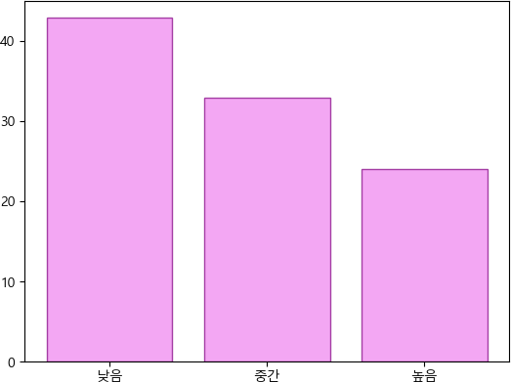

In [39]:

*#* 연습문제 *1.1, p55*

**from** matplotlib **import** pyplot **as** plt

non_serious_heart_attack **=** [29, 17, 18]

serious_heart_attack **=** [19, 20, 9]

thread **=** sum(non_serious_heart_attack), sum(serious_heart_attack) values **=** []

desc **=** ['치명적이지\n않은', '치명적인']

**for** i **in** range(len(thread)):

total **=** sum(thread)

data **=** round((thread[i] **/** total), 3) data **=** round((data **\*** 100), 1) values**.**append(data)

plt**.**rc('font', family**=**'Malgun Gothic')

plt**.**bar(desc, values, color**=**'violet', alpha**=**0.7, edgecolor**=**'purple') plt**.**show()

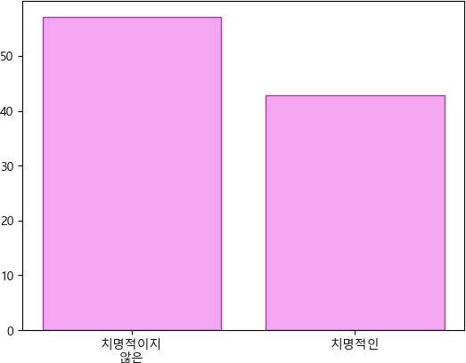

Loading [MathJax]/jax/output/CommonHTML/fonts/TeX/fontdata.js