In [1]:

*#* 연습문제 *2, p55* **import** matplotlib.pyplot **as** plt **import** numpy **as** np **import** pandas **as** pd

*#* 폰트값 설정

plt**.**rc('font', family**=**'Malgun Gothic')

*#* 데이터 입력

label **=** ['이상 없음', '이마', '정수리'] vunder_25 **=** [137, 22, 40]

v25_to_28 **=** [218, 34, 57]

vhigh_28 **=** [153, 30, 68] values **=** []

colors **=** ['red', 'green', 'blue']

valve **=** ['vunder_25', 'v25_to_28', 'vhigh_28']

*# under_25*

total **=** sum(vunder_25)

**for** i **in** range(len(vunder_25)):

data **=** round((vunder_25[i] **/** total **\*** 100) ,1) values**.**append(data)

fig, ax **=** plt**.**subplots(figsize**=**(12,6)) bar_width **=** 0.25

index **=** np**.**arange(1)

plt**.**subplot(121)

b1 **=** plt**.**bar(index, values[0], bar_width, alpha**=**0.4, color**=**'red', label**=**label[0])

b2 **=** plt**.**bar(index **+** bar_width, values[1], bar_width, alpha**=**0.4, color**=**'blue', label**=**label[1])

b3 **=** plt**.**bar(index **+** 2 **\*** bar_width, values[2], bar_width, alpha**=**0.4, color**=**'green', label**=**label[2]) plt**.**xlabel('< 25\n신체 용적 지수', size **=** 13)

plt**.**legend()

plt**.**subplot(122)

plt**.**xlabel('< 25\n신체 용적 지수', size **=** 13) quarters **=** [' ']

*#* 탑 형식의 데이터 지정

plt**.**bar(quarters, values[0])

plt**.**bar(quarters, values[1], bottom**=**values[0]) plt**.**bar(quarters, values[2], bottom**=**values[0]**+**values[1])

plt**.**show()

C:\Users\starl\AppData\Local\Temp\ipykernel_25368\2966323603.py:28: MatplotlibDeprecationWarning: Auto-removal of overlapping axes is deprecated since 3.6 an d will be removed two minor releases later; explicitly call ax.remove() as needed.

plt.subplot(121)

C:\Users\starl\AppData\Roaming\Python\Python311\site-packages\IPython\core\pylabtools.py:152: UserWarning: Glyph 8722 (\N{MINUS SIGN}) missing from curr ent font.

fig.canvas.print_figure(bytes_io, **kw)

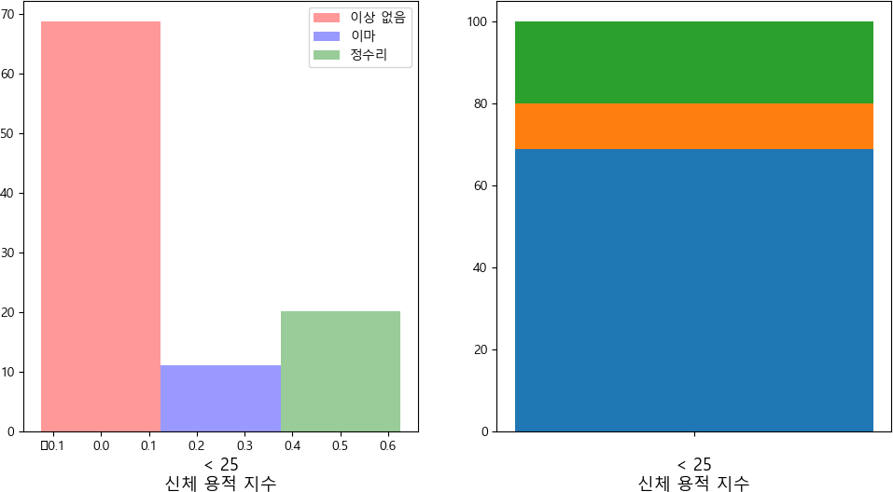

In [127]:

*#* 연습문제 *2.1, p55* **import** matplotlib.pyplot **as** plt **import** numpy **as** np

bar_width **=** 0.25

plt**.**rc('font', family**=**'Malgun Gothic')

label **=** ['이상 없음', '이마', '정수리'] vunder_25 **=** [137, 22, 40]

v25_to_28 **=** [218, 34, 67]

vhigh_28 **=** [153, 30, 68]

values, values2, values3 **=** [], [], []

colors **=** ['red', 'green', 'blue']

valve **=** ['vunder_25', 'v25_to_28', 'vhigh_28'] desc **=** ['< 25', '25 ~ 28', '> 28']

x_save, x_save1, x_save2 **=** [], [], []

*# under_25*

total **=** sum(vunder_25)

**for** i **in** range(len(vunder_25)):

data **=** round((vunder_25[i] **/** total **\*** 100) ,1) x_save**.**append(data)

**if** i **==** 0: values**.**append(data)

**elif** i **==** 1: values2**.**append(data)

# else:

values3**.**append(data)

total **=** sum(v25_to_28)

**for** i **in** range(len(v25_to_28)):

data **=** round((v25_to_28[i] **/** total **\*** 100) ,1) x_save1**.**append(data)

**if** i **==** 0:

values**.**append(data)

**elif** i **==** 1:

values2**.**append(data)

# else:

values3**.**append(data)

total **=** sum(vhigh_28)

**for** i **in** range(len(vhigh_28)):

data **=** round((vhigh_28[i] **/** total **\*** 100) ,1) x_save2**.**append(data)

**if** i **==** 0:

values**.**append(data)

**elif** i **==** 1:

values2**.**append(data)

# else:

values3**.**append(data)

plt**.**subplot(121) index **=** np**.**arange(3)

b1 **=** plt**.**bar(index, values, bar_width, alpha**=**0.4, color**=**'red', label**=**label[0])

b2 **=** plt**.**bar(index **+** bar_width, values2, bar_width, alpha**=**0.4, color**=**'blue', label**=**label[1])

b3 **=** plt**.**bar(index **+** 2 **\*** bar_width, values3, bar_width, alpha**=**0.4, color**=**'green', label**=**label[2])

plt**.**xticks(np**.**arange(bar_width, 3 **+** bar_width, 1), desc) plt**.**xlabel('신체 용적 지수', size **=** 13)

plt**.**legend()

plt**.**subplot(122)

print(x_save, x_save1, x_save2) print(values)

*# plot2*

plt**.**bar("< 25", x_save[0])

plt**.**bar("< 25", x_save[1], bottom**=**x_save[0])

plt**.**bar("< 25", x_save[2], bottom**=**x_save[0]**+**x_save[1])

*# plot 2-1*

plt**.**bar("25 ~ 28", x_save2[0])

plt**.**bar("25 ~ 28", x_save2[1], bottom**=**x_save2[0])

plt**.**bar("25 ~ 28", x_save2[2], bottom**=**x_save2[0]**+**x_save2[1])

*# plot 2-2*

plt**.**bar("> 28", x_save2[0])

plt**.**bar("> 28", x_save2[1], bottom**=**x_save2[0])

plt**.**bar("> 28", x_save2[2], bottom**=**x_save2[0]**+**x_save2[1]) plt**.**show()

[68.8, 11.1, 20.1] [68.3, 10.7, 21.0] [61.0, 12.0, 27.1]

[68.8, 68.3, 61.0]

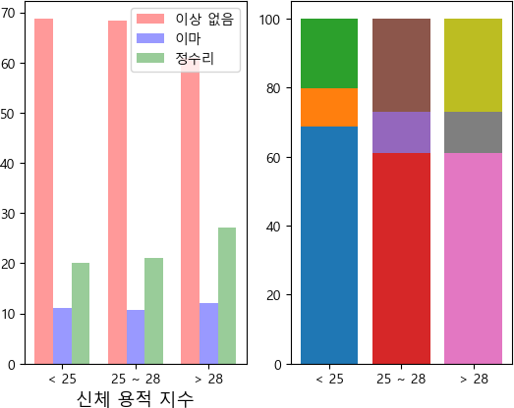

Loading [MathJax]/jax/output/CommonHTML/fonts/TeX/fontdata.js