In [8]:

*#* 연습문제 *4 /* 예제*(5.21), p173*

**from** scipy.stats **import** norm

mu **=** 50 *#* 평균

sigma **=** 10 *#* 표준편차

*# P(60 < X < 65)*

prob **=** norm**.**cdf(65, mu, sigma) **-** norm**.**cdf(60, mu, sigma)

print(f"P(60 < X < 65) = {prob}")

P(60 < X < 65) = 0.09184805266259899

In [1]:

*#* 연습문제 *4 -* 그래프 출력하기 */* 예제*(5.21), p173*

**import** matplotlib.pyplot **as** plt

**import** numpy **as** np

**from** scipy.stats **import** norm

mu **=** 50 *#* 평균

sigma **=** 10 *#* 표준편차

x **=** np**.**linspace(mu **-** 4 **\*** sigma, mu **+** 4 **\*** sigma, 1000) y **=** norm**.**pdf(x, mu, sigma)

*# P(60 < X < 65)*

x_fi**l =** np**.**linspace(60, 65, 100) y_fi**l =** norm**.**pdf(x_fi**l**, mu, sigma)

plt**.**plot(x, y)

plt**.**fi**l**_between(x_fi**l**, y_fi**l**, alpha**=**0.5) plt**.**title("P(60 < X < 65)")

plt**.**axvline(60, color**=**"red", linestyle**=**"--") plt**.**axvline(65, color**=**"red", linestyle**=**"--") plt**.**show()

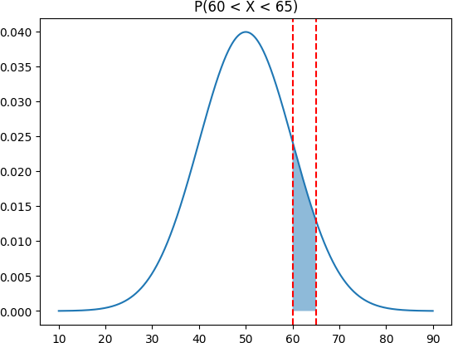

Loading [MathJax]/jax/output/CommonHTML/fonts/TeX/fontdata.js