In [14]:

*#* 연습문제 *5 /* 예제*(5.23), p174* **from** scipy.stats **import** norm **import** matplotlib.pyplot **as** plt **import** numpy **as** np

plt**.**rc('font', family**=**'Malgun Gothic') mu **=** 1500

sigma **=** 75

*# P(X < 1410)*

prob **=** norm**.**cdf(1410, mu, sigma)

*# P(1563 <= X <= 1648)*

prob2 **=** norm**.**cdf(1648, mu, sigma) **-** norm**.**cdf(1563, mu, sigma)

*#* 백열전구의 수명이 *1410*시간 이하일 확률 print(f"P(X < 1410) = {prob:.4f}") print(f"P(1536 < X < 1648) = {prob2:.4f}")

x **=** np**.**linspace(mu **-** 4 **\*** sigma, mu **+** 4 **\*** sigma, 1000) y **=** norm**.**pdf(x, mu, sigma)

*# P(X < 1410)*

x_fi**l =** np**.**linspace(mu **-** 4 **\*** sigma, 1410, 100) y_fi**l =** norm**.**pdf(x_fi**l**, mu, sigma)

plt**.**plot(x, y, label**=**"P(X < 1410)") plt**.**fi**l**_between(x_fi**l**, y_fi**l**, alpha**=**0.5) plt**.**title("P(X < 1410) / P(Z <= -1.2)")

x **=** np**.**linspace(mu **-** 4 **\*** sigma, mu **+** 4 **\*** sigma, 1000) y **=** norm**.**pdf(x, mu, sigma)

*# P(1563 <= X <= 1648)*

x_fi**l =** np**.**linspace(1563, 1648, 100) y_fi**l =** norm**.**pdf(x_fi**l**, mu, sigma)

plt**.**plot(x, y, label**=**"P(1563 <= X <= 1648)") plt**.**fi**l**_between(x_fi**l**, y_fi**l**, alpha**=**0.5) plt**.**title("total Graph")

plt**.**legend()

*# legend =* 범례

plt**.**show()

P(X < 1410) = 0.1151 P(1536 < X < 1648) = 0.1762

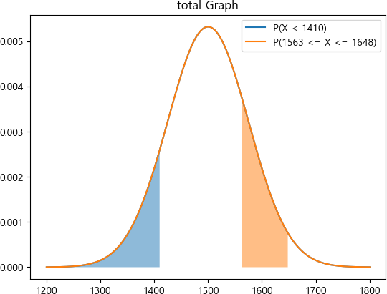

In [11]:

*#* 연습문제 *5-1 /* 예제*(5.23), p174 /* 분할 그래프 그리기

**from** scipy.stats **import** norm

**import** matplotlib.pyplot **as** plt

**import** numpy **as** np

plt**.**rc('font', family**=**'Malgun Gothic') mu **=** 1500

sigma **=** 75

x **=** np**.**linspace(mu **-** 4 **\*** sigma, mu **+** 4 **\*** sigma, 1000) y **=** norm**.**pdf(x, mu, sigma)

*# P(X < 1410)*

x_fi**l =** np**.**linspace(mu **-** 4 **\*** sigma, 1410, 100) y_fi**l =** norm**.**pdf(x_fi**l**, mu, sigma)

plt**.**subplot(121) plt**.**plot(x, y)

plt**.**fi**l**_between(x_fi**l**, y_fi**l**, alpha**=**0.5) plt**.**title("P(X < 1410) / P(Z <= -1.2)")

x **=** np**.**linspace(mu **-** 4 **\*** sigma, mu **+** 4 **\*** sigma, 1000) y **=** norm**.**pdf(x, mu, sigma)

*# P(1563 <= X <= 1648)*

x_fi**l =** np**.**linspace(1563, 1648, 100) y_fi**l =** norm**.**pdf(x_fi**l**, mu, sigma)

plt**.**subplot(122) plt**.**plot(x, y)

plt**.**fi**l**_between(x_fi**l**, y_fi**l**, alpha**=**0.5) plt**.**title("P(1563 <= X <= 1648)")

plt**.**show()

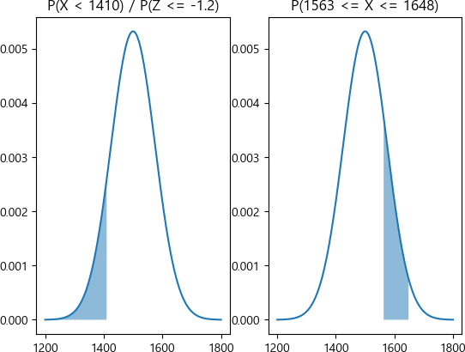

Loading [MathJax]/jax/output/CommonHTML/fonts/TeX/fontdata.js