In [5]:

*#* 연습문제 *6 /* 예제*(5.25), p176*

**from** scipy.stats **import** norm

mu **=** 6

sigma **=** 2.366

x **=** 5

*# P(4.5 <= X <= 5.5)*

prob **=** norm**.**cdf(x **+** 0.5, mu, sigma) **-** norm**.**cdf(x **-** 0.5, mu, sigma) print(f"5대가 결점이 있을 확률 : {round((prob), 4)}")

5대가 결점이 있을 확률 : 0.1533

In [7]:

*#* 연습문제 *6-1 /* 예제*(5.25), p176 +* 시각화

**import** matplotlib.pyplot **as** plt

**import** numpy **as** np

**from** scipy.stats **import** norm

mu **=** 6

sigma **=** 2.366

x **=** np**.**linspace(mu **-** 4 **\*** sigma, mu **+** 4 **\*** sigma, 1000) y **=** norm**.**pdf(x, mu, sigma)

fig, ax **=** plt**.**subplots() ax**.**plot(x, y)

ax**.**fi**l**_between(x, y, where**=**(4.5 **<=** x) **&** (x **<=** 5.5), color**=**'red', alpha**=**0.2) ax**.**set_xlabel('X')

ax**.**set_ylabel('P(X)')

ax**.**set_title('P(4.5 <= X <= 5.5) / P(-0.66 <= Z <= - 0.22)')

plt**.**show()

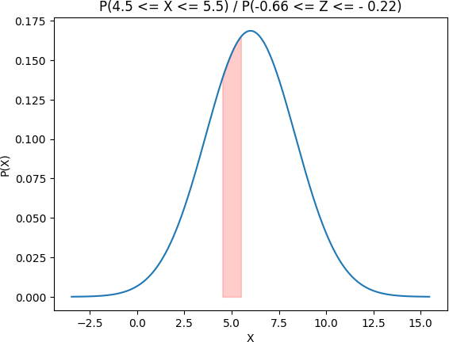

Loading [MathJax]/jax/output/CommonHTML/fonts/TeX/fontdata.js