In [8]:

*#* 연습문제 *7 /* 예제*(5.27), p177* **from** scipy.stats **import** norm **import** numpy **as** np **import** matplotlib.pyplot **as** plt

plt**.**rc('font', family**=**'Malgun Gothic') x **=** 155

mu **=** (250 **\*** 0.6)

sigma **=** 7.746

prob **=** norm**.**cdf(x **+** 0.5, mu, sigma) print(f"예산삭감을 지지할 확률 : {round((prob), 4)}")

x **=** np**.**linspace(**-**4, 4, 1000) y **=** norm**.**pdf(x)

fig, ax **=** plt**.**subplots() ax**.**plot(x, y)

ax**.**fi**l**_between(x, y, where**=**(x **<=** 0.71), color**=**'red', alpha**=**0.2) ax**.**set_xlabel('Z의 위치')

ax**.**set_ylabel('사람')

ax**.**set_title('P(Z <= 0.71)')

plt**.**show()

예산삭감을 지지할 확률 : 0.7612

C:\Users\starl\AppData\Roaming\Python\Python311\site-packages\IPython\core\pylabtools.py:152: UserWarning: Glyph 8722 (\N{MINUS SIGN}) missing from curr

ent font. fig.canvas.print_figure(bytes_io, **kw)

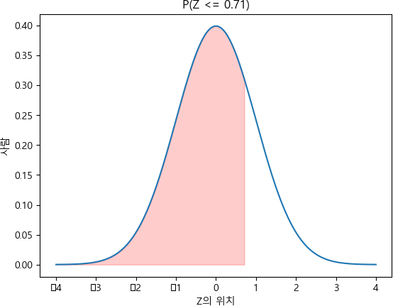

Loading [MathJax]/jax/output/CommonHTML/fonts/TeX/fontdata.js