In [6]:

*#* 연습문제 *4 p211* **from** scipy.stats **import** norm **import** math

z1 **=** (75 **-** 75) **/** (10 **/** math**.**sqrt(25)) z2 **=** (79 **-** 75) **/** (10 **/** math**.**sqrt(25)) print(z1, z2)

prob **=** norm**.**cdf(z2) **-** norm**.**cdf(z1) print(f'P({z1:.4f} <= Z <= {z2:.4f}) : {prob:.4f}')

0.0 2.0

P(0.0000 <= Z <= 2.0000): 0.4772

In [11]:

**import** matplotlib.pyplot **as** plt **import** numpy **as** np **from** scipy.stats **import** norm

x **=** np**.**linspace(**-**4, 4, 1000) y **=** norm**.**pdf(x)

z1 **=** 0

z2 **=** 2

x_fi**l =** np**.**linspace(z1, z2, 1000) y_fi**l =** norm**.**pdf(x_fi**l**)

fig, ax **=** plt**.**subplots() ax**.**plot(x, y)

ax**.**fi**l**_between(x_fi**l**, y_fi**l**, alpha**=**0.5) ax**.**axvline(0, color**=**"red", linestyle**=**"--") plt**.**axvline(2, color**=**"red", linestyle**=**"--")

ax**.**set_title(f'P({z1} <= Z <= {z2}) / P(75 <= X <= 79)') plt**.**show()

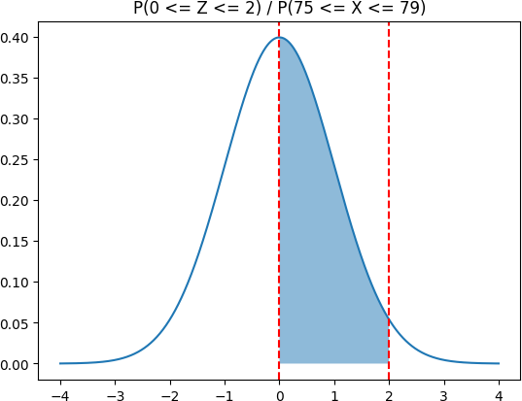

Loading [MathJax]/jax/output/CommonHTML/fonts/TeX/fontdata.js