In [1]:

*#* 연습문제 *5 p212* **from** math **import** sqrt **from** scipy.stats **import** norm

mean1 **=** 50

var1 **=** 9

mean2 **=** 40

var2 **=** 4

n1 **=** 5

n2 **=** 4

mean_di **f =** mean1 **-** mean2

std_dev_di **f =** sqrt(var1 **/** n1 **+** var2 **/** n2) prob **=** norm**.**cdf(8.2, mean_di **f**, std_dev_di **f**)

print(f"P(X-Y < 8.2)의 확률: {prob:.4f}")

P(X-Y< 8.2)의 확률: 0.1410

In [2]:

*#* 연습문제 *5 p212 +* 시각화 **import** matplotlib.pyplot **as** plt **import** numpy **as** np **from** math **import** sqrt

**from** scipy.stats **import** norm

mean1 **=** 50

var1 **=** 9

mean2 **=** 40

var2 **=** 4

n1 **=** 5

n2 **=** 4

mean_di **f =** mean1 **-** mean2

std_dev_di **f =** sqrt(var1 **/** n1 **+** var2 **/** n2)

x **=** np**.**linspace(mean_di **f -** 4 **\*** std_dev_di **f**, mean_di **f +** 4 **\*** std_dev_di **f**, 1000) pdf **=** norm**.**pdf(x, mean_di **f**, std_dev_di **f**)

prob **=** norm**.**cdf(8.2, mean_di **f**, std_dev_di **f**)

*#* 그래프 그리기

plt**.**plot(x, pdf, label**=**"PDF of X-Y")

plt**.**fi**l**_between(x[x **<** 8.2], pdf[x **<** 8.2], alpha**=**0.5) plt**.**axvline(8.2, color**=**"red", linestyle**=**"--") plt**.**legend()

plt**.**title(f"P(X-Y < 8.2)={prob:.4f}") plt**.**show()

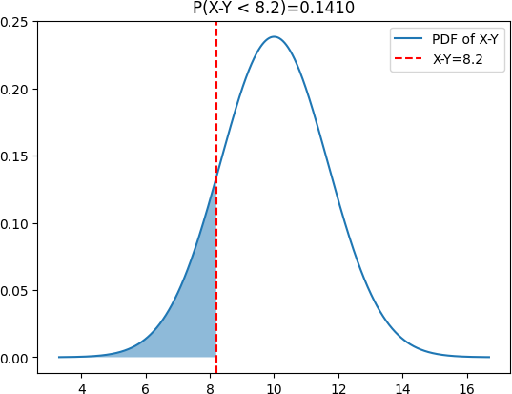

Loading [MathJax]/jax/output/CommonHTML/fonts/TeX/fontdata.js