In [11]:

*#* 연습문제 *6 p213*

**from** scipy.stats **import** t

df **=** [17, 6, 18, 17]

t_value **=** [**-**1.740, 3.143, 1.330, **-**2.567]

p_value **=** t**.**cdf(t_value[0], df[0]) print(f'P(T < {t_value[0]}) = {p_value:.2f}')

p_value **=** t**.**cdf(t_value[1], df[1]) **-** t**.**cdf(**-**t_value[1], df[1])

print(f'P(|T| < {t_value[1]}) = {p_value:.2f}')

p_value **=** t**.**cdf(**-**t_value[2], df[2]) **-** t**.**cdf(t_value[2], df[2])

print(f'P({**-**t_value[2]} < T < {t_value[2]}) = {round((abs(p_value)), 3)}') p_value **=** 1 **-** t**.**cdf(t_value[3], df[3])

print(f'P(T > {t_value[3]}) = {p_value:.2f}')

P(T < -1.74) = 0.05

P(|T| < 3.143) = 0.98

P(-1.33 < T < 1.33) = 0.8

P(T > -2.567) = 0.99

In [16]:

*#* 연습문제 *6 p213 +* 시각화 */ P(T < -1.74) /* 오류로 제외 예정 */* 프리체크 필요

**import** matplotlib.pyplot **as** plt

**import** numpy **as** np

**from** scipy.stats **import** t

t_value **= -**1.74 df **=** 17

x **=** np**.**linspace(t**.**ppf(0.01, df), t**.**ppf(0.99, df), 100) y **=** t**.**pdf(x, df)

fig, ax **=** plt**.**subplots()

ax**.**plot(x, y, alpha**=**0.6, label**=**'t pdf') plt**.**title('P(T < -1.74)')

ax**.**fi**l**_between(x[x **<** t_value], y[x **<** t_value], alpha**=**0.5)

plt**.**show()

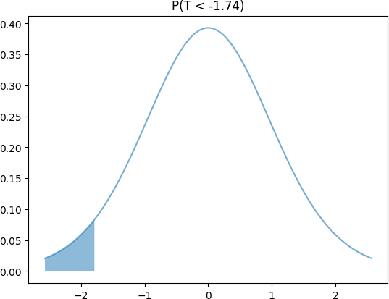

Loading [MathJax]/jax/output/CommonHTML/fonts/TeX/fontdata.js