In [3]:

*#* 연습문제 *1 p241 , node (3)* **from** math **import** sqrt **from** scipy.stats **import** norm

n **=** 40 *#* 샘플 사이즈

x **=** 34 *#* 성공한 샘플의 수

p_hat **=** x **/** n *#* 성공률

z **=** norm**.**ppf(0.975)

se **=** sqrt(p_hat **\*** (1 **-** p_hat) **/** n) lower **=** p_hat **-** z **\*** se

upper **=** p_hat **+** z **\*** se

print(f"성공률 p의 95% 신뢰구간 : ({round((lower), 3)} < p < {round((upper), 3)})")

성공률 p의 95% 신뢰구간 : (0.739 < p < 0.961)

In [8]:

*#* 연습문제 *1 p241 , node (3) +* 시각화

**import** matplotlib.pyplot **as** plt

lower **=** 0.739

upper **=** 0.961

plt**.**figure(figsize**=**(6, 1))

plt**.**hlines(0, lower, upper, linewidth**=**3) plt**.**axvline(lower, linestyle**=**'--', color**=**'gray') plt**.**axvline(upper, linestyle**=**'--', color**=**'gray') plt**.**xlim(0, 1)

plt**.**yticks([])

plt**.**xticks([lower, upper], [f'{lower:.3f}', f'{upper:.3f}']) plt**.**title('0.739 < p < 0.961')

plt**.**show()

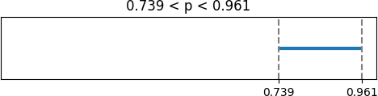

In [ ]:

Loading [MathJax]/jax/output/CommonHTML/fonts/TeX/fontdata.js