In [8]:

*#* 연습문제 *2 p242, node (7)* **from** math **import** sqrt **from** scipy.stats **import** norm

a **=** [928, 72] *#* 품목 *A*

b **=** [772, 28] *#* 품목 *B*

n1 **=** sum(a) n2 **=** sum(b)

p1 **=** a[1] **/** n1 p2 **=** b[1] **/** n2

p_hat **=** p1 **-** p2

z **=** norm**.**ppf(0.975)

se **=** sqrt((p1 **\*** (1 **-** p1) **/** n1) **+** (p2 **\*** (1 **-** p2) **/** n2)) lower **= -**(p_hat **-** z **\*** se)

upper **=** p_hat **+** z **\*** se

print(f"신뢰 상한과 하한 : ({lower:.4f}, {upper:.4f})\n식 : ({lower:.4f} < p1 - p2 < {upper:.4f})")

신뢰 상한과 하한 : (-0.0165, 0.0575)

식 : (-0.0165 < p1 - p2 < 0.0575)

In [9]:

*#* 연습문제 *2 p242, node (7) +* 시각화

**import** matplotlib.pyplot **as** plt

lower **= -**0.0165 upper **=** 0.0575

plt**.**figure(figsize**=**(6, 1))

plt**.**hlines(0, lower, upper, linewidth**=**3) plt**.**axvline(lower, linestyle**=**'--', color**=**'gray') plt**.**axvline(upper, linestyle**=**'--', color**=**'gray') plt**.**xlim(**-**0.1, 0.1)

plt**.**yticks([])

plt**.**xticks([lower, upper], [f'{lower:.4f}', f'{upper:.4f}']) plt**.**title('-0.0165 < p1 - p2 < 0.0575')

plt**.**show()

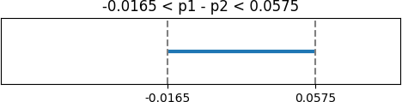

Loading [MathJax]/jax/output/CommonHTML/fonts/TeX/fontdata.js