In [12]:

*#* 연습문제 *3 p242, node (7)*

**from** scipy.stats **import \***

n **=** 100

sample_mean **=** 1.022

sigma **=** 0.021

sem **=** sigma **/** (n **\*\*** 0.5)

ci **=** norm**.**interval(0.95, loc**=**sample_mean, scale**=**sem)

print(f"95% 신뢰구간 : ({round((ci[0]), 3)} < mu < {round((ci[1]), 3)}) [단위 : mm]")

95% 신뢰구간 : (1.018 < mu < 1.026) [단위 : mm]

In [15]:

*#* 연습문제 *3 p242, node (7) +* 시각화 **import** matplotlib.pyplot **as** plt **import** numpy **as** np

x **=** np**.**linspace(1.015, 1.029, 1000)

mu **=** 1.022

sigma **=** 0.021

pdf **=** (1 **/** (sigma **\*** np**.**sqrt(2 **\*** np**.**pi))) **\*** np**.**exp(**-**0.5 **\*** ((x **-** mu) **/** sigma) **\*\*** 2) plt**.**plot(x, pdf, color**=**'blue')

plt**.**fi**l**_between(x, pdf, where**=**(x **>** 1.018) **&** (x **<** 1.026), color**=**'blue', alpha**=**0.3) plt**.**axvline(1.018, color**=**"red", linestyle**=**"--")

plt**.**axvline(1.026, color**=**"red", linestyle**=**"--") plt**.**title('1.018 < mu < 1.026')

plt**.**show()

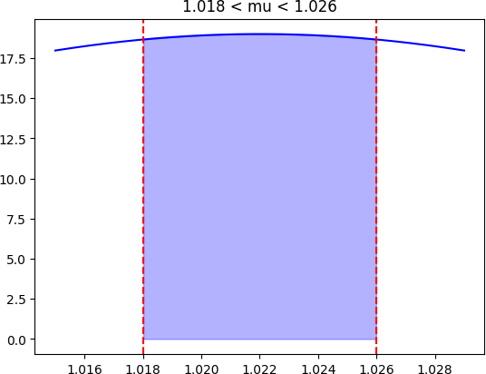

Loading [MathJax]/jax/output/CommonHTML/fonts/TeX/fontdata.js